Supplementary Material

Cerebrospinal fluid biomarkers reveal transdiagnostic synaptic dysfunction across major psychiatric disorders
Andreas Göteson^{1,2}, Johanna Nilsson¹, Elena Camporesi¹, Anna Luisa Klahn¹, Elin Hörbeck^{1,3}, Robert Sigström^{1,2}, Lina Jonsson¹, Timea Sparding¹, Erik Pålsson¹, Aurimantas Pelanis¹, Anneli Goulding^{1,3}, Anniella Isgren^{1,3}, Sophie Erhardt⁴, Simon Cervenka^{5,6}, Cynthia M. Bulik^{7,8,9}, Henrik Zetterberg^{1,10,11,12,13,14,15,16}, Kaj Blennow^{1,10,17,18}, Carl M. Sellgren^{4,6}, Ann Brinkmalm¹, Mikael Landén^{1,9}

1 Department of Psychiatry and Neurochemistry, Institute of Neuroscience and Physiology, Sahlgrenska Academy, University of Gothenburg, Gothenburg, Sweden
2 Department of Psychiatry for Affective Disorders, Region Västra Götaland, Sahlgrenska University Hospital, Gothenburg, Sweden
3 Department of Psychotic Disorders, Sahlgrenska University Hospital, Gothenburg, Sweden
4 Department of Physiology and Pharmacology, Karolinska Institutet, Stockholm, Sweden
5 Department of Medical Sciences, Psychosis Research and Preventive Psychiatry, Uppsala University, Uppsala, Sweden
6 Centre for Psychiatry Research, Department of Clinical Neuroscience, Karolinska Institutet, Stockholm, Sweden
7 Department of Psychiatry, University of North Carolina at Chapel Hill, Chapel Hill, NC, USA
8 Department of Nutrition, University of North Carolina at Chapel Hill, Chapel Hill, NC, USA
9 Department of Medical Epidemiology and Biostatistics, Karolinska Institutet, Stockholm, Sweden
10 Clinical Neurochemistry Laboratory, Sahlgrenska University Hospital, Mölndal, Sweden
11 Department of Neurodegenerative Disease, Dementia Research Centre, UCL Institute of Neurology, Queen Square, London, UK
12 UK Dementia Research Institute, University College London, London, UK
13 Hong Kong Center for Neurodegenerative Diseases, Hong Kong, China
14 Wisconsin Alzheimer’s Disease Research Center, University of Wisconsin-Madison, Madison, WI, USA
15 Department of Pathology and Laboratory Medicine, University of Wisconsin School of Medicine and Public Health, Madison, WI, USA
16 Centre for Brain Research, Indian Institute of Science, Bangalore, India
17 Paris Brain Institute, ICM, Pitié-Salpêtrière Hospital, Sorbonne University, Paris, France
18 Neurodegenerative Disorder Research Center, Division of Life Sciences and Medicine, and Department of Neurology, Institute on Aging and Brain Disorders, University of Science and Technology of China and First Affiliated Hospital of USTC, Hefei, P.R. China

Supplementary Tables
Table S1. Concentration of internal standard, repeatability, and intermediate precision for each peptide from panel 1 and 2.

Table S2. LC-MS/MS settings for panel 1 and 2, as well as the analyses of SNAP25 and SYT1.

Table S3. Summary statistics from main case-control analyses.

Table S4. Variance explained (R2) for each drug adjusted for age, sex, diagnostic group and the non-disease covariance reference.

Table S5. Results from expression quantitative trait loci associations, comparing summary statistics from MetaBrain with results in CSF. Proteins with a significant association (nominal p-value < 0.05) are shown.

Supplementary Methods

Adjusting for non-disease covariance (Figure S1 and S2)
To account for inter-individual variability in CSF synapse protein levels, we sought to identify proteins that could serve as a reference for CSF dynamics. We calculated a rank based on five scores. First, a reference protein should not be associated with case-control status. Therefore, we ranked proteins by results from the primary case-control linear regression models, retaining the highest absolute standardized beta value from the five case–control comparisons, where a lower score was preferable. Second, a reference protein should have similar variance in cases and controls. Therefore, we estimated the variance for each protein in cases and controls and created a ratio where values close to 1 are preferable, indicating that the variance in cases is similar to controls. Third, a reference protein should closely resemble the main covariance. We captured the main covariance using principal component analyses based on four subgroups: female and male controls at time point 1 and 2. We then averaged the loadings for the first component across the four models to obtain an indicator of proteins with a high degree of correlation to the main covariance in females and males at various time points. Fourth, in the absence of disease, a reference protein should be shed or released into CSF at a stable rate over time within one individual—i.e., most of the variance should originate from between-individual variability rather than within-individual variability over time. We quantified this contrast, commonly referred to as the intraclass correlation coefficient (ICC), in a linear mixed effects model based on longitudinal data from controls. A higher ICC yielded a higher rank. Fifth, we calculated Pearson’s correlation coefficients between synapse proteins and amyloid-beta 40, which has previously been suggested to have the characteristics of a reference protein. Amyloid-beta 40 was previously measured in a subset of the participants (n=121 cases and 71 controls). In a final step, we scaled all five scores using min-max scaling transformed such that a high score always indicates optimal characteristics for a reference protein (i.e., low std. beta, high PC1 loading). We then averaged the five scores to create a rank (Figure S1A).

The reference for non-disease covariance was computed as a singular value decomposition from the top three most highly ranked candidates (SYUB, STX7, NCAM2) using the nipals algorithm. The composite score was highly correlated with the candidate proteins (Figure S1B).

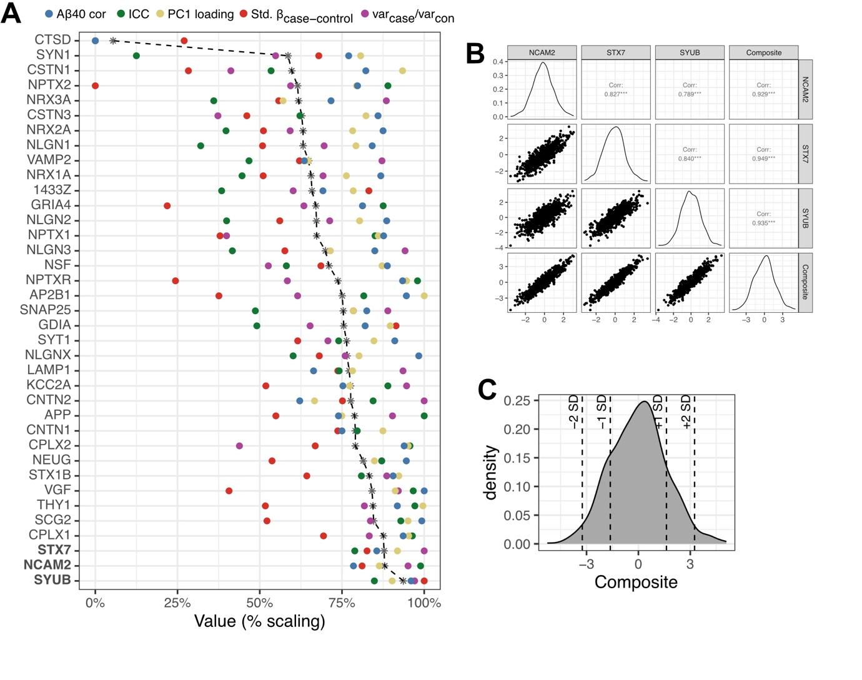
Figure S1. Ranking of synapse proteins for a non-disease covariance reference. A) The candidate reference proteins were ranked by five scores, represented in the figure as colored dots. The black line indicates the composite of the four scores. B) The correlation of each of the three selected reference biomarkers to the reference composite. C) A density plot of the variability of the non-disease covariance reference across individuals.

Regressing protein concentrations on this reference and calculating protein-protein correlations revealed that the main covariance was attenuated, yet closely related proteins maintained a high degree of correlation (Figure S2A).

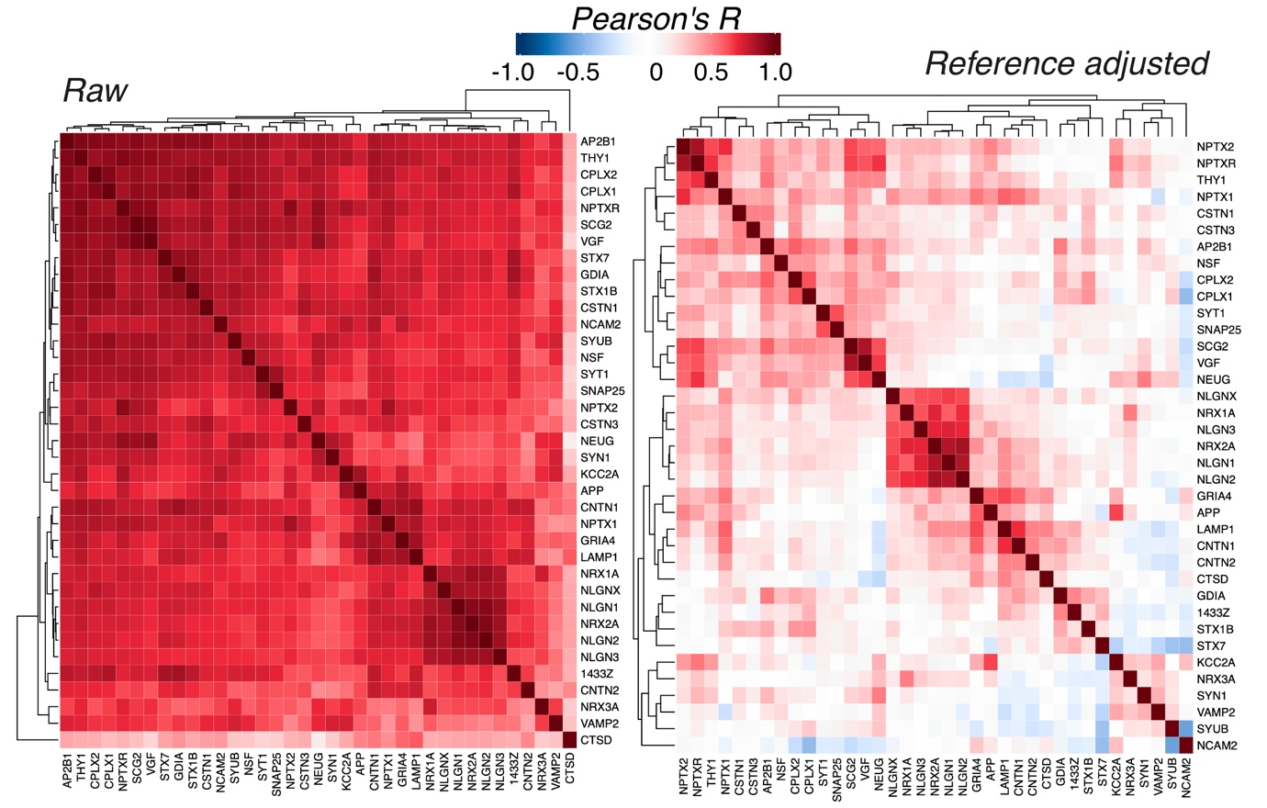
Figure S2. Adjusting for the CSF synapse reference. Heatmaps showing the correlation coefficient for each pairwise protein-protein correlation using raw CSF levels (left) and CSF levels adjusted for the non-disease covariance reference (right).

The effect of expression quantitative trait loci (eQTL’s) on CSF protein concentrations was evaluated using a set of high-confidence eQTL’s (< 5% false discovery rate) reported by the MetaBrain initiative, using the frontal cortex subset³⁴. For each protein available in the synapse panels, we extracted the lead cis eQTL variant for the subset of the baseline controls with individual-level genetic data available (n=132). Linear regression models were fitted to evaluate the additive effect of each respective eQTL variant, adjusting for age and sex. This analysis was done using both raw CSF concentrations and adjusted for non-disease covariance. Results are presented in Table S5.

Definition of cognitive impairment (Figure S3)
To identify distinct cognitive domains, data from the cognitive test battery in control participants were subjected to hierarchical clustering using the Ward D2 linkage method. The resulting dendrogram was cut at a height selected by the authors to yield a broad representation of cognitive domains. From each resulting cluster, one representative test score was selected. These representative tests were then used to perform principal component analysis (PCA) on control data, with unit variance scaling applied. The first two principal components (PC1 and PC2) together explained 45% of the total variance among controls. Euclidean distances in the PC1–PC2 space were computed for controls, and the mean and standard deviation of these distances were used to define a normative range. Data from case participants were projected onto this dimensionality-reduced space, and cases whose projections fell more than 1.96 standard deviations below the control distribution were classified as cognitively impaired.

For associations with specific cognitive domains, the scaled FSIQ summary score from WAIS (version 3 or 4) was used to represent full-scale IQ, and executive function, processing speed, and visual memory were calculated as composite scores using the first principal component of raw scores from representative tests, including:

Executive function: TMT condition 4 (number–letter switching), CWIT conditions 3 (inhibition) and 4 (inhibition/switching), and VFT condition 3 (category switching accuracy).

Processing speed: RCFT time to copy, TMT conditions 2 (number sequencing) and 5 (motor speed), and CWIT conditions 1 (color naming) and 2 (word reading).

Visual memory: RCFT immediate recall and delayed recall.

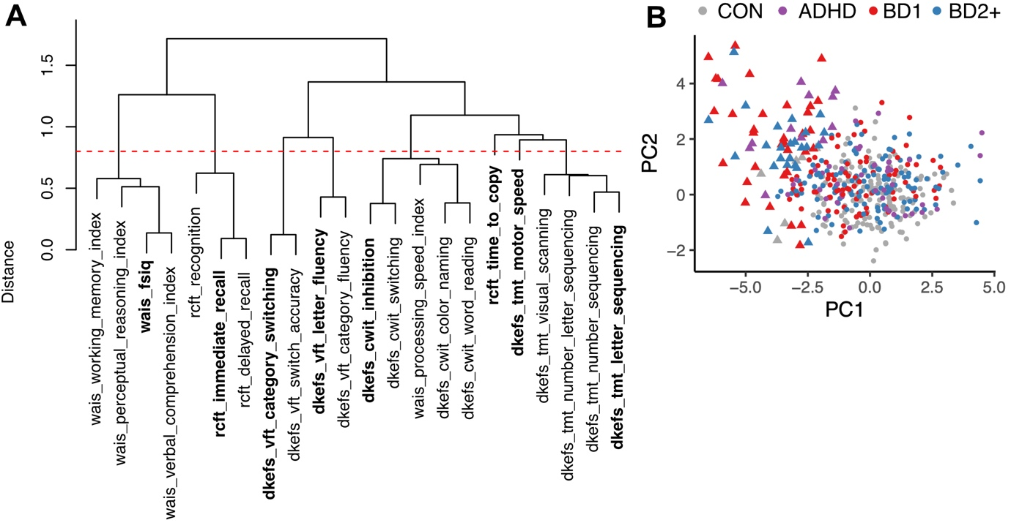

Figure S3. Definition of cognitive impairment. A) A dendrogram representation of the hierarchical clustering of cognitive tests in controls. One representative test score was chosen from each cluster, labeled in bold. B) A score plot of the first two principal components of cognitive scores. Cases labeled ‘cognitively impaired’ are labeled with triangles.

