Supplementary Table S1: Interpretation of Weighted Proportion Scale and Consensus Index
Table 1: Interpretation of WPS scale
Magnitude | Range | Interpretation
Weighted Proportion Score (WPS)
Indistinct | −0.1 < w < +0.1 | Neutral or no clear collective perception
Perceptible | +0.1 ≤ w < +0.5 or −0.5 < w ≤ −0.1 | Non-significant perception of increase/decrease
Considerable | +0.5 ≤ w < +1.0 or −1.0 < w ≤ −0.5 | Significant perception of increase/decrease
Overwhelming | +1.0 ≤ w < +2.0 or −2 < w ≤ −1.0 | Very strong perception of increase/decrease
Consensus Index (CI)
Low confidence | 0.0 ≤ c < 0.4 | Weak consensus; high variability in responses
Modest confidence | 0.4 ≤ c < 0.6 | Moderate agreement; some variability in perceptions
High confidence | 0.6 ≤ c < 0.8 | Strong agreement; low variability in perceptions
Very high confidence | 0.8 ≤ c ≤ 1.0 | Near-unanimous consensus; consistent perception
w: weighted proportion score (WPS) value; c: consensus index (CI) value

Supplementary Figure S2: Pearson correlation between predictor and outcome variables in the Heckman model
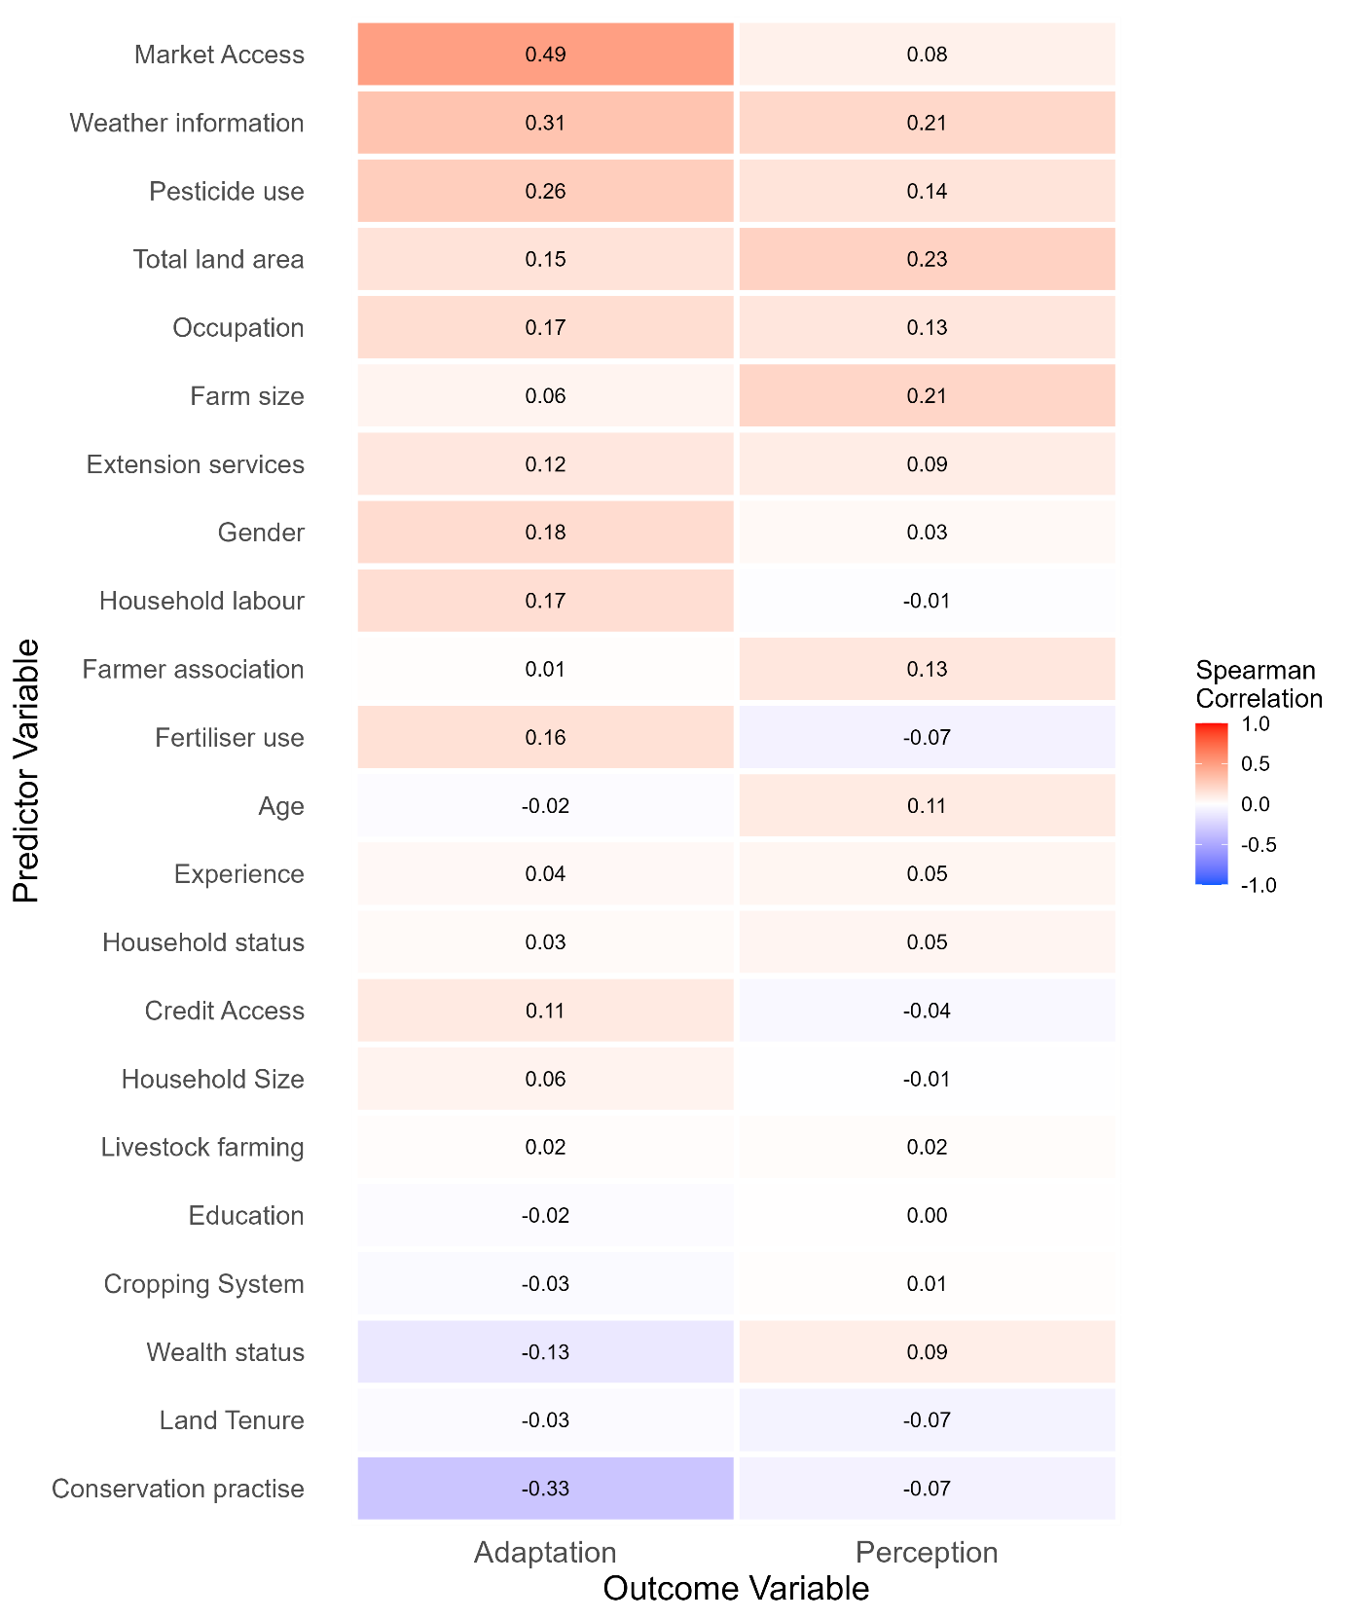

Supplementary Table S3: Variance Inflation Factor check of Heckman selection model
Variables | Outcome (adaptation) | Selection (perception)
Socioeconomic characteristics
Age bracket | 2.183 | 1.876
Education | 1.360 | 1.255
Gender | 2.694 | 1.226
Household status | 2.872 | -
Occupation | 1.357 | -
Wealth status | 1.433 | -
Household size | - | 1.062
Household labour | 1.187 | -
Total land | 1.394 | -
Land tenure | 1.182 | -
Farming attributes
Experience | 1.805 | 1.662
Farm size | 1.151 | -
Cropping system | 1.178 | 1.190
Fertilizer use | 1.623 | 1.553
Pesticide use | 1.462 | 1.476
Conservation | 1.400 | -
Livestock farming | 1.199 | -
Institutional factors
Access to extension services | 1.486 | 1.237
Farmer association membership | 1.406 | 1.232
Access to weather information | 1.251 | -
Access to credit | 1.091 | -
Access to market | 1.364 | -
Agroecological zone | 1.771 | 1.414

Supplementary File S4: Annual climate trends between 2000 and 2023 using MK and Sen’s slope tests
a. Annual Rainfall (mm)
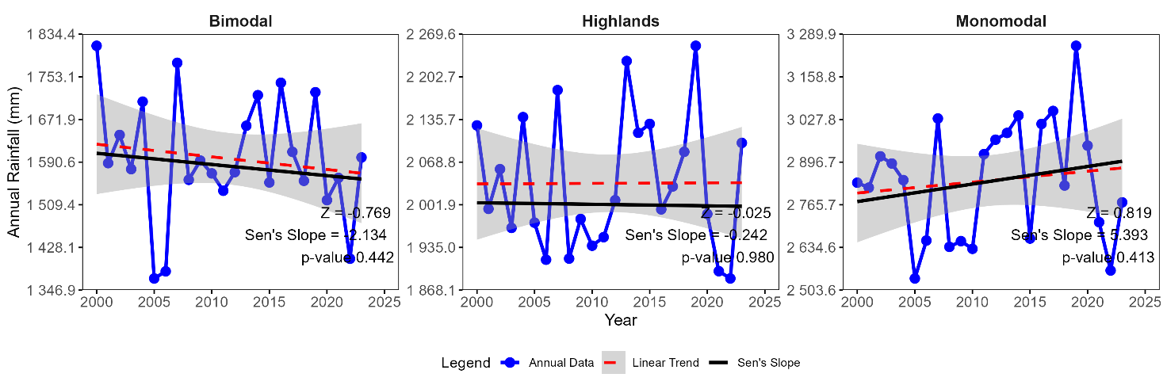
b. Annual Minimum temperature (ºC)
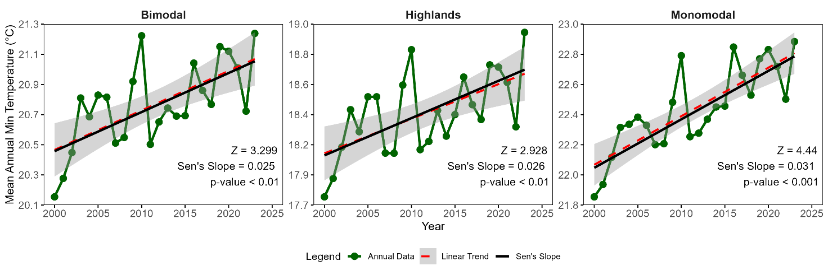
c. Annual Mean temperature (ºC)
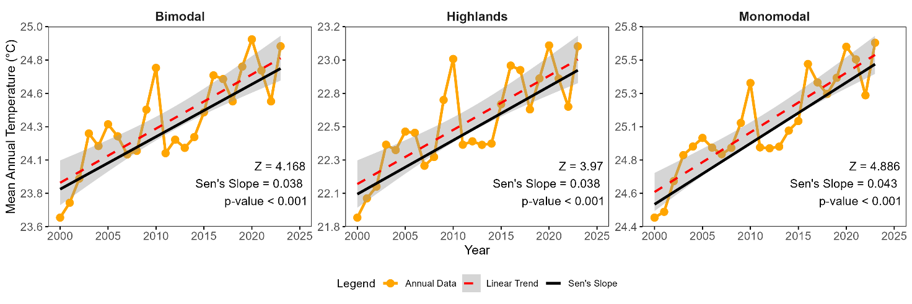
d. Annual Maximum temperature (ºC)
