Multi-omics analysis of exosomes induced by ischemic stimulation

Supplementary Information

Supplementary Table 1. Annotation of each protein related to inflammation in gene ontology (GO) terms. The annotation was obtained from UniProt database (https://www.uniprot.org/).

Protein | Annotation
PYGL | Glycogen phosphorylase, liver form.
PYGB | Glycogen phosphorylase, brain form; glycogen phosphorylase that regulates glycogen mobilization.
NAMPT | Nicotinamide phosphoribosyltransferase; catalyzes the condensation of nicotinamide with 5-phosphoribosyl-1-pyrophosphate to yield nicotinamide mononucleotide, an intermediate in the biosynthesis of NAD.
C3 | Complement C3; C3 plays a central role in the activation of the complement system. Its processing by C3 convertase is the central reaction in both classical and alternative complement pathways.
ACLY | ATP-citrate synthase; ATP-citrate synthase is the primary enzyme responsible for the synthesis of cytosolic acetyl-CoA in many tissues. Has a central role in de novo lipid synthesis.
PSMD3 | 26S proteasome non-ATPase regulatory subunit 3; component of the 26S proteasome, a multiprotein complex involved in the ATP-dependent degradation of ubiquitinated proteins.
AGL | Glycogen debranching enzyme; multifunctional enzyme acting as 1,4-alpha-D-glucan:1,4-alpha-D-glucan 4-alpha-D-glycosyltransferase and amylo-1,6-glucosidase in glycogen degradation.
DYNC1H1 | Cytoplasmic dynein 1 heavy chain 1; cytoplasmic dynein 1 acts as a motor for the intracellular retrograde motility of vesicles and organelles along microtubules.
XRCC6 | X-ray repair cross-complementing protein 6; single-stranded DNA-dependent ATP-dependent helicase. Has a role in chromosome translocation.
UBR4 | E3 ubiquitin-protein ligase UBR4; E3 ubiquitin-protein ligase, which is a component of the N-end rule pathway. Recognizes and binds to proteins bearing specific N-terminal residues that are destabilizing according to the N-end rule, leading to their ubiquitination and subsequent degradation.
DDX3X | ATP-dependent RNA helicase DDX3X; multifunctional ATP-dependent RNA helicase. The ATPase activity can be stimulated by various ribo- and deoxynucleic acids indicative for a relaxed substrate specificity.
PSMC2 | 26S proteasome regulatory subunit 7; component of the 26S proteasome, a multiprotein complex involved in the ATP-dependent degradation of ubiquitinated proteins.
CAPN1 | Calpain-1 catalytic subunit; calcium-regulated non-lysosomal thiol-protease which catalyzes limited proteolysis of substrates involved in cytoskeletal remodeling and signal transduction; Belongs to the peptidase C2 family.
CAND1 | Cullin-associated NEDD8-dissociated protein 1; key assembly factor of SCF (SKP1-CUL1-F-box protein) E3 ubiquitin ligase complexes that promotes the exchange of the substrate-recognition F-box subunit in SCF complexes, thereby playing a key role in the cellular repertoire of SCF complexes.
CYFIP1 | Cytoplasmic FMR1-interacting protein 1; component of the CYFIP1-EIF4E-FMR1 complex which binds to the mRNA cap and mediates translational repression. In the CYFIP1-EIF4E-FMR1 complex this subunit is an adapter between EIF4E and FMR1.

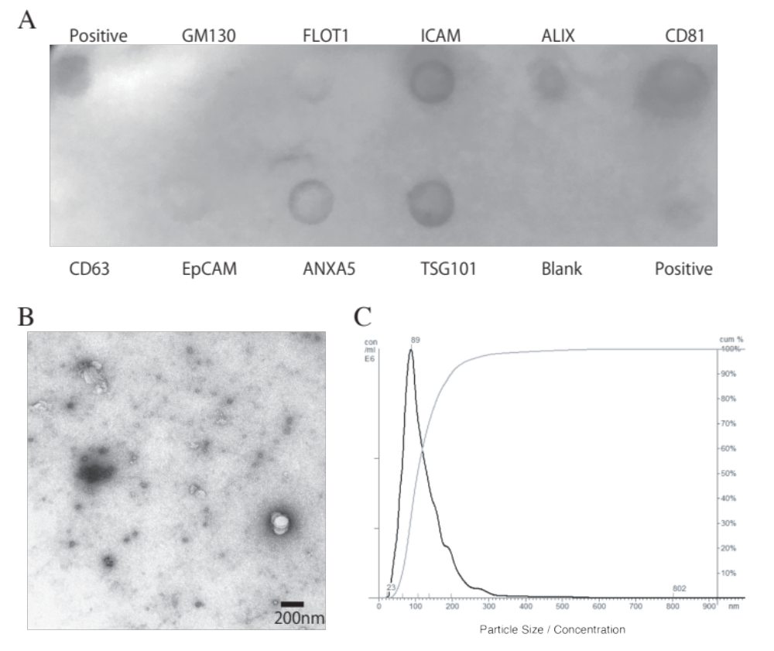
Supplementary Figure 1. Identification and morphological characterization of exosomes. The isolation of exosomes was confirmed via immunoblotting using Exo-Check Antibody Array, a transmission electron microscope, and nanoparticle tracking analysis.
(A) The exosome compartments of the samples were placed into the pre-printed spots of eight antibodies against known exosome markers (FLOT1, ICAM, ALIX, CD81, CD63, EpCAM, TSG101, and ANXA5) and to the positive control and the blank (negative control) to examine the presence of exosome-specific proteins. (B) Representative images from transmission electron microscopy showed a typical cup-shape morphology of the exosomes. (C) The size distribution (black line) and its cumulative distribution (gray line) of exosomes were measured by nanoparticle tracking analysis.
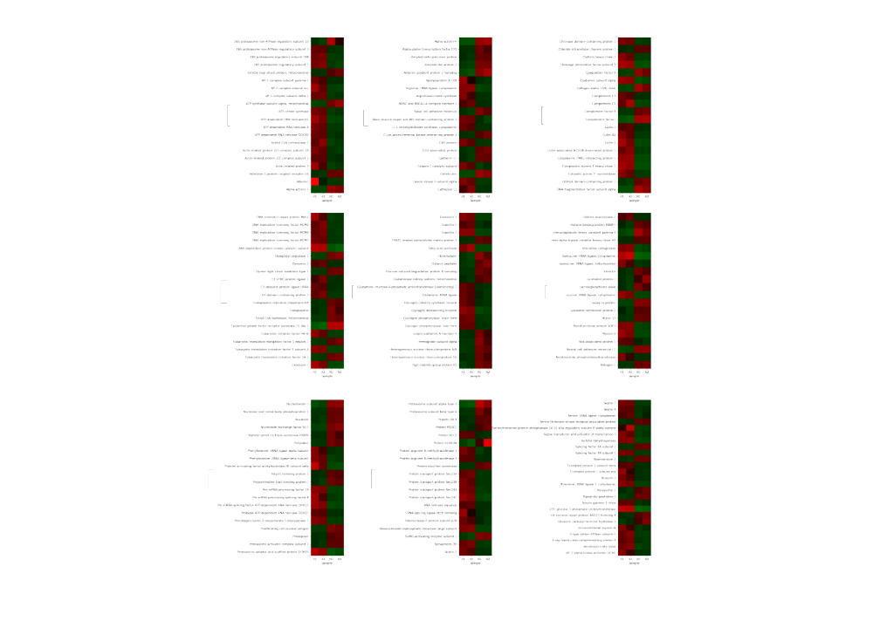
Supplementary Figure 2. Heat map of protein expression changes after ischemic stimulation
The protein contents of exosomes were extracted and quantified using high performance liquid chromatography–mass spectrometry. A list of the proteins that showed more than a 2-fold increase/decrease and p<0.01 (Student’s t-test) between the normoxia group and hypoxia group are shown. Values increase progressively from blue to red in the color scale.
N1, N2: normoxia samples, H1, H2: hypoxia samples.

