Supplementary Material for Linking Structural Forest Heterogeneity and Ecological Processes Using Sentinel-2 and FAD-Based Zoning
Sanjana Dutt∗¹, Jakub Wojtasik², Dimitri Justeau-Allaire³, Tarmo K. Remmel⁴, Mieczysław Kunz¹

¹ Faculty of Earth Sciences and Spatial Management, Nicolaus Copernicus University, Toruń, Poland
² Centre for Statistical Analysis, Nicolaus Copernicus University, Toruń, Poland
³ AMAP Laboratory (Botany and Modeling of Plant Architecture and Vegetation), Montpellier, France
⁴ Faculty of Environmental and Urban Change, York University, Canada

Corresponding author*. E-mail address: sanjana.dutt@doktorant.umk.pl

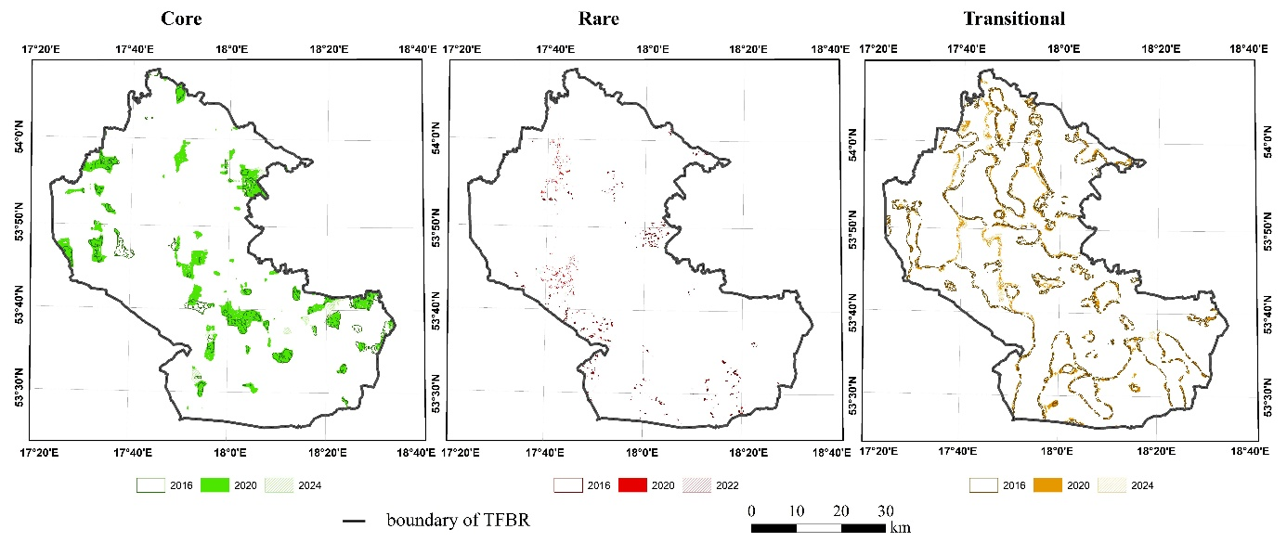Supplementary Figure S1. Spatial persistence and transitions of Core, Rare, and Transitional zones in TFBR across 2016, 2020, and 2024. Color hues indicate temporal overlap and shifts of zone types, offering insight into fragmentation trajectory over time.

Supplementary Table S1. Vegetation Indices Used in This Study with Corresponding Formulas and Ecological Relevance
The table summarizes the vegetation indices computed from Sentinel-2 bands (B2–B11), grouped by their functional ecological domains. Each formula reflects the actual implementation used in this study, and the indices are categorized based on their relevance to greenness/biomass, moisture stress, pigment content, and soil or shadow correction.

🔶 Greenness / Biomass Indices
Index | Formula | Notes
NDVI | (B8 − B4) / (B8 + B4) | Normalized Difference Vegetation Index
EVI | 2.5 × (B8 − B4) / (B8 + 6 × B4 − 7.5 × B2 + 1) | Enhanced Vegetation Index using Blue for atmospheric correction
EVI2 | 2.5 × (B8 − B4) / (B8 + 2.4 × B4 + 1) | Two-band EVI, avoids blue band
GNDVI | (B8 − B3) / (B8 + B3) | Green NDVI, more sensitive to chlorophyll content
GRNDVI | (B5 − B3) / (B5 + B3) | Red Edge NDVI, useful for early stress detection
GSAVI | ((B8 − B4) × (1 + 0.5)) / (B8 + B4 + 0.5) | Green Soil-Adjusted Vegetation Index, L = 0.5
LAI | 3.618 × ((B8 − B4) / (B8 + 6 × B4 − 7.5 × B2 + 1)) − 0.118 | Proxy for Leaf Area Index, derived from EVI
DVI | B8 − B4 | Difference Vegetation Index, simple reflectance gap

🔷 Moisture Stress Indices
Index | Formula | Notes
NDMI | (B8 − B11) / (B8 + B11) | Normalized Difference Moisture Index using NIR and SWIR
GVMI | (B8 + 0.1 − (B11 + 0.02)) / (B8 + 0.1 + (B11 + 0.02)) | Global Vegetation Moisture Index, atmospheric-corrected variant

🟢 Pigment / Chlorophyll Indices
Index | Formula | Notes
GARI | (B8 − (B3 − (B2 − B4))) / (B8 + (B3 − (B2 − B4))) | Green Atmospherically Resistant Index, sensitive to chlorophyll
MCARI | ((B5 − B4) − 0.2 × (B5 − B3)) × (B5 / B4) | Modified Chlorophyll Absorption Ratio Index
MTVI2 | 1.5 × [1.2 × (B5 − B3) − 2.5 × (B4 − B3)] / √[(2 × B5 + 1)² − (6 × B5 − 5 × √B4) − 0.5] | Modified Triangular Vegetation Index 2
NDRE | (B8 − B5) / (B8 + B5) | Normalized Difference Red Edge Index
GBNDVI | (B8 − (B3 + B2)) / (B8 + (B3 + B2)) | Green-Blue NDVI, sensitive to nutrient/pigment shifts

🟫 Soil / Shadow Correction Indices
Index | Formula | Notes
CVI | (B8 × B4) / (B3²) | Chlorophyll Vegetation Index, proxy for vegetation cover density
MSAVI | (2 × B8 + 1 − √[(2 × B8 + 1)² − 8 × (B8 − B4)]) / 2 | Modified Soil-Adjusted Vegetation Index, soil background minimized

Band Mapping (Sentinel-2)
- B2 – Blue (490 nm)
- B3 – Green (560 nm)
- B4 – Red (665 nm)
- B5 – Red Edge 1 (705 nm)
- B8 – Near Infrared (842 nm)
- B11 – Shortwave Infrared (1610 nm)

Supplementary Table S2. Degradation Codebook
Code | English Description | Assigned Number
D1 | Degraded | 1
D2 | Strongly degraded | 2
D3 | Devastated | 3
N1 | Natural | 4
N2 | Semi-natural | 5
Z1 | Distorted | 6
Z2 | Strongly distorted | 7
Z3 | Transformed | 8

Supplementary Table S3. Moisture Content Codebook
Code | Description | Assigned Number
BBM | Very wet bog | 1
BM | Wet bog | 2
BO | Drained bog | 3
BSO | Strongly drained bog | 4
SU | Dry soils | 5
SŚ | Very fresh soils | 6
WO | Drained moist soils | 7
WSW | Very moist soils | 8
WW | Moist soils | 9
ŁP | Floodplain forest (flooded/drained) | 10
ŁZ | Floodplain forest (flooded) | 11
Ś | Fresh soils | 12
Supplementary Table S4. Site Type Codebook
Code | Description | Assigned Number
BB | Bog coniferous forest | 1
BMB | Mixed bog forest | 2
BMW | Mixed moist coniferous forest | 3
BMŚW | Mixed fresh coniferous forest | 4
BS | Dry coniferous forest | 5
BW | Moist coniferous forest | 6
BŚW | Fresh coniferous forest | 7
LMB | Mixed swamp forest | 8
LMW | Mixed moist broadleaf forest | 9
LMŚW | Mixed fresh broadleaf forest | 10
LW | Moist broadleaf forest | 11
LŁ | Riparian floodplain forest | 12
LŚW | Fresh broadleaf forest | 13
OL | Alder swamp forest | 14
OLJ | Ash-alder swamp forest | 15

Supplementary Table S5: Extra Trees Settings for Predicting Field-Based Ecological Attributes
Below are the tuned settings for Extra Trees models, organized by field-based ecological attribute (FEA), fragmentation zone (Core, Transitional, Rare), and year (2016, 2020, 2024). Settings include: Number of Trees (trees in the model), Features for Decisions (number of input features considered), Min Samples to Split (minimum samples to split a decision point), and Min Samples per Node (minimum samples in a final node).
a) Degradation
Zone | Year | Number of Trees | Features for Decisions | Min Samples to Split | Min Samples per Node
Rare | 2016 | 1000 | 16 | 2 | 1
Rare | 2020 | 1000 | 9 | 2 | 1
Rare | 2024 | 1000 | 9 | 2 | 1
Transitional | 2016 | 1000 | 17 | 18 | 1
Transitional | 2020 | 1000 | 17 | 20 | 4
Transitional | 2024 | 1000 | 17 | 20 | 4
Core | 2016 | 1000 | 15 | 20 | 1
Core | 2020 | 878 | 17 | 6 | 10
Core | 2024 | 474 | 16 | 18 | 7
b) Stand Age
Zone | Year | Number of Trees | Features for Decisions | Min Samples to Split | Min Samples per Node
Rare | 2016 | 1000 | 13 | 2 | 1
Rare | 2020 | 1000 | 11 | 10 | 1
Rare | 2024 | 1000 | 13 | 10 | 1
Transitional | 2016 | 978 | 10 | 20 | 1
Transitional | 2020 | 1000 | 8 | 20 | 2
Transitional | 2024 | 1000 | 10 | 20 | 1
Core | 2016 | 1000 | 12 | 20 | 1
Core | 2020 | 1000 | 9 | 20 | 5
Core | 2024 | 1000 | 12 | 20 | 1
c) Moisture Content
Zone | Year | Number of Trees | Features for Decisions | Min Samples to Split | Min Samples per Node
Transitional | 2016 | 822 | 14 | 13 | 3
Transitional | 2020 | 1000 | 15 | 20 | 4
Transitional | 2024 | 822 | 14 | 13 | 3
Core | 2016 | 822 | 14 | 13 | 3
Core | 2020 | 1000 | 17 | 20 | 4
Core | 2024 | 1000 | 17 | 20 | 5
d) Site Type
Zone | Year | Number of Trees | Features for Decisions | Min Samples to Split | Min Samples per Node
Rare | 2016 | 1000 | 17 | 2 | 1
Rare | 2020 | 1000 | 9 | 6 | 1
Rare | 2024 | 1000 | 17 | 2 | 2
Transitional | 2016 | 1000 | 17 | 20 | 1
Transitional | 2020 | 1000 | 17 | 20 | 5
Transitional | 2024 | 1000 | 17 | 20 | 5
Core | 2016 | 1000 | 17 | 20 | 1
Core | 2020 | 1000 | 17 | 20 | 4
Core | 2024 | 1000 | 12 | 18 | 1

Supplementary Table S6: Mean Squared Error (MSE) and Mean Absolute Error (MAE) values from Extra Trees and LightGBM models trained to predict four ecological ground indices (Degradation, Moisture Content, Site Type, and Stand Age) across FAD fragmentation classes (Rare, Transitional, Core) and years (2016, 2020, 2024). Values are presented separately for training and test sets. These results guided model selection for subsequent feature importance and interpretability analyses.

Ground validation | year | metric | set | rare |  | transitional |  | core
 |  |  |  | Extra Trees | LGBM | Extra Trees | LGBM | Extra Trees | LGBM
Degradation | 2016 | MSE | train | 0.0000 | 0.3167 | 0.3800 | 0.8457 | 0.2979 | 0.5777
Degradation | 2016 | MSE | test | 0.4911 | 0.5279 | 0.9247 | 0.9420 | 0.6316 | 0.6417
Degradation | 2016 | MAE | train | 0.0000 | 0.4306 | 0.5276 | 0.7977 | 0.4263 | 0.5985
Degradation | 2016 | MAE | test | 0.5245 | 0.5625 | 0.8286 | 0.8423 | 0.6257 | 0.6311
Degradation | 2020 | MSE | train | 0.0000 | 0.4801 | 0.4824 | 0.8213 | 0.5137 | 0.7235
Degradation | 2020 | MSE | test | 0.6481 | 0.6825 | 0.8907 | 0.8954 | 0.7463 | 0.7521
Degradation | 2020 | MAE | train | 0.0000 | 0.5846 | 0.6215 | 0.8175 | 0.6061 | 0.7226
Degradation | 2020 | MAE | test | 0.6711 | 0.7014 | 0.8478 | 0.8534 | 0.7316 | 0.7365
Degradation | 2024 | MSE | train | 0.0000 | 0.4850 | 0.5011 | 0.8782 | 0.4142 | 0.6342
Degradation | 2024 | MSE | test | 0.7421 | 0.7705 | 0.9254 | 0.9338 | 0.6733 | 0.6781
Degradation | 2024 | MAE | train | 0.0000 | 0.5970 | 0.6422 | 0.8568 | 0.5240 | 0.6501
Degradation | 2024 | MAE | test | 0.7335 | 0.7557 | 0.8760 | 0.8838 | 0.6701 | 0.6724
Moisture Content | 2016 | MSE | train | 0.0000 | 1.0585 | 1.7015 | 3.2823 | 0.5173 | 0.8878
Moisture Content | 2016 | MSE | test | 3.3411 | 3.7551 | 3.5456 | 3.6115 | 1.0064 | 1.0239
Moisture Content | 2016 | MAE | train | 0.0000 | 0.4931 | 0.6683 | 0.9437 | 0.1860 | 0.2468
Moisture Content | 2016 | MAE | test | 0.8570 | 0.9317 | 0.9812 | 0.9886 | 0.2665 | 0.2654
Moisture Content | 2020 | MSE | train | 0.3579 | 2.1324 | 2.4190 | 3.5762 | 0.8985 | 1.3300
Moisture Content | 2020 | MSE | test | 3.2964 | 3.4204 | 3.8757 | 3.9129 | 1.3901 | 1.3988
Moisture Content | 2020 | MAE | train | 0.2535 | 0.6679 | 0.7522 | 0.9225 | 0.2729 | 0.3350
Moisture Content | 2020 | MAE | test | 0.8222 | 0.8384 | 0.9649 | 0.9644 | 0.3444 | 0.3428
Moisture Content | 2024 | MSE | train | 0.3928 | 3.1530 | 2.0689 | 3.8898 | 0.7678 | 1.0182
Moisture Content | 2024 | MSE | test | 4.0947 | 4.1929 | 4.1683 | 4.1982 | 1.1778 | 1.1846
Moisture Content | 2024 | MAE | train | 0.2793 | 0.8529 | 0.7280 | 1.0086 | 0.2345 | 0.2711
Moisture Content | 2024 | MAE | test | 0.9463 | 0.9663 | 1.0519 | 1.0451 | 0.2950 | 0.2925
Site Type | 2016 | MSE | train | 0.0000 | 1.9109 | 2.2577 | 4.7335 | 0.9002 | 1.8913
Site Type | 2016 | MSE | test | 5.2886 | 5.6835 | 5.2355 | 5.3250 | 2.0667 | 2.1100
Site Type | 2016 | MAE | train | 0.0000 | 1.0254 | 1.2079 | 1.7744 | 0.6082 | 0.9005
Site Type | 2016 | MAE | test | 1.7347 | 1.8018 | 1.8396 | 1.8715 | 0.9208 | 0.9399
Site Type | 2020 | MSE | train | 0.5164 | 3.0805 | 3.0707 | 4.9907 | 0.9378 | 1.5775
Site Type | 2020 | MSE | test | 4.8349 | 5.0059 | 5.3062 | 5.3329 | 1.6627 | 1.6764
Site Type | 2020 | MAE | train | 0.5562 | 1.4202 | 1.4073 | 1.8230 | 0.5783 | 0.7604
Site Type | 2020 | MAE | test | 1.7519 | 1.7903 | 1.8583 | 1.8765 | 0.7718 | 0.7782
Site Type | 2024 | MSE | train | 0.3550 | 3.2902 | 3.1324 | 5.1645 | 0.8189 | 1.7311
Site Type | 2024 | MSE | test | 5.3478 | 5.4392 | 5.5047 | 5.5089 | 1.8546 | 1.8734
Site Type | 2024 | MAE | train | 0.4502 | 1.4702 | 1.4347 | 1.8707 | 0.5519 | 0.8120
Site Type | 2024 | MAE | test | 1.8459 | 1.8957 | 1.9095 | 1.9253 | 0.8335 | 0.8381
Stand Age | 2016 | MSE | train | 0.0000 | 268.9510 | 405.2102 | 769.3967 | 281.4542 | 562.2617
Stand Age | 2016 | MSE | test | 747.3080 | 793.0772 | 845.6752 | 856.3144 | 608.6250 | 618.2795
Stand Age | 2016 | MAE | train | 0.0000 | 11.9544 | 16.0089 | 22.1318 | 12.7420 | 18.1369
Stand Age | 2016 | MAE | test | 19.4408 | 20.2882 | 23.0373 | 23.2354 | 18.6947 | 18.9155
Stand Age | 2020 | MSE | train | 169.4794 | 462.7494 | 615.2930 | 1030.3012 | 431.9596 | 651.3972
Stand Age | 2020 | MSE | test | 652.9835 | 672.6903 | 1094.1886 | 1098.0216 | 673.1787 | 678.0556
Stand Age | 2020 | MAE | train | 9.0716 | 15.4731 | 19.6523 | 25.5795 | 16.0512 | 19.9115
Stand Age | 2020 | MAE | test | 18.1192 | 18.5197 | 26.2680 | 26.3333 | 20.1023 | 20.2300
Stand Age | 2024 | MSE | train | 141.7045 | 412.3192 | 569.7954 | 1097.1861 | 327.6254 | 654.1738
Stand Age | 2024 | MSE | test | 586.8752 | 600.7807 | 1183.4747 | 1189.8587 | 709.3864 | 713.3502
Stand Age | 2024 | MAE | train | 8.2464 | 14.4584 | 18.9441 | 26.3012 | 13.8434 | 19.6359
Stand Age | 2024 | MAE | test | 17.0806 | 17.1967 | 27.2026 | 27.2870 | 20.2769 | 20.3625

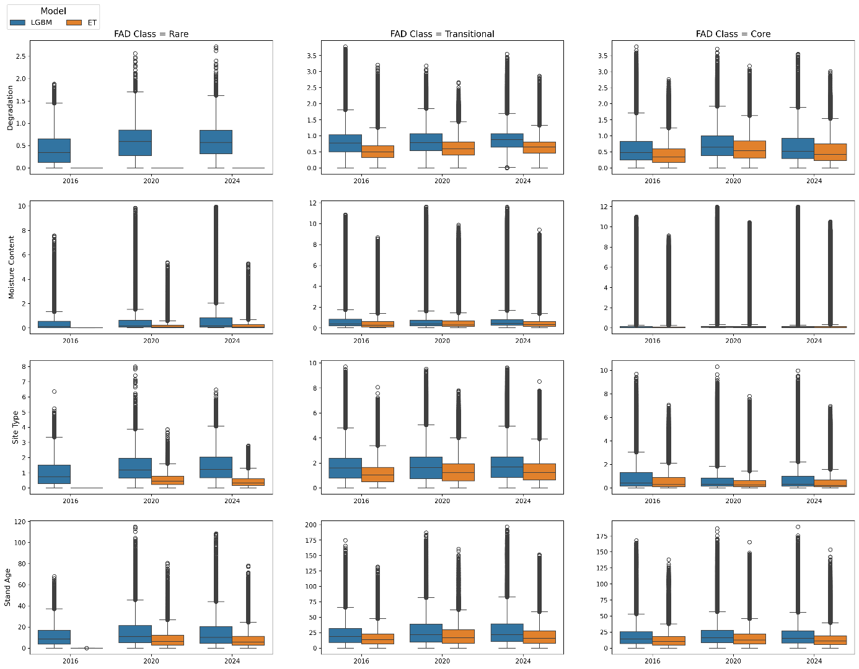
Supplementary Figure S2. Boxplots of prediction errors on the train set for Extra Trees (ET) and LightGBM (LGBM) models across three forest fragmentation classes (Rare, Transitional, Core) and years (2016, 2020, 2024), for each of the four ground indices
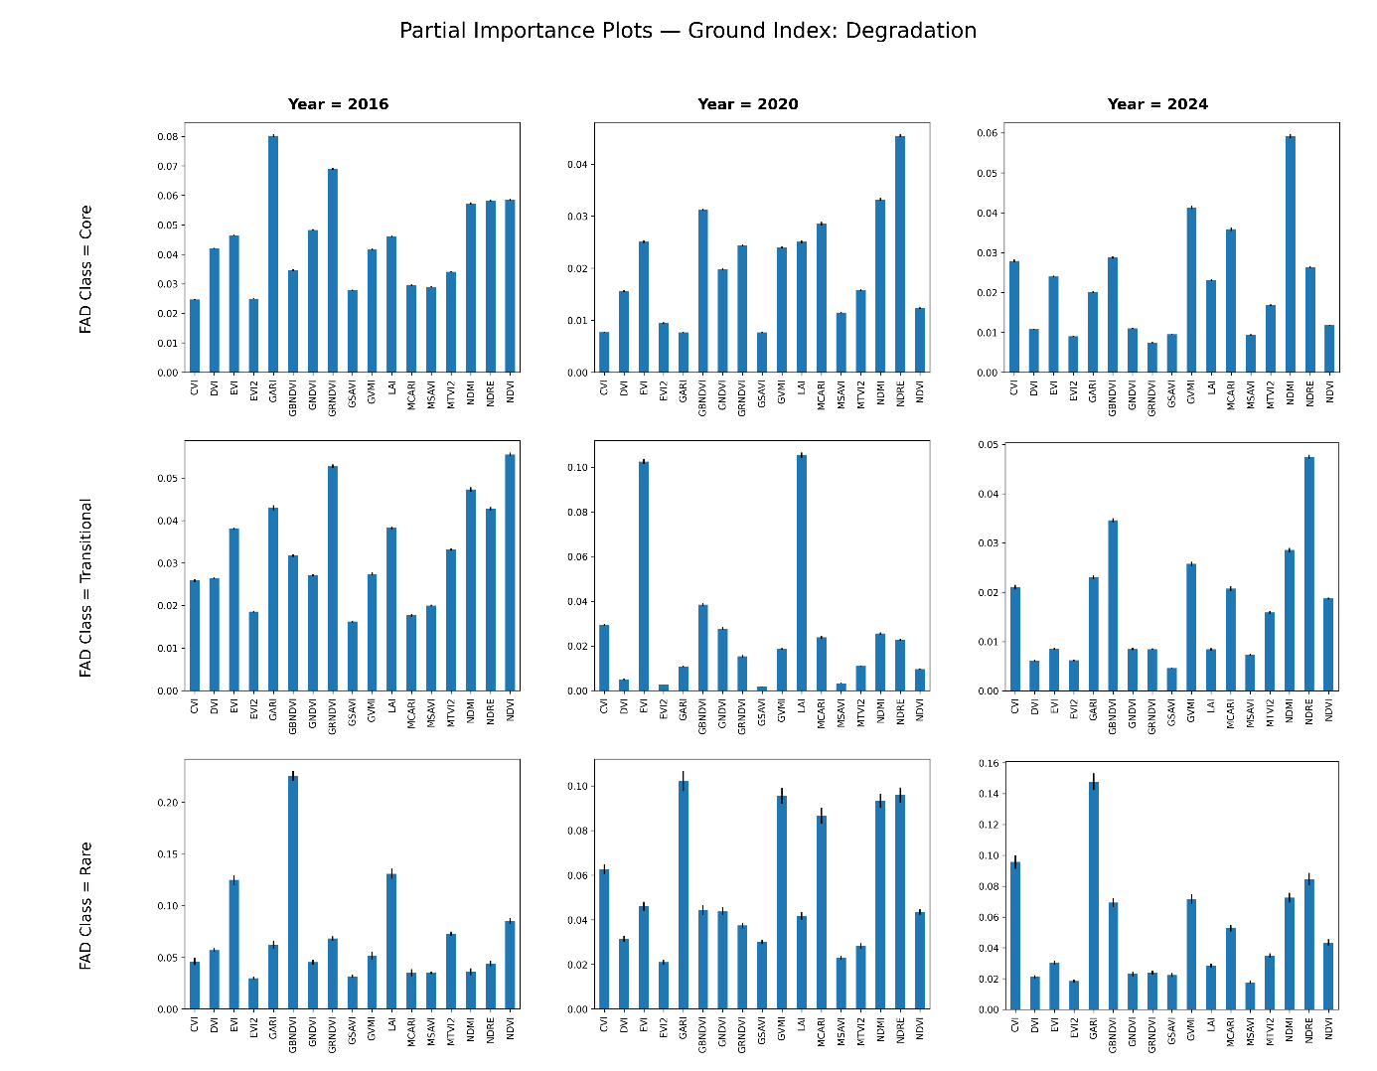
Supplementary Figure S3: Partial Importance (PI) grid showing the relative importance of vegetation indices used in predicting degradation levels across fragmentation classes (Core, Transitional, Rare) and years (2016, 2020, 2024), based on Extra Trees regressors. NDWI, GNDVI, and NDRE frequently emerged as key contributors.
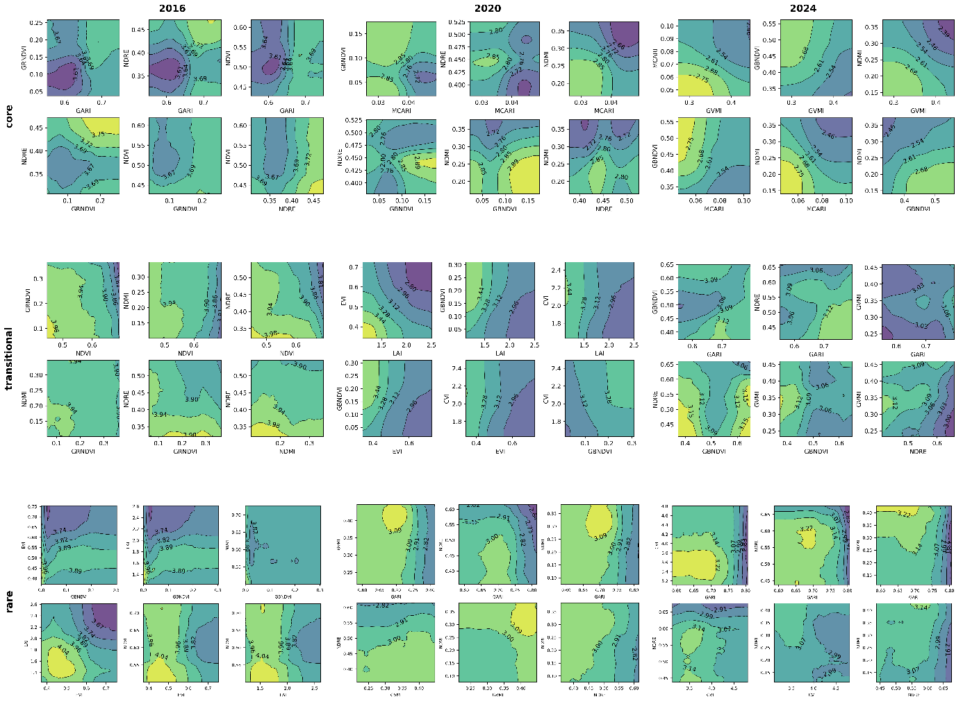
Supplementary Figure S4. Additional PDP layouts for degradation prediction, illustrating alternative VI pairs across zones and years.

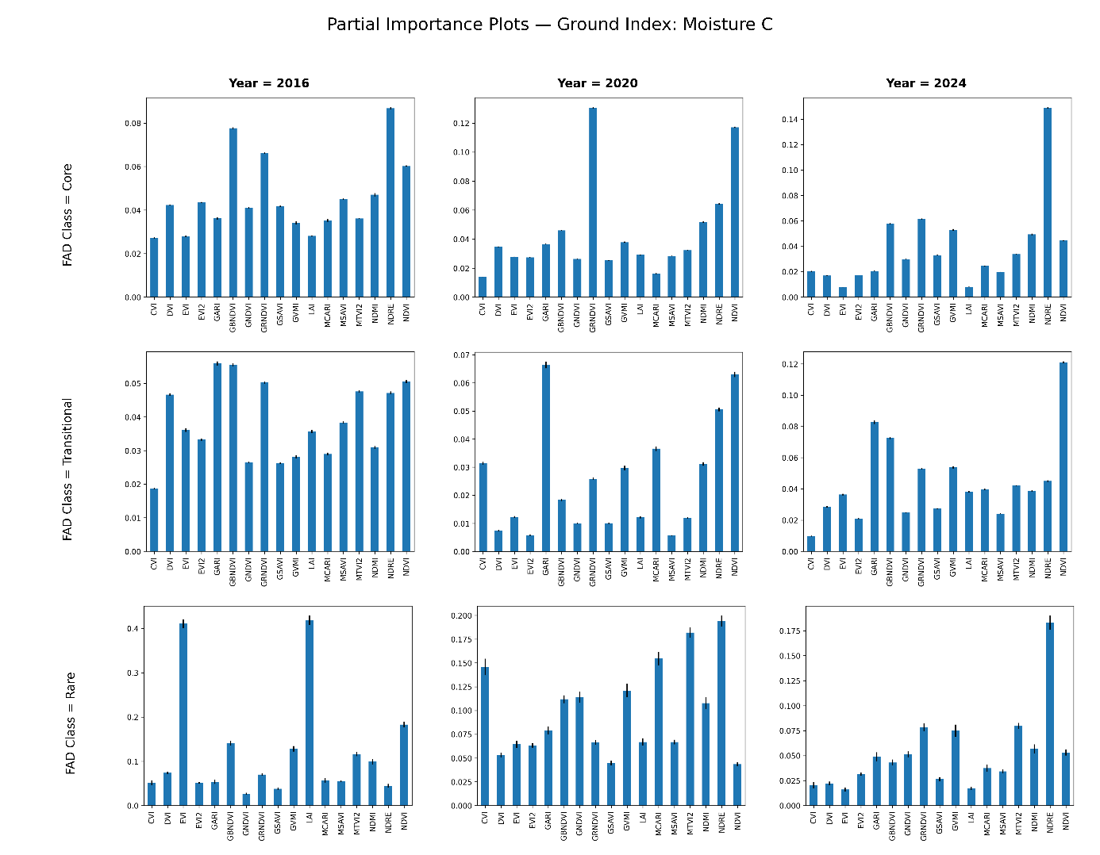
Supplementary Figure S5. Partial Importance (PI) grid for moisture content, summarizing vegetation index relevance for moisture predictions across zones and years. NDWI and NDRE emerged as the most important indices, particularly in less fragmented areas.
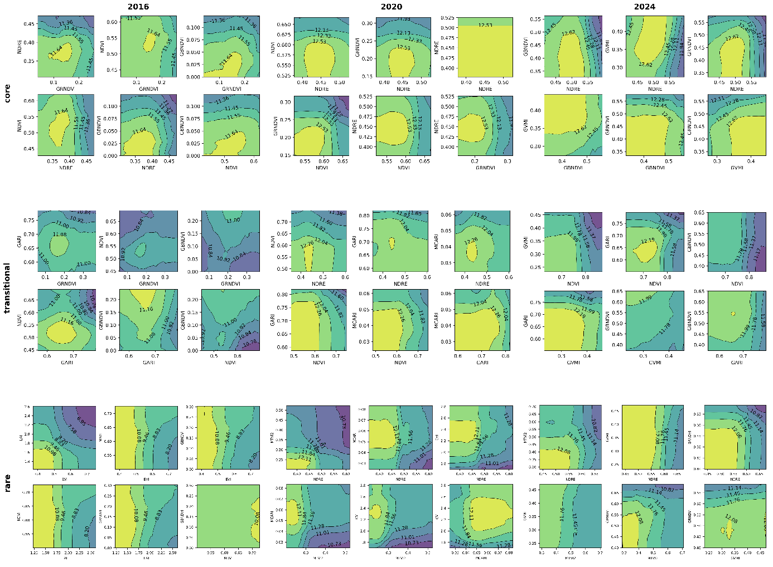
Supplementary Figure S6. Additional PDPs for moisture content, displaying alternative vegetation index pairings used to model moisture variation across FAD zones and time.

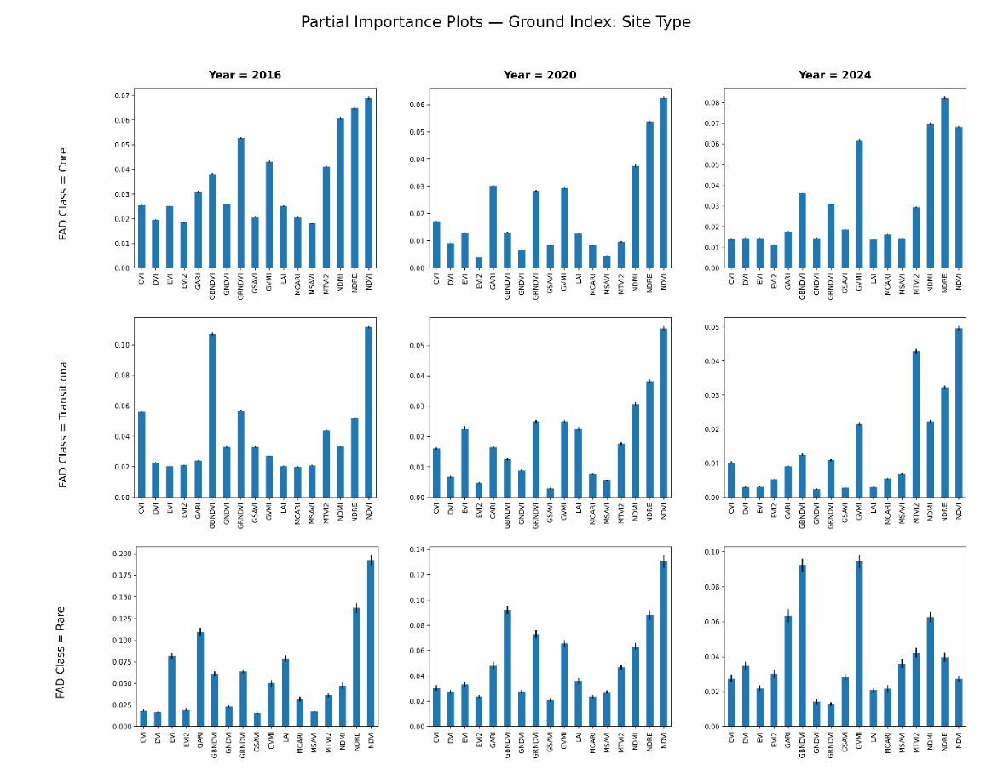
Supplementary Figure S7. Partial Importance (PI) grid showing the relative contribution of vegetation indices to Site Type predictions across fragmentation classes (Core, Transitional, Rare) and years (2016, 2020, 2024), based on Extra Trees regressors. NDVI, CIre, and NDWI emerged as consistent top predictors.

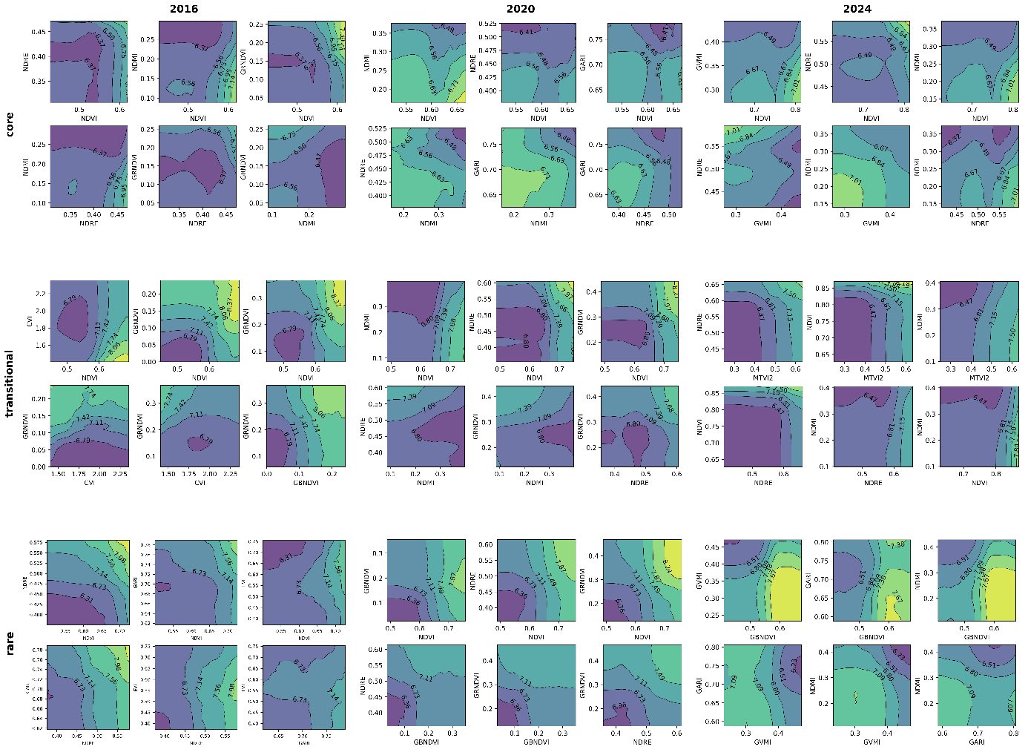Supplementary Figure S8. PDP layouts for alternate VI pairs used for Site Type prediction across different FAD zones and years.

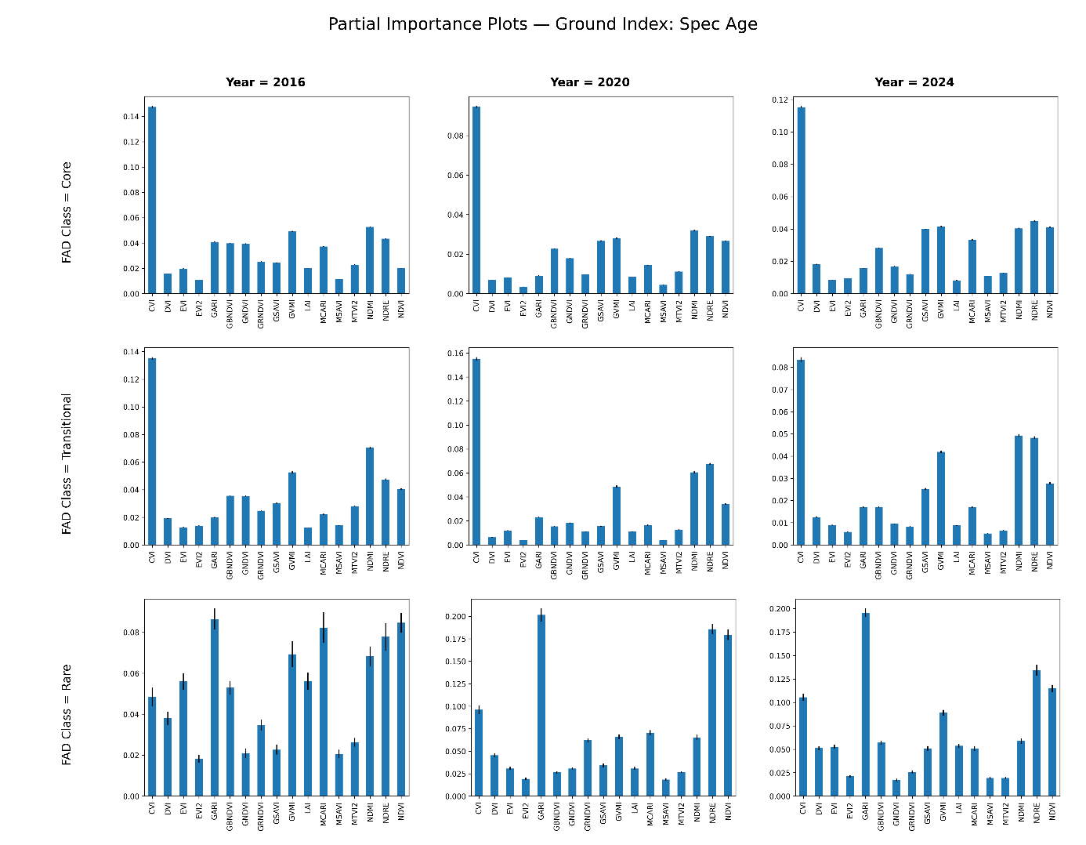
Supplementary Figure S9. Partial Importance (PI) grid showing the relative importance of vegetation indices used in predicting stand age across fragmentation classes (Core, Transitional, Rare) and years (2016, 2020, 2024), based on Extra Trees regressors. CIre, NDVI, and NDRE emerged as key predictors, with CIre particularly influential in fragmented areas.
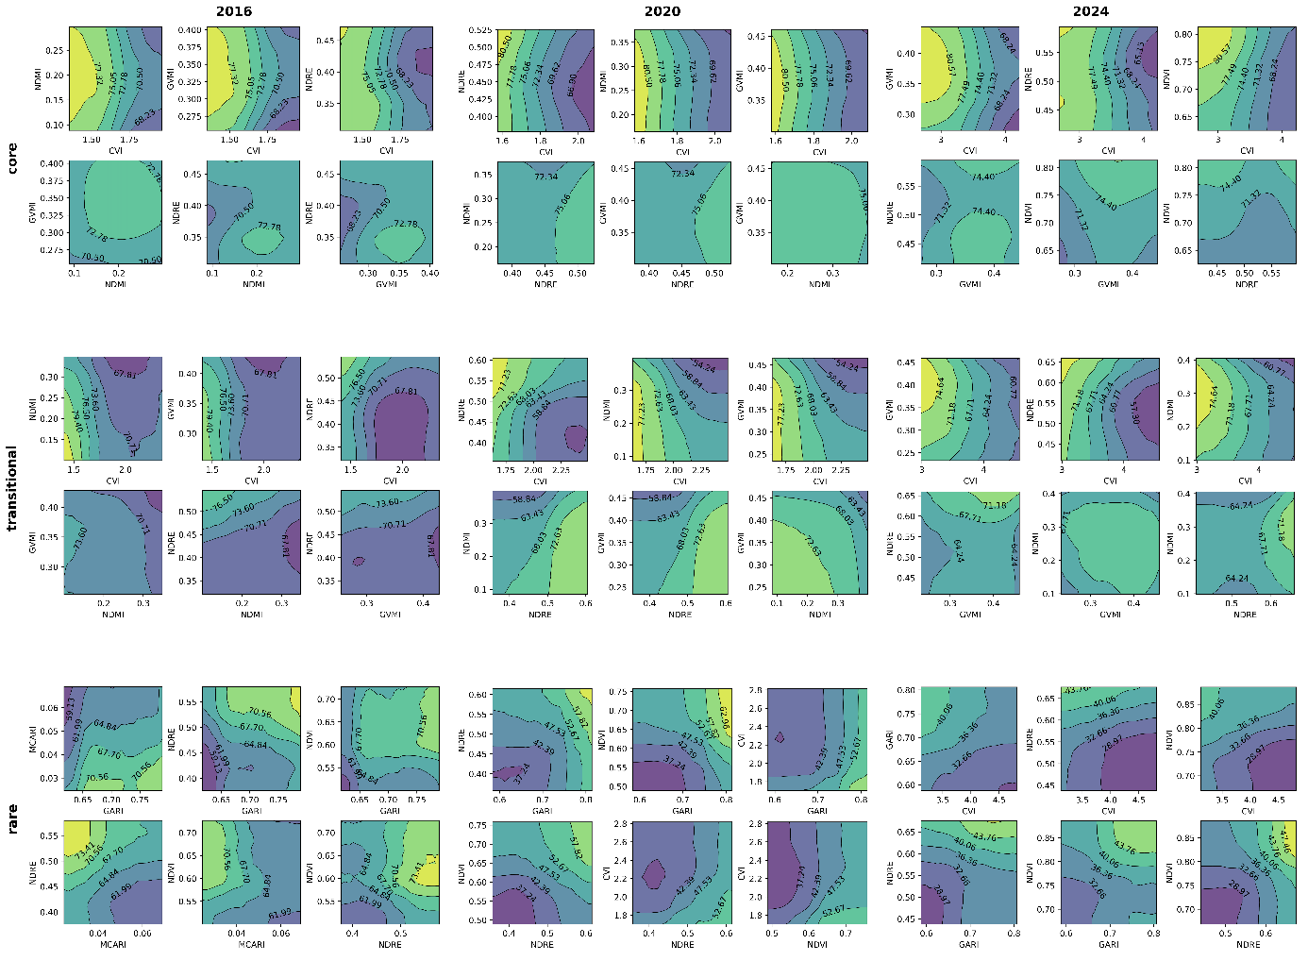
Supplementary Figure S10. PDP layouts for alternate VI pairs used for stand age prediction across different FAD zones and years.

