Additional document 3. Measuring the feasibility of keyword assignment by AI
We wanted to see how well an AI could automatically choose relevant keywords for cancer projects, compared to how well people do. We asked eight individuals to each select up to eight keywords (from a list of 54 standard terms) to describe 10 different cancer projects. Then, we compared the keywords people chose to the keywords the AI selected for the same projects. The results were very encouraging – the AI’s choices closely matched human selections, as shown by a 'similarity score' of around 0.9. This score indicates the AI is performing almost as well as a person at identifying the most relevant keywords.
To fairly compare keywords suggested by humans and those selected by AI, we took a few key steps. First, we converted each keyword into a numerical representation called an embedding. Think of embeddings as translating words into lists of numbers. These numbers aren't random; they’re learned by a computer to capture the meaning of the word.
Importantly, similar words have similar lists of numbers, placing them “close” to each other in a kind of mathematical space. This lets computers understand relationships between words – for example, recognizing that "king" and "queen" are related, even if they don't share any letters.
Once we have these numerical representations, we used a technique called cosine similarity to measure how alike the keywords are in meaning. Imagine two arrows pointing from the centre of a circle; the closer they point in the same direction, the more similar they are. Cosine similarity does the same thing with the numerical lists – it measures the angle between them. A smaller angle (higher cosine similarity) means the keywords are more semantically similar. This allows us to objectively compare the AI and human suggestions
Comparison of the human and AI-assigned keywords
Figure 1 below shows how well keywords suggested by people matched those selected by the AI for different projects. The scores consistently showed a strong agreement – meaning the AI and human experts largely identified similar keywords. Initially, the order in which we presented the human-generated keywords could slightly influence the results. To fix this, we changed the order and re-ran the analysis, achieving a median similarity score of 0.863. This high score confirms a strong level of agreement and demonstrates the AI’s ability to understand and suggest keywords that align with human expertise.
Figure 1: Semantic Similarity between Human Assigned Keywords and AI-assigned (LLM) keywords for the 10 selected projects.
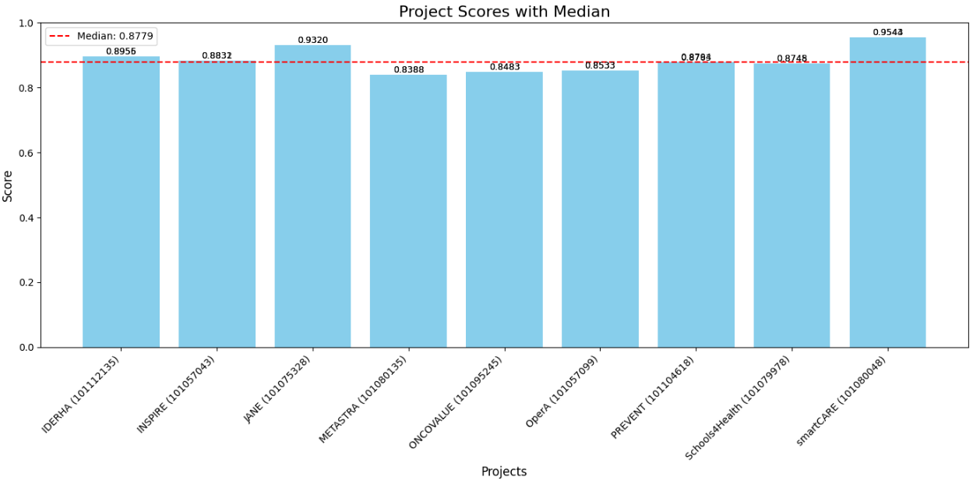
Additionally, we calculated the variability between the human-assigned keywords for each project and compared the values to the AI keyword selection. In this exercise, we first ranked all keywords that were selected by the 8 individuals for each project with the frequency of selection. Some keywords were assigned by all 8 people, others by only 1 person. We then selected those keywords that were selected for each project by at least 3 people.
For each person and for the AI-selection, we calculated the percentage of keywords they selected that was present in the list of the top keywords (i.e. selected by at least 3 individuals). We calculated the quartiles, mean, and 95% confidence intervals for the percentages per project and presented the comparability between human- and AI- assigned keywords using box plots.
Figure 2 below demonstrates that the variability between the 8 individuals for the keyword assignment was quite substantial, ranging from 40 % of top ranked keywords assigned (minimum for project 3), up to 100% for projects 1-8 (maximum). The AI assigned keywords were higher than the mean of the percentages across the 8 individuals for 60 % of the projects (Projects: 4, 5, 7, 8, 9, 10), and for the remaining projects it was within the range of the Confidence Intervals.
Figure 2. Box plot representing the variability of keyword assignment by humans (mean x) and AI (diamond).

