Additional file 1

Table of Contents
- The equivalence of WTE for M/M/1 and M/M/c models
- Poisson arrival analysis
- Full RTE heatmap with values
- Heatmaps showing relationship between utilization TE, sensitivity & specificity
- Description of the creation and validation of the Synthpop for TriEff

2. Poisson arrival analysis
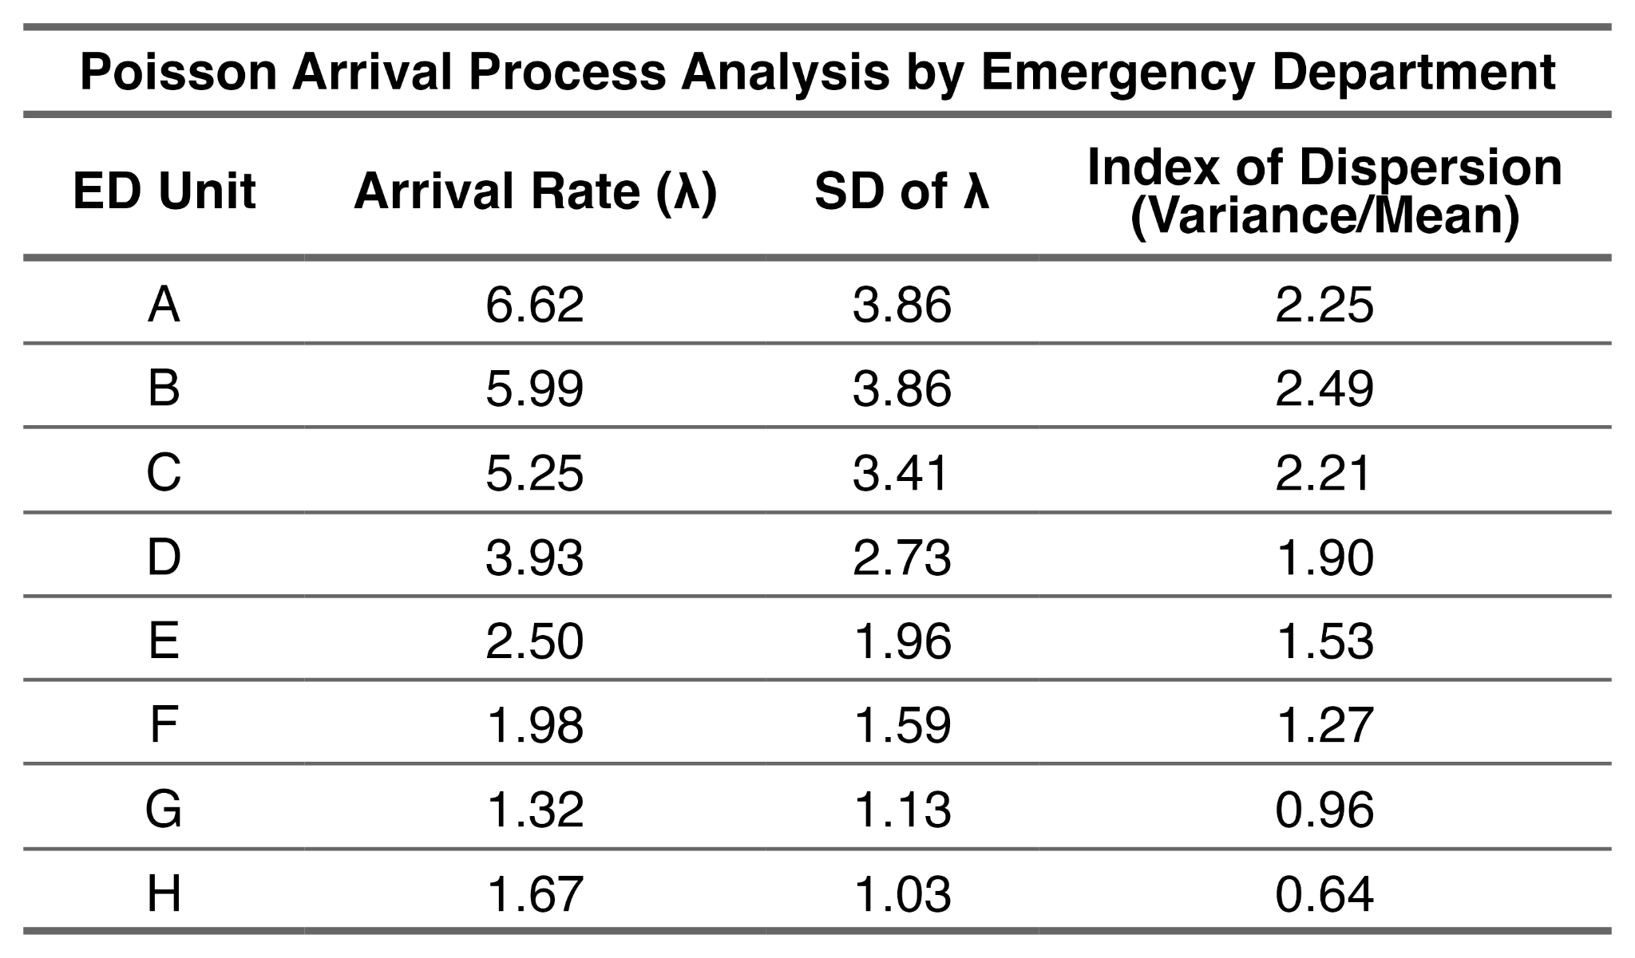
Suppl. Table 1: Poisson arrival process validation across emergency departments. Analysis of hourly arrival patterns during operating hours for each emergency department to validate the Poisson arrival assumption used in M/M/1 queueing theory calculations. The Index of Dispersion represents the variance-to-mean ratio, where a value of 1.0 indicates perfect adherence to the assumption of a Poisson arrival process. Values greater than 1.0 indicate overdispersion (greater variability than expected under Poisson).

3. Full RTE heatmap with values
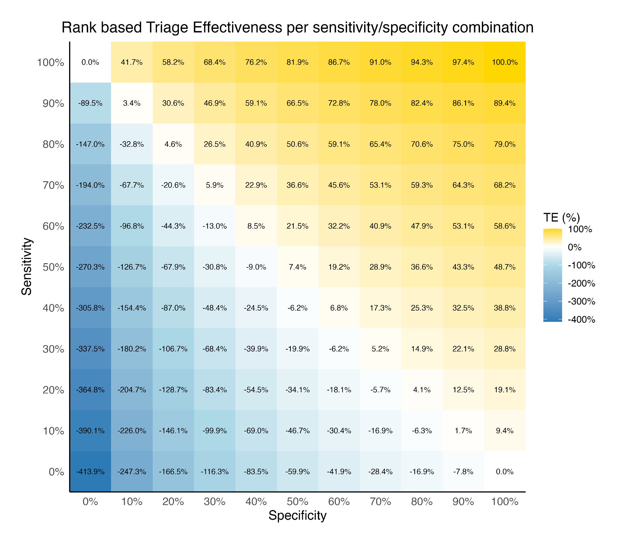
Figure s1: Heatmap showing mean Ranked Triage Effectiveness (RTE) across EDs with the data for each ED duplicated to achieve at least 10,000 time-critical patients. The diagonal line from the upper left corner to the lower right represents values where sensitivity + specificity = 100%. Due to duplication, each heatmap cell contains 4,565,089 patient visits with 107,433 time critical cases each.

4. Heatmaps showing relationship between utilization TE, sensitivity & specificity
(see next page)

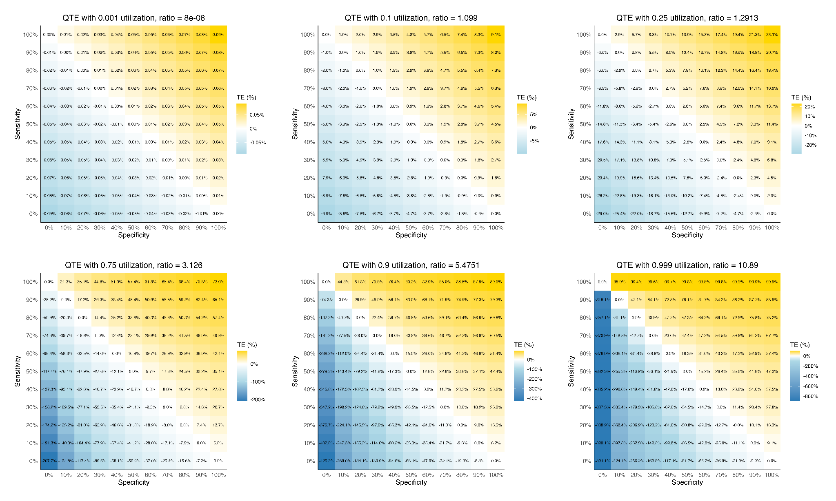
Figure s2: Heatmaps showing the relationship between sensitivity, specificity, and utilization using Queue Theory-based Triage Effectiveness (QTE) with time-critical prevalence set to 10%. For each heatmap, the title shows the ratio between TE at 100% sensitivity/10% specificity and TE at 10% sensitivity/100% specificity. A higher ratio indicates that sensitivity contributes more to TE than specificity when sensitivity + specificity > 100%. This relationship reverses on the negative side of the TE scale (e.g. when sensitivity + specificity < 100%), where increased utilization makes TE more responsive to specificity than sensitivity. The figure demonstrates that this effect approaches zero as utilization approaches 0%. The figure also shows that maximum achievable TE (i.e., at 100% sensitivity, 100% specificity) is constrained by utilization, approaching 0% as utilization nears 0% and approaching 100% as utilization nears 100%.

5. Description synthpop generated for TriEff package

Overview
To enable testing and validation of the TriEff statistical package, we generated a synthetic dataset based on emergency department visits across two of the hospitals in the Skåne Emergency Medicine (SEM) cohort. The synthetic dataset preserves statistical relationships and patterns from the complete SEM database while containing no data from real patients.

Methods

Data Preprocessing
Starting with the cleaned dataset from the original study, we performed additional preprocessing steps specific to synthetic data generation. Chief complaints were translated to English and systematically recoded into clinically meaningful categories (e.g., various pain-related complaints were grouped, trauma types were consolidated). Chief complaints with fewer than 300 cases were excluded to ensure robust synthetic data generation. This preprocessing removed 4.6% of the total patient population while significantly improving the quality of synthetic data generation.
Temporal variables were standardized as proportional measures to facilitate synthesis across different hospital flow patterns. Time to physician was expressed as a fraction of total ED stay, and priority assignment time as a fraction between arrival and physician contact. This approach ensured realistic temporal relationships in the synthetic data without requiring the synthesis algorithm to generate exact time points. Finally we filtered and used only two of the EDs C and E for the first year of the cohort to bring down the data size but still keep temporal variations during one year.

Synthetic Data Generation
We used the synthpop R package to generate synthetic data, implementing a grouped approach based on chief complaints to better preserve the relationships between variables critical for triage effectiveness calculations. We generated synthetic data following a logical sequence that mimics the actual patient journey through the ED. This began with patient characteristics (age, gender), followed by arrival circumstances, clinical assessments (including triage priority and unit assignment), and concluded with process times and outcomes. To ensure complete de-identification, we applied a jittering algorithm to eliminate any rows that remained identical to the original data across key variables. The algorithm identified 0 such rows. The complete variable sequence and detailed implementation are available in the supplementary code.

Validation
The synthetic dataset underwent validation to ensure it maintained key statistical properties of the original data while preserving patient privacy. We compared univariate distributions for all variables and assessed the preservation of critical relationships between variables.

Key variable comparisons between the original and synthetic datasets are shown in Suppl Table 1. The synthetic data closely matched the original data's priority level distribution, with differences of less than 1 percentage point across most variables. Age distributions were also well-preserved, with nearly identical means and standard deviations.
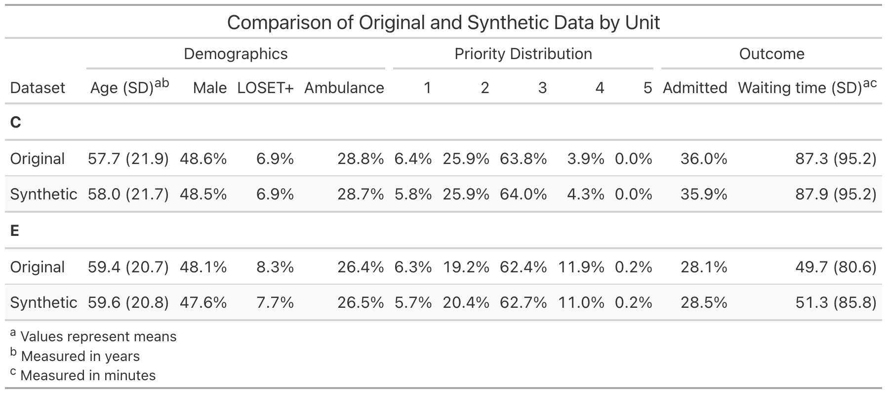
Suppl. Table 2: Comparison of key variables between the original data in SEM (named Original, n = 55,721) and the synthpop created based on the same population (named Synthetic, n = 53,265).

The triage effectiveness metrics for both datasets are compared in Figure s3 and s4. While the synthetic data shows some differences in the Observed TE, it maintains sufficient similarity in the relative performance patterns across complaint categories to serve as an effective test dataset for the TriEff package.

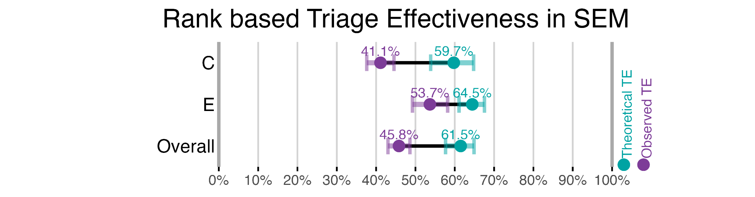
Figure s3: Rank based Triage Effectiveness (RTE) for the SEM, separated into EDs categories, this is identical to Figure 2 in the main manuscript. n = 55,721. Error bars represent 95% confidence intervals derived from 2000 bootstrap iterations.

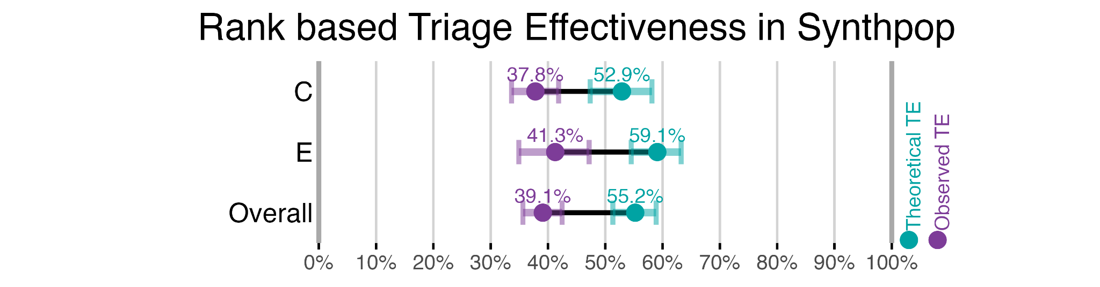
Figure s4: Rank based Triage Effectiveness (RTE) for the Synthpop, separated into EDs categories. n = 53,265. Error bars represent 95% confidence intervals derived from 2000 bootstrap iterations.

Limitations
This synthetic dataset is intended for testing the TriEff statistical package and should not be considered equivalent to the original SEM data. While it preserves many important statistical relationships, some metrics show notable differences from the original data. These differences do not impact its utility for package testing but should be considered when using the synthetic data for other purposes.

Data Availability
The synthetic dataset is included in the ANONYMIZED

