Supplemental Figure 1
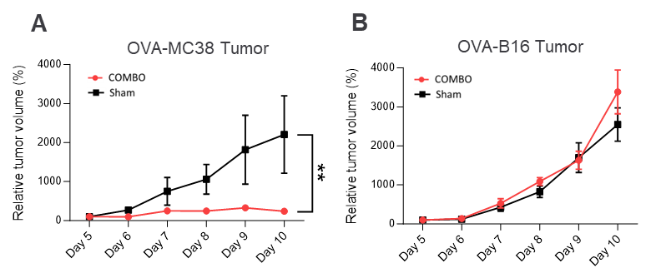
Supplemental Figure 1: COMBO treatment suppresses tumor growth in therapy-responsive OVA-MC38 tumors. All the mice were sacrificed ten days after tumor inoculation. From day 5 after tumor inoculation, the relative tumor volume of (A) OVA-MC38 and (B) OVA-B16 tumors was determined daily using calipers until the end of the trial on day 10. From day 5, the tumors were measurable in all experimental mice, which is why the tumor volumes on this day served as a reference value. The dots represent the mean ± SEM of one group: OVA-MC38 tumors on day 10. Comparisons between relative tumor growth were performed using 2-way ANOVA and Sidak’s multiple comparison test (**p = 0.0289). n = 4–6.

Supplemental Figure 2
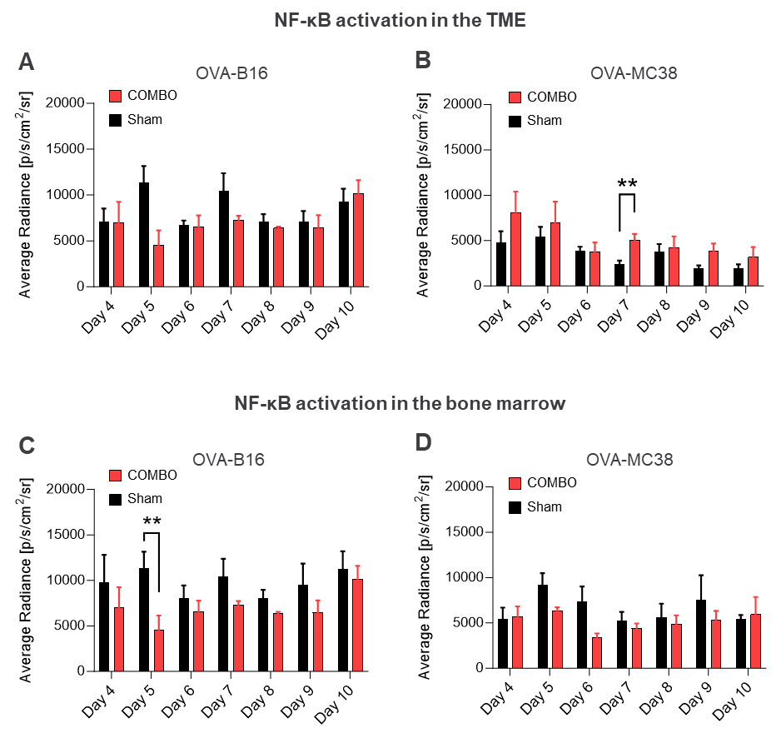
Supplemental Figure 2: Monitoring of NF-κB activity in OVA-B16- and OVA-MC38-bearing ^{NF-κB}Luc-reporter mice during treatment with COMBO or sham using BLI. ^{NF-κB}Luc-reporter mice were inoculated with s.c. OVA-B16 or OVA-MC38 tumor cells on day 0. After three days, the mice underwent initial 2 Gy low-dose whole-body irradiation. One day later (day 4), the experimental animals received an adoptive transfer of OVA-T_{H}1 cells or a PBS application (i.p.). On days 5, 7 and 9, i.p. the immune checkpoint inhibitors anti-PD-L1 and anti-LAG-3 (ICB) were administered intravenously. The graphs illustrate the average radiance in p/s/cm²/sr of the bioluminescence signal of the TME of (A) OVA-B16 tumor-bearing and (B) OVA-MC38 tumor-bearing (day 7: *p = 0.0092) ^{NF-κB}Luc reporter mice. Furthermore, the graphs show the average radiance in p/s/cm²/sr of the bioluminescence signal of the bone marrow of (C) OVA-B16 tumor-bearing (day 5: *p = 0.0183) and (D) OVA-MC38 tumor-bearing ^{NF-κB}Luc reporter mice. For statistical evaluation, the two experimental groups were compared on the same day using an unpaired parametric t test. n = 4-6.

Supplemental Figure 3
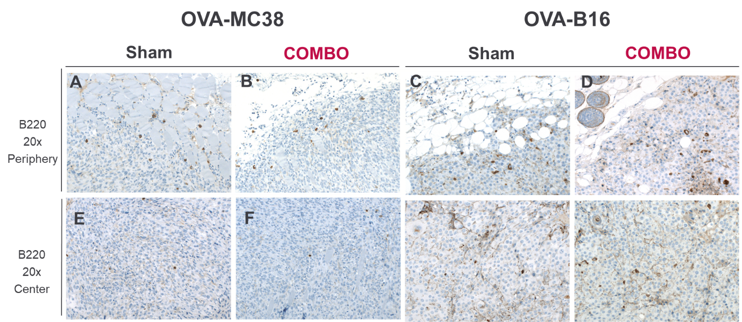
Supplemental Figure 3: Immunohistochemical (B220) analysis of the OVA-MC38 and OVA-B16 tumors of ^{NF-κB}Luc-reporter mice 10 days after tumor inoculation and treatment with COMBO or sham. Representative B220 immunohistochemistry of the B cells of the two experimental groups showing the marginal area of the tumor (magnification: 20x; periphery; A-D) and the tumor center (magnification: 20x; center; E-H). n = 4–6.

Supplemental Figure 4
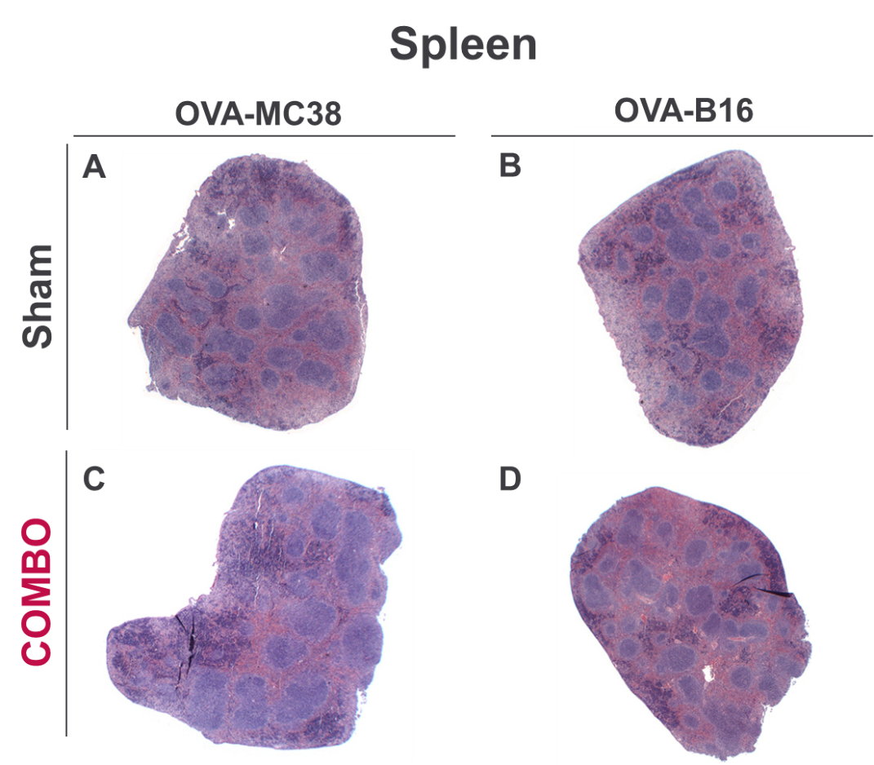
Supplemental Figure 4: Histopathological (H&E) analysis of the spleens of OVA-MC38 and OVA-B16 tumor-bearing ^{NF-κB}Luc-reporter mice 10 days after tumor inoculation and treatment with COMBO or sham. Representative H&E images of the spleens of OVA-MC38 (A+C) and OVA-B16 tumor-bearing ^{NF-κB}Luc-reporter mice (B+D) in both therapy groups are shown in the overview (magnification: 12.5x). n = 4–6.

Supplemental Figure 5

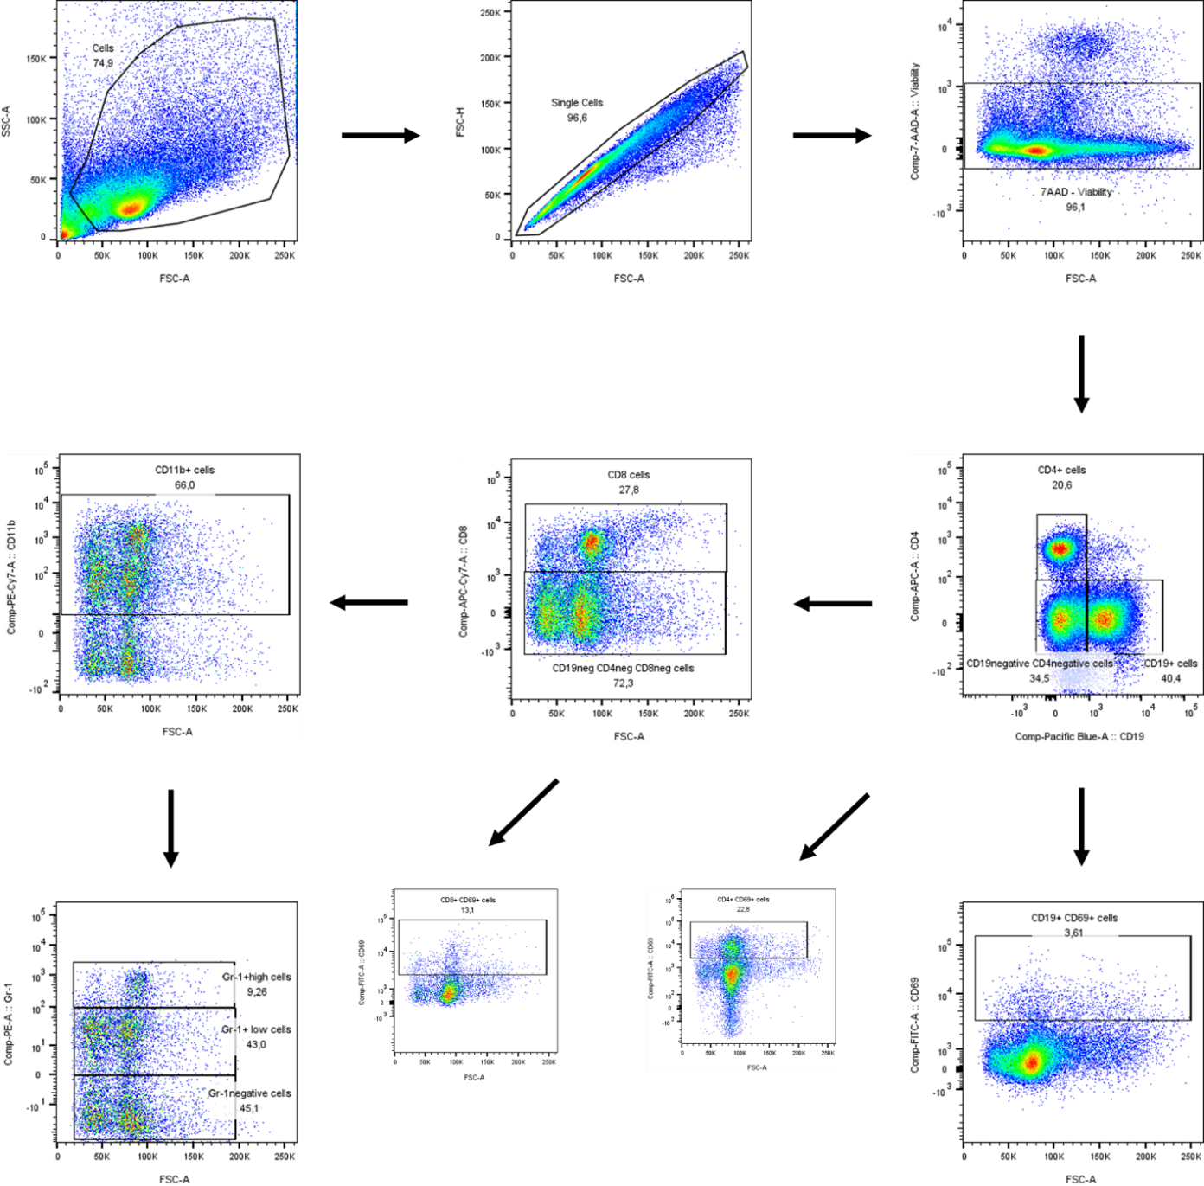
Supplemental Figure 5: Gating strategy for flow cytometric analysis of immune cell subsets.
Forward scatter (FSC-A) and side scatter (SSC-A) were used to identify the lymphocyte population. Singlets were gated on FSC-A versus FSC-H to exclude doublets. Viable cells were identified by excluding 7-AAD-positive cells. CD19-negative and CD4-negative cells were selected to further gate CD8⁺ T-cell subsets. CD8⁺ and CD4⁺ T cells and CD19⁺ cells were subdivided into CD8⁺CD69⁺ activated T cells, CD8⁺CD69⁺ T cells and CD19⁺CD69⁺ cells. Furthermore, CD11b⁺ cells were chosen to divide Gr-1 into Gr-1high, Gr-1low and Gr-1-negative cells. Data were acquired using a flow cytometer and analyzed using FlowJo software. Compensation controls were applied to ensure accurate gating.

Supplemental Figure 6
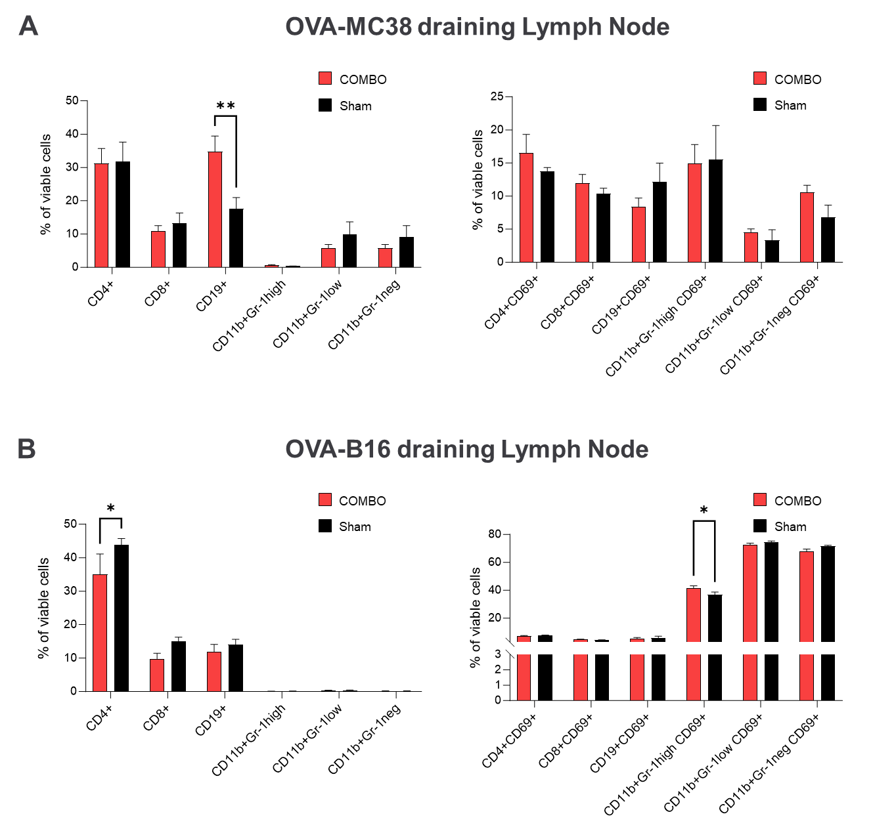
Figure 6: Flow cytometry analysis of the percentage of immune cells in the draining lymph nodes of OVA-MC38 and OVA-B16 tumor-bearing ^{NF-κB}Luc-reporter mice treated with COMBO or sham. Ten days after tumor inoculation (7 days after therapy initiation), the percentages of CD4⁺ and CD8⁺ T cells, CD19⁺ B cells, and CD11⁺Gr-1high, CD11⁺Gr-1low, and CD11⁺Gr-1neg cells were determined in the (A) draining lymph nodes of OVA-MC38 and (B) bone marrow of OVA-B16 tumor-bearing mice (left graph). In addition, the surface membrane expression of CD69 was investigated in all immune cells (right graph). For statistical analysis of the flow cytometry data, a two-factor ANOVA with Šidák’s correction for multiple testing was used. A bar represents the mean ± SEM of each group. n = 4–6.

Supplemental Figure 7
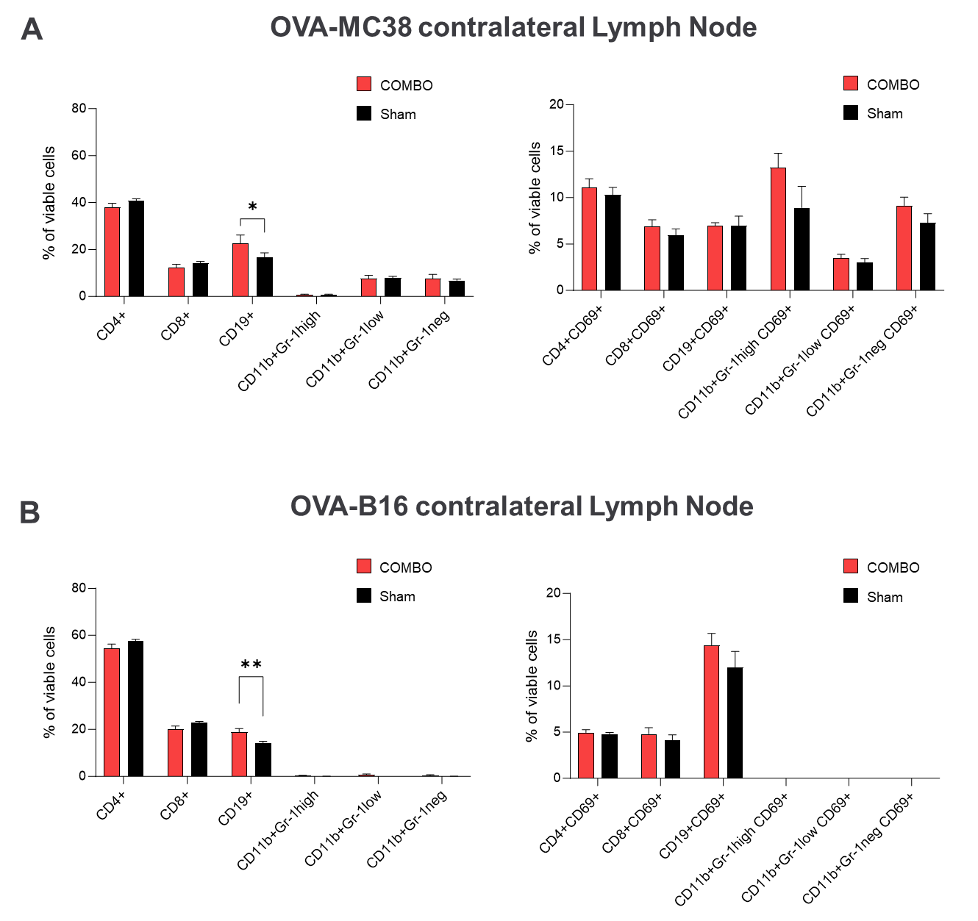
Figure 7: Flow cytometry analysis of the percentage of immune cells in the contralateral lymph nodes of OVA-MC38 and OVA-B16 tumor-bearing ^{NF-κB}Luc-reporter mice treated with COMBO or sham. Ten days after tumor inoculation (7 days after therapy initiation), the percentages of CD4⁺ and CD8⁺ T cells, CD19⁺ B cells, and CD11⁺Gr-1high, CD11⁺Gr-1low, and CD11⁺Gr-1neg cells were determined in the (A) contralateral lymph nodes of OVA-MC38 and (B) bone marrow of OVA-B16 tumor-bearing mice (left graph). In addition, the surface membrane expression of CD69 was investigated in all immune cells (right graph). For statistical analysis of the flow cytometry data, a two-factor ANOVA with Šidák’s correction for multiple testing was used. A bar represents the mean ± SEM of each group. n = 4–6.

Supplemental Figure 8
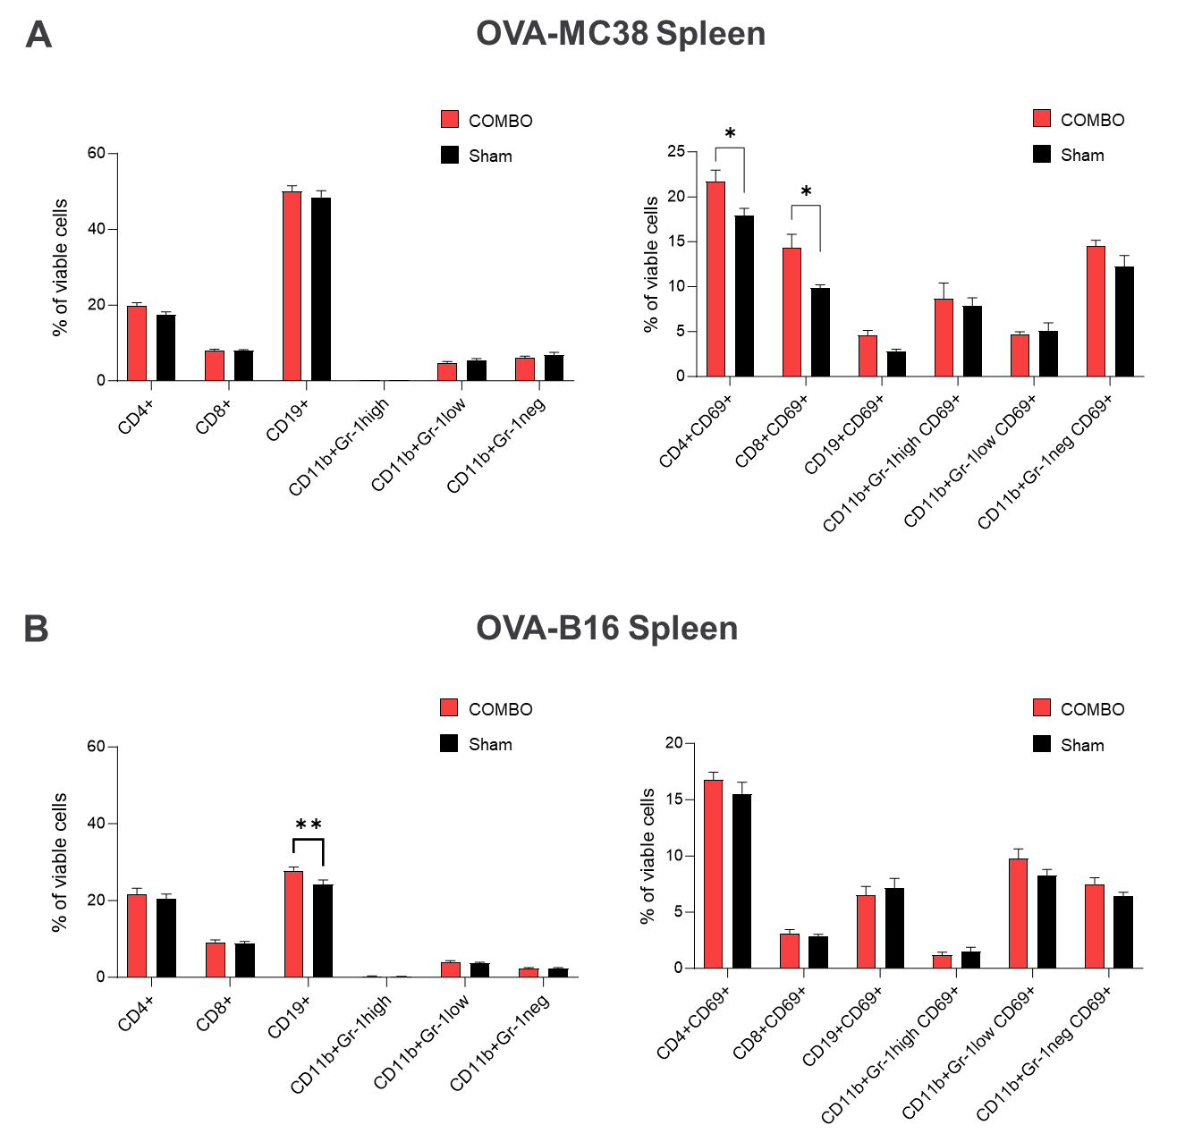
Figure 8: Flow cytometry analysis of the percentage of immune cells in the spleens of OVA-MC38 and OVA-B16 tumor-bearing ^{NF-κB}Luc-reporter mice treated with COMBO or sham. Ten days after tumor inoculation (7 days after therapy initiation), the percentages of CD4⁺ and CD8⁺ T cells, CD19⁺ B cells, and CD11⁺Gr-1high, CD11⁺Gr-1low, and CD11⁺Gr-1neg cells were determined in the (A) spleens of OVA-MC38 and (B) bone marrow of OVA-B16 tumor-bearing mice (left graph). In addition, the surface membrane expression of CD69 was investigated in all immune cells (right graph). For statistical analysis of the flow cytometry data, a two-factor ANOVA with Šidák’s correction for multiple testing was used. A bar represents the mean ± SEM of each group. n = 4–6.

