Supplementary Information

Expression patterns of risk genes associated with three evolutionarily relevant syndromes in rhesus macaque and human brains

Authors:
Kalyani B. Karunakaran^{1*}, Meera Purushottam¹, N. Balakrishnan², Biju Viswanath^{1*}, Ken-ichi Amemori³, Sanjeev Jain¹
Affiliations:
¹ Molecular Genetics Lab, Department of Psychiatry, National Institute of Mental Health and Neurosciences, Bangalore, India
² Supercomputer Education and Research Centre, Indian Institute of Science, Bangalore, India
³ Institute for the Advanced Study of Human Biology, Kyoto University, Kyoto, Japan
*Correspondence to: Kalyani B. Karunakaran (kalyanithepebble@gmail.com) and Biju Viswanath (bijuv1@gmail.com)

This file contains:
- Supplementary Methods
- Supplementary Notes 1 and 2
- Supplementary Figures 1 to 17
- Supplementary References 1 to 11
Supplementary Methods
Gene compilation
To capture the full spectrum of AD, DD and SZ genetic architectures, we included variants at levels ‘suggestive’ of genome-wide significance (p-value < 1E-05), in addition to those reaching genome-wide significance (p-value < 1E-08). Genetic data is available at the syndrome level for AD and SZ from the GWAS catalog,¹ while for DD, it is categorized into broad, lifetime and recurrent depression. This distinction likely reflects a mixture of adaptive and pathological forms of the trait. The rhesus macaque orthologs (taxon ID: 9544) of the human genes were retrieved from the Homologene database (https://www.ncbi.nlm.nih.gov/datasets/gene/).
Macaque spatial and temporal expression profiles
To identify clusters of syndrome-associated genes having distinct expression profiles in macaques, considering spatial and temporal aspects separately, we examined microarray data from 128 brain structures sampled across ten developmental stages in six macaque brains available in NIH Blueprint Atlas.² For ease of interpretation, we classified the brain structures into 22 regions, including four ganglionic eminences, seven presumptive hippocampal and dentate gyrus structures, as well as the amygdala, hippocampus, ventral striatum, thalamus, cortical amygdaloid nucleus, dorsolateral prefrontal, medial orbitofrontal, and caudal orbitofrontal cortices, cingulate cortex, and primary visual and somatosensory cortices. The temporal expression data covered six prenatal stages corresponding to key phases of macaque cortical development: peak neurogenesis (E40), and the formation of layer 6 (E50), layer 5 (E70), layer 4 (E80), layer 2-3 (E90), and the stage when laminar patterns are established (E120), and four postnatal stages including neonate (0 months), infancy (3 months), juvenile (12 months), and post-pubertal adulthood (48 months). Expression data for 1,604 syndrome-associated genes were available in the macaque dataset.
Human spatial and temporal expression profiles
We examined RNA-sequencing data from 26 brain structures sampled across ten developmental stages from the BrainSpan Atlas³ to identify clusters of syndromes genes with distinct expression signatures, analyzing spatial and temporal aspects separately. For convenience of interpretation, we grouped these structures into eight major areas: the diencephalon, limbic system, frontal lobe, parietal lobe, temporal lobe, occipital lobe, cerebellum, and fetal tissues (including the caudal, medial, and lateral ganglionic eminences, and the upper rhombic lip). The temporal expression data covered 31 temporal points, which were grouped into ten developmental stages. These stages included early (8-12 pcw), early-mid (13-17 pcw), late-mid (19-24 pcw), and late prenatal (25-37 pcw) stages, early (4 months) and late infancy (10 months-1 year), early (2-4 years) and late childhood (8-11 years), adolescence (13-19 years), and adulthood (21-40 years). Expression data for 1,953 syndrome genes were available in the human dataset.
To replicate the spatial patterns seen with human data, we examined adult microarray data available in the Allen Brain Atlas.⁴ Normalized microarray data was available for 29,130 genes from the brains of six healthy donors, each dissected into 363-946 samples – yielding a total of 3702 samples – from 13 areas in the brain.
Hierarchical clustering of expression profiles
Log₂ transformation was performed on all probe intensity (or RPKM, where RPKM is Reads Per Kilobase Million) values to reduce the influence of extreme values. Hierarchical clustering was conducted on a data matrix containing the log₂probe intensity (or RPKM) values of the syndrome-associated genes across various brain structures and developmental stages, using the Morpheus software.⁵ Pairwise distances in the data matrix were calculated using Pearson correlation, and closely linked clusters were identified using the average linkage method.
Organ system enrichment analysis
The enrichment of the syndrome-linked genes for genes expressed in specific tissues was computed using RNA-sequencing data from GTEx.⁶ Genes showing high/moderate expression (TPM ≥ 9, where TPM is Transcripts Per Million) in the RNA-sequencing data of 52 postnatal human tissues were included, provided that they were not housekeeping genes, i.e., genes detected in all the tissues with TPM ≥ 1. The enrichment of the syndrome genes in various tissues was examined using a hypergeometric test, and the Benjamini-Hochberg (BH) method for multiple hypotheses correction was applied to the obtained p-values. The threshold for statistical significance was set at p-value < 0.05.
Brain region enrichment analysis
After clustering the spatial expression profiles, we asked whether a substantial number of genes within a particular spatial cluster exhibited a significant bias toward high expression in any of the structures in the dataset. We compiled a list of genes highly expressed in any of the structures relative to others, as described by Rouillard et al.,⁷ in the form of a gene matrix transposed (GMT) file. This GMT file was uploaded as a custom database to WebGestalt⁸ for performing an over-representation analysis (ORA) with the syndrome genes. Statistical significance of the overlap between the list of genes belonging to a spatial cluster and the genes highly expressed in a specific structure was computed using the hypergeometric distribution. In this method, p-value is computed from the probability of k successes in n draws (without replacement) from a finite population of size N containing exactly K objects with an interesting feature.
$$P \left(X=k\right)=\frac{\left({K \atop k}\right)\left({N-K \atop n-k}\right)}{\left({N \atop n}\right)}$$
Population size N = Number of genes expressed in the human brain
Number of successes in the population K = Number of genes highly expressed in a specific structure
Sample size n = Number of syndrome-associated genes
Number of successes in the sample k = K ∩ n
The p-values derived from ORA were corrected for multiple hypothesis using the BH method. In this method, the hypergeometric p-values are sorted from small to large, and multiplied by the total number of tests and then divided by its rank order. P-value < 0.05 after BH correction was considered to be statistically significant.
PCA and t-SNE of expression profiles
Following the established approach to reduce the influence of extreme values on the principal components (PCs),⁹ the probe intensity (or RPKM) values were log₂-transformed and assembled into a data matrix containing syndrome-associated genes (rows) and samples (columns), which was used as input for principal component analysis (PCA), performed using the web-based tool Clustvis.¹⁰ The data matrix was pre-processed to include only those rows and columns with less than 70% missing values. The log₂probe intensity (or RPKM) values in the matrix were centered using the unit variance scaling method, in which the values are divided by standard deviation so that each row or column has a variance of one; this ensures that all variables assume equal importance in component calculation. The method called singular value decomposition (SVD) with imputation was used to extract PCs. In this method, missing values are predicted and iteratively filled using neighboring values, until the estimates converge. The number of PCs computed was equal to the number of column dimensions in the data matrix, i.e., the number of structures/stages. PCA transformed the original variables (log₂probe intensity) into uncorrelated variables or PCs. These PCs were ranked in descending order based on the percentage of total variance explained. The positions of each observation (denoting a specific gene) on the PC plot are called component scores and are calculated as linear combinations of the original variables (expression of the gene in specific structures/stages) and the corresponding weights a_{ij} (also known as loading values). For example, the score for the r^{th} sample on the k^{th} principal component is calculated as
$$Y_{rk}=a_{1k}x_{r1}+ a_{2k}x_{r2}+… {+ a}_{pk}x_{rp}$$
t-SNE plots were constructed using the Morpheus software⁵ based on the spatial and temporal expression profiles of syndrome-associated genes across samples, using the following parameters: distance metric = 1 – Pearson Correlation Coefficient, epsilon = 10, perplexity = 30 (varied to 10 and 50 to detect local and global patterns), and maximum number of iterations = 1000.
Functional enrichment analyses
The enrichment of the clusters for the genes associated with specific biological processes (Gene Ontology¹¹) was computed using WebGestalt.⁸ WebGestalt calculates the distribution of genes belonging to a particular functional category in the input list and compares it with the background distribution of genes in that category among all the genes annotated with any functional category in the selected database. Statistical significance of enrichment was assessed using the hypergeometric test and corrected for multiple hypotheses using the BH method. Annotations with a BH-corrected p-value < 0.05 were considered significant.

Supplementary Note 1
Temporal profiles of DD and SZ genes in macaque brains
When TC-I was merged with TC-II, only two additional DD genes were added to the 67 DD genes in TC-I. While DD genes remained significantly enriched in the combined cluster (FDR-corrected p-value = 1.67E-03), their enrichment was more significant in TC-I alone (FDR-corrected p-value < 2.2E-16), strongly suggesting that DD genes follow the temporal profile of TC-I. The AD-enriched TC-III displayed the highest postnatal expression among TC-I, TC-II and TC-III. When TC-IV and TC-V were combined, although 383 of the 805 genes were linked to SZ, their enrichment was not statistically significant. This indicates that the temporal profile of TC-V is linked to SZ.

Supplementary Note 2
t-SNE of macaque temporal data at different perplexities
In t-SNE (perplexity 30), one quadrant was strongly enriched for DD genes (p-value < 2.2E-16), one quadrant for SZ (p-value = 0.035) and two for AD (p-value = 6.5E-03, 0.035) were enriched, with intersecting AD and SZ quadrants (both at p-value = 0.035). At perplexity 10, DD enrichment (p-value < 2.2E-16) again remained strong, with three AD-enriched quadrants (p-value = 0.027, 0.026, 0.015) and one for SZ (p-value = 0.014); one AD and SZ quadrant intersected. At perplexity 50, DD genes were again strongly enriched (p-value < 2.2E-16), with two AD quadrants (p-value = 0.013, 5.77E-03) and one SZ quadrant (p-value = 0.03); the AD (p-value = 0.013) and SZ (p-value = 0.03) quadrants intersected. All the p-values reported here are FDR-corrected.

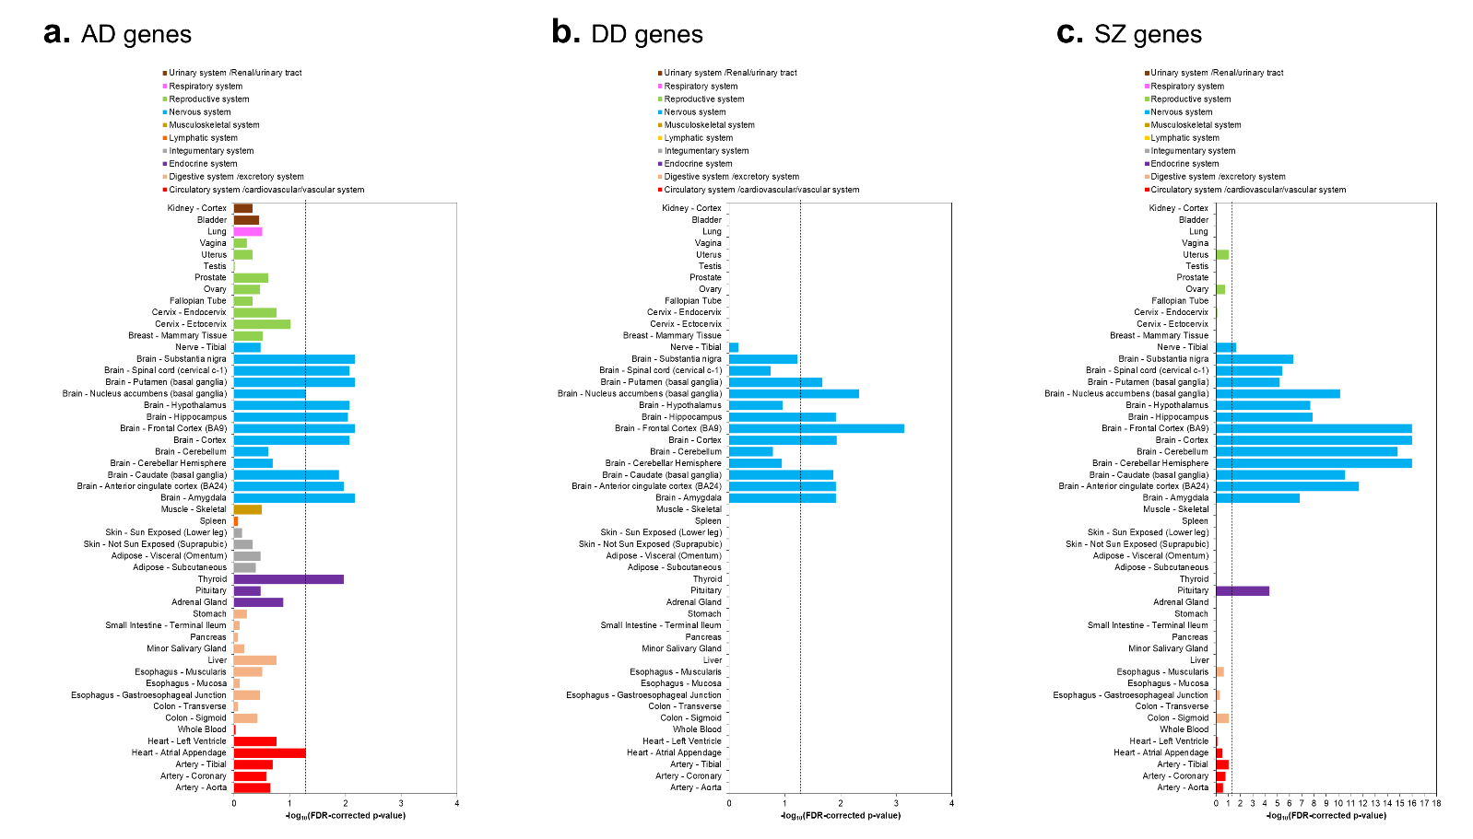
Supplementary Fig. 1: Selective expression of syndrome gene sets in the nervous system. The figure shows tissue-specific enrichment results for a AD genes, b DD genes, and c SZ genes according to data from GTEx. Genes (excluding housekeeping genes) that showed high or moderate expression (transcripts per million (TPM) ≥ 9) in 52 GTEx tissues were considered. The dotted black line indicates the cut-off value for statistical significance, after correction for multiple hypotheses using the Benjamini-Hochberg method (p-value < 0.05, log₁₀(p-value) > 1.30103).

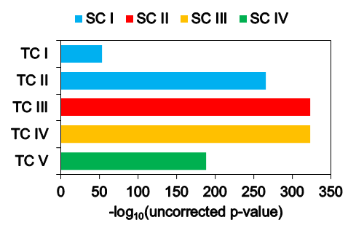
Supplementary Figure 2: Intersection of the macaque spatial and temporal clusters. Hypergeometric tests were used to assess the significance of the overlap of spatial clusters I-1V with temporal clusters I-V. X-axis shows the statistical significance denoted by -log₁₀(FDR-corrected p-value) obtained after multiple test adjustment using the Benjamini-Hochberg method. Note that all the intersections cross 1.30103 (corresponding to a p-value of 0.05, the cut-off for statistical significance) to a great degree; hence, the cutoff has not been indicated here.

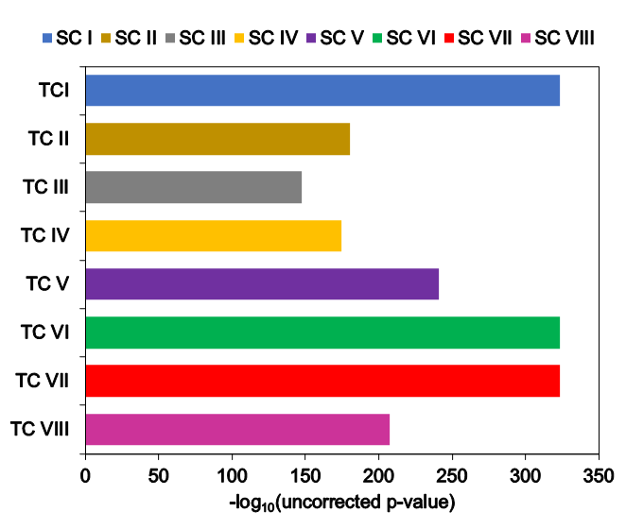
Supplementary Figure 3: Intersection of the human spatial and temporal clusters. Hypergeometric tests were used to assess the significance of the overlap of spatial clusters I-VIII with temporal clusters I-VIII. X-axis shows the statistical significance denoted by -log₁₀(FDR-corrected p-value) obtained after multiple test adjustment using the Benjamini-Hochberg method. Note that all the intersections cross 1.30103 (corresponding to a p-value of 0.05, the cut-off for statistical significance) to a great degree; hence, the cutoff has not been indicated here.

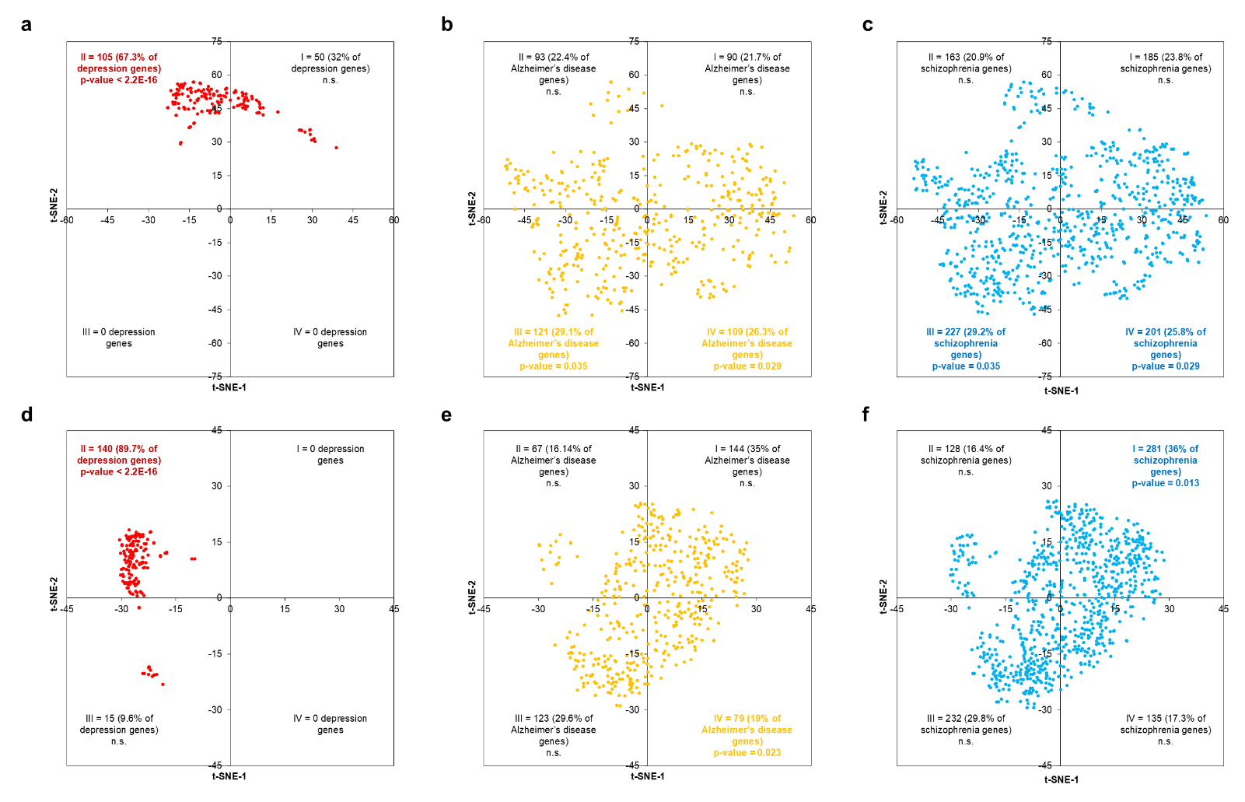
Supplementary Figure 4: t-SNE plots of DD, AD and SZ genes based on macaque spatial data at perplexities 10 and 50. The distribution of a DD genes, b AD genes, and c SZ genes, based on the spatial expression profiles (NIH Blueprint Atlas) of the three gene sets at perplexity 10 (distance metric = 1 – Pearson Correlation Coefficient, epsilon = 10). The distribution of d DD genes, e AD genes, f SZ genes, based on the spatial expression profiles of the three gene sets at perplexity 50 (distance metric = 1 – Pearson Correlation Coefficient, epsilon = 10). The genes have been color-coded based on their syndrome affiliation.

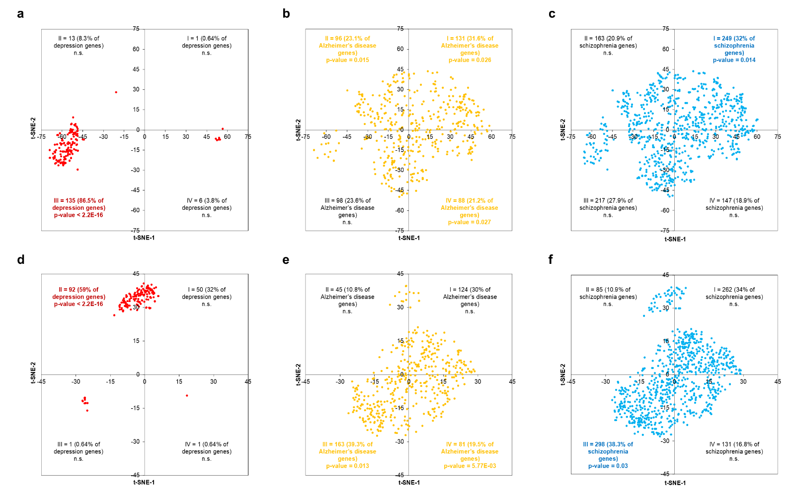
Supplementary Figure 5: t-SNE plots of DD, AD and SZ genes based on macaque temporal data at perplexities 10 and 50. The distribution of a DD genes, b AD genes, and c SZ genes, based on the temporal expression profiles (NIH Blueprint Atlas) of the three gene sets at perplexity 10 (distance metric = 1 – Pearson Correlation Coefficient, epsilon = 10). The distribution of d DD genes, e AD genes, f SZ genes, based on the temporal expression profiles of the three gene sets at perplexity 50 (distance metric = 1 – Pearson Correlation Coefficient, epsilon = 10). The genes have been color-coded based on their syndrome affiliation.

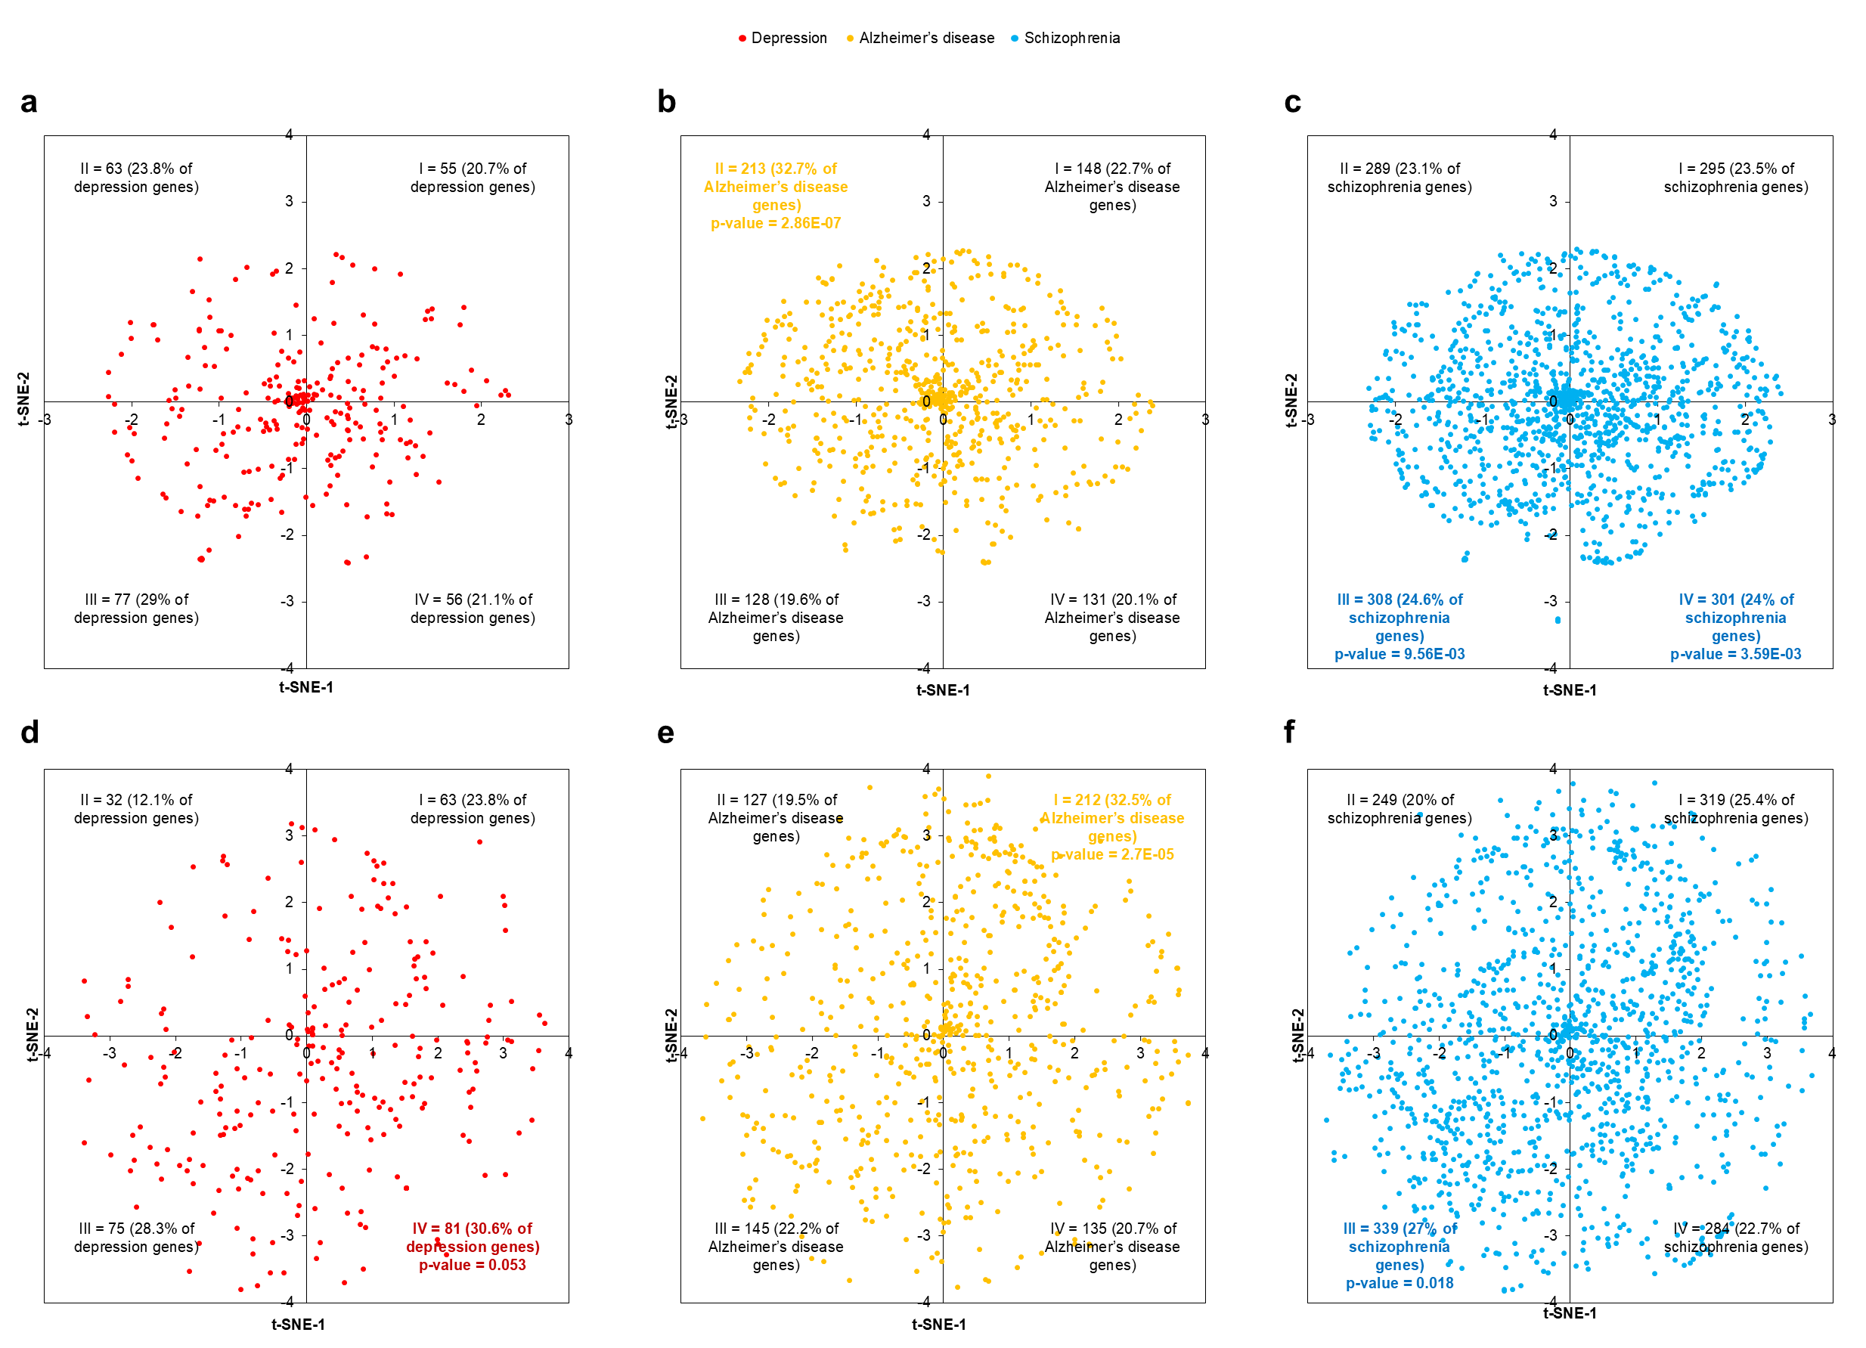
Supplementary Figure 6: t-SNE plots of DD, AD and SZ genes based on human spatial data at perplexities 10 and 50. The distribution of a DD genes, b AD genes, and c SZ genes, based on the spatial expression profiles (BrainSpan Atlas) of the three gene sets at perplexity 10 (distance metric = 1 – Pearson Correlation Coefficient, epsilon = 10). The distribution of d DD genes, e AD genes, f SZ genes, based on the spatial expression profiles of the three gene sets at perplexity 50 (distance metric = 1 – Pearson Correlation Coefficient, epsilon = 10). The genes have been color-coded based on their syndrome affiliation.

Supplementary Figure 7: t-SNE plots of DD, AD and SZ genes based on human temporal data at perplexities 10 and 50. The distribution of a DD genes, b AD genes, and c SZ genes, based on the temporal expression profiles (BrainSpan Atlas) of the three gene sets at perplexity 10 (distance metric = 1 – Pearson Correlation Coefficient, epsilon = 10). The distribution of d DD genes, e AD genes, f SZ genes, based on the temporal expression profiles of the three gene sets at perplexity 50 (distance metric = 1 – Pearson Correlation Coefficient, epsilon = 10). The genes have been color-coded based on their syndrome affiliation.

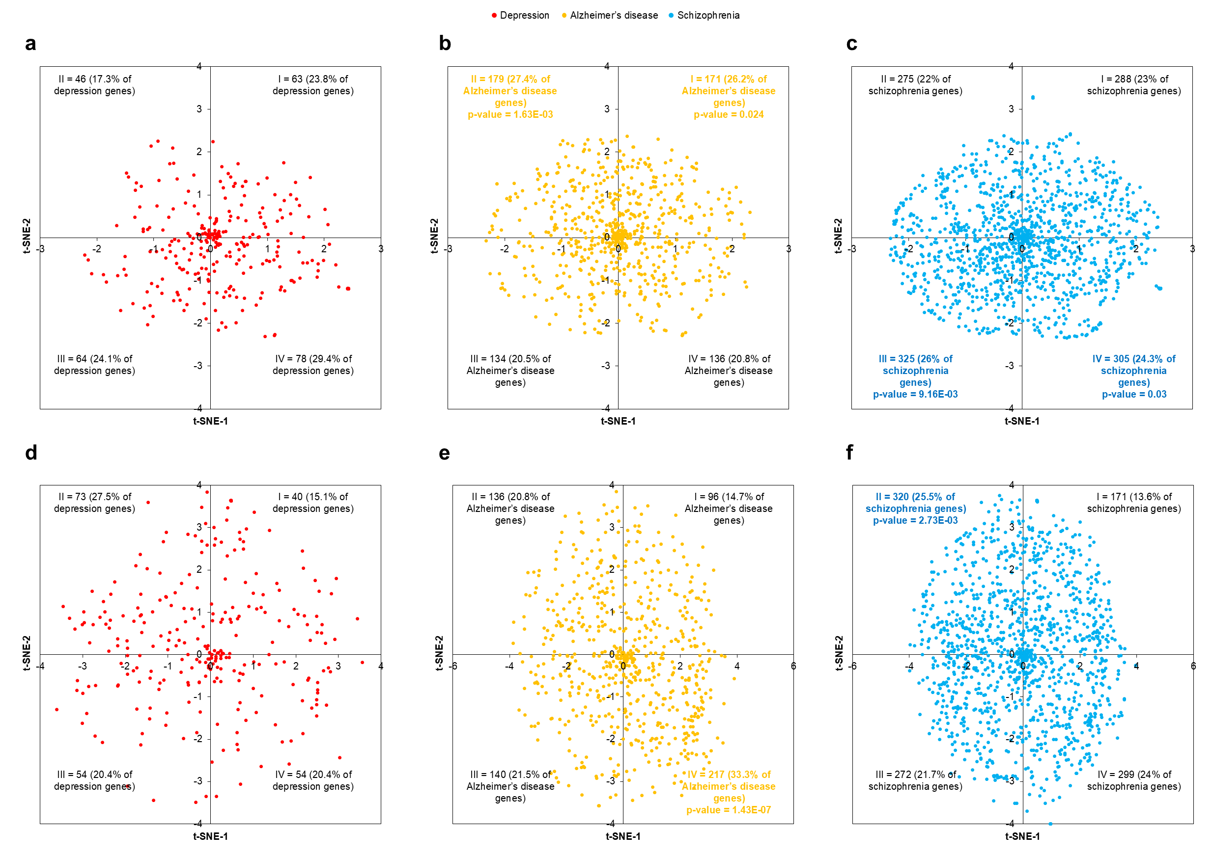

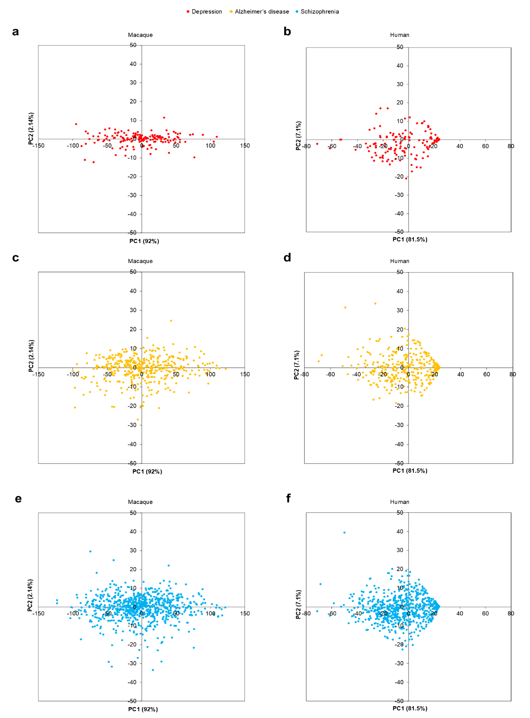

Supplementary Figure 8: Comparison of the PC plots for macaque and human expression data across PC1 and PC2. The distribution of a DD, c AD and e SZ genes for which expression profiles were available in the macaque dataset, and b, d, f their distribution patterns in the human dataset across PC1 and PC2, based on NIH Blueprint Atlas and BrainSpan Atlas expression profiles (transformation method = ln(x), scaling method = unit variance scaling, PCA method = singular value decomposition). The genes have been color-coded based on their syndrome affiliation.

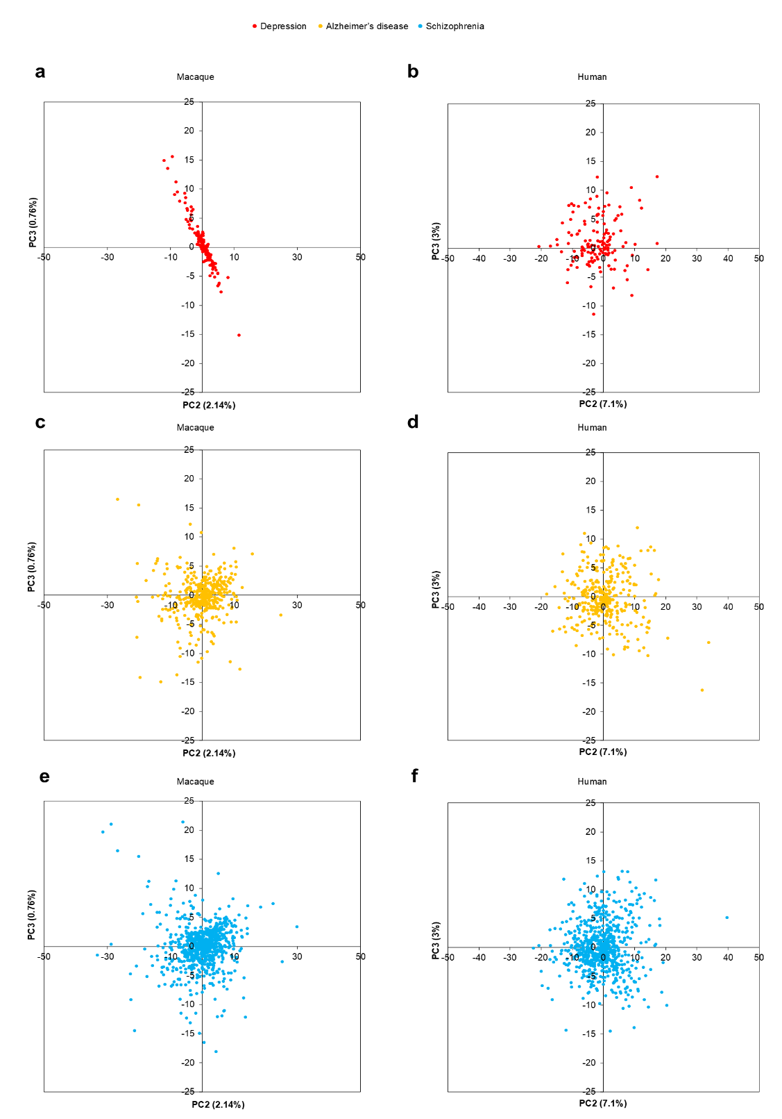
Supplementary Figure 9: Comparison of the PC plots for macaque and human expression data across PC2 and PC3. The distribution of a DD, c AD and e SZ genes for which expression profiles were available in the macaque dataset, and b, d, f their distribution patterns in the human dataset across PC2 and PC3, based on NIH Blueprint Atlas and BrainSpan Atlas expression profiles (transformation method = ln(x), scaling method = unit variance scaling, PCA method = singular value decomposition). The genes have been color-coded based on their syndrome affiliation.

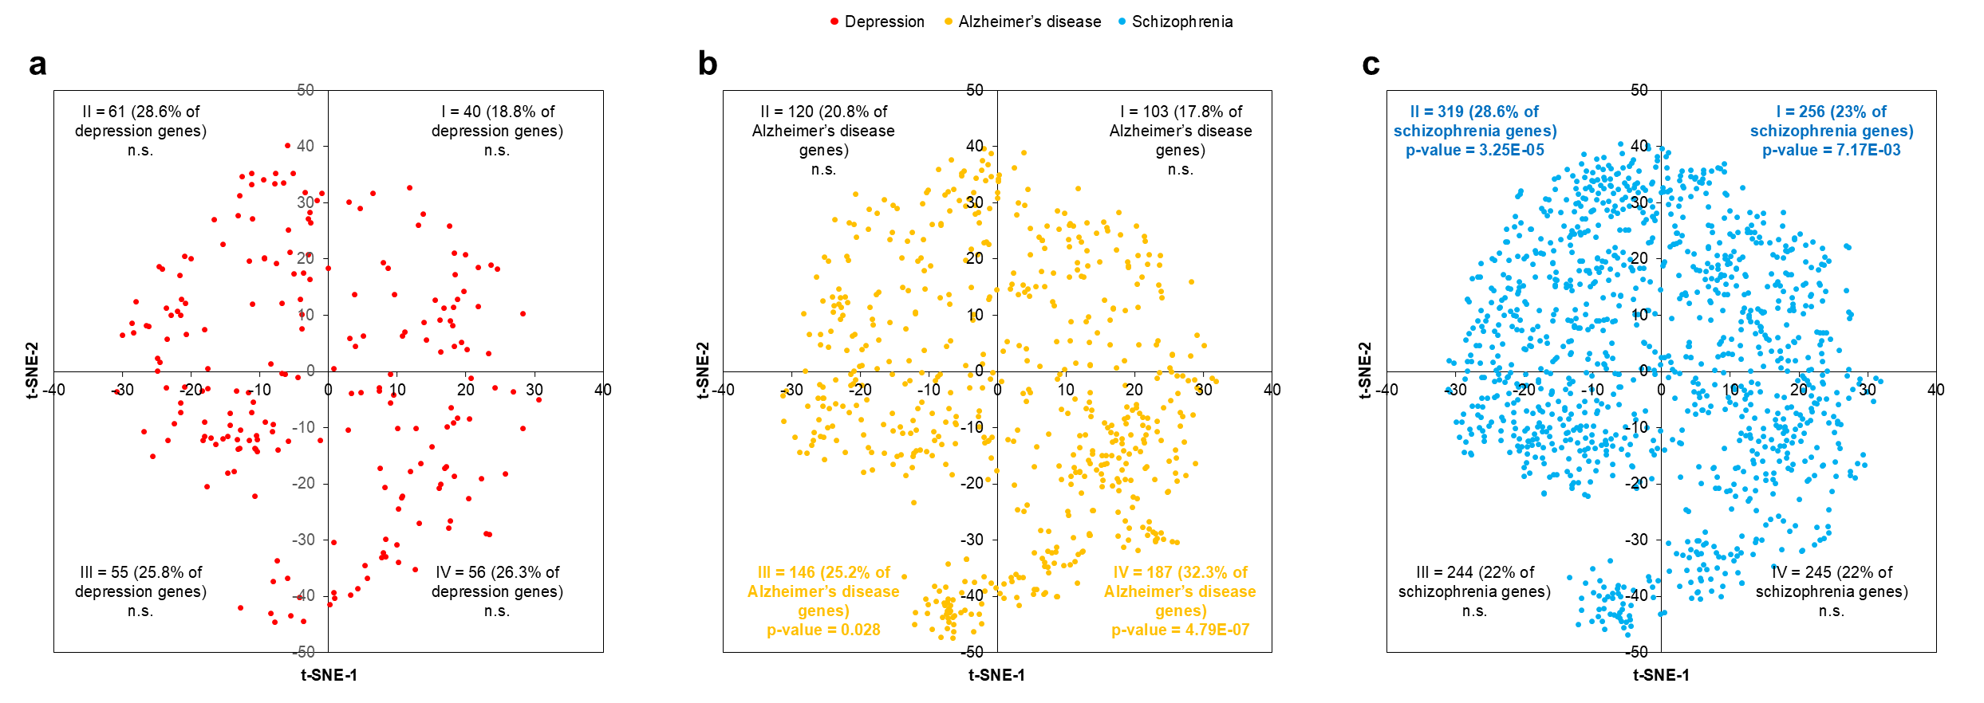
Supplementary Figure 10: t-SNE based on a spatial dataset with extensive coverage of brain structures recapitulated the distributed profiles of DD, AD, and SZ genes in the human brain. The distribution of a DD genes, b AD genes, and c SZ genes, based on the spatial expression profiles of the three gene sets (human microarray dataset from Allen Brain Atlas). Distance metric = 1 – Pearson Correlation Coefficient, epsilon = 10 and perplexity = 30. The genes have been color-coded based on their syndrome affiliation.

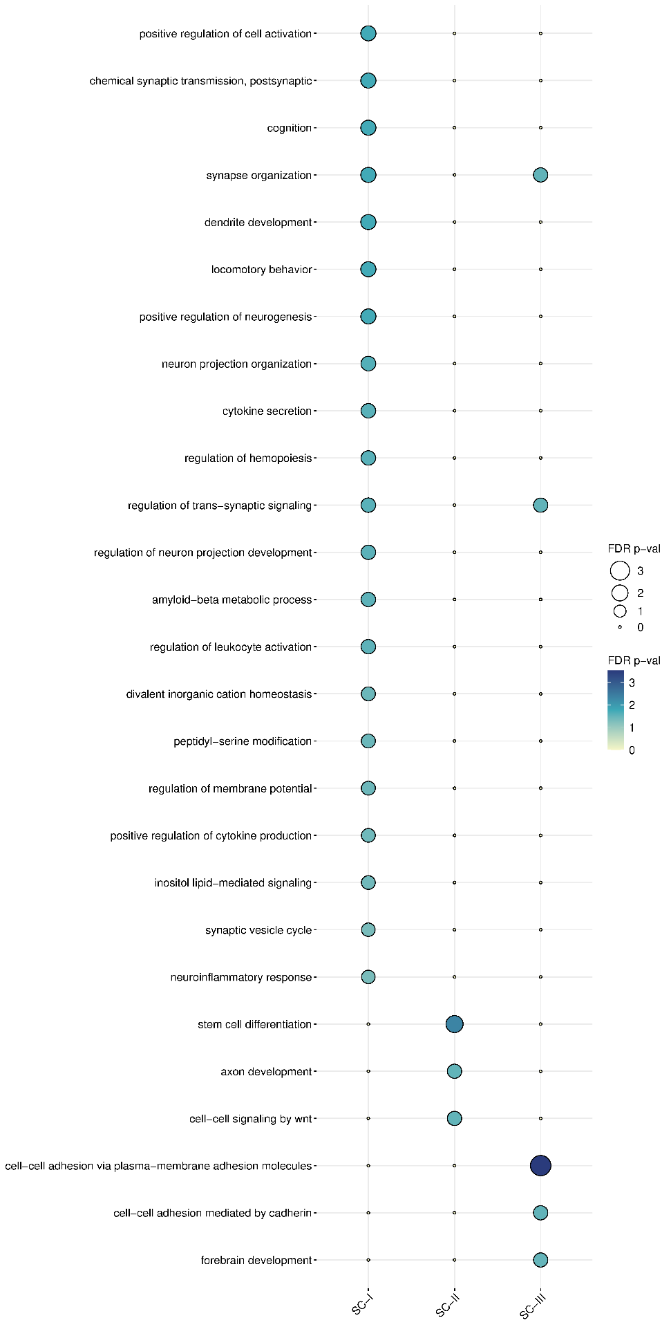

Supplementary Figure 11: Enrichment of macaque spatial clusters for various Gene Ontology (GO) biological processes. The balloon plot shows the enrichment of three macaque spatial clusters (X-axis) for genes belonging to different GO processes (Y-axis). The size and colour of the circles indicate the FDR-corrected statistical significance of the enrichments (shown as -log₁₀(p-value)); larger the circle and deeper the colour, higher is the statistical significance. Note that only those enrichments that cross the p-value threshold after FDR correction have been shown (p-value < 0.05, log₁₀(p-value) > 1.30103).

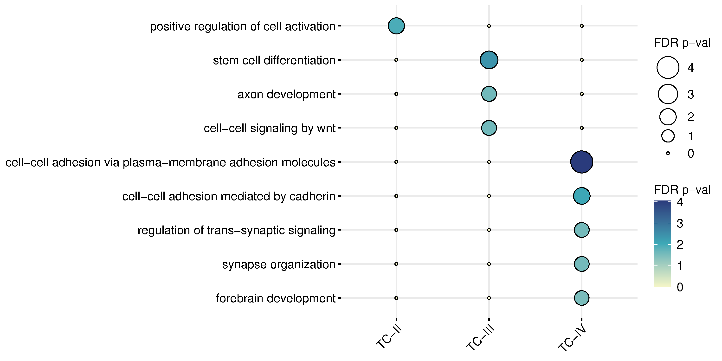
Supplementary Figure 12: Enrichment of macaque temporal clusters for various Gene Ontology (GO) biological processes. The balloon plot shows the enrichment of three macaque temporal clusters (X-axis) for genes belonging to different GO processes (Y-axis). The size and colour of the circles indicate the FDR-corrected statistical significance of the enrichments (shown as -log₁₀(p-value)); larger the circle and deeper the colour, higher is the statistical significance. Note that only those enrichments that cross the p-value threshold after FDR correction have been shown (p-value < 0.05, log₁₀(p-value) > 1.30103).

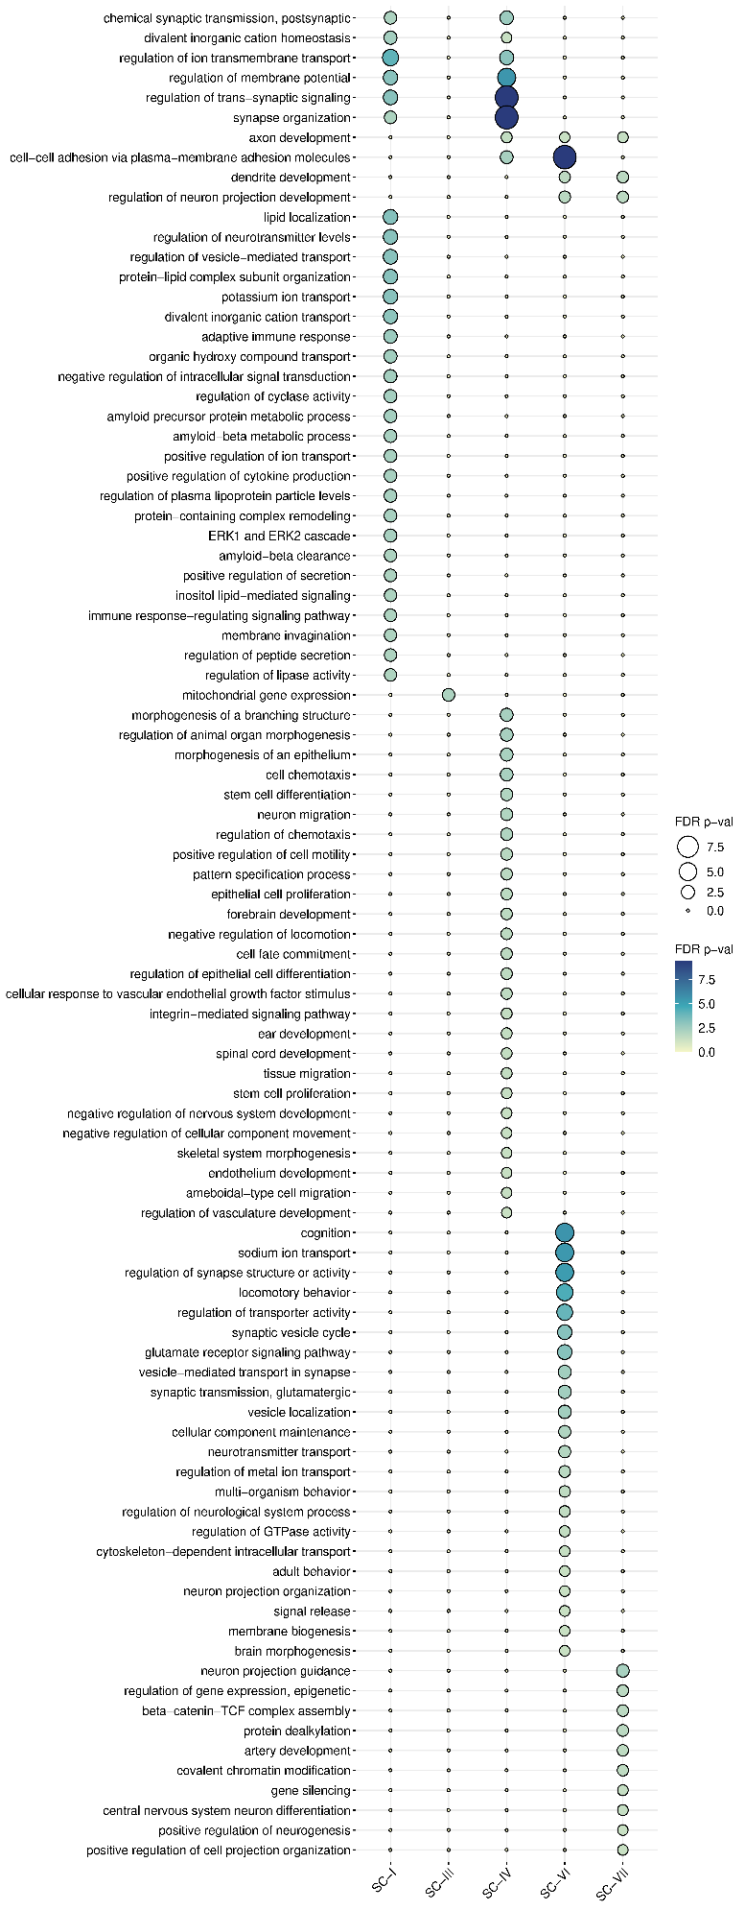
Supplementary Figure 13: Enrichment of human spatial clusters for various Gene Ontology (GO) biological processes. The balloon plot shows the enrichment of five human spatial clusters (X-axis) for genes belonging to different GO processes (Y-axis). The size and colour of the circles indicate the FDR-corrected statistical significance of the enrichments (shown as -log₁₀(p-value)); larger the circle and deeper the colour, higher is the statistical significance. Note that only those enrichments that cross the p-value threshold after FDR correction have been shown (p-value < 0.05, log₁₀(p-value) > 1.30103).
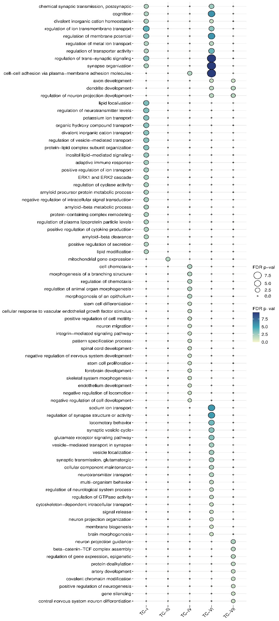
Supplementary Figure 14: Enrichment of human temporal clusters for various Gene Ontology (GO) biological processes. The balloon plot shows the enrichment of five human temporal clusters (X-axis) for genes belonging to different GO processes (Y-axis). The size and colour of the circles indicate the FDR-corrected statistical significance of the enrichments (shown as -log₁₀(p-value)); larger the circle and deeper the colour, higher is the statistical significance. Note that only those enrichments that cross the p-value threshold after FDR correction have been shown (p-value < 0.05, log₁₀(p-value) > 1.30103).
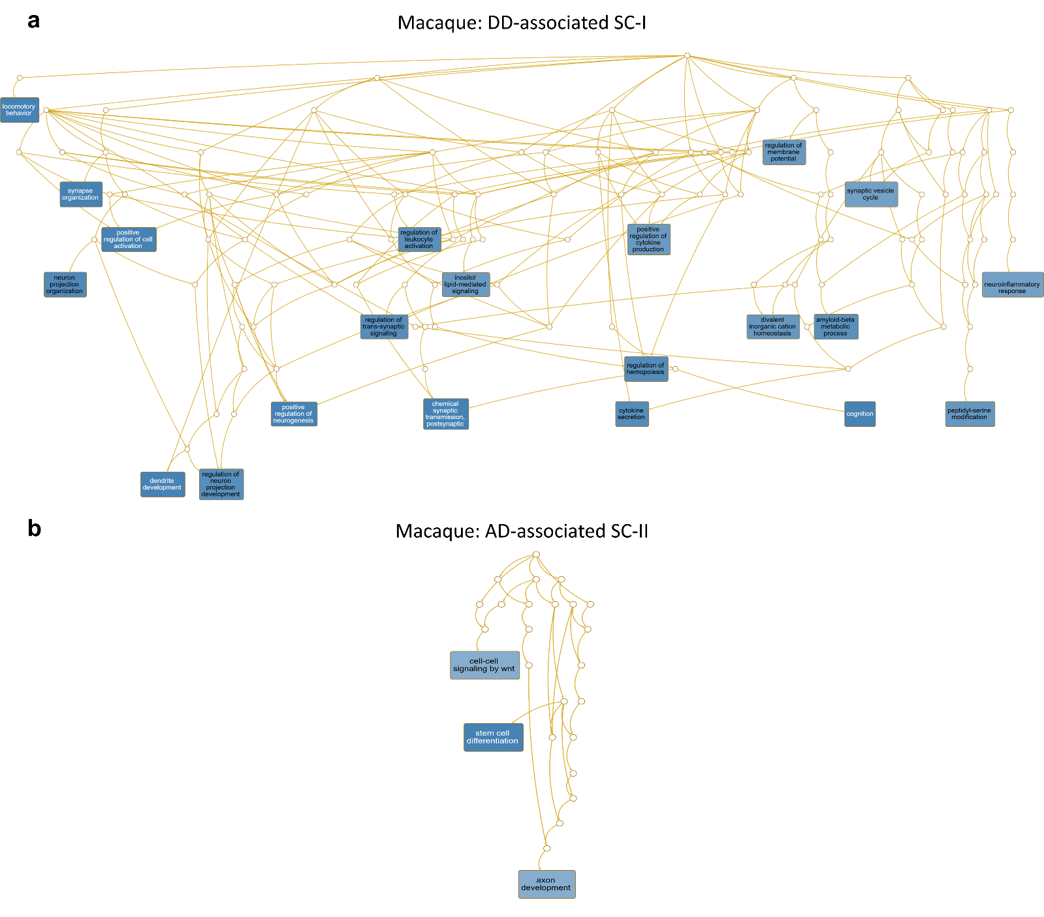Supplementary Figure 15: Gene Ontology (GO) hierarchies of biological processes associated with macaque spatial clusters. GO hierarchies of biological processes enriched in macaque data-derived a DD-associated spatial cluster I and b AD-associated spatial cluster II. Darker blue indicates higher statistical significance.

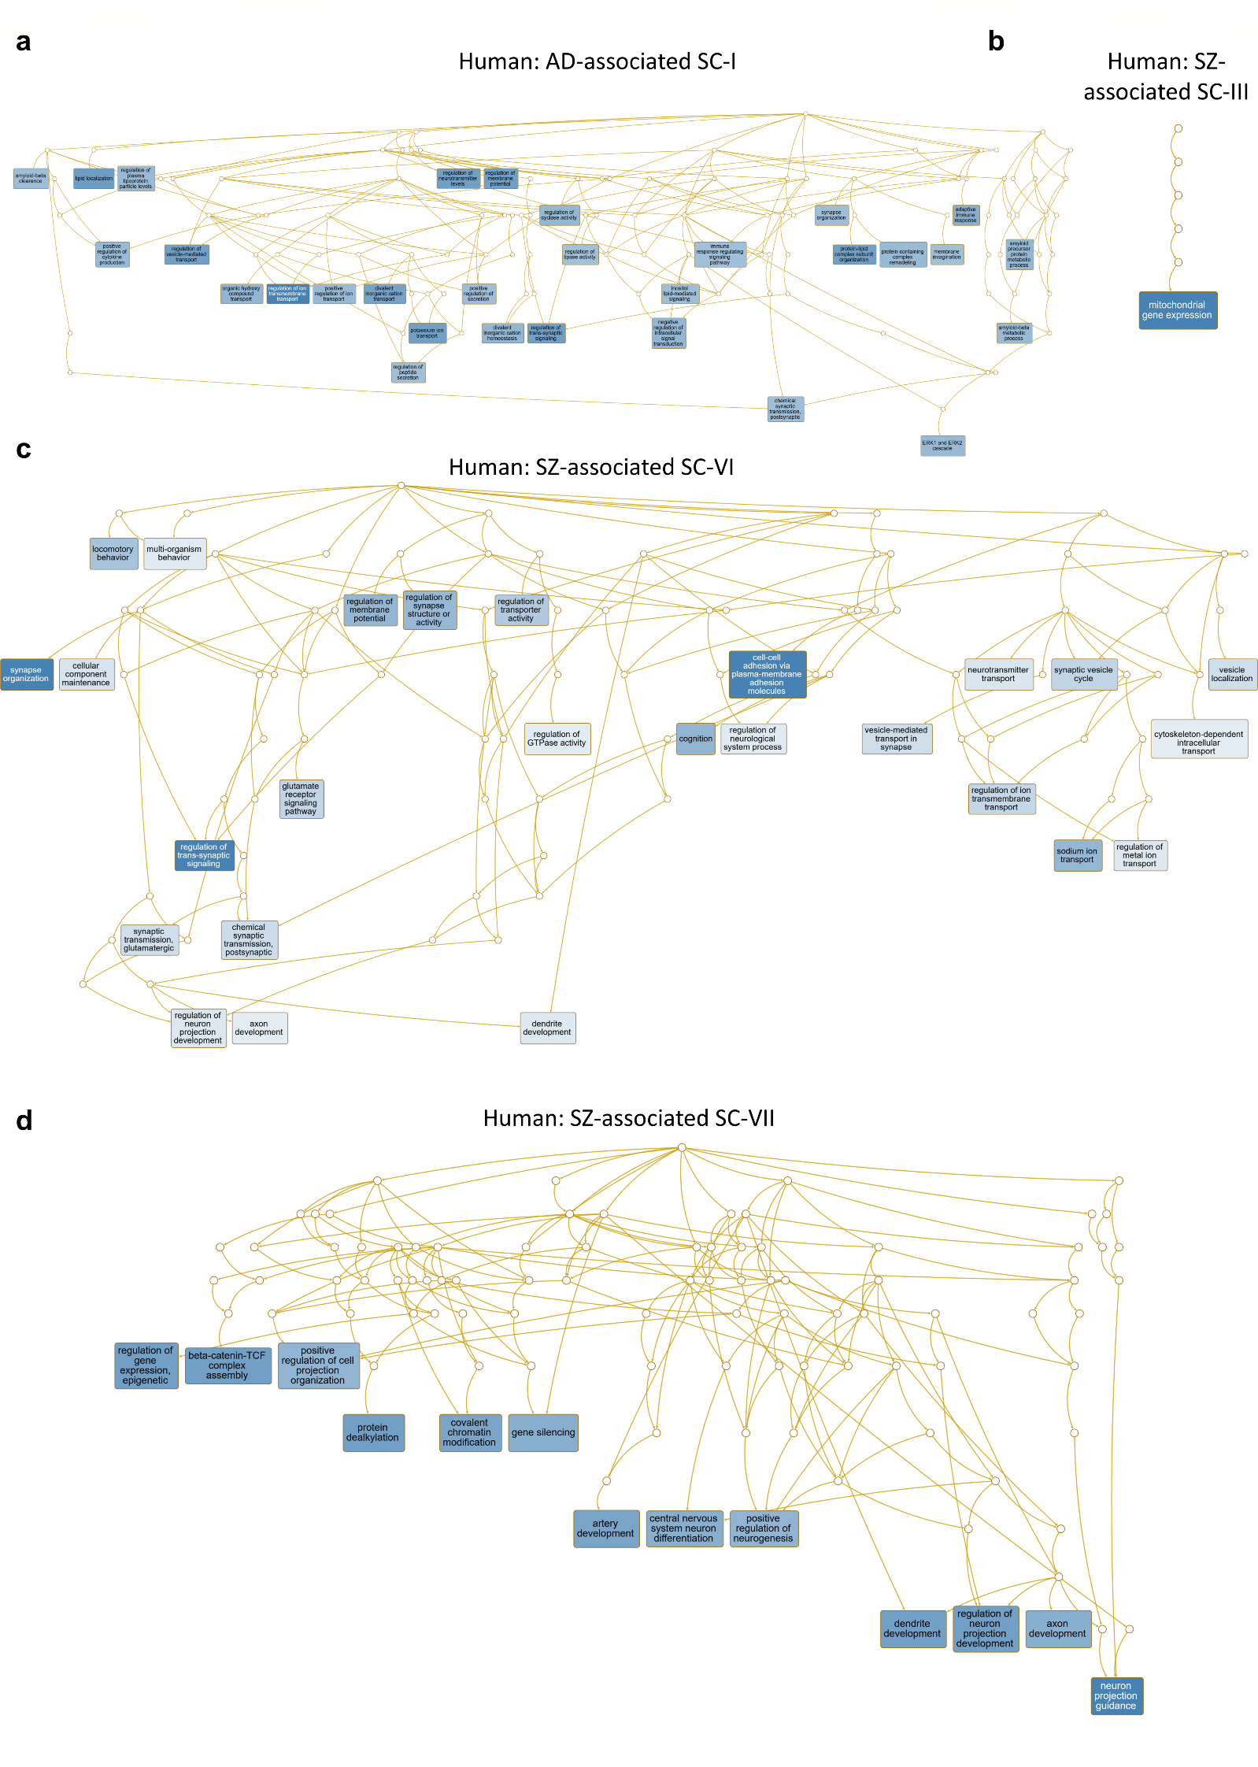
Supplementary Figure 16: Gene Ontology (GO) hierarchies of biological processes associated with human spatial clusters. GO hierarchies of biological processes enriched in human data-derived a AD-associated spatial cluster I, and SZ-associated b spatial cluster III, c spatial cluster VI, and d spatial cluster VII. Darker blue indicates higher statistical significance.

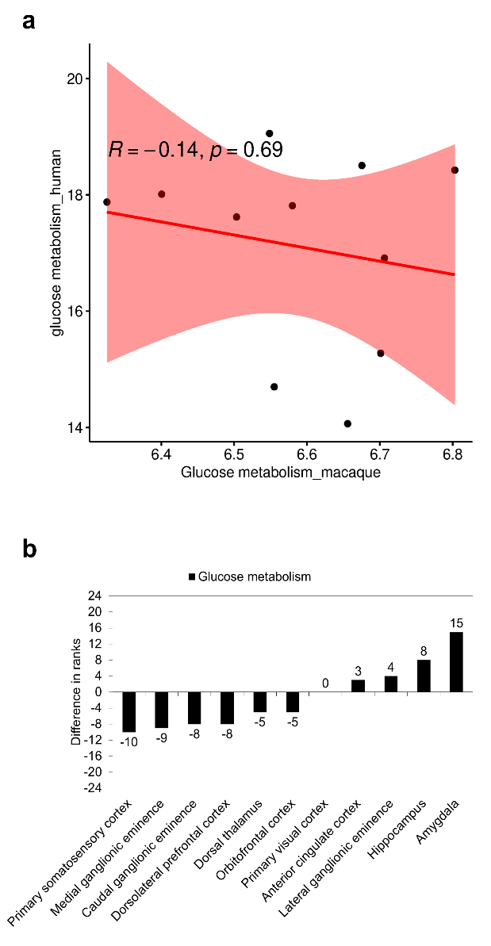
Supplementary Figure 17: Correlation of expression patterns of genes involved in glucose metabolism in human and macaque brains. Correlation of the expression of a genes involved in glucose metabolism in eleven comparable macaque and human brain regions. Spearman’s rank correlation was used to examine the relationship between the expression values; R indicates the strength and direction of the association, whereas p indicates the statistical significance of the association. Region-wise difference in ranks between macaques and humans have been shown for the same gene set in b; the differences have been indicated as data labels next to the bar plots.

Supplementary References
1 Buniello, A. et al. The NHGRI-EBI GWAS Catalog of published genome-wide association studies, targeted arrays and summary statistics 2019. Nucleic acids research 47, D1005-D1012 (2019).
2 Bakken, T. E. et al. A comprehensive transcriptional map of primate brain development. Nature 535, 367-375 (2016).
3 Sunkin, S. M. et al. Allen Brain Atlas: an integrated spatio-temporal portal for exploring the central nervous system. Nucleic acids research 41, D996-D1008 (2012).
4 Hawrylycz, M. J. et al. An anatomically comprehensive atlas of the adult human brain transcriptome. Nature 489, 391 (2012).
5 Starruß, J., De Back, W., Brusch, L. & Deutsch, A. Morpheus: a user-friendly modeling environment for multiscale and multicellular systems biology. Bioinformatics 30, 1331-1332 (2014).
6 Consortium, G. The Genotype-Tissue Expression (GTEx) pilot analysis: Multitissue gene regulation in humans. Science 348, 648-660 (2015).
7 Rouillard, A. D. et al. The harmonizome: a collection of processed datasets gathered to serve and mine knowledge about genes and proteins. Database 2016 (2016).
8 Liao, Y., Wang, J., Jaehnig, E. J., Shi, Z. & Zhang, B. WebGestalt 2019: gene set analysis toolkit with revamped UIs and APIs. Nucleic acids research (2019).
9 Love, M. I., Anders, S., Kim, V. & Huber, W. RNA-Seq workflow: gene-level exploratory analysis and differential expression. F1000Research 4 (2015).
10 Metsalu, T. & Vilo, J. ClustVis: a web tool for visualizing clustering of multivariate data using Principal Component Analysis and heatmap. Nucleic acids research 43, W566-W570 (2015).
11 Consortium, G. O. The gene ontology resource: 20 years and still GOing strong. Nucleic acids research 47, D330-D338 (2019).

