Supplementary Information
Real-time Dual-telescope Normalization for Absorption Muography: an Improved Density Estimation Approach
Hamid Basiri^{1*}, Jun Matsushima¹, Masashi Kodama^{1,2}, Toshiyuki Yokota², Mohammed Y. Ali³, Fateh Bouchaala³, Ahmed Eleslambouly³, Hiroyuki K.M. Tanaka⁴, Eduardo Cortina Gil⁵, Andrea Giammanco⁵
¹Department of Environment Systems, Graduate School of Frontier Sciences, The University of Tokyo, Tokyo, Japan.
²Geological Survey of Japan, National Institute of Advanced Industrial Science and Technology (AIST), Japan.
³Department of Earth Sciences, Khalifa University of Science and Technology, Abu Dhabi, United Arab Emirates.
⁴Earthquake Research Institute, The University of Tokyo, Tokyo, Japan.
⁵Centre for Cosmology, Particle Physics and Phenomenology, Université catholique de Louvain (UCLouvain), Chemin du Cyclotron 2, Louvain-la-Neuve, B-1348, Belgium.

* Corresponding author
Email: Basiri.hamid@edu.k.u-tokyo.ac.jp;

Supplementary Figure 1 shows a detector unit, and Table 1 summarizes key features of the detector components.
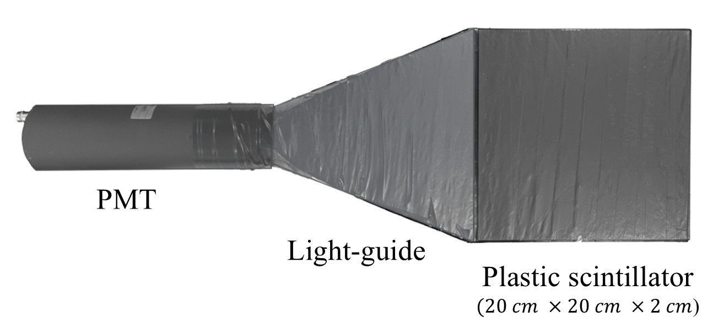
Supplementary Figure 1 | PMT-scintillator detector configuration. A photograph of the detection unit consisting of a 20 cm × 20 cm × 2 cm polystyrene scintillator tile optically coupled through a PMMA light guide to a Hamamatsu H6410 photomultiplier tube (PMT) with peak sensitivity near 420 nm. This assembly constitutes a single detection channel within each of the three-plane coincidence telescopes employed in the experiments.

Supplementary Table 1 | Key parameters of detector components.
Component | Parameter | Value
Plastic scintillator tile | Active volume | 20 cm × 20 cm × 2 cm
 | Emission peak | ∼ 420 nm
 | Light attenuation length | ∼ 90 to 110 cm
 | Density | ∼ 1.04 gcm⁻³
PMMA light guide | Refractive index | ∼ 1.49
 | Total transmittance | ∼ 93%
 | Specific gravity | ∼ 1.19 gcm⁻³
PMT assembly (Hamamatsu H6410) | Spectral response | 300 to 650 nm
 | Peak wavelength | 420 nm
 | Gain (typ.) | 3.0 × 10⁶
 | Transit time spread (typ.) | ∼ 1.1 ns
 | Rise time (typ.) | ∼ 2.7 ns
 | Operating HV (anode to cathode) | about −2000 V

MIP selection by a robust valley method:
Cosmic–ray muons traversing plastic scintillators produce a Landau–like pulse–height spectrum with a most–probable, minimum–ionizing peak (MIP) and a long right tail. To select MIPs in each channel and data set (background, acrylic, blind targets), we apply a robust, data–driven valley region of interest (ROI). The method is noise–resistant yet precise, and we verified its reproducibility across runs. The procedure mirrors our analysis code:
- Build histograms: For each channel, form the pulse–height (ADC) histogram with 1-ADC bins on 0...1024.
- Savitzky–Golay (SG) smoothing: We apply a SG smoothing step to the binned counts to aid in locating the primary peak and its left and right boundaries. This is applied with scipy.signal.savgol filter using window w = 21 (odd) and polynomial order p = 3, with edge mode ’interp’. We validate p+2 ≤ w ≤ N −1 (rounding w to the nearest valid odd if needed). The SG curve is used only to locate the peak and the left/right boundaries; all event counting uses the raw histogram. These settings (w = 21, p = 3) were chosen to minimize peak-location jitter across runs and are stable for w ∈ [17, 25].
- Constrain the search ROI: To avoid the low-ADC pedestal and spurious structures, restrict the MIP search to ADC ∈ [170,360] (empirically determined from detector response). The upper bound excludes the Landau tail, which is dominated by rare δ-ray–producing collisions and adds variance and geometry/angle-dependent bias.
- Initial peak on the smoothed spectrum: Within the ROI, take the maximum of the SG-smoothed curve to obtain a noise-robust first peak index i₀.
- Refine on the raw data: Search the raw histogram in a ±25-bin window around i₀ and take the absolute maximum. This refined index is the MIP peak.
- Valley/boundary search on the smoothed spectrum: Compute left/right boundaries on the SG curve starting from the refined peak:
  - Left boundary ADC_{left}: nearest local minimum to the left (then expand by a small safety margin).
  - Right boundary ADC_{right}: because the Landau tail is often monotonic, a right minimum may not exist. Choose the latter of (i) the first right local minimum (if present) and (ii) the fractional-threshold crossing
b + α (peak − b), α = 0.12,
where b is a local background estimated from low-quantile statistics in the ROI. Enforce a minimum window width and apply small left/right safety expansions (6 bins each).
- Define the MIP window:
[ADCleft, ADCright]
with ADC_{left} from the left minimum and ADC_{right} from the latter of the first right minimum or the fractional-threshold crossing.
- Apply the window and count events: Events with ADC inside the window are tagged as MIPs. From hourly counts per channel and sums over three channels to obtain counts per hour (CPH).
- Uncertainties and rationale for the high-ADC cut: Hourly counts are treated as Poisson; later propagation includes calibration contributions.
For thin plastic scintillators, occasional hard collisions yield energetic δ rays, producing a long, geometry-dependent high-ADC tail that is not representative of the minimum ionizing loss. Our hybrid rule of left minimum and, on the right, (minimum if present) else a fractional threshold avoids chasing noise minima, deliberately excludes the tail, and yields a stable, geometry-agnostic MIP counter. The same automatic procedure is applied uniformly to all runs. Supplementary Figs. 2 and 3 illustrate the SG and Automated MIP valley–selection workflows.
Supplementary Fig. 4 summarizes the workflow for density estimation using single and dual-telescope approaches.
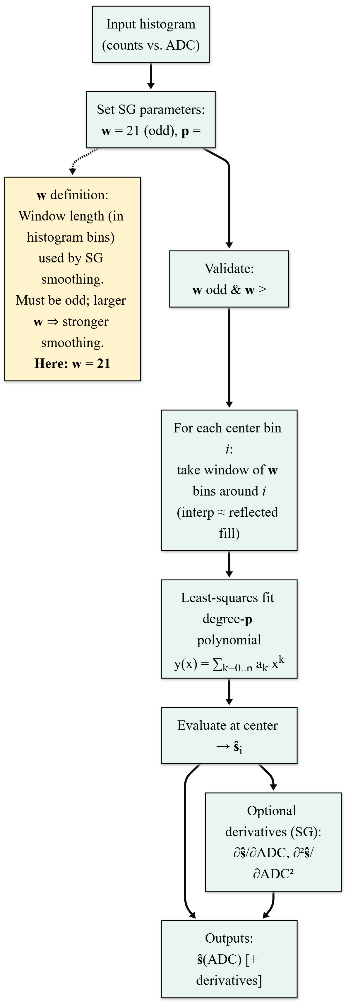
Supplementary Figure 2 | Savitzky–Golay smoothing used in the valley-finding algorithm. The smoothing is applied with parameters $w=21$(odd), $p=3$, and mode = interp. The window width $w$satisfies the stability and validity conditions $w≥p+2$and $w≤N-1$.

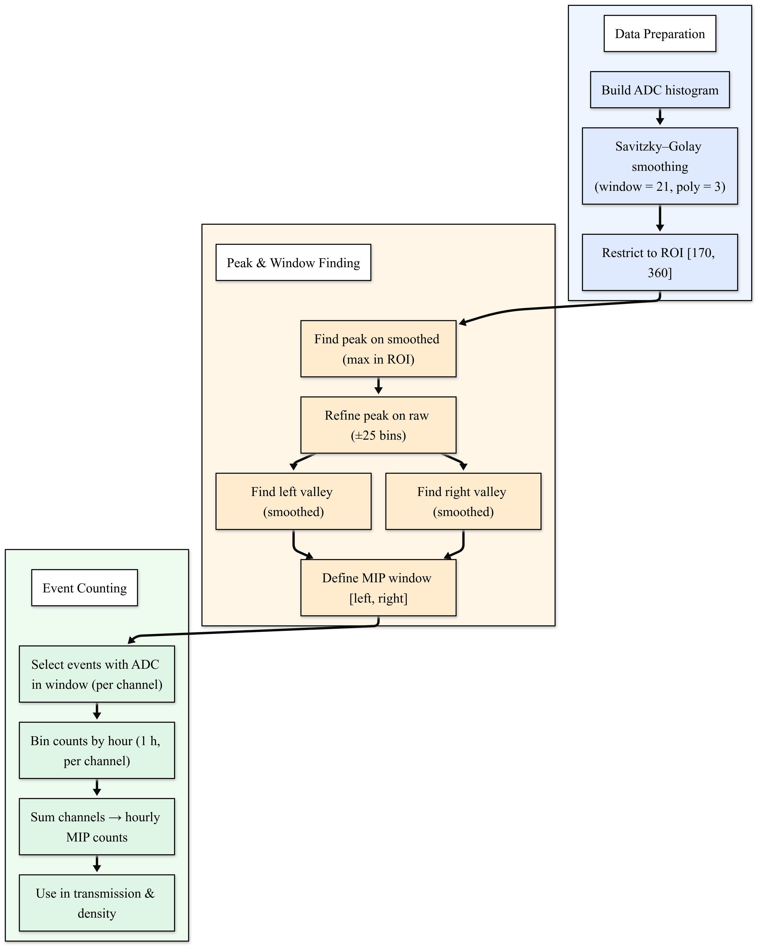
Supplementary Figure 3 | Automated MIP valley–selection workflow. The procedure identifies the MIP region by locating the peak on the Savitzky–Golay–smoothed spectrum, defining boundaries using the right-hand fractional rule on the same curve, and performing event counting in the corresponding raw pulse-height space.

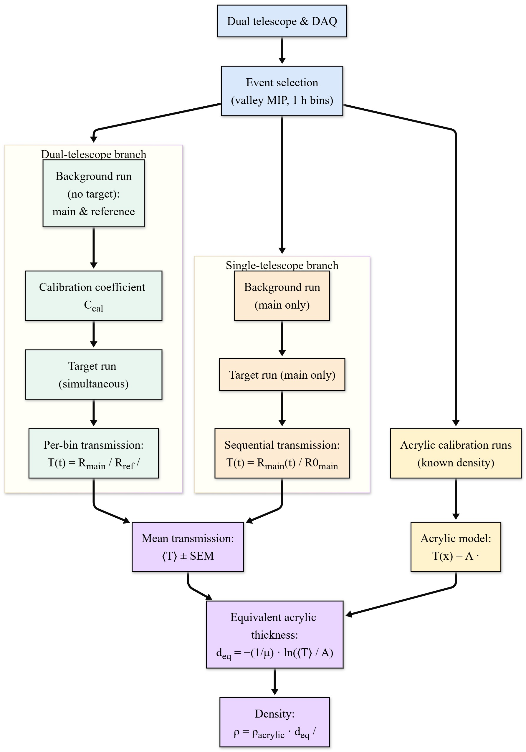
Supplementary Figure 4 | Workflow for density estimation. The Dual-telescope approach (green) employs simultaneous main and reference count rates normalized by a calibration factor, while the Single-telescope approach (orange) relies on sequential main-only measurements referenced to a baseline. The acrylic calibration (yellow) converts mean transmission values into equivalent acrylic thickness and corresponding material density.

