Appendix A. Supplementary Data

Supplementary Data:
Analysis methods
S1. Scanning Electron Microscopy (SEM) and Energy-Dispersive X-ray Spectroscopy (EDS).
Field-emission SEM (Zeiss Sigma, Carl Zeiss Microscopy GmbH, Germany) equipped with a Gemini column and an EDS detector (Thermo Scientific, USA) was used to examine surface morphology and elemental composition of MLG.

S2. Fourier Transform Infrared Spectroscopy (FTIR).
FTIR spectra were collected on a Vertex 80 spectrometer (Bruker Optics, Germany) using KBr pellets prepared from MLG powders.

S3. Brunauer–Emmett–Teller (BET) and Barrett–Joyner–Halenda (BJH) Analysis.
Specific surface area and pore size distribution were determined using N₂ adsorption–desorption isotherms measured with a surface area and porosity analyzer (ASAP 2010, Micromeritics, USA) at KBSI.

S1. Scanning Electron Microscopy (SEM) and Energy-Dispersive X-ray Spectroscopy (EDS).
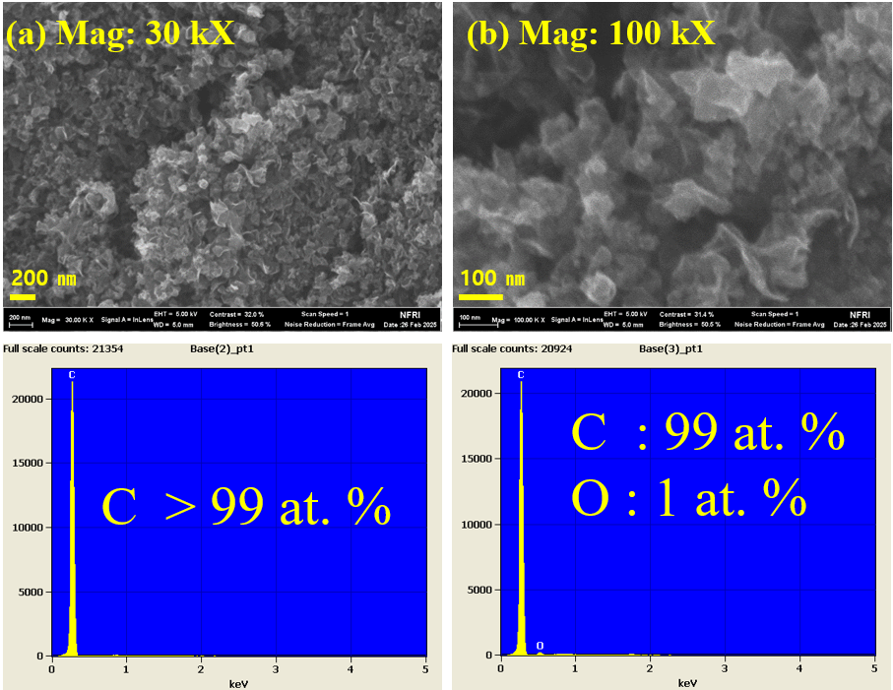
Figure. S1. FE-SEM images of MLG at (a) 30 kX and (b) 100 kX, and (c) EDS elemental analysis

FE-SEM analysis was performed to support morphological characterization of MLG. In Fig. S1a (30 kX), the sample appears as large agglomerates of graphene flakes with noticeable interparticle voids, which is a typical feature of multi-layer graphene powders formed through van der Waals restacking after plasma synthesis. In Fig. S1b (100 kX), thin sheet-like structures with wrinkled and overlapped features are evident, indicating the presence of layered carbon domains. Such stacked and folded morphologies are commonly reported for MLG synthesized via gas-phase plasma processes. The EDS spectra (Fig. S1c) confirm that the product is composed of >99 at.% carbon with only ~1 at.% oxygen. This trace oxygen is most likely attributed to surface adsorption during sampling and collection, when MLG generated from the plasma torch came into contact with the ambient atmosphere. Considering that the synthesis was carried out in pure CH₄ plasma, the oxygen signal is not intrinsic but instead reflects extrinsic surface adsorption. These results demonstrate that the microwave plasma torch process effectively produces high-purity MLG with negligible contamination.

S2. Fourier Transform Infrared Spectroscopy (FTIR).
Figure S2. FT-IR spectrum of the synthesized MLG

The FT-IR spectrum of the synthesized MLG (Fig. S2) exhibits several characteristic absorption bands. A distinct peak at ~1630 cm⁻¹ is attributed to C=C stretching vibrations within sp² carbon domains, confirming the presence of conjugated double bonds consistent with the graphene lattice. In the range of 1380–1450 cm⁻¹, weak but noticeable bands are observed, which can be assigned to C–H bending vibrations. These modes are likely associated with residual hydrogen bonded to edge carbons or defect-related sites in the multilayer graphene structure. Additional weak absorptions appear in the 1050–1150 cm⁻¹ region, suggesting trace contributions from C–O stretching. Such features may arise from ether- or epoxy-type groups at defect sites or may have been introduced during handling and exposure to ambient conditions. Considering that the XPS survey spectrum shows only ~0.9 at.% oxygen, the contribution of oxygen-containing groups must be minimal, although FT-IR is sensitive enough to detect such surface vibrations. These spectral features indicate that the synthesized MLG is predominantly composed of sp² graphitic carbon, with only minor contributions from C–H and C–O groups. This interpretation is consistent with the high crystallinity observed in TEM and the high carbon purity confirmed by XPS.

S3. Brunauer–Emmett–Teller (BET) and Barrett–Joyner–Halenda (BJH) Analysis.
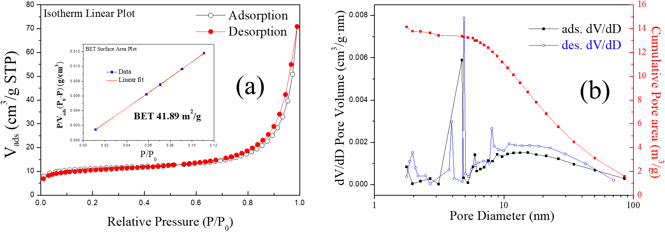
Figure. S3. Nitrogen adsorption–desorption isotherm, BET surface area plot (a) , and BJH pore size distribution (b) of MLG

The nitrogen adsorption–desorption isotherm of the synthesized MLG (Fig. S3a) shows a typical type-IV profile with a distinct hysteresis loop at higher relative pressures, indicating the presence of mesoporous structures. The BET surface area calculated from the linear region is 41.89 m²/g. This value is explained by the multilayer stacking of graphene, which reduces the exposed surface area compared with single-layer graphene. The pore size distribution derived from the BJH analysis (Fig. S3b) shows mesopores mainly in the 2–10 nm range, with a tailing distribution toward larger pores. The total pore volume is relatively small, which is consistent with the moderate surface area and the dominance of interparticle mesopores rather than intrinsic microporosity. The distribution exhibits a single-peaked profile, suggesting that most pores arise from interlayer voids and imperfect stacking between graphene sheets. The extended tail toward larger pore sizes also indicates partial macroporosity, which can be attributed to agglomeration of graphene flakes during synthesis and collection. This porosity helps molecules attach to the surface and enables ions to move more easily, which is useful for catalytic and electrochemical energy storage applications.

