Synthesis and Characterization of Biocompatible Cryogels Based on Chitosan, Poly(ethylene glycol) Diacrylate, and Graphene with a Controlled Porous Structure

A.S. Buinov¹*, E.R. Gafarova², K.N. Bardakova^{2,3}, B.Ch. Kholkhoev¹, V.M. Poglazova², N.B. Serezhnikova², Y.M. Efremov², I.A. Farion¹, D.I. Gapich^{4,5}, V.A. Kuznetsov^{4,5}, P.S. Timashev^{2,6,7}, V.F. Burdukovskii¹

¹ Baikal Institute of Nature Management
Siberian branch of the Russian Academy of Sciences,
Russian Federation, 670047 Ulan-Ude, 6 Sakhyanovoy str.
² Institute for Regenerative Medicine, Sechenov First Moscow State Medical University (Sechenov University), Russian Federation, 119991 Moscow, 8-2 Trubetskaya str.
³ National Research Centre “Kurchatov Institute”, Russian Federation, 123182 Moscow, 1 Akademika Kurchatova Square
⁴ Nikolaev Institute of Inorganic Chemistry
Siberian Branch of Russian Academy of Sciences, Russian Federation, 630090 Novosibirsk, 3 Acad. Lavrentiev Ave.
⁵ Novosibirsk State Technical University, Russian Federation, 630073 Novosibirsk, 20 K. Marx ave.
⁶ Semenov Institute of Chemical Physics, Russian Academy of Sciences, Russian Federation, 119991 Moscow, 4 Kosygina str.
⁷ Chemistry Department, Lomonosov Moscow State University, Russian Federation, 119991 Moscow, 1-3 Leninskiye Gory

*Corresponding author
E-mail: buinov.aleksandr.96@mail.ru

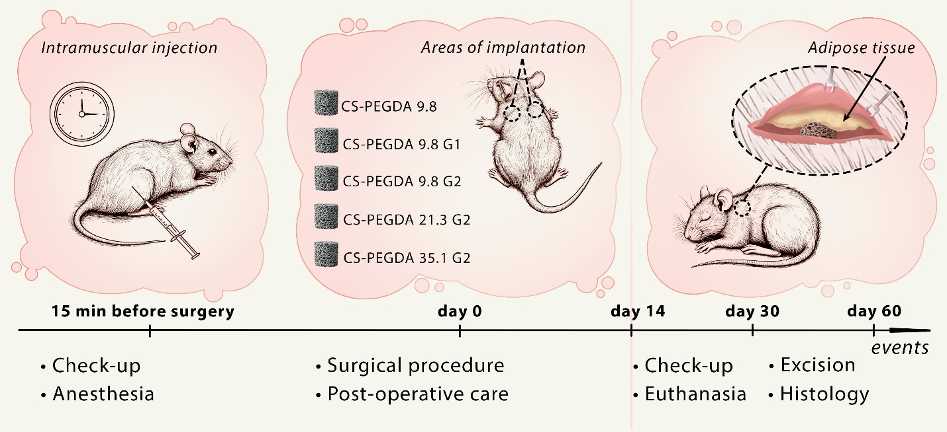
Figure S1. Experimental design of subcutaneous implantation in rats.

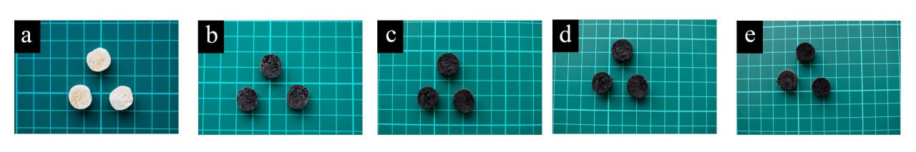
Figure S2. Macrophotographs of porous chitosan-based scaffolds crosslinked with PEGDA: (a) CS-PEGDA 9.8, (b) CS-PEGDA 9.8 G1, (c) CS-PEGDA 9.8 G2, (d) CS-PEGDA 21.3 G2, (e) CS-PEGDA 35.1 G2.

Table S1. Criteria for semi-quantitative evaluations of morphological parameters of skin samples with implanted material according to a five-point scale
Parameter | Evaluation criteria | Grade
Inflammatory reaction in the dermis (infiltration of lymphocytes, macrophages, neutrophils) | Absent | 0
 | Single immune cells | 1
 | Several clusters of immune cells | 2
 | Multiple clusters of immune cells | 3
 | Significant diffuse infiltration of immune cells | 4
Exudative inflammation in the implant (neutrophil infiltration) | Absent | 0
 | Single neutrophils on the implant surface | 1
 | Individual small clusters of neutrophils in the pores of the implant, occupying ~ 1/3 of the implant area | 2
 | Numerous clusters of neutrophils in the pores of the implant, occupying ~ 1/2 of the implant area | 3
 | All pores of the implant are filled with neutrophilic detritus and fibrin | 4
Infiltration of the implant by macrophages and giant multinucleated cells | Absent | 0
 | Single immune cells | 1
 | Several clusters of immune cells | 2
 | Multiple clusters of immune cells | 3
 | Significant diffuse infiltration by immune cells | 4
Implant resorption | Absent | 0
Implant resorption | Single fibers of the implant material are loosened and undergo cellular resorption | 1
Implant resorption | Several clusters of resorptions of the implant material along the periphery | 2
Implant resorption | Multiple clusters of resorptions of the material over the entire area of ​​the implant | 3
Implant resorption | Significant resorptions of the entire implant material | 4
Implant ingrowth by connective tissue | Absent | 0
Implant ingrowth by connective tissue | Single strands of connective tissue penetrating the surface layer of the implant | 1
Implant ingrowth by connective tissue | Few strands of connective tissue penetrating 1/3 of the implant thickness | 2
Implant ingrowth by connective tissue | Numerous strands of connective tissue penetrating 1/2 of the implant thickness | 3
Implant ingrowth by connective tissue | Numerous strands of connective tissue penetrating the entire implant | 4
Connective tissue capsule around the implant | Absent | 0
Connective tissue capsule around the implant | Very thin (10-50 µm) with minimal inflammatory infiltration and vascularization | 1
Connective tissue capsule around the implant | Thin (50-200 µm) with weak inflammatory infiltration and vascularization | 2
Connective tissue capsule around the implant | Fairly thick (200-400 µm) with moderate inflammatory infiltration and vascularization | 3
Connective tissue capsule around the implant | Significant thickness (more than 400 µm) with pronounced inflammatory infiltration and vascularization | 4

