Supporting Information
Microbial-geochemical interactions in underground reservoirs: Implications for hydrogen storage
Laura Fablet¹*, Arnaud Belcour^{2,3}*, Sylvain Stephant¹, Caroline Michel¹, Delphine Ropers^{2,3}, Katerina Cerna⁵, Petra Bombach⁶, Jakub Riha⁵, Joachim Tremosa⁷, Biwen Annie An-Stepec⁴, Kristyna Fadrhonc⁵, Nicole Dopffel⁴, Setareh Rad¹
* These authors contributed equally to this work.
¹ BRGM, 3 Avenue Claude Guillemin, 45060 Orléans Cedex 2, France
² Univ. Grenoble Alpes, Inria, 38000 Grenoble, France
³ Université Grenoble Alpes, CNRS, LIPhy, Grenoble, France
⁴ NORCE Research AS, Nygardsgaten 112, 5008 Bergen, Norway
⁵Technical University of Liberec, Institute for Nanomaterials, Advanced Technologies and Innovation, Bendlova 7, Liberec, Czechia
⁶ Isodetect GmbH, Deutscher Platz 5b, 04103 Leipzig, Germany
⁷ Geostock, 2 rue des Martinets, 92500 Rueil-Malmaison, France

Methods S1: Extented statistical analysis
All analyses were performed in R version 4.4.2.
- Replicate similarity
To assess the similarity between sequenced sample replicates, Bray-Curtis dissimilarities were calculated between all pairs of replicates, using the vegdist function of “vegan” package.¹ The distribution of intra-sample Bray-Curtis distances (distances between replicates of the same sample) was then compared to the distribution of inter-sample Bray-Curtis distances (distances between replicates of different samples) using a Wilcoxon rank-sum test (wilcox.test()).² This allows testing whether replicates are significantly more similar to each other than to different samples. In addition, a non-metric multidimensional scaling (NMDS: metaMDS() function of the “vegan” package)³ ordination was performed on the Bray-Curtis distance matrix.
- Chemical clustering and analyses
The sampled sites were clustered according to their chemical composition using k-means algorithm. The number of clusters was determined by two methods: the sum of squared errors (Elbow method) and the silhouette measure,⁴ using the fviz_nbclust() function from the “factoextra” package.⁵ While the Elbow method suggested an optimal partition into three clusters, the silhouette method indicated a slightly higher optimal number of four clusters (Fig. S1). The average silhouette width was also higher for four cluster (0.405) than for three clusters (0.370), supporting the use of four cluster. Since the silhouette method is more sensitive to fine substructures, it was decided to set the number of clusters to four, allowing for a more consistent hydrochemical classification with clear geochemical signatures. To better understand the chemical differences between the identified clusters, a Principal Component Analysis (PCA)⁶ was performed on the chemical dataset. PCA allows the visualization of the distribution of samples in a reduced-dimensional space, highlighting patterns and similarities among them. In addition, to provide a more intuitive comparison of the average chemical composition of each cluster, a radar chart was constructed using “fmsb” package. The Shapiro test was used to determine the normality of the data.⁷ Kruskal-Wallis test was used to examine differences in chemistry between clusters.⁸
- Microbial community analyses
To study the microbial communities of the sites, a NMDS analysis was performed using a dissimilarity matrix calculated using the Bray-Curtis distance on the average abundances per site and microbial genus. The obtained stress was 0.22, indicating an ordination with moderate quality. Unsupervised clustering using k-means method was then performed on the sample coordinates obtained by NMDS analysis. The optimal number of clusters (k = 3) was determined using both the Elbow method and mean silhouette method (Fig. S2). Controls were treated separately and assigned to a fourth group for visualization purposes only. To assess whether microbial community compositions significantly differed between the identified clusters, a PERMANOVA test (adonis2 function, “vegan” package) was initially considered.⁹ However, the assumption of homogeneity of multivariate dispersion among groups, assessed using the betasiper() function followed by a permutation test (permute()) was not met (p < 0.05). Given this violation, a non-parametric ANOSIM (Analysis of Similarities) was used instead, as it is less sensitive to dispersion differences.¹⁰ A Venn diagram was used to compare the number of bacterial and archaeal genus in each cluster, using the “ggven” package.¹¹ The alpha diversity of microbial communities was assessed for each cluster using three indices: specific richness, Shannon index, and Simpson index, using the diversity function of the “vegan” package.^{12,13} The calculated alpha-diversity parameters of clusters were computed together using a Kruskal-Wallis test, fllowed by a Dunn’s test to identify the different clusters.¹⁴
- Determination of dominant and indicator genera
The “dominant” genera correspond to those with the highest relative abundance in the communities studies. They reflect the most represented tawa in terms of numbers.The dominant genera per cluster were identified taking into account the ten most abundant species, separating bacteria and archaea. To do this, the sum of the abundances of each genus was calculated per cluster to identify the most reprsentative genera in terms of total contribution in each cluster. The “indicator” genera are specific to a given environment. Their indication is qualitative and statistical. Indicator genera are detected using an Indicator value analysis, which combines their fidelity (frequency of presence in a given cluster) and specificity (presence mainly in this cluster rather than others). Indicator genera are not necessarily dominant in abundance, but are characterized by their preferential presence in an environment. Indicator genus for both domains, bacteria and archaea, were identified using the multipatt() function in the “indicspecies” package was used to tun the analysis with 999 permutations. Significant results were estimated with p-value < 0.01.^{15,16}
- Correlation and ordination analyses between chemistry and microbiology
To explore the relationships between archeal and bacterial abundance and the physico-chemical parameters of each cluster, indicator and dominant archeal and bacterial genus were grouped according to their putative ecological characteristics, based on their trophic and ecophysiological modes known from the litterature (Table S3). Concerning archaea, the genera were distributed into five categories:
- Non-methanogenic halophiles: Archaeal genera thrive in high-salinity (halophiles) but do not produce methane.^{17,18}
- Halophilic methanogens: Archaeal genera that require salinity conditions for their growth and are capable of producing methane (methanogenesis) under anaerobic conditions.^{17,19}
- Non-halophilic methanogens: Archaeal genera that produce methan but do not require high salinity for growth.^{20,21}
- Specialised methanogens: Archaeal genera that produce methan under specific metabolic or environmental conditions, often relying on syntrophic relationships or restricted substrates, such as methylotrophic methanogenesis.^{22–24}
- Other extremophiles: Archaeal genera that thrive in extreme environmental conditions, such as high temperatures or acidity, but do not fall under the categories of halophiles and/or methanogens.^{25,26}
For bacteria, the genera were divided into the following categories:
- Generalists: Bacteria with a broad metabolic range allowing them to degrade various organic substrates, resist environmental variations and colonize various habitats.^{27–31}
- Halophiles: Bacteria requiring or tolerating high concentrations of salt for their growth, often participating in the degradation of organic matter in these hypersaline environments.^{32–36}
- Fermenters: Bacteria that carry out the fermentation of organic compound into organic acids, gases and alcohols, contributing to the degradation of organic matter under anaerobic conditions.^{37–41}
- Thermophiles: Bacteria adapted to high temperatures (> 45°C), which participate in the degradation of organic matter and specific biogeochemical cycles.^{42–45}
- Sulfate-reducing bacteria: Bacteria capable of respiring sulfate as an electron acceptor under anaerobic conditions, producing hydrogen sulfide.^{46–48}
- Methanogenic syntrophs: Bacteria capable of degrading complex subtrates in partnership with methanogenic archaea, providing necessary elements for methanogenesis.^{49,50}
- Plantomycetes: Bacteria belonging to the Planctomycetota phylum, which participate in the nitrogen cycle and in the degradation of organic matter.^{51,52}
- Human-associated bacteria: Bacteria indicating human-associated microbial signature (human commensal microbiota, opportunistic pathogens, intracellular pathogens). ^{53–58}
Ambiguous cases were classified as “undetermined” when no dominant function could be identified. Spearman correlation tests were used between these ecological groups and environmental parameters,⁵⁹ except for the “Undetermined” bacterial group. As this group consists of a heterogenerous mixture of taxa, correlation tests would not provide interpretable information and were therefore excluded from statistical analyses.
Canonical Correspondence Analysis (CCA) was also performed of two datasets: (i) testing the parameters Na⁺, Cl⁻, SO₄²⁻, K⁺, Fe_{total}, pH, salinity and temperature on all nineteen sites, (ii) testing the parameters Na⁺, Cl⁻, SO₄²⁻, K⁺, Fe_{total}, Mg²⁺, Ca²⁺, pH, salinity, temperature, TIC and DOC at fourteen sites (deletion of SC1, PR1, SC6, SC7 and SC8). CCA was performed using cca() function in the “vegan” package.⁶⁰
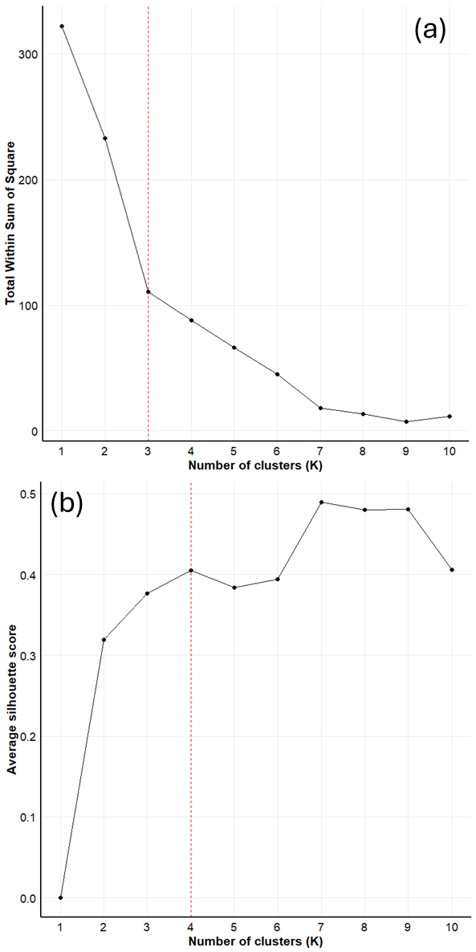
Fig. S1 Determination of the optimal number of clusters from chemical data with (a) the sum of squared errors method and (b) the silhouette method. The red dotted line indicates the optimal cluster number for each method.

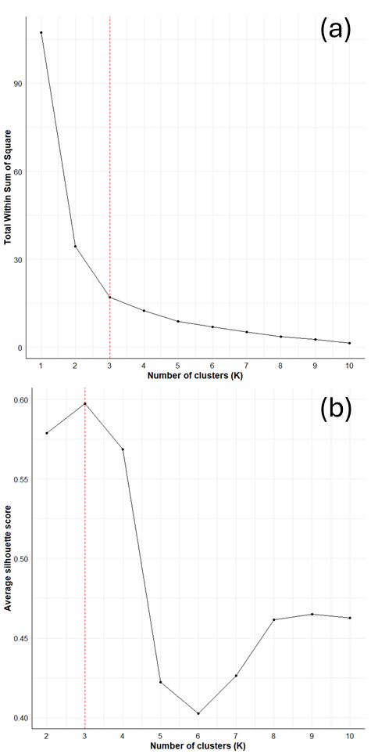
Fig. S2 Determination of the optimal number of clusters from microbiological data with (a) the sum of squared errors method and (b) the silhouette method. The red dotted line indicates the optimal cluster number for each method.

Table S1 Ecological characteristics of dominant and indicators archaeal and bacterial genera. Indicator genera are noted with a red star before the genus name. Archaeal genera are divided into five categories: non-methanogenic halophiles, ^{17,18}, halophilic methanogens.^{17,19}, non-halophilic methanogens, ^{20,21}, specialised methanogens, ^{22–24} and other extremophiles.^{25,26} Bacterial genera are divided into seven categories: generalists,^{27–31} halophiles,^{32–36}, fermenters,^{37–41} thermophiles,^{42–45} sulfate-reducing bacteria,^{46–48} methanogenic syntrophs,^{49,50} plantomycetes,^{51,52} and human-associated bacteria.^{53–58}
Genus | Phylum | Ecological characteristic
Archaea
* Candidatus Haloredivivus | Nanohaloarchaeota | Non-methanogenic halophiles
Candidatus Methanomethylicus | Thermoproteota | Specialised methanogens
Candidatus Methanoplasma | Thermoplasmatota | Specialised methanogens
Halanaeroarchaeum | Halobacteriota | Non-methanogenic halophiles
* Halarchaeum | Halobacteriota | Non-methanogenic halophiles
* Haloarcula | Halobacteriota | Non-methanogenic halophiles
Halobaculum | Halobacteriota | Non-methanogenic halophiles
Halobellus | Halobacteriota | Non-methanogenic halophiles
* Halolamina | Halobacteriota | Non-methanogenic halophiles
* Halomicrobium | Halobacteriota | Non-methanogenic halophiles
Haloparvum | Halobacteriota | Non-methanogenic halophiles
Halopenitus | Halobacteriota | Non-methanogenic halophiles
* Haloplanus | Halobacteriota | Non-methanogenic halophiles
Incertae Sedis | Halobacteriota | Other extremophiles
Incertae Sedis | Iainarchaeota | Other extremophiles
* Incertae Sedis | Nanoarchaeota | Other extremophiles
Incertae Sedis | Nanohaloarchaeota | Non-methanogenic halophiles
Incertae Sedis | Thermoplasmatota | Other extremophiles
Incertae Sedis | Thermoproteota | Other extremophiles
* Methanobacterium | Methanobacteriota | Non-halophilic methanogens
* Methanocalculus | Halobacteriota | Non-halophilic methanogens
Methanohalobium | Halobacteriota | Halophilic methanogens
Methanolobus | Halobacteriota | Halophilic methanogens
Methanomassiliicoccus | Thermoplasmatota | Specialised methanogens
Methanomethylovorans | Halobacteriota | Halophilic methanogens
* Methanothermobacter | Methanobacteriota | Non-halophilic methanogens
* Methanothrix | Halobacteriota | Non-halophilic methanogens
* Natronomonas | Halobacteriota | Non-methanogenic halophiles
* Unidentified | Halobacteriota | Non-methanogenic halophiles
Bacteria
* Acetomicrobium | Synergistota | Methanogenic syntrophy
Aeromonas | Pseudomonadota | Generalists
Aliifodinibius | Balneolota | Generalists
* Arhodomonas | Pseudomonadota | Generalists
Blastopirellula | Planctomycetota | Planctomycetes
Burkholderia-Caballeronia-Paraburkholderia | Pseudomonadota | Generalists
* Candidatus Caldatribacterium | Atribacterota | Fermenters
* Candidatus Finniella | Pseudomonadota | Fermenters
Coprothermobacter | Coprothermobacterota | Thermophiles
* Coxiella | Pseudomonadota | Human-associated bacteria
* CSP1-2 | Dadabacteria | Generalists
Curvibacter | Pseudomonadota | Generalists
Cutibacterium | Actinomycetota | Human-associated bacteria
* Desulfitibacter | Bacillota | Sulfate-reducing bacteria
Desulfoscipio | Bacillota | Sulfate-reducing bacteria^{46–48}
Dolosigranulum | Bacillota | Human-associated bacteria
Dyella | Pseudomonadota | Generalists
Escherichia-Shigella | Pseudomonadota | Human-associated bacteria
* Gelria | Bacillota | Thermophiles
Geosporobacter | Bacillota | Generalists
* Glycocaulis | Pseudomonadota | Generalists
Halobacillus | Bacillota | Halophiles
Halomonas | Pseudomonadota | Halophiles
* hgcI clade | Actinomycetota | Generalists
Hoppeia | Bacteroidota | Generalists
Hydrogenophilus | Pseudomonadota | Generalists
* Incertae Sedis | Bacillota | Undetermined
* Incertae Sedis Candidatus | Eremiobacterota | Fermenters
* Incertae Sedis | Chlamydiota | Undetermined
* Incertae Sedis | Dependentiae | Undetermined
* JGI-0000079-D21 | Synergistota | Generalists
* LD29 | Verrucomicrobiota | Generalists
* Legionella | Pseudomonadota | Human-associated bacteria
Marinilabilia | Bacteroidota | Generalists
* ML310M-34 | Balneolota | Generalists
Moheibacter | Bacteroidota | Generalists
Moorella | Bacillota | Thermophiles
* Mycobacterium | Actinomycetota | Human-associated bacteria
Noviherbaspirillum | Pseudomonadota | Generalists
Oleidesulfovibrio | Thermodesulfobacteriota | Sulfate-reducing bacteria
* Owenweeksia | Bacteroidota | Generalists
Pelagibacterium | Pseudomonadota | Generalists
* Petrotoga | Thermotogota | Thermophiles
* Pirellula | Planctomycetota | Planctomycetes
Proteiniphilum | Bacteroidota | Fermenters
Pseudothermotoga | Thermotogota | Thermophiles
Ralstonia | Pseudomonadota | Generalists
* Rhodohalobacter | Balneolota | Halophiles
* Salibacter | Bacteroidota | Generalists
Salinarimonas | Pseudomonadota | Halophiles
Sporomusa | Bacillota | Fermenters
Sporosalibacterium | Bacillota | Fermenters
Staphylococcus | Bacillota | Human-associated bacteria
Streptococcus | Bacillota | Human-associated bacteria
Sumerlaea | Sumerlaeota | Generalists
Syntrophus | Thermodesulfobacteriota | Syntrophic methanogens
Tangfeifania | Bacteroidota | Generalists
* Thermodesulfovibrio | Nitrospirota | Sulfate-reducing bacteria
* Thermovirga | Synergistota | Thermophiles
* Truepera | Deinococcota | Generalists
* Unidentified | Bacteroidota | Undetermined
Unidentified | Balneolota | Undetermined
Unidentified | Patescibacteria | Undetermined
* Urania-1B-19 marine sediment group | Planctomycetota | Planctomycetes
Variovorax | Pseudomonadota | Generalists
* Wenzhouxiangella | Pseudomonadota | Generalists

Table S2 Physico-chemical parameters of groundwater samples provinding of porous reservoirs (PR) and salt caverns (SC) (n.a. = not-analyzed).
Parameters | PR1 | PR2 | PR3 | PR4 | PR5 | PR6 | PR7 | PR8 | PR9 | PR10 | PR11
SO₄ (mg/L) | 0.48 | 1035 | 12 | <5 | 2970 | 50 | <0.5 | <0.5 | 3 | 5.8 | 0.1
Cl (mg/L) | 13230 | 6130 | 6000 | 9212 | 13750 | 1020 | 110000 | 40 | 10100 | 55803 | 549000
PO₄ (mg/L) | <0.1 | 0 | 0.1 | 1.8 | 47.5 | 0.3 | <0.01 | <0.01 | 0.1 | n.a | 0.1
NO₃ (mg/L) | <0.1 | 0 | 6 | <5 | 5 | 10 | 630 | <0.01 | 0.1 | n.a | 0.1
NO₂ (mg/L) | <0.1 | 0 | 15.1 | 0.2 | 14.5 | 5.7 | <0.02 | <0.01 | 0.1 | n.a | 0.1
S₂ (mg/L) | n.a | <1 | <1 | 0.2 | 13.7 | 0.1 | <0.05 | <0.05 | n.a | 0 | 0
Na (mg/L) | 6565 | 4610 | 3550 | 6474 | 3650 | 996 | 21300 | 1.59 | 6075 | 25300 | 25300
Ca (mg/L) | n.a | 830 | 123 | <50 | 48 | 14.3 | 42500 | 12.9 | 287.5 | 3919 | 3725
Mg (mg/L) | n.a | 160 | 200 | <50 | 11.4 | 4.8 | 86.2 | 0.3 | 175 | 1535 | 1515
Mn (mg/L) | n.a | n.a | n.a | 0.02 | n.a | 0.26 | 48 | 0.07 | n.a | n.a | n.a
K (mg/L) | 700 | 115 | 1465 | 410 | 52200 | 11.3 | 1730 | 1.87 | 132.5 | 412 | 402
NH₄ (mg/L) | <0.1 | n.a | n.a | 66.4 | n.a | 6.9 | 1.71 | 4.9 | n.a | n.a | n.a
Fe (mg/L) | 35.9 | 1.3 | 19.5 | 73.2 | 10.75 | 7.25 | 11.2 | 0.45 | 0.9 | 25 | 31
HCO₃ (mg/L) | n.a | 164.9 | 1166 | 2452 | 25945 | 1172 | 2.8 | 7.9 | 191.4 | 22.9 | 5
CO₃ (mg/L) | n.a | 0.6 | 2.52 | 18.43 | 9882 | 17.06 | 0.001 | 0.011 | 0.65 | 0.01 | 0.002
TIC (mg/L) | n.a | 38.7 | 272.6 | 563 | 7212 | 244 | 2.1 | 1.7 | 44.4 | 8.9 | 2.2
DOC (mg/L) | n.a | 598 | 445.6 | 127 | 2088.9 | 20 | 22.8 | 12.9 | 96.2 | 40.7 | 469.3
pH | 8.1 | 7.4 | 7.2 | 7.7 | 9.2 | 8.2 | 5.9 | 7.4 | 7.4 | 6.3 | 6.1
Eh (mV) | n.a | 232 | -15 | -57 | -300 | -172 | n.a | n.a | -108 | n.a | n.a
Salinity (g/L) | 20.53 | 13 | 11.71 | 16.86 | 79.94 | 2.39 | 176.31 | 0.06 | 10.83 | 87 | 85.87
Temperature (°C) | 13.3 | 90 | 49 | 47 | 44 | 41 | 46 | 150 | 39 | 61.5 | 61.5
Parameters | SC1 | SC2 | SC3 | SC4 | SC5 | SC6 | SC7 | SC8
SO₄ (mg/L) | 4644 | 3891 | 3990 | 3590 | 11200 | 5200 | 4550 | 4650
Cl (mg/L) | 197303 | 184564 | 182379 | 196500 | 244000 | 194000 | 188000 | 184000
PO₄ (mg/L) | <1 | <0.1 | <0.1 | <0.04 | <0.04 | <250 | <250 | <250
NO₃ (mg/L) | n.a | <50 | <50 | <250 | <250 | <250 | <250 | <250
NO₂ (mg/L) | n.a | <0.01 | <0.01 | <250 | <250 | <250 | <250 | <250
S₂ (mg/L) | <1 | <0.1 | <0.1 | <0.05 | <0.05 | n.a | n.a | n.a
Na (mg/L) | 129313 | 116190 | 114326 | 114000 | 146000 | 109000 | 114000 | 114000
Ca (mg/L) | n.a | 1522 | 1499 | 1870 | 1540 | 26.1 | 20.2 | 114
Mg (mg/L) | n.a | 489 | 448 | 1305 | 383 | 3.3 | 2 | 2.5
Mn (mg/L) | n.a | 0.11 | 0.13 | 3.54 | 0.18 | 0.31 | 0.2 | 0.23
K (mg/L) | 42.5 | 662 | 646 | 1220 | 1260 | 66.8 | 105 | 76.6
NH₄ (mg/L) | <1 | 3.2 | 2.4 | 8.5 | 2.1 | 8.1 | 118 | 6.3
Fe (mg/L) | 0.35 | 0 | <20 | 8.58 | 3.04 | 1.27 | 0.67 | 0.85
HCO₃ (mg/L) | 159.4 | 16.7 | 11.3 | 63.5 | 12.7 | n.a | n.a | n.a
CO₃ (mg/L) | 0.19 | 0.03 | 0 | 0.13 | 0.02 | n.a | n.a | n.a
TIC (mg/L) | 147 | 12.6 | 16 | 49 | 19 | n.a | n.a | n.a
DOC (mg/L) | n.a | 0.9 | 0.8 | 4.6 | 12.8 | n.a | n.a | n.a
pH | 6.6 | 6.8 | 5.1 | 6.8 | 6.7 | 11.4 | 11.5 | 11.4
Eh (mV) | n.a | 246 | 26 | 264 | -90 | n.a | n.a | n.a
Salinity (g/L) | 331.45 | 307.48 | 303.45 | 318.91 | 404.41 | 308.31 | 306.8 | 302.85
Temperature (°C) | 48 | 18 | 18 | 14.96 | 21 | 30 | 30 | 30

Table S3 Heatmap showing the strength of the correlation between physicochemical parameters and principal component (PC) axis. Significant variables (p < 0.05) are shown in bold. The color varies from red to green depending on the intensity of the correlation strength.
Physicochemical parameters | PC1 | PC2
SO₄ | 0.02 | 0.83
Cl | 0.2 | 0.72
PO₄ | 0.97 | 0.03
S₂ | 0.96 | 0.03
Na | 0.2 | 0.75
Ca | 0.01 | 0.04
Mg | 0.05 | 0.01
Mn | 0.04 | 0.05
K | 0.92 | 0.05
NH₄ | 0.89 | 0.03
Fe | 0.01 | 0.26
HCO₃ | 0.96 | 0.03
CO₃ | 0.95 | 0.03
TIC | 0.96 | 0.03
DOC | 0.86 | 0.02
pH | 0.02 | 0.15
Salinity | 0.14 | 0.78
Eh | 0.07 | 0.12
Temperature | 0.01 | 0.03

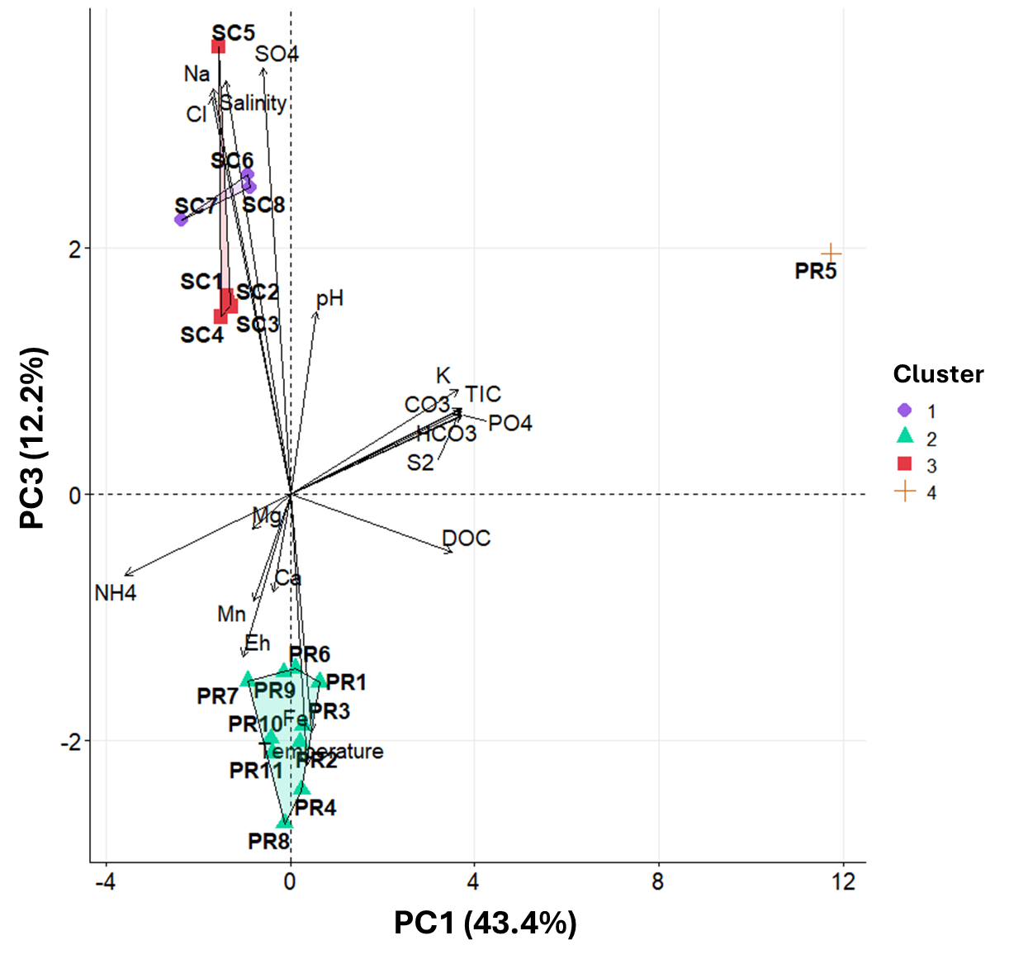Fig. S3 Principal Component Analyses (PCA) biplot of groundwater samples based on their chemical composition and regrouped in four clusters. The principal components 1 and 3, (PC1 and PC3), explain 43.4% and 12.2% of the total variance, respectively. Arrows indicate the direction and strength of each chemical variable contribution to the principal components. Cluster 1 is represented by purple circles, Cluster 2 by green triangles, Cluster 3 by red squares and Cluster 4 by orange cross.

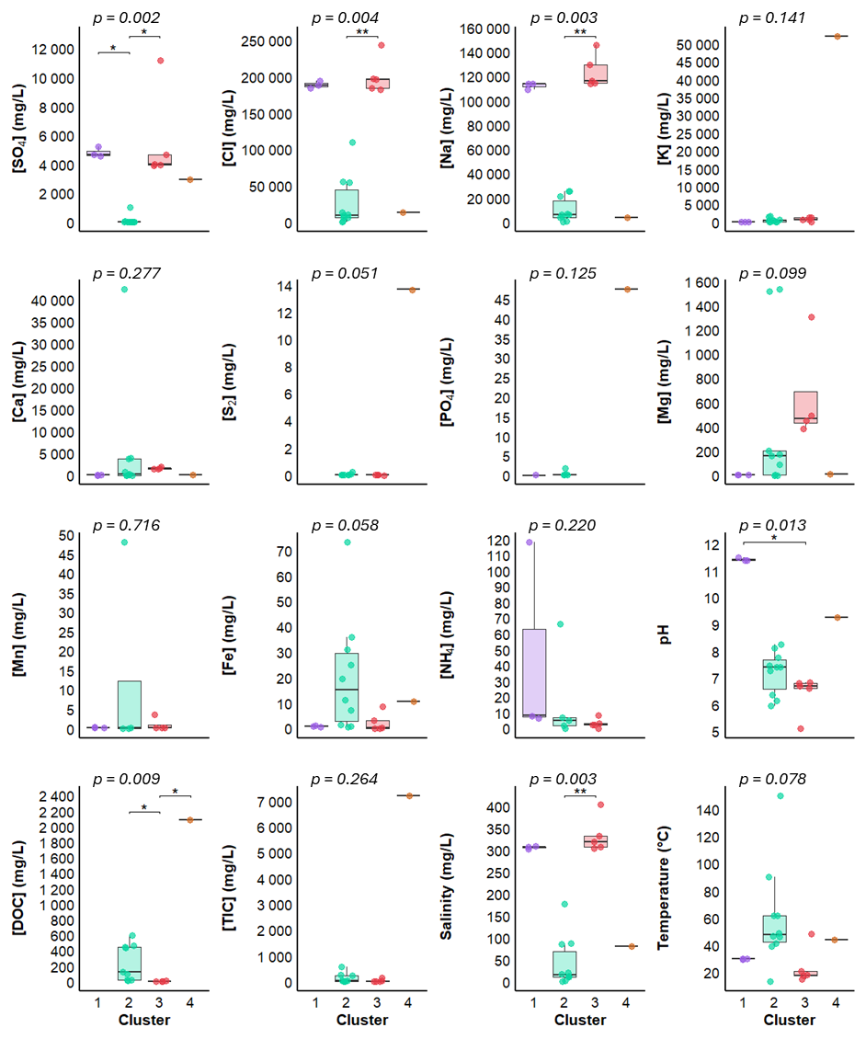
Fig. S4 Boxplots of the average concentrations of physico-chemical parameters by cluster. The p-value (p) obtained for the Kruskal-Wallis tests is indicated for each parameter. Significance stars displayed when the p-value is less than 0.05 represent significant differences between two groups according to Dunn’s test. It should be noted that small sample sizes in some clusters may reduce the sensitivity of Dunn’s test.

Text S1 Reproducibility of microbial sample replicates
The sequenced samples and the number of replicates per sample are shown in Table S5. In order to verify the similarity of microbial composition between replicates of the same sample, Bray-Curtis distances were calculated between replicates (Table S5). Intra-sample distances (between replicates of the same samples) are significantly smaller than inter-sample distances (between replicates of different samples), as determined by a Wilcoxon test (p < 0.001). Replicates are represented spatially in Fig. S5. The proximity of replicates for the same sample in ordered space strongly suggests the stability of their microbial composition, but also confirms that all steps of protocol are reproducible from sampling to DNA extraction. This confirms the consistency of the replicates and justifies their grouping by averaging in subsequent analysis.

Table S4 Replicates of each samples for sequencing with Bray-Curtis distance calculated between replicates. SC = Salt cavern and PR = Porous reservoir.
Sample | Replicate 1 | Replicate 2 | Bray-Curtis distance
PR1 | PR1.1 | PR1.2 | 0.353
PR2 | PR2
PR3 | PR3.1 | PR3.2 | 0.149
PR4 | PR4.1 | PR4.2 | 0.0717
PR5 | PR5.1 | PR5.2 | 0.0843
PR6 | PR6.1 | PR6.2 | 0.07
PR7 | PR7.1 | PR7.2 | 0.0471
PR8 | PR8.1 | PR8.2 | 0.0887
PR9 | PR9.1 | PR9.2 | 0.317
PR10 | PR10.1 | PR10.2 | 0.0647
PR11 | PR11.1 | PR11.2 | 0.053
SC1 | SC1
SC2 | SC2
SC3 | SC3
SC4 | SC4
SC5 | SC5.1 | SC5.2 | 0.0568
SC6 | SC6.1 | SC6.2 | 0.0503
SC7 | SC7.1 | SC7.2 | 0.208
SC8 | SC8.1 | SC8.2 | 0.113

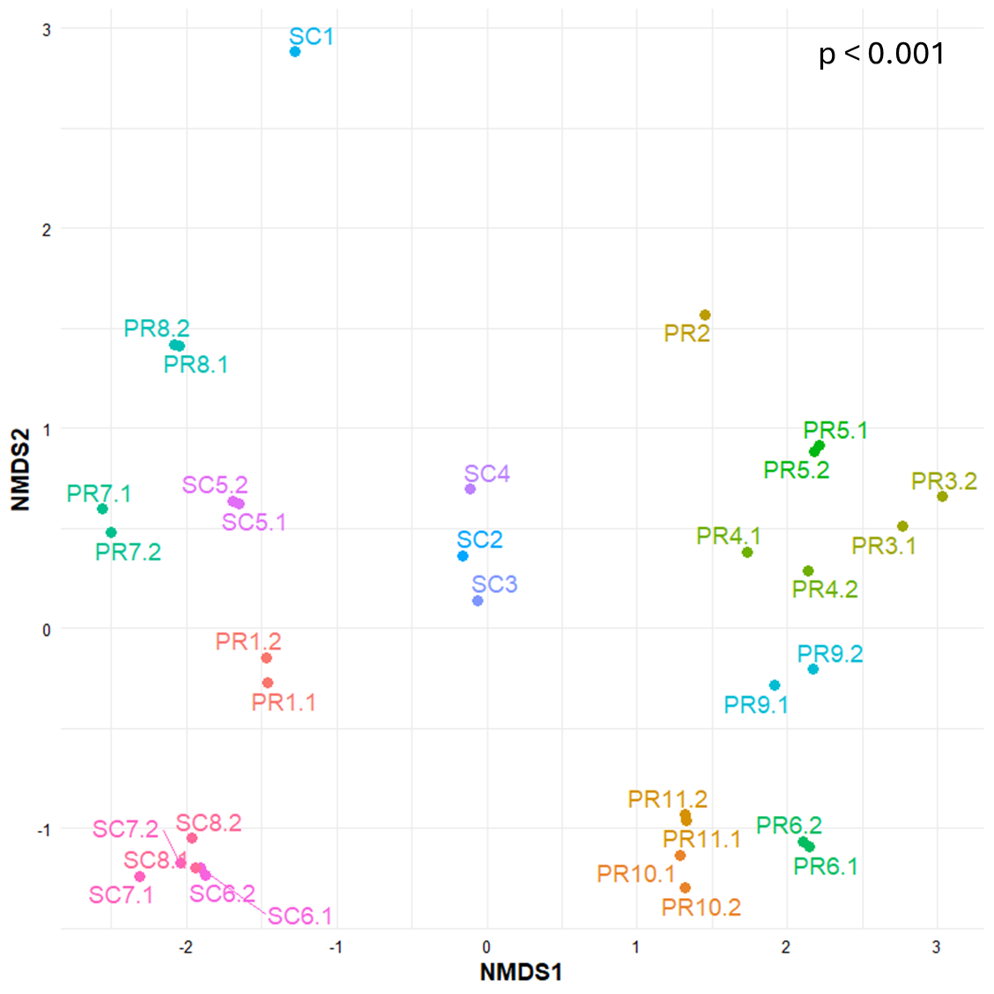
Fig. S5 Non-metric multidimensional scaling (NMDS) plot showing the spatial distribution of each replicate, according to the calculated Calculated Bray-Curtis distance between replicates of Bacteria and Archaea sequencing data. A significant difference between groups was observed (Wilcoxon test, p < 0.001).

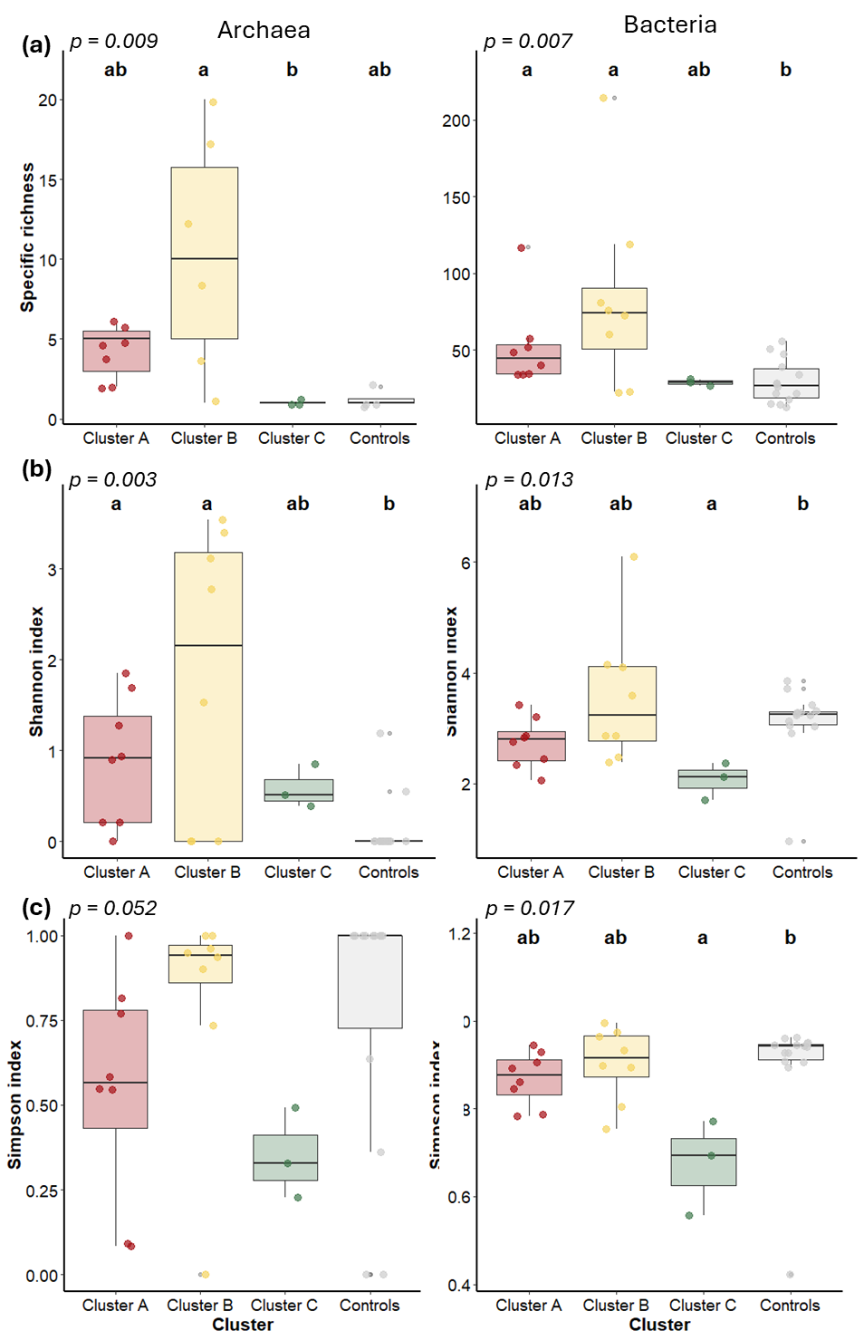
Fig. S6 Alpha diversity indices: (a) specific richness, (b) Shannon index and (c) Simpson index, of clusters and controls for archaea and bacteria. P values are from Kruskal-Wallis test. Letters were assigned according to Dunn’s test.
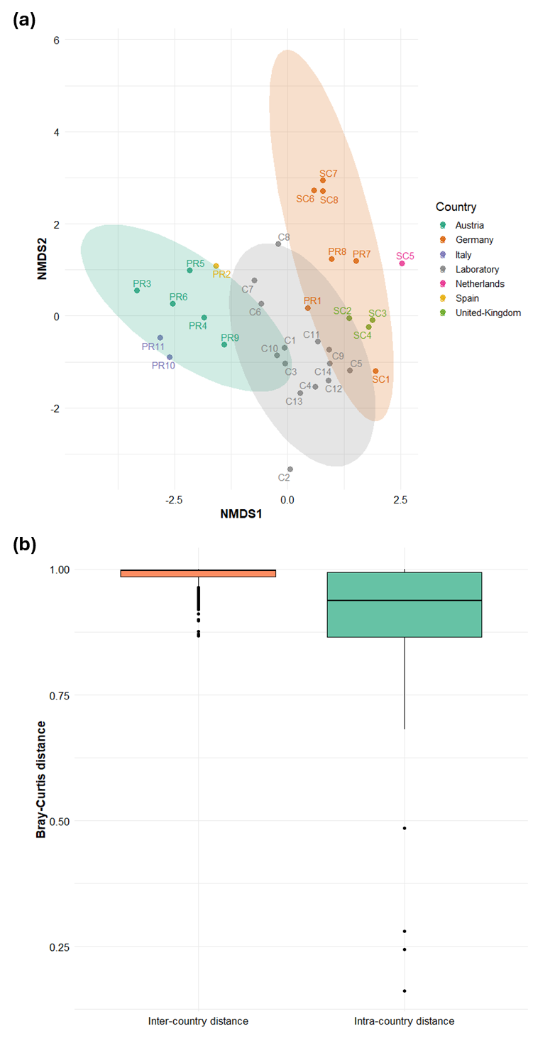
Fig. S7 (a) Non-metric multidimensional scaling (NMDS) plot showing microbial community for each site coloring by country. (b) Distribution of Bray-Curtis distances showing the similarity of microbial communities within countries (“Intra-country distance”) and between different country (“Inter-country distance”). A significant difference between groups was observed (Wilcoxon test, p < 0.001).

Table S5 Genera identified as potential contaminant using the decontam prevalence method, with their presence/absence in samples
Identified contaminants |  | Number of contaminated sites | Site concerned
Genus | Phylum | Number of contaminated sites | Site concerned
Atopostipes | Bacillota | 0
Blastocatella | Acidobacteriota | 0
Brevibacterium | Actinomycetota | 0
Dolosigranulum | Bacillota | 0
Escherichia-Shigella | Pseudomonadota | 8 | PR1, PR4, PR7, PR8, PR9, PR11, SC2, SC3
Paludibaculum | Acidobacteriota | 0
Pseudoalteromonas | Pseudomonadota | 0
Rhodococcus | Actinomycetota | 0
Rubellimicrobium | Pseudomonadota | 0
Rubrobacter | Actinomycetota | 0
SH-PL14 | Planctomycetota | 0

Table S6 List of the ten most abundant bacterial genera per cluster, which correspond to the dominant genera, with their proportion within each cluster (Cluster A, Cluster B, Cluster C, and Controls). Bold numbers indicate the cluster in which each genus is identified as dominant. The dominant bacterial genera represent 65.7%, 49.9%, 92.5% and 41.0% of the total bacterial genera in Cluster A, B, C, and the Controls, respectively.
Genus | Phylum | Cluster | Proportion (%)
Acetomicrobium | Synergistota | Cluster A | 3.46
Acetomicrobium | Synergistota | Cluster B | 0.00
Acetomicrobium | Synergistota | Cluster C | 0.00
Acetomicrobium | Synergistota | Controls | 0.55
Aeromonas | Pseudomonadota | Cluster A | 0.00
Aeromonas | Pseudomonadota | Cluster B | 0.29
Aeromonas | Pseudomonadota | Cluster C | 0.04
Aeromonas | Pseudomonadota | Controls | 8.98
Aliifodinibius | Balneolota | Cluster A | 0.00
Aliifodinibius | Balneolota | Cluster B | 6.65
Aliifodinibius | Balneolota | Cluster C | 0.00
Aliifodinibius | Balneolota | Controls | 0.13
Arhodomonas | Pseudomonadota | Cluster A | 0.00
Arhodomonas | Pseudomonadota | Cluster B | 0.00
Arhodomonas | Pseudomonadota | Cluster C | 2.32
Arhodomonas | Pseudomonadota | Controls | 0.00
Burkholderia-Caballeronia-Paraburkholderia | Pseudomonadota | Cluster A | 0.00
Burkholderia-Caballeronia-Paraburkholderia | Pseudomonadota | Cluster B | 5.81
Burkholderia-Caballeronia-Paraburkholderia | Pseudomonadota | Cluster C | 0.00
Burkholderia-Caballeronia-Paraburkholderia | Pseudomonadota | Controls | 0.00
Coprothermobacter | Coprothermobacterota | Cluster A | 14.43
Coprothermobacter | Coprothermobacterota | Cluster B | 0.00
Coprothermobacter | Coprothermobacterota | Cluster C | 0.00
Coprothermobacter | Coprothermobacterota | Controls | 0.00
Curvibacter | Pseudomonadota | Cluster A | 0.00
Curvibacter | Pseudomonadota | Cluster B | 2.75
Curvibacter | Pseudomonadota | Cluster C | 0.00
Curvibacter | Pseudomonadota | Controls | 0.00
Cutibacterium | Actinomycetota | Cluster A | 0.00
Cutibacterium | Actinomycetota | Cluster B | 1.00
Cutibacterium | Actinomycetota | Cluster C | 0.00
Cutibacterium | Actinomycetota | Controls | 4.58
Desulfoscipio | Bacillota | Cluster A | 1.97
Desulfoscipio | Bacillota | Cluster B | 0.00
Desulfoscipio | Bacillota | Cluster C | 0.00
Desulfoscipio | Bacillota | Controls | 0.00
Dolosigranulum | Bacillota | Cluster A | 0.00
Dolosigranulum | Bacillota | Cluster B | 0.00
Dolosigranulum | Bacillota | Cluster C | 0.00
Dolosigranulum | Bacillota | Controls | 2.25
Dyella | Pseudomonadota | Cluster A | 0.00
Dyella | Pseudomonadota | Cluster B | 2.91
Dyella | Pseudomonadota | Cluster C | 0.00
Dyella | Pseudomonadota | Controls | 0.00
Escherichia-Shigella | Pseudomonadota | Cluster A | 0.01
Escherichia-Shigella | Pseudomonadota | Cluster B | 0.59
Escherichia-Shigella | Pseudomonadota | Cluster C | 0.00
Escherichia-Shigella | Pseudomonadota | Controls | 3.20
Geosporobacter | Bacillota | Cluster A | 1.37
Geosporobacter | Bacillota | Cluster B | 0.00
Geosporobacter | Bacillota | Cluster C | 0.00
Geosporobacter | Bacillota | Controls | 2.08
Glycocaulis | Pseudomonadota | Cluster A | 0.00
Glycocaulis | Pseudomonadota | Cluster B | 0.00
Glycocaulis | Pseudomonadota | Cluster C | 2.77
Glycocaulis | Pseudomonadota | Controls | 0.00
Halobacillus | Bacillota | Cluster A | 0.00
Halobacillus | Bacillota | Cluster B | 1.81
Halobacillus | Bacillota | Cluster C | 0.00
Halobacillus | Bacillota | Controls | 0.00
Halomonas | Pseudomonadota | Cluster A | 0.01
Halomonas | Pseudomonadota | Cluster B | 0.02
Halomonas | Pseudomonadota | Cluster C | 28.53
Halomonas | Pseudomonadota | Controls | 0.23
Hydrogenophilus | Pseudomonadota | Cluster A | 0.00
Hydrogenophilus | Pseudomonadota | Cluster B | 0.03
Hydrogenophilus | Pseudomonadota | Cluster C | 0.00
Hydrogenophilus | Pseudomonadota | Controls | 5.37
Incertae Sedis | Candidatus_Eremiobacterota | Cluster A | 0.00
Incertae Sedis | Candidatus_Eremiobacterota | Cluster B | 0.00
Incertae Sedis | Candidatus_Eremiobacterota | Cluster C | 2.03
Incertae Sedis | Candidatus_Eremiobacterota | Controls | 0.00
Marinilabilia | Bacteroidota | Cluster A | 2.55
Marinilabilia | Bacteroidota | Cluster B | 0.00
Marinilabilia | Bacteroidota | Cluster C | 0.00
Marinilabilia | Bacteroidota | Controls | 0.00
ML310M-34 | Balneolota | Cluster A | 0.00
ML310M-34 | Balneolota | Cluster B | 0.00
ML310M-34 | Balneolota | Cluster C | 21.19
ML310M-34 | Balneolota | Controls | 0.00
Moheibacter | Bacteroidota | Cluster A | 0.01
Moheibacter | Bacteroidota | Cluster B | 0.01
Moheibacter | Bacteroidota | Cluster C | 0.00
Moheibacter | Bacteroidota | Controls | 4.06
Noviherbaspirillum | Pseudomonadota | Cluster A | 0.00
Noviherbaspirillum | Pseudomonadota | Cluster B | 6.84
Noviherbaspirillum | Pseudomonadota | Cluster C | 0.00
Noviherbaspirillum | Pseudomonadota | Controls | 0.00
Oleidesulfovibrio | Thermodesulfobacteriota | Cluster A | 0.00
Oleidesulfovibrio | Thermodesulfobacteriota | Cluster B | 0.76
Oleidesulfovibrio | Thermodesulfobacteriota | Cluster C | 0.00
Oleidesulfovibrio | Thermodesulfobacteriota | Controls | 5.95
Owenweeksia | Bacteroidota | Cluster A | 0.00
Owenweeksia | Bacteroidota | Cluster B | 0.00
Owenweeksia | Bacteroidota | Cluster C | 1.72
Owenweeksia | Bacteroidota | Controls | 0.00
Petrotoga | Thermotogota | Cluster A | 4.86
Petrotoga | Thermotogota | Cluster B | 0.00
Petrotoga | Thermotogota | Cluster C | 0.00
Petrotoga | Thermotogota | Controls | 0.00
Pseudothermotoga | Thermotogota | Cluster A | 21.95
Pseudothermotoga | Thermotogota | Cluster B | 0.00
Pseudothermotoga | Thermotogota | Cluster C | 0.00
Pseudothermotoga | Thermotogota | Controls | 0.00
Ralstonia | Pseudomonadota | Cluster A | 0.00
Ralstonia | Pseudomonadota | Cluster B | 12.69
Ralstonia | Pseudomonadota | Cluster C | 0.00
Ralstonia | Pseudomonadota | Controls | 0.00
Rhodohalobacter | Balneolota | Cluster A | 0.00
Rhodohalobacter | Balneolota | Cluster B | 0.00
Rhodohalobacter | Balneolota | Cluster C | 9.38
Rhodohalobacter | Balneolota | Controls | 0.00
Salibacter | Bacteroidota | Cluster A | 0.00
Salibacter | Bacteroidota | Cluster B | 0.00
Salibacter | Bacteroidota | Cluster C | 3.20
Salibacter | Bacteroidota | Controls | 0.00
Sporomusa | Bacillota | Cluster A | 0.00
Sporomusa | Bacillota | Cluster B | 3.10
Sporomusa | Bacillota | Cluster C | 0.00
Sporomusa | Bacillota | Controls | 0.00
Sporosalibacterium | Bacillota | Cluster A | 8.24
Sporosalibacterium | Bacillota | Cluster B | 0.00
Sporosalibacterium | Bacillota | Cluster C | 0.00
Sporosalibacterium | Bacillota | Controls | 0.00
Staphylococcus | Bacillota | Cluster A | 0.01
Staphylococcus | Bacillota | Cluster B | 0.11
Staphylococcus | Bacillota | Cluster C | 0.00
Staphylococcus | Bacillota | Controls | 2.24
Streptococcus | Bacillota | Cluster A | 0.04
Streptococcus | Bacillota | Cluster B | 0.91
Streptococcus | Bacillota | Cluster C | 0.00
Streptococcus | Bacillota | Controls | 2.32
Syntrophus | Thermodesulfobacteriota | Cluster A | 2.58
Syntrophus | Thermodesulfobacteriota | Cluster B | 0.01
Syntrophus | Thermodesulfobacteriota | Cluster C | 0.00
Syntrophus | Thermodesulfobacteriota | Controls | 0.03
Tangfeifania | Bacteroidota | Cluster A | 2.34
Tangfeifania | Bacteroidota | Cluster B | 0.00
Tangfeifania | Bacteroidota | Cluster C | 0.00
Tangfeifania | Bacteroidota | Controls | 0.00
Thermovirga | Synergistota | Cluster A | 3.28
Thermovirga | Synergistota | Cluster B | 0.00
Thermovirga | Synergistota | Cluster C | 0.00
Thermovirga | Synergistota | Controls | 0.06
Unidentified | Balneolota | Cluster A | 0.00
Unidentified | Balneolota | Cluster B | 4.08
Unidentified | Balneolota | Cluster C | 0.00
Unidentified | Balneolota | Controls | 0.00
Urania-1B-19 marine sediment group | Planctomycetota | Cluster A | 0.00
Urania-1B-19 marine sediment group | Planctomycetota | Cluster B | 0.00
Urania-1B-19 marine sediment group | Planctomycetota | Cluster C | 2.41
Urania-1B-19 marine sediment group | Planctomycetota | Controls | 0.00
Variovorax | Pseudomonadota | Cluster A | 0.00
Variovorax | Pseudomonadota | Cluster B | 3.24
Variovorax | Pseudomonadota | Cluster C | 0.00
Variovorax | Pseudomonadota | Controls | 0.00
Wenzhouxiangella | Pseudomonadota | Cluster A | 0.00
Wenzhouxiangella | Pseudomonadota | Cluster B | 0.00
Wenzhouxiangella | Pseudomonadota | Cluster C | 18.96
Wenzhouxiangella | Pseudomonadota | Controls | 0.00

Table S7 List of indicator bacterial genera, which correspond to genera specifically associated with particular environmental conditions, for each cluster (A, B, C and Controls), with the associated indicator value. The indicator value corresponds to the probability that a genus is both frequent and faithful to a given group and varies between 0 and 1. Numbers in bold indicate the cluster in which each genus is identified as an indicator. Cluster A has 12 indicator genus, Cluster B has 2, Cluster C has 19 and Controls has 0.
Genus | Phylum | Cluster A | Cluster B | Cluster C | Control
Acetobacterium | Bacillota | 0.72 | 0.14 | 0 | 0
Acetomicrobium | Synergistota | 0.87 | 0 | 0 | 0.14
Arhodomonas | Pseudomonadota | 0 | 0 | 1.00 | 0
Candidatus Caldatribacterium | Atribacterota | 0.79 | 0 | 0 | 0
Candidatus Finniella | Pseudomonadota | 0 | 0.12 | 0.94 | 0
Coxiella | Pseudomonadota | 0 | 0.32 | 0.85 | 0
Desulfitibacter | Bacillota | 0.85 | 0.12 | 0 | 0.07
Gelria | Bacillota | 0.87 | 0 | 0 | 0
Glycocaulis | Pseudomonadota | 0 | 0 | 1.00 | 0
hgcI clade | Actinomycetota | 0 | 0.32 | 0.85 | 0
Incertae Sedis | Bacillota | 0.73 | 0.55 | 0 | 0.10
Incertae Sedis Candidatus | Eremiobacterota | 0 | 0.12 | 0.94 | 0
Incertae Sedis | Chlamydiota | 0.11 | 0.77 | 0 | 0.25
Incertae Sedis | Dependentiae | 0 | 0.75 | 0 | 0.09
JGI-0000079-D21 | Synergistota | 0.79 | 0 | 0 | 0
LD29 | Verrucomicrobiota | 0 | 0 | 1.00 | 0
Legionella | Pseudomonadota | 0 | 0.46 | 0.74 | 0.16
ML310M-34 | Balneolota | 0 | 0 | 1.00 | 0
Moorella | Bacillota | 0.80 | 0.13 | 0 | 0
Mycobacterium | Actinomycetota | 0 | 0.21 | 0.85 | 0.12
Owenweeksia | Bacteroidota | 0 | 0 | 1.00 | 0
Petrotoga | Thermotogota | 0.87 | 0 | 0 | 0
Pirellula | Planctomycetota | 0 | 0 | 0.78 | 0.08
Proteiniphilum | Bacteroidota | 0.79 | 0 | 0 | 0.15
Rhodohalobacter | Balneolota | 0 | 0 | 1.00 | 0
Salibacter | Bacteroidota | 0 | 0 | 1.00 | 0
Thermodesulfovibrio | Nitrospirota | 0.79 | 0 | 0 | 0
Thermovirga | Synergistota | 0.87 | 0 | 0 | 0.14
Truepera | Deinococcota | 0.00 | 0.22 | 0.89 | 0
Unidentified | Bacteroidota | 0.09 | 0.55 | 0.73 | 0
Urania-1B-19 marine sediment group | Planctomycetota | 0 | 0 | 1.00 | 0
Wenzhouxiangella | Pseudomonadota | 0 | 0 | 1.00 | 0

Table S8 List of the ten or less most abundant archaeal genera per cluster, which correspond to the dominant genera, with their proportion within each cluster (Cluster A, Cluster B, Cluster C, and Controls). Bold numbers indicate the cluster in which each genus is identified as dominant. Some genera are dominant genera in multiple cluster. The dominant archael genera represent 99.9%, 88.3%, 100% and 100% of the total bacterial genera in Cluster A, B, C, and the Controls, respectively.
Genera | Phylum | Cluster | Proportion
Incertae Sedis | Halobacteriota | Cluster A | 0.00
Incertae Sedis | Halobacteriota | Cluster B | 1.21
Incertae Sedis | Halobacteriota | Cluster C | 0.00
Incertae Sedis | Halobacteriota | Controls | 0.60
Incertae Sedis | Thermoproteota | Cluster A | 0.00
Incertae Sedis | Thermoproteota | Cluster B | 0.03
Incertae Sedis | Thermoproteota | Cluster C | 0.00
Incertae Sedis | Thermoproteota | Controls | 1.75
Incertae Sedis | Iainarchaeota | Cluster A | 0.00
Incertae Sedis | Iainarchaeota | Cluster B | 0.00
Incertae Sedis | Iainarchaeota | Cluster C | 0.00
Incertae Sedis | Iainarchaeota | Controls | 93.16
Incertae Sedis | Nanoarchaeota | Cluster A | 0.00
Incertae Sedis | Nanoarchaeota | Cluster B | 0.01
Incertae Sedis | Nanoarchaeota | Cluster C | 99.93
Incertae Sedis | Nanoarchaeota | Controls | 0.85
Halobaculum | Halobacteriota | Cluster A | 0.00
Halobaculum | Halobacteriota | Cluster B | 1.66
Halobaculum | Halobacteriota | Cluster C | 0.00
Halobaculum | Halobacteriota | Controls | 0.00
Incertae Sedis | Nanohaloarchaeota | Cluster A | 0.00
Incertae Sedis | Nanohaloarchaeota | Cluster B | 2.12
Incertae Sedis | Nanohaloarchaeota | Cluster C | 0.00
Incertae Sedis | Nanohaloarchaeota | Controls | 0.00
Halobellus | Halobacteriota | Cluster A | 0.00
Halobellus | Halobacteriota | Cluster B | 2.15
Halobellus | Halobacteriota | Cluster C | 0.00
Halobellus | Halobacteriota | Controls | 0.00
Candidatus Haloredivivus | Nanohaloarchaeota | Cluster A | 0.00
Candidatus Haloredivivus | Nanohaloarchaeota | Cluster B | 2.26
Candidatus Haloredivivus | Nanohaloarchaeota | Cluster C | 0.00
Candidatus Haloredivivus | Nanohaloarchaeota | Controls | 0.00
Haloparvum | Halobacteriota | Cluster A | 0.00
Haloparvum | Halobacteriota | Cluster B | 2.96
Haloparvum | Halobacteriota | Cluster C | 0.00
Haloparvum | Halobacteriota | Controls | 0.00
Halanaeroarchaeum | Halobacteriota | Cluster A | 0.00
Halanaeroarchaeum | Halobacteriota | Cluster B | 3.10
Halanaeroarchaeum | Halobacteriota | Cluster C | 0.00
Halanaeroarchaeum | Halobacteriota | Controls | 0.00
Halopenitus | Halobacteriota | Cluster A | 0.00
Halopenitus | Halobacteriota | Cluster B | 3.64
Halopenitus | Halobacteriota | Cluster C | 0.00
Halopenitus | Halobacteriota | Controls | 0.00
Halolamina | Halobacteriota | Cluster A | 0.00
Halolamina | Halobacteriota | Cluster B | 3.98
Halolamina | Halobacteriota | Cluster C | 0.00
Halolamina | Halobacteriota | Controls | 0.00
Halarchaeum | Halobacteriota | Cluster A | 0.00
Halarchaeum | Halobacteriota | Cluster B | 14.84
Halarchaeum | Halobacteriota | Cluster C | 0.00
Halarchaeum | Halobacteriota | Controls | 0.00
Methanohalobium | Halobacteriota | Cluster A | 0.00
Methanohalobium | Halobacteriota | Cluster B | 51.57
Methanohalobium | Halobacteriota | Cluster C | 0.00
Methanohalobium | Halobacteriota | Controls | 0.00
Candidatus Methanomethylicus | Thermoproteota | Cluster A | 0.29
Candidatus Methanomethylicus | Thermoproteota | Cluster B | 0.00
Candidatus Methanomethylicus | Thermoproteota | Cluster C | 0.00
Candidatus Methanomethylicus | Thermoproteota | Controls | 0.00
Incertae Sedis | Thermoplasmatota | Cluster A | 0.86
Incertae Sedis | Thermoplasmatota | Cluster B | 0.01
Incertae Sedis | Thermoplasmatota | Cluster C | 0.00
Incertae Sedis | Thermoplasmatota | Controls | 2.96
Methanomethylovorans | Halobacteriota | Cluster A | 1.18
Methanomethylovorans | Halobacteriota | Cluster B | 0.00
Methanomethylovorans | Halobacteriota | Cluster C | 0.00
Methanomethylovorans | Halobacteriota | Controls | 0.00
Methanocalculus | Halobacteriota | Cluster A | 5.87
Methanocalculus | Halobacteriota | Cluster B | 0.00
Methanocalculus | Halobacteriota | Cluster C | 0.00
Methanocalculus | Halobacteriota | Controls | 0.00
Methanothrix | Halobacteriota | Cluster A | 7.55
Methanothrix | Halobacteriota | Cluster B | 0.00
Methanothrix | Halobacteriota | Cluster C | 0.00
Methanothrix | Halobacteriota | Controls | 0.00
Methanobacterium | Methanobacteriota | Cluster A | 12.04
Methanobacterium | Methanobacteriota | Cluster B | 0.00
Methanobacterium | Methanobacteriota | Cluster C | 0.00
Methanobacterium | Methanobacteriota | Controls | 0.65
Candidatus Methanoplasma | Thermoplasmatota | Cluster A | 13.06
Candidatus Methanoplasma | Thermoplasmatota | Cluster B | 0.00
Candidatus Methanoplasma | Thermoplasmatota | Cluster C | 0.00
Candidatus Methanoplasma | Thermoplasmatota | Controls | 0.00
Methanomassiliicoccus | Thermoplasmatota | Cluster A | 15.14
Methanomassiliicoccus | Thermoplasmatota | Cluster B | 0.00
Methanomassiliicoccus | Thermoplasmatota | Cluster C | 0.00
Methanomassiliicoccus | Thermoplasmatota | Controls | 0.00
Methanothermobacter | Methanobacteriota | Cluster A | 17.28
Methanothermobacter | Methanobacteriota | Cluster B | 0.00
Methanothermobacter | Methanobacteriota | Cluster C | 0.00
Methanothermobacter | Methanobacteriota | Controls | 0.00
Methanolobus | Halobacteriota | Cluster A | 26.63
Methanolobus | Halobacteriota | Cluster B | 0.00
Methanolobus | Halobacteriota | Cluster C | 0.00
Methanolobus | Halobacteriota | Controls | 0.00

Table S9 List of indicator archaael genera, which correspond to genera specifically associated with particular environmental conditions, for each cluster (A, B, C and Controls), with the associated indicator value. The indicator value corresponds to the probability that a genus is both frequent and faithful to a given group and varies between 0 and 1. Numbers in bold indicate the cluster in which each genus is identified as an indicator. Cluster A has 4 indicator genus, Cluster B has 8, Cluster C has 1 and Controls has 0.
Genera | Phylum | Cluster A | Cluster B | Cluster C | Control
Candidatus Haloredivivus | Nanohaloarchaeota | 0.00 | 0.71 | 0.00 | 0.00
Halarchaeum | Halobacteriota | 0.00 | 0.61 | 0.00 | 0.00
Haloarcula | Halobacteriota | 0.00 | 0.61 | 0.00 | 0.00
Halolamina | Halobacteriota | 0.00 | 0.61 | 0.00 | 0.00
Halomicrobium | Halobacteriota | 0.00 | 0.61 | 0.00 | 0.00
Haloplanus | Halobacteriota | 0.00 | 0.61 | 0.00 | 0.00
Incertae Sedis | Nanoarchaeota | 0.00 | 0.11 | 0.89 | 0.00
Methanobacterium | Methanobacteriota | 0.66 | 0.13 | 0.00 | 0.00
Methanocalculus | Halobacteriota | 0.61 | 0.00 | 0.00 | 0.00
Methanothermobacter | Methanobacteriota | 0.71 | 0.00 | 0.00 | 0.00
Methanothrix | Halobacteriota | 0.71 | 0.00 | 0.00 | 0.00
Natronomonas | Halobacteriota | 0.00 | 0.61 | 0.00 | 0.00
Unidentified | Halobacteriota | 0.00 | 0.61 | 0.00 | 0.00

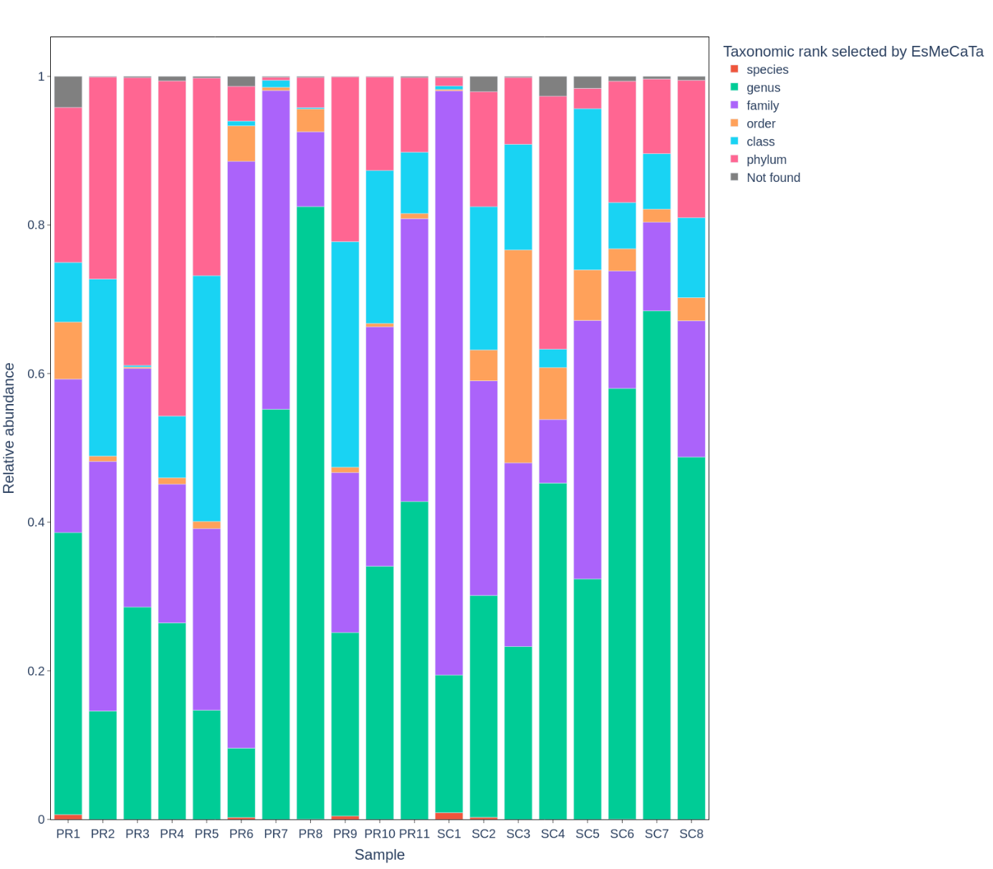Fig. S8 Barplot showing the taxonomic rank used by EsMeCaTa to make functional predictions with the relative abundance of the associated organisms for the samples.

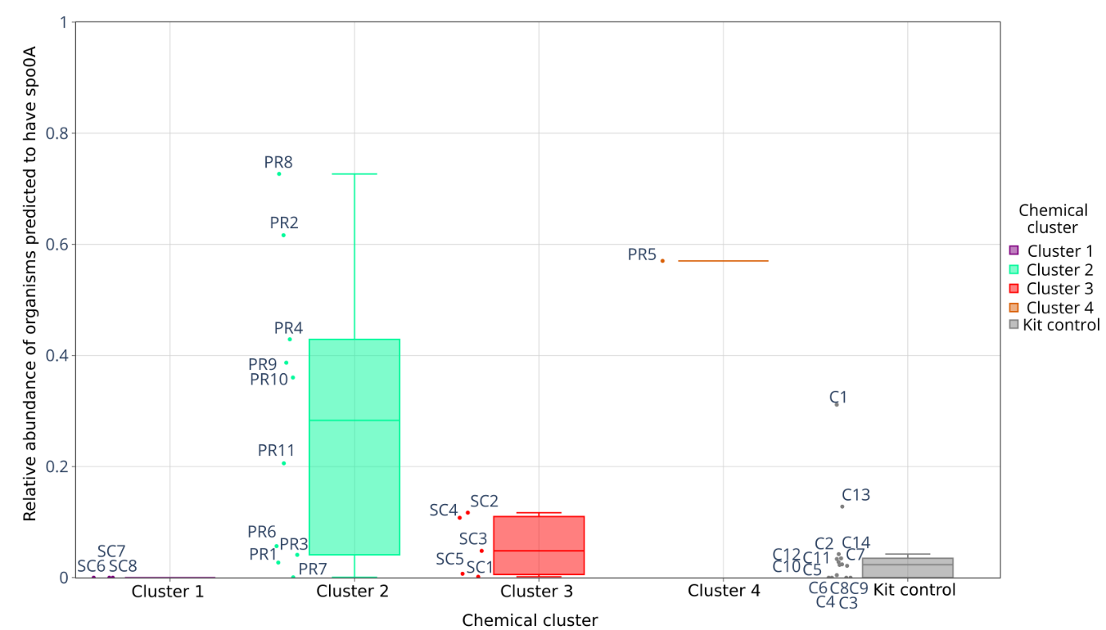Fig S9 Boxplot showing the relative abundance of organisms predicted to carry the sporulation gene spo0A across chemical clusters. Sample IDs are displayed next to their corresponding nodes.

Table S10 Results of Spearman correlation tests (p-value and rho value) performed between archaeal ecological characteristic and physico-chemical parameters. Values in bold correspond to significant values (p-value < 0.05). When NA is indicated, this means that there was insufficient data to perform the Spearman test.
Ecological characteristic | Parameter | Ca | Cl | DOC | Fe | K | Mg | Mn | Na | NH₄ | NO₂ | NO₃ | pH | PO₄ | S₂ | Salinity | SO₄ | Temperature | TIC
Non-methanogenic halophiles | Rho | 0.26 | 0.34 | -0.61 | -0.4 | 0.25 | 0.36 | -0.27 | 0.49 | -0.2 | NA | NA | -0.38 | NA | -0.24 | 0.38 | 0.32 | -0.45 | -0.18
Non-methanogenic halophiles | p-value | <0.01 | <0.01 | <0.01 | <0.01 | <0.01 | <0.01 | <0.01 | <0.01 | 0.01 | NA | NA | <0.01 | NA | <0.01 | <0.01 | <0.01 | <0.01 | <0.01
Halophilic methanogens | Rho | 0.18 | 0.07 | 0.3 | 0.11 | 0.01 | 0.23 | NA | 0.05 | -0.2 | -0.1 | -0.3 | -0.16 | 0.2 | 0.04 | 0.07 | -0.02 | 0.23 | 0.01
Halophilic methanogens | p-value | 0.21 | 0.61 | 0.05 | 0.43 | 0.91 | 0.11 | NA | 0.73 | 0.14 | 0.77 | 0.28 | 0.24 | 0.5 | 0.8 | 0.61 | 0.88 | 0.09 | 0.93
Non-halophilic methanogens | Rho | -0.22 | -0.4 | 0.4 | 0.35 | 0.2 | -0.07 | -0.34 | -0.42 | 0.22 | -0 | -0.4 | 0.11 | 0.3 | 0.5 | -0.43 | -0.34 | 0.17 | 0.46
Non-halophilic methanogens | p-value | 0.08 | <0.01 | <0.01 | <0.01 | 0.08 | 0.55 | 0.03 | <0.01 | 0.12 | 0.98 | 0.04 | 0.33 | 0.1 | <0.01 | <0.01 | <0.01 | 0.15 | <0.01
Specialised methanogens | Rho | -0.33 | -0.34 | 0.14 | 0.21 | -0.02 | -0.19 | -0.02 | -0.37 | 0.23 | 0.3 | 0.26 | 0.21 | 0.4 | 0.51 | -0.32 | -0.12 | 0.1 | 0.42
Specialised methanogens | p-value | 0.02 | 0.01 | 0.37 | 0.12 | 0.91 | 0.18 | 0.92 | 0.01 | 0.16 | 0.22 | 0.3 | 0.12 | 0.1 | <0.01 | 0.02 | 0.37 | 0.47 | <0.01
Other extremophiles | Rho | -0.25 | -0.04 | 0.14 | 0.13 | 0.04 | -0.24 | 0 | -0.09 | 0.05 | 0.07 | -0.1 | 0.33 | 0.2 | 0.47 | -0.06 | 0.05 | -0.19 | 0.31
Other extremophiles | p-value | 0.04 | 0.76 | 0.29 | 0.27 | 0.73 | 0.05 | 0.98 | 0.44 | 0.73 | 0.73 | 0.68 | <0.01 | 0.2 | <0.01 | 0.6 | 0.66 | 0.1 | 0.02

Table S11 Results of Spearman correlation tests (p-value and rho value) performed between bacterial ecological characteristic and physico-chemical parameters. Values in bold correspond to significant values (p-value < 0.05). When NA is indicated, this means that there was insufficient data to perform the Spearman test.
Ecological characteristic | Parameter | Ca | Cl | DOC | Fe | K | Mg | Mn | Na | NH₄ | NO₂ | NO₃ | pH | PO₄ | S₂ | Salinity | SO₄ | Temperature | TIC
Fermenters | Rho | 0.09 | -0.16 | 0.15 | 0.11 | 0.12 | -0 | 0.03 | -0.2 | -0.15 | 0.27 | 0.23 | -0.11 | 0.43 | 0.06 | -0.16 | -0.28 | 0.3 | -0.23
Fermenters | p-value | 0.62 | 0.34 | 0.44 | 0.52 | 0.46 | 0.89 | 0.9 | 0.14 | 0.47 | 0.4 | 0.47 | 0.51 | 0.12 | 0.76 | 0.34 | 0.09 | 0.07 | 0.22
Generalists | Rho | 0.03 | 0.11 | -0.11 | -0.06 | -0.1 | -0.1 | 0.15 | 0.07 | 0.01 | -0.23 | 0.13 | 0.04 | -0.31 | -0.15 | 0.09 | 0.02 | -0.05 | -0.26
Generalists | p-value | 0.59 | 0.05 | 0.08 | 0.29 | 0.19 | 0.12 | 0.04 | 0.21 | 0.82 | 0.02 | 0.19 | 0.45 | <0.01 | 0.02 | 0.11 | 0.67 | 0.36 | <0.01
Halophiles | Rho | -0.3 | 0.19 | -0.26 | -0.32 | -0.2 | -0.3 | 0.02 | 0.17 | 0.29 | 0.3 | 0.22 | 0.37 | -0.4 | -0.07 | 0.18 | 0.35 | -0.19 | -0.08
Halophiles | p-value | 0.07 | 0.15 | 0.09 | 0.02 | 0.08 | 0.07 | 0.91 | 0.2 | 0.07 | 0.22 | 0.39 | <0.01 | 0.07 | 0.67 | 0.17 | 0.01 | 0.15 | 0.62
Human-associated bacteria | Rho | 0.24 | -0.05 | -0.23 | -0.05 | 0.02 | 0.18 | -0.1 | 0.02 | -0.37 | -0.63 | -0.1 | -0.31 | -0.09 | -0.28 | -0.06 | -0.33 | -0.02 | -0.31
Human-associated bacteria | p-value | 0.03 | 0.62 | 0.06 | 0.66 | 0.85 | 0.11 | 0.34 | 0.83 | <0.01 | <0.01 | 0.48 | <0.01 | 0.59 | 0.02 | 0.55 | <0.01 | 0.86 | 0.01
Syntrophic methnogens | Rho | -0.1 | -0.33 | 0.26 | 0.32 | 0.05 | 0.04 | -0.1 | -0.3 | 0.19 | 0.21 | -0 | 0.04 | 0.28 | 0.44 | -0.34 | -0.19 | 0.19 | 0.34
Syntrophic methnogens | p-value | 0.45 | 0.04 | 0.17 | 0.05 | 0.77 | 0.82 | 0.75 | 0.04 | 0.35 | 0.52 | 0.94 | 0.81 | 0.32 | 0.02 | 0.03 | 0.26 | 0.26 | 0.07
Planctomycetes | Rho | -0.3 | 0.36 | NA | -0.29 | -0.4 | -0.5 | 0.27 | 0.26 | 0.45 | NA | NA | 0.63 | -0.64 | NA | 0.31 | 0.53 | -0.24 | NA
Planctomycetes | p-value | 0.19 | 0.13 | NA | 0.24 | 0.09 | 0.06 | 0.43 | 0.28 | 0.13 | NA | NA | <0.01 | 0.13 | NA | 0.2 | 0.02 | 0.33 | NA
Sulfate-reducing bacteria | Rho | 0.38 | 0.11 | 0.07 | 0.27 | 0.09 | 0.45 | 0.28 | 0.09 | 0.21 | -0.36 | -0.4 | -0.27 | -0.14 | -0.18 | 0.11 | -0.1 | 0.09 | -0.18
Sulfate-reducing bacteria | p-value | 0.03 | 0.52 | 0.73 | 0.11 | 0.59 | 0.01 | 0.21 | 0.59 | 0.29 | 0.25 | 0.25 | 0.11 | 0.62 | 0.36 | 0.52 | 0.53 | 0.59 | 0.35
Thermophiles | Rho | -0.2 | -0.41 | 0.54 | 0.48 | 0.26 | 0.02 | -0.4 | -0.4 | 0.38 | 0.2 | -0.4 | 0.03 | 0.35 | 0.47 | -0.41 | -0.36 | 0.34 | 0.44
Thermophiles | p-value | 0.23 | <0.01 | <0.01 | <0.01 | 0.02 | 0.86 | 0.01 | 0 | 0.01 | 0.35 | 0.09 | 0.78 | 0.07 | <0.01 | <0.01 | <0.01 | <0.01 | <0.01

Table S12 Results of CCA analyses carried out for dominant and indicator archaeal communities with p-value and F-value (Ratio between the variance explained by the variable and the residual variance in the CCA model). CCA1 = all sites ; CCA2 : deletion of SC1 and PR1 ; CCA3 = deletion of SC1, PR1, SC6, SC7 and SC8. Significative p-values (< 0.05) are in bold.
Physicochemical parameter |  | Archaeal dominant genus |  |  | Archaeal indicator genus
 |  | CCA1 | CCA2 | CCA3 | CCA1 | CCA2 | CCA3
SO₄ | F | 3.00 | 19.94 | 21.12 | 5.09 | 35.43 | 804.2
SO₄ | p-value | 0.001 | 0.001 | 0.004 | 0.013 | 0.002 | 0.001
Cl | F | 3.01 | 20.03 | 21.21 | 5.53 | 38.52 | 874.3
Cl | p-value | 0.001 | 0.001 | 0.004 | 0.007 | 0.001 | 0.001
Na | F | 2.6 | 11.6 | 12.3 | 0.71 | 4.96 | 110.7
Na | p-value | 0.003 | 0.001 | 0.009 | 0.957 | 0.044 | 0.013
K | F | 1.79 | 12.84 | 12.86 | 2.81 | 22.88 | 443.3
K | p-value | 0.108 | 0.001 | 0.007 | 0.101 | 0.002 | 0.001
Fe | F | 2.04 | 13.45 | 14.12 | 3.53 | 23.28 | 557.3
Fe | p-value | 0.052 | 0.001 | 0.008 | 0.061 | 0.002 | 0.001
pH | F | 1.67 | 10.52 | 8.94 | 1.57 | 13.57 | 149.8
pH | p-value | 0.192 | 0.001 | 0.014 | 0.529 | 0.004 | 0.011
Salinity | F | 1.86 | 13.73 |  | 0.39 | 7.18
Salinity | p-value | 0.072 | 0.001 |  | 0.962 | 0.012
Temperature | F | 2.79 | 9.33 | 4.46 | 1.31 | 5.62 | 168.7
Temperature | p-value | 0.002 | 0.001 | 0.034 | 0.499 | 0.020 | 0.004
Mg | F |  | 10.68 |  |  | 18.59
Mg | p-value |  | 0.001 |  |  | 0.003
Ca | F |  | 12.26 |  |  | 15.46
Ca | p-value |  | 0.001 |  |  | 0.003
TIC | F |  |  | 15.79 |  |  | 88.82
TIC | p-value |  |  | 0.005 |  |  | 0.006
DOC | F |  |  | 11.07 |  |  | 71.67
DOC | p-value |  |  | 0.012 |  |  | 0.015

Table S13 Results of CCA analyses carried out for dominant and indicator bacterial communities with p-calue and F-value (Ratio between the variance explained by the variable and the residual variance in the CCA model). CCA1 = all sites ; CCA2 : deletion of SC1 and PR1 ; CCA3 = deletion of SC1, PR1, SC6, SC7 and SC8. Significative p-values (< 0.05) are in bold
Physicochemical parameter |  | Bacterial dominant genus |  |  | Bacterial indicator genus
 |  | CCA1 | CCA2 | CCA3 | CCA1 | CCA2 | CCA3
SO₄ | F | 2.32 | 2.6 | 2.38 | 5.30 | 5.25 | 8.3
SO₄ | p-value | 0.02 | 0.06 | 0.42 | 0.001 | 0.001 | 0.001
Cl | F | 1.82 | 2.05 | 2.05 | 2.98 | 2.95 | 9.04
Cl | p-value | 0.2 | 0.21 | 0.56 | 0.01 | 0.02 | 0.001
Na | F | 1.33 | 1.42 | 1.46 | 1.21 | 1.19 | 5.75
Na | p-value | 0.46 | 0.5 | 0.71 | 0.49 | 0.43 | 0.01
K | F | 0.39 | 0.23 | 0.56 | 1.75 | 2.66 | 8.92
K | p-value | 0.97 | 0.96 | 0.87 | 0.20 | 0.08 | 0.002
Fe | F | 0.71 | 0.64 | 0.68 | 2.26 | 2.23 | 5.38
Fe | p-value | 0.91 | 0.89 | 0.96 | 0.07 | 0.10 | 0.01
pH | F | 2.29 | 1.73 | 0.91 | 3.42 | 2.19 | 2.33
pH | p-value | 0.01 | 0.22 | 0.82 | 0.002 | 0.05 | 0.16
Salinity | F | 1.17 | 1.71 | 2.01 | 0.89 | 0.49
Salinity | p-value | 0.58 | 0.31 | 0.37 | 0.70 | 0.76
Temperature | F | 1.51 | 1.57 | 1.79 | 1.89 | 2.05 | 6.0
Temperature | p-value | 0.24 | 0.32 | 0.39 | 0.15 | 0.09 | 0.01
Mg | F |  | 1.43 |  |  | 1.06
Mg | p-value |  | 0.47 |  |  | 0.53
Ca | F |  | 1.32 |  |  | 2.02
Ca | p-value |  | 0.58 |  |  | 0.11
TIC | F |  |  | 1.74 |  |  | 5.02
TIC | p-value |  |  | 0.50 |  |  | 0.02
DOC | F |  |  | 1.32 |  |  | 3.83
DOC | p-value |  |  | 0.82 |  |  | 0.03

Text S1 Canonical Correspondence Analysis (CCA): detailed results
The influence of environmental gradients on dominant and indicator archaeal and bacterial genera was assessed using the CCA method with three filtering strategies based on available data: CCA1 (all sites), CCA2 (elimination of SC1 and PR1, addition of Mg and Ca) and CCA3 (elimination of SC1, PR1, SC6, SC7 and SC8, addition of TIC and DOC). The results for archaea are presented in Table S12 and for bacteria in Table S13, with p-value and F-value (ratio of variance explained by the parameter to residual variance).
For archaeal communities, SO₄, Ca and salinity were consistently significant in all three CCA, with notably very high F-value for CCA2 (~35-38) and CCA3 (~800-870) for indicator archaea. Dominant archaea also showed significant structuring by these ions, but with lower F-value (max. ~21 in CCA3). These elements strongly structure in the distribution of archaeal communities across sites. Na, K and Fe showed significant but weaker structuting effects, especially in CCA2 and CCA3, with indicator genera displaying increasing F-values after site filtering (F-value from ~0.1-4 to ~110-558), suggesting that these ions further refine niche differentiation when sites are excluded. Ca and Mg (CCA2) are significant with larger F-values for indicator genera (~15-19) than dominant genera (~10-13), demonstrating their strong involvement in community structuring. Temperature and pH are moderate strcturing factors, with significant effects mainly in CCA2 and CCA3 (~2-6) for indicator genera, indicating that these variables also play a role, but to a lesser extent than ionic parameters. Carbon (DOC and TIC, CCA3) strongly structures archaeal genera (F-value ~11-16 for dominant genera and F-value ~70-89 for indicators), showing that carbon sources become significant structuring factors when additional carbon data are applied. Thus, indicator archaea are strongly structured by ionic gradients (SO₄, Cl, Na, Ca, Mg, K, Fe) and carbon sources (TIC, DOC), with increasing exaplanatory power afeter filtering by site. Dominant genera remain influenced by these parameters, but show weaker structuring.
Indicator bacterial genera showed significant and consistent structuring with SO₄ (~5-9), Cl (~2-9) and K (~1-9). The structuring effect became particularly evident with CCA3, with F-value peaking for SO₄, Cl and K, showing that indicator bacteria, like archaea, are sensitive to ionic gradient. Na showed a weaker but significant structuring effect with CCA3 (F-value = 5.75), while Fe also became significant with CCA3 (F-value = 5.38). Dominant bacterial genera were only weakly structured by these variables, with occasional significance for SO₄ in CCA1 (F-value = 2.32), but a loss of significance in the filtered datasets, indicating weak and inconsistent structuring of dominant bacteria by ionic parameters. Ca and Mg (CCA2) were not significant for bacterial communities. Indicator bacteria showed moderate structuring by pH (F-value = 3.42 in CCA1 and 2.9 in CCA2) and temperature (F-value = 6.0 in CCA3), suggesting that these gradients contribute to the structuring of indicator bacteria. TIC (F-value = 5.02) and DOC (F-value = 3.83) significantly structured indicator bacteria, indicating that carbon sources are relevant factors for bacterial indicators. In summary, bacterial indicator genera exhibit clear structuring by SO₄ and Cl, and assumed by K, TIC and DOC, with increasing clarity upon site filtering. Dominant bacterial genera exhibit minimal and inconsistent structuring.

References
1 J. R. Bray and J. T. Curtis, An Ordination of the Upland Forest Communities of Southern Wisconsin, Ecological Monographs, 1957, 27, 325–349.
2 F. Wilcoxon, Individual Comparisons by Ranking Methods, Biometrics Bulletin, 1945, 1, 80–83.
3 J. B. Kruskal, Nonmetric Multidimensional Scaling: A Numerical Method, Psychometrika, 1964, 29, 115–129.
4 In ResearchGate.
5 K. Alboukadel and M. Fabian, factoextra: Extract and Visualize the Results of Multivariate Data Analyses, CRAN: Contributed Packages, DOI:10.32614/cran.package.factoextra.
6 I. T. Jolliffe and J. Cadima, Principal component analysis: a review and recent developments, Philosophical Transactions of the Royal Society A: Mathematical, Physical and Engineering Sciences, 2016, 374, 20150202.
7 S. S. SHAPIRO and M. B. WILK, An analysis of variance test for normality (complete samples)†, Biometrika, 1965, 52, 591–611.
8 W. H. Kruskal and W. A. and Wallis, Use of Ranks in One-Criterion Variance Analysis, Journal of the American Statistical Association, 1952, 47, 583–621.
9 M. J. Anderson, A new method for non-parametric multivariate analysis of variance, Austral Ecology, 2001, 26, 32–46.
10 K. R. Clarke, Non-parametric multivariate analyses of changes in community structure, Australian Journal of Ecology, 1993, 18, 117–143.
11 L. Yan, 2021.
12 E. H. Simpson, Measurement of Diversity, Nature, 1949, 163, 688–688.
13 A. E. Magurran, Ecological Diversity and Its Measurement, Springer Science & Business Media, 2013.
14 O. J. Dunn, Multiple Comparisons Using Rank Sums, Technometrics, 1964, 6, 241–252.
15 M. D. Cáceres and P. Legendre, Associations between species and groups of sites: indices and statistical inference, Ecology, 2009, 90, 3566–3574.
16 M. Dufrêne and P. Legendre, Species Assemblages and Indicator Species:the Need for a Flexible Asymmetrical Approach, Ecological Monographs, 1997, 67, 345–366.
17 A. Oren, Microbial life at high salt concentrations: phylogenetic and metabolic diversity, Saline Systems, 2008, 4, 2.
18 A. Oren, Thermodynamic limits to microbial life at high salt concentrations, Environmental Microbiology, 2011, 13, 1908–1923.
19 T. J. McGenity and D. Y. Sorokin, in Biogenesis of Hydrocarbons, Springer, Cham, 2019, pp. 283–309.
20 G. Borrel, P. W. O’Toole, H. M. B. Harris, P. Peyret, J.-F. Brugère and S. Gribaldo, Phylogenomic Data Support a Seventh Order of Methylotrophic Methanogens and Provide Insights into the Evolution of Methanogenesis, Genome Biology and Evolution, 2013, 5, 1769–1780.
21 R. K. Thauer, A.-K. Kaster, H. Seedorf, W. Buckel and R. Hedderich, Methanogenic archaea: ecologically relevant differences in energy conservation, Nat Rev Microbiol, 2008, 6, 579–591.
22 A. Söllinger and T. Urich, Methylotrophic methanogens everywhere — physiology and ecology of novel players in global methane cycling, Biochemical Society Transactions, 2019, 47, 1895–1907.
23 P. O. Sheridan, Y. Meng, T. A. Williams and C. Gubry-Rangin, Recovery of Lutacidiplasmatales archaeal order genomes suggests convergent evolution in Thermoplasmatota, Nat Commun, 2022, 13, 4110.
24 S. L. Bräuer, N. Basiliko, H. M. P. Siljanen and S. H. Zinder, Methanogenic archaea in peatlands, FEMS Microbiology Letters, 2020, 367, fnaa172.
25 R. Cavicchioli, Archaea — timeline of the third domain, Nat Rev Microbiol, 2011, 9, 51–61.
26 E. A. Eloe-Fadrosh, N. N. Ivanova, T. Woyke and N. C. Kyrpides, Metagenomics uncovers gaps in amplicon-based detection of microbial diversity, Nat Microbiol, 2016, 1, 15032.
27 J. K. Lee, J. H. Baek, J.-H. Yoon, C.-J. Cha, W. Kim, M. K. Kim, T. Seo and C. O. Jeon, A report of 21 unrecorded bacterial species belonging to the phyla Bacillota and Verrucomicrobiota in Korea, Journal of Species Research, 2023, 12, 15–22.
28 K. Zhao, Q. Wei, X. Zhang, Y. Liu and F. Li, Anaerobic co-digestion of food waste and excess sludge by humus composites: Characteristics and microbial community structure, Journal of Environmental Chemical Engineering, 2024, 12, 113673.
29 T. Coenye and P. Vandamme, Diversity and significance of Burkholderia species occupying diverse ecological niches, Environmental Microbiology, 2003, 5, 719–729.
30 S.-C. Chobert, M. Roger-Margueritat, L. Flandrin, S. Berraies, C. T. Lefèvre, L. Pelosi, I. Junier, N. Varoquaux, F. Pierrel and S. S. Abby, Dynamic quinone repertoire accompanied the diversification of energy metabolism in Pseudomonadota, The ISME Journal, 2025, 19, wrae253.
31 J. M. Janda and S. L. Abbott, The Genus Aeromonas: Taxonomy, Pathogenicity, and Infection, Clinical Microbiology Reviews, 2010, 23, 35–73.
32 B. Ollivier, P. Caumette, J. L. Garcia and R. A. Mah, Anaerobic bacteria from hypersaline environments, Microbiological Reviews, 1994, 58, 27–38.
33 T. N. Zhilina and G. A. Zavarzin, Extremely halophilic, methylotrophic, anaerobic bacteria, FEMS Microbiology Reviews, 1990, 7, 315–321.
34 A. T. Kivistö and M. T. Karp, Halophilic anaerobic fermentative bacteria, Journal of Biotechnology, 2011, 152, 114–124.
35 S. SPRING, W. LUDWIG, M. C. MARQUEZ, A. VENTOSA and K.-H. SCHLEIFER, Halobacillus gen. nov., with Descriptions of Halobacillus litoralis sp. nov. and Halobacillus trueperi sp. nov., and Transfer of Sporosarcina halophila to Halobacillus halophilus comb. nov., International Journal of Systematic and Evolutionary Microbiology, 1996, 46, 492–496.
36 A. Ventosa, J. J. Nieto and A. Oren, Biology of Moderately Halophilic Aerobic Bacteria, Microbiology and Molecular Biology Reviews, 1998, 62, 504–544.
37 M. Ji, T. J. Williams, K. Montgomery, H. L. Wong, J. Zaugg, J. F. Berengut, A. Bissett, M. Chuvochina, P. Hugenholtz and B. C. Ferrari, Candidatus Eremiobacterota, a metabolically and phylogenetically diverse terrestrial phylum with acid-tolerant adaptations, The ISME Journal, 2021, 15, 2692–2707.
38 C. F. Gutiérrez, N. Rodríguez-Romero, S. Egan, E. Holmes and J. Sanabria, Exploiting the Potential of Bioreactors for Creating Spatial Organization in the Soil Microbiome: A Strategy for Increasing Sustainable Agricultural Practices, Microorganisms, 2022, 10, 1464.
39 H. Kawamoto, M. Watanabe, H. Mochimaru, N. Nakahara, X.-Y. Meng, S. Sakamoto, K. Morinaga, T. Katayama, H. Yoshioka, N. Nomura and H. Tamaki, Atrimonas thermophila gen. nov., sp. nov., a novel anaerobic thermophilic bacterium of the phylum Atribacterota isolated from deep subsurface gas field and proposal of Atrimonadaceae fam. nov. within the class Atribacteria in the phylum Atribacterota, Systematic and Applied Microbiology, 2024, 47, 126515.
40 E. Perman, A. Schnürer, A. Björn and J. Moestedt, Serial anaerobic digestion improves protein degradation and biogas production from mixed food waste, Biomass and Bioenergy, 2022, 161, 106478.
41 M. I. Prokofeva, A. G. Elcheninov, A. A. Klyukina, A. A. Novikov, G. S. Kachmazov, S. V. Toshchakov, E. N. Frolov and O. A. Podosokorskaya, Anaeroselena agilis gen. nov., sp. nov., a Novel Sulfite- and Arsenate-Respiring Bacterium Within the Family Acetonemataceae Isolated from a Thermal Spring of North Ossetia, Curr Microbiol, 2025, 82, 71.
42 G. Leng, W. Yan, Z. Chen, Z. Li, B. Liu, P. Deng, C. Zhang, W. Liu and H. Qi, Technical challenges and opportunities of hydrogen storage: A comprehensive review on different types of underground storage, Journal of Energy Storage, 2025, 114, 115900.
43 A. Farrell, Evolution and Adaptation to Temperature in Thermotogota, Dartmouth College Ph.D Dissertations.
44 J. K. Choi, S. Poudel, N. Yee and J. L. Goff, Deeply branching Bacillota species exhibit atypical Gram-negative staining, Microbiology Spectrum, 2024, 12, e00732-24.
45 J. G. Zeikus, Thermophilic bacteria: Ecology, physiology and technology, Enzyme and Microbial Technology, 1979, 1, 243–252.
46 S. Dyksma and M. Pester, Growth of sulfate-reducing Desulfobacterota and Bacillota at periodic oxygen stress of 50% air-O2 saturation, Microbiome, 2024, 12, 191.
47 Z. Zhang, C. Zhang, Y. Yang, Z. Zhang, Y. Tang, P. Su and Z. Lin, A review of sulfate-reducing bacteria: Metabolism, influencing factors and application in wastewater treatment, Journal of Cleaner Production, 2022, 376, 134109.
48 O. J. Hao, Chen ,Jin M., Huang ,Li and R. L. and Buglass, Sulfate‐reducing bacteria, Critical Reviews in Environmental Science and Technology, 1996, 26, 155–187.
49 J. R. Sieber, M. J. McInerney, N. Müller, B. Schink, R. P. Gunsalus and C. M. Plugge, in Biogenesis of Hydrocarbons, Springer, Cham, 2019, pp. 179–209.
50 A. N. Nozhevnikova, Yu. I. Russkova, Yu. V. Litti, S. N. Parshina, E. A. Zhuravleva and A. A. Nikitina, Syntrophy and Interspecies Electron Transfer in Methanogenic Microbial Communities, Microbiology, 2020, 89, 129–147.
51 M. Kündgen, C. Jogler and N. Kallscheuer, Substrate utilization and secondary metabolite biosynthesis in the phylum Planctomycetota, Appl Microbiol Biotechnol, 2025, 109, 123.
52 S. Yadav, M. Koenen, N. J. Bale, W. Reitsma, J. C. Engelmann, K. Stefanova, J. S. S. Damsté and L. Villanueva, Organic matter degradation in the deep, sulfidic waters of the Black Sea: insights into the ecophysiology of novel anaerobic bacteria, Microbiome, 2024, 12, 98.
53 E. Orlova, O. Ogarkov and L. I. Kolesnikova, Features of the lung microbiota in tuberculosis infection, Bulletin of Siberian Medicine, DOI:10.20538/1682-0363-2024-1-166-175.
54 K. Aboushaala, A. V. Chee, D. Adnan, S. J. Toro, H. Singh, A. Savoia, E. S. Dhillon, C. Yuh, J. Dourdourekas, I. K. Patel, R. Vucicevic, A. A. Espinoza-Orias, J. T. Martin, C. Oh, A. Keshavarzian, H. B. Albert, J. Karppinen, M. Kocak, A. Y. L. Wong, E. J. Goldberg, F. M. Phillips, M. W. Colman, F. M. K. Williams, J. A. Borgia, A. Naqib, S. J. Green, C. B. Forsyth, H. S. An and D. Samartzis, Gut microbiome dysbiosis is associated with lumbar degenerative spondylolisthesis in symptomatic patients, JOR SPINE, 2024, 7, e70005.
55 S. Flores-Treviño, Bocanegra-Ibarias ,Paola, Salas-Treviño ,Daniel, Ramírez-Elizondo ,María Teresa, Pérez-Alba ,Eduardo and A. and Camacho-Ortiz, Microbiota transplantation and administration of live biotherapeutic products for the treatment of dysbiosis-associated diseases, Expert Opinion on Biological Therapy, 25, 1–14.
56 T. Qin, T. Yu, Y. Liu, J. Wu, Y. Jiang and G. Zhang, Roseicella aerolata GB24T from bioaerosol attenuates Streptococcus pneumoniae-introduced inflammation through regulation of gut microbiota and acetic acid, Front. Microbiol., DOI:10.3389/fmicb.2023.1225548.
57 N. S. Stanislav, I. S. Tartakovsky and N. V. Rudakov, Current knowledge of the taxonomy and classification of representatives from the order Legionellales (Legionellaceae, Coxiellaceae) Phylum Pseudomonadota, Clinical microbiology and antimicrobial chemotherapy, 2024, 26, 161–170.
58 Y. Ma, X. Peng, J. Zhang, Y. Zhu, R. Huang, G. Li, Y. Wu, C. Zhou, J. You, S. Fang, S. Xiang and J. Qiu, Gut microbiota in preterm infants with late-onset sepsis and pneumonia: a pilot case-control study, BMC Microbiol, 2024, 24, 272.
59 C. Spearman, The proof and measurement of association between two things, International Journal of Epidemiology, 2010, 39, 1137–1150.
60 J. Oksanen, R package version, 2015, 2, 3.

