Suppelementary data
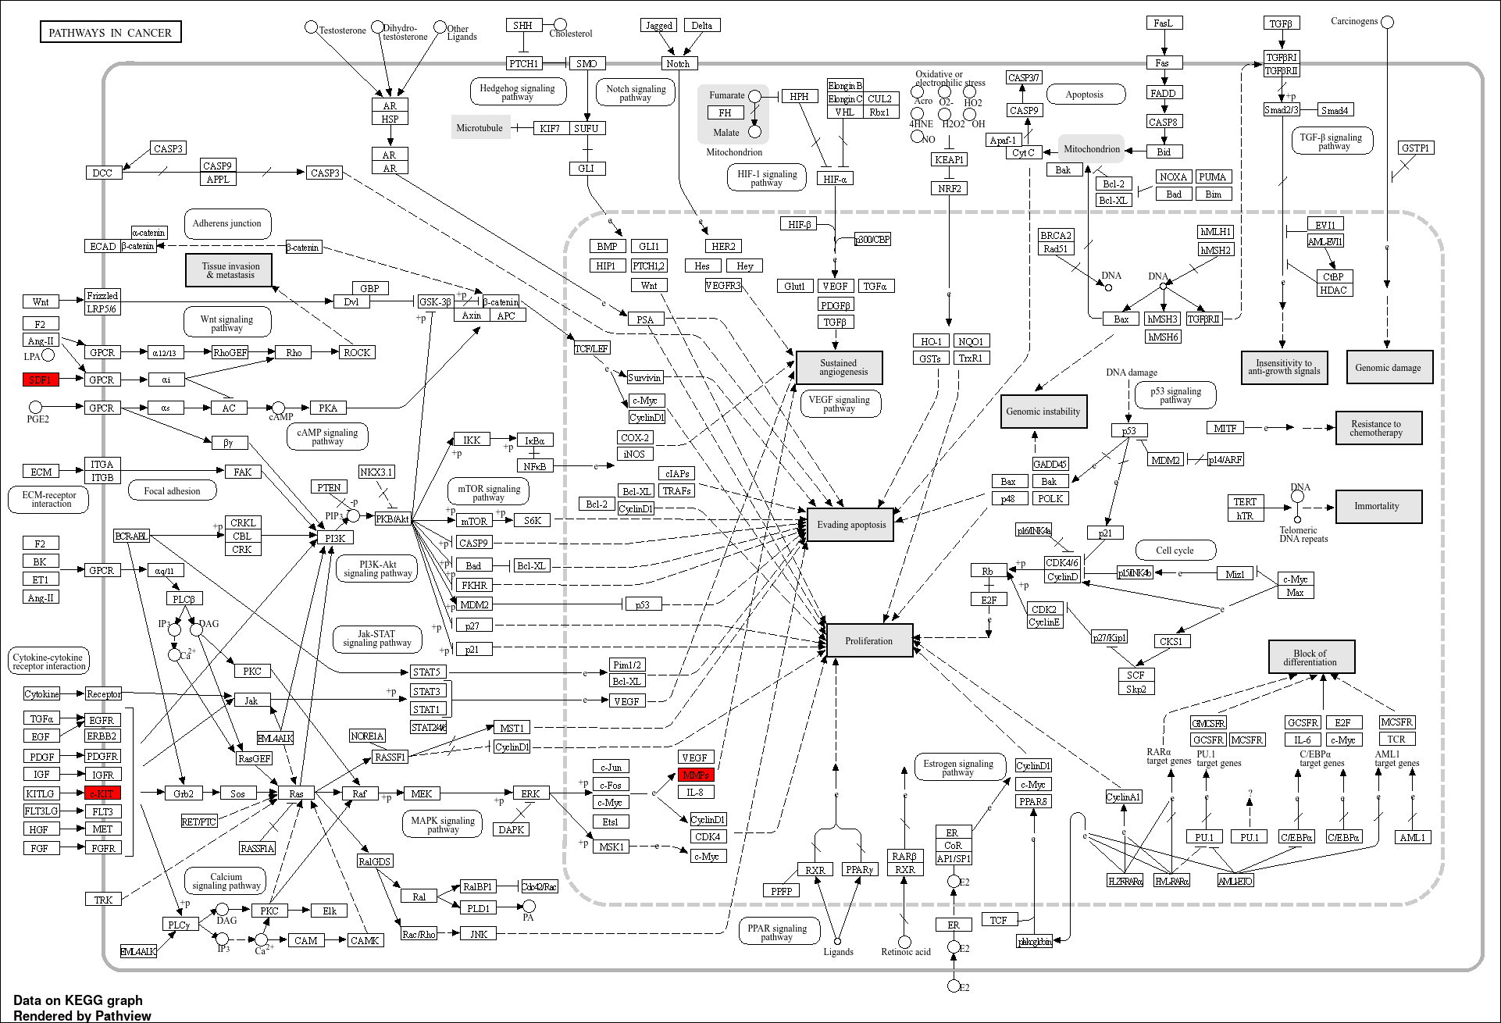
A
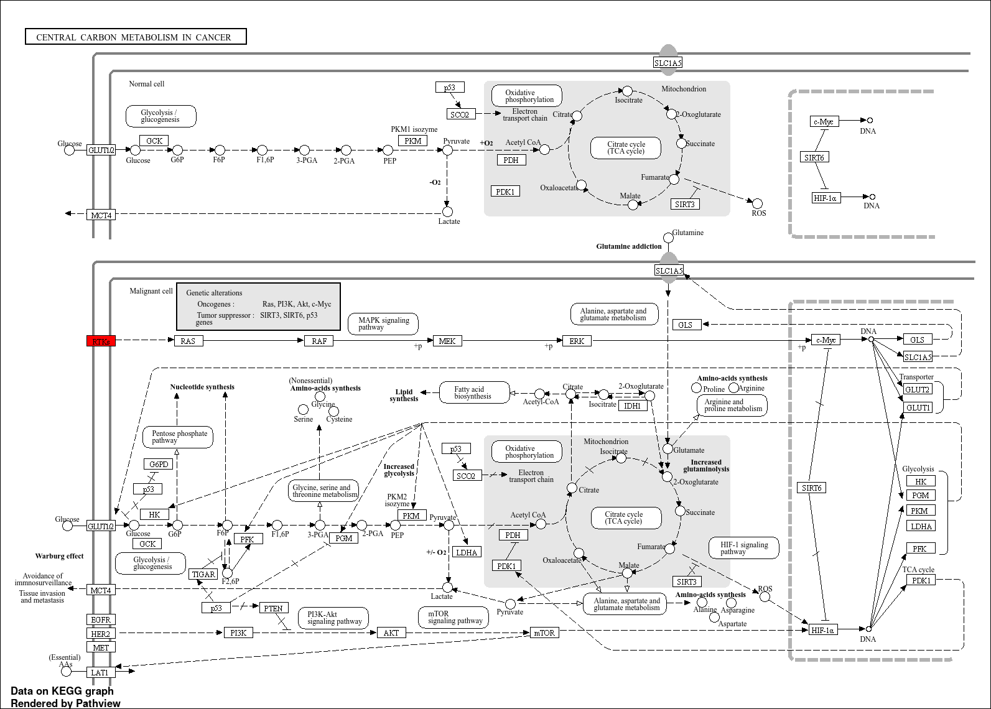
B
Supplementary data 1 KEGG Pathway analysis of (A) hsa-miR-221-3p; (B) hsa-miR-222-3p and hsa-miR-146b-5p target genes.

