Supplementary Table1 Baseline characteristics of the study subjects in Phase I, II, and III.
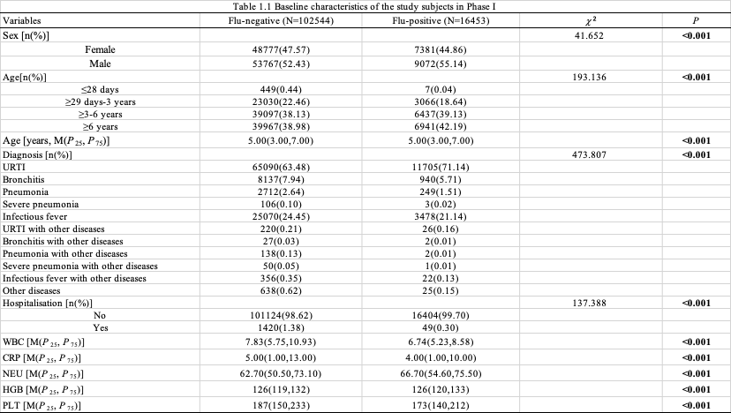
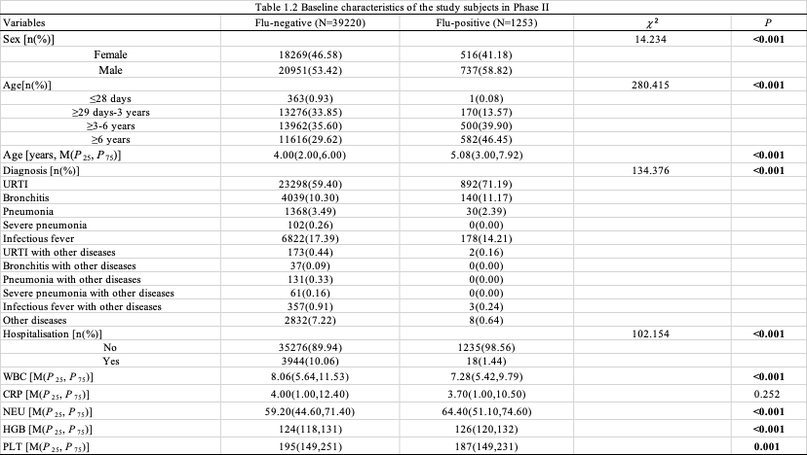
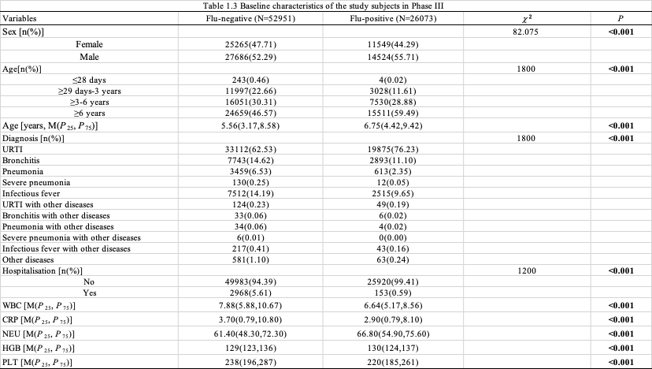
Supplementary Table 2 Comparison of the flu-positive rate in different age groups
