Table 1 Baseline characteristics of the study subjects
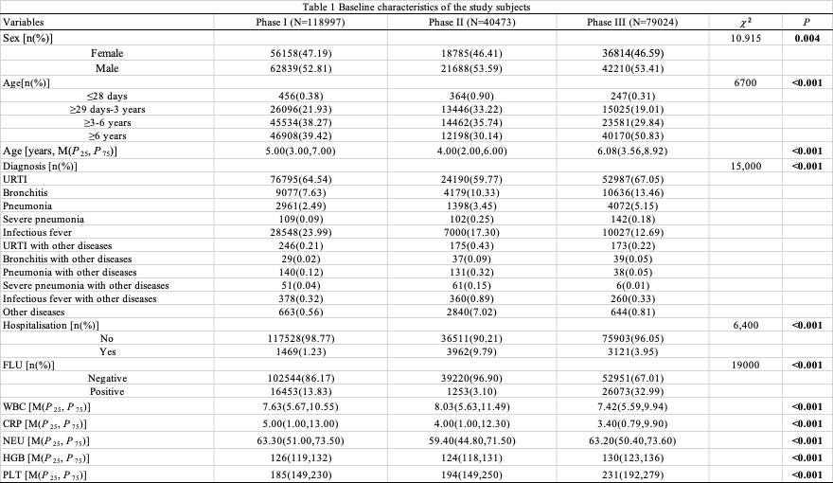
Table 2 Comparison of the flu-positive rate in different age groups
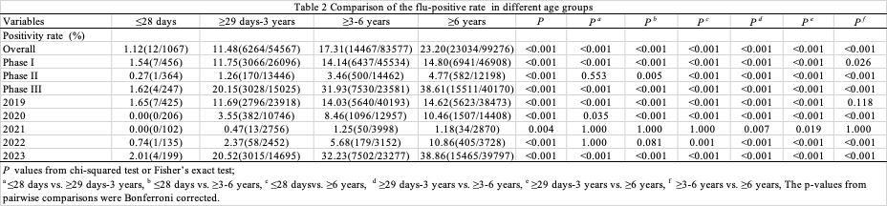
Table 3 Comparisons of Flu-positive patients’ clinical data between outpatient and inpatient
