Supplementary Materials for
European Child & Adolescent Psychiatry
Dynamic Interplay Between Internet Addiction and Anxiety Across Distinct Loneliness Trajectories in Adolescents: A Cross-Lagged Panel Network Analysis

Yuntai Wang^{1,*}, Zijuan Ma², Shiyi Lin¹, Guodong Gong¹, Xiaoyi Huang¹
¹Department of Psychology, Yunnan Normal University, Kunming, 650500, Yunnan province, PR China
²Center for Studies of Psychological Application, School of Psychology, and Guangdong Key Laboratory of Mental Health and Cognitive Science, South China Normal University, Guangzhou, 510006, Guangdong, PR China
Supplementary Figure and table legends
Supplementary Table 1. Partial directed correlations of T1 → T2 cross-lagged panel network adjacency matrix in the stable-low group (N=1,273).
Supplementary Table 2. Partial directed correlations of T1 → T2 cross-lagged panel network adjacency matrix in the increasing group (N=60).
Supplementary Table 3. Partial directed correlations of T1 → T2 cross-lagged panel network adjacency matrix in the decreasing group (N=207).
Supplementary Table 4. Partial directed correlations of T1 → T2 cross-lagged panel network adjacency matrix in the decreasing group (N=180).
Supplementary Table 5. Centrality estimates across four trajectories of loneliness symptoms (z values).
Supplementary Fig. 1. Accuracy of edge-weight value estimation in the cross-lagged panel network cross distinct trajectories of loneliness symptoms.
Supplementary Fig. 2. Bootstrapped difference test for edges in the cross-lagged panel network (α = 0.05) cross distinct trajectories of loneliness symptoms.
Supplementary Fig. 3. Stability of centrality metrics in the cross-lagged panel network cross distinct trajectories of loneliness symptoms.
Supplementary Fig. 4. Bootstrapped difference test for in-expected influence of nodes in the cross-lagged panel network cross distinct trajectories of loneliness symptoms.
Supplementary Fig. 5. Bootstrapped difference test for out-expected influence of nodes in the cross-lagged panel network cross distinct trajectories of loneliness symptoms.
Supplementary Fig. 6. Bootstrapped difference test for bridge-expected influence of nodes in the cross-lagged panel network cross distinct trajectories of loneliness symptoms.
Supplementary Fig. 7. Cross-lagged panel network of Internet addiction, loneliness, and anxiety symptoms from 2024 to 2025.

Supplementary Table 1. Partial directed correlations of T1→ T2 cross-lagged panel network adjacency matrix in the stable-low group (N=1,273). Independent variables (i.e., predictors) are in rows, and dependent variables are in columns.
 | A1 | A2 | A3 | A4 | A5 | A6 | A7 | I1 | I2 | I3 | I4 | I5 | I6 | L1 | L2
A1 | 1.15 | 1.03 | 1.06 | 1.05 | 1.00 | 1.00 | 1.00 | 1.00 | 1.00 | 1.04 | 1.00 | 1.02 | 1.00 | 1.04 | 1.03
A2 | 1.00 | 1.13 | 1.05 | 1.03 | 1.00 | 1.00 | 1.06 | 1.00 | 1.00 | 1.00 | 1.00 | 1.00 | 1.00 | 1.00 | 1.00
A3 | 1.06 | 1.08 | 1.18 | 1.06 | 1.00 | 1.02 | 1.08 | 1.00 | 1.00 | 1.00 | 1.01 | 1.00 | 1.00 | 1.00 | 1.00
A4 | 1.08 | 1.10 | 1.03 | 1.16 | 1.06 | 1.07 | 1.00 | 1.00 | 1.00 | 0.98 | 1.00 | 1.00 | 1.00 | 1.00 | 1.05
A5 | 1.00 | 0.93 | 1.00 | 1.00 | 1.10 | 1.00 | 1.00 | 1.00 | 1.00 | 0.99 | 0.96 | 1.00 | 1.00 | 1.00 | 1.00
A6 | 1.08 | 1.16 | 1.09 | 1.12 | 1.11 | 1.33 | 1.07 | 1.00 | 1.01 | 1.00 | 1.01 | 1.00 | 1.00 | 1.03 | 1.00
A7 | 1.01 | 1.00 | 1.01 | 1.01 | 1.00 | 1.00 | 1.19 | 0.96 | 0.96 | 0.94 | 0.95 | 0.94 | 0.98 | 1.00 | 1.00
I1 | 1.00 | 1.00 | 1.01 | 1.00 | 1.04 | 1.04 | 1.04 | 1.44 | 1.08 | 1.07 | 1.18 | 1.00 | 1.09 | 1.00 | 1.00
I2 | 1.00 | 1.00 | 1.01 | 1.00 | 1.05 | 1.00 | 1.00 | 1.14 | 1.42 | 1.14 | 1.22 | 1.11 | 1.14 | 1.02 | 1.00
I3 | 1.00 | 1.00 | 1.00 | 1.00 | 1.01 | 1.00 | 1.00 | 1.03 | 1.09 | 1.28 | 1.00 | 1.10 | 1.00 | 1.01 | 1.06
I4 | 1.00 | 1.01 | 1.00 | 1.00 | 1.00 | 1.02 | 1.00 | 1.00 | 1.00 | 1.00 | 1.12 | 0.99 | 1.02 | 1.00 | 1.00
I5 | 1.02 | 1.02 | 1.01 | 1.00 | 1.00 | 1.03 | 1.00 | 1.05 | 1.12 | 1.13 | 1.09 | 1.50 | 1.00 | 1.00 | 0.94
I6 | 1.00 | 1.00 | 1.00 | 1.00 | 1.00 | 1.00 | 1.01 | 1.04 | 1.00 | 1.02 | 1.00 | 0.97 | 1.44 | 1.00 | 1.02
L1 | 1.17 | 1.17 | 1.14 | 1.11 | 1.12 | 1.10 | 1.07 | 1.07 | 1.05 | 1.08 | 1.02 | 1.05 | 1.00 | 1.59 | 1.15
L2 | 1.00 | 1.01 | 1.01 | 1.09 | 1.00 | 1.01 | 1.00 | 1.00 | 1.02 | 1.06 | 1.00 | 1.00 | 1.03 | 1.14 | 1.45

Supplementary Table 2. Partial directed correlations of T1→ T2 cross-lagged panel network adjacency matrix in the increasing group (N=60). Independent variables (i.e., predictors) are in rows, and dependent variables are in columns.
 | A1 | A2 | A3 | A4 | A5 | A6 | A7 | I1 | I2 | I3 | I4 | I5 | I6 | L1 | L2
A1 | 1.34 | 1.17 | 1.16 | 1.38 | 1.17 | 1.00 | 1.00 | 1.00 | 1.00 | 1.00 | 1.00 | 1.00 | 1.00 | 1.05 | 1.00
A2 | 1.00 | 1.00 | 1.37 | 1.00 | 1.00 | 1.16 | 1.00 | 1.00 | 1.00 | 1.00 | 1.00 | 1.00 | 1.00 | 1.00 | 1.00
A3 | 1.00 | 1.00 | 1.00 | 1.00 | 1.17 | 1.00 | 1.37 | 1.00 | 1.00 | 1.01 | 1.12 | 1.00 | 1.00 | 1.01 | 1.00
A4 | 1.00 | 1.00 | 1.00 | 1.12 | 1.00 | 1.00 | 1.00 | 1.21 | 1.16 | 1.18 | 1.00 | 1.00 | 1.00 | 1.00 | 1.00
A5 | 1.00 | 1.00 | 1.00 | 0.90 | 1.00 | 1.00 | 1.00 | 1.00 | 1.00 | 1.00 | 1.00 | 1.06 | 1.00 | 1.00 | 1.00
A6 | 1.00 | 1.19 | 1.00 | 1.30 | 1.02 | 1.39 | 1.00 | 1.00 | 1.00 | 1.00 | 1.00 | 1.00 | 1.00 | 1.00 | 1.00
A7 | 1.00 | 1.00 | 1.00 | 1.17 | 1.00 | 1.07 | 1.08 | 1.00 | 1.02 | 1.29 | 1.00 | 1.03 | 1.00 | 1.15 | 1.00
I1 | 1.00 | 1.00 | 1.00 | 0.94 | 1.00 | 1.00 | 1.00 | 1.12 | 1.00 | 1.00 | 1.00 | 1.00 | 1.00 | 1.00 | 1.00
I2 | 1.00 | 1.00 | 1.00 | 1.00 | 1.00 | 1.00 | 1.00 | 1.00 | 1.07 | 1.00 | 1.00 | 1.00 | 1.00 | 1.00 | 1.00
I3 | 1.00 | 1.00 | 1.00 | 0.84 | 1.00 | 1.00 | 1.00 | 1.08 | 1.09 | 1.12 | 1.00 | 1.10 | 1.00 | 1.00 | 1.00
I4 | 1.00 | 1.00 | 1.00 | 1.11 | 1.24 | 1.19 | 1.00 | 1.12 | 1.03 | 1.00 | 1.19 | 1.00 | 1.00 | 1.04 | 1.00
I5 | 1.00 | 1.00 | 1.00 | 0.87 | 1.00 | 1.00 | 1.00 | 1.00 | 1.01 | 1.00 | 1.00 | 1.19 | 1.00 | 1.00 | 1.00
I6 | 0.96 | 0.89 | 1.00 | 1.00 | 0.94 | 1.00 | 1.00 | 1.00 | 1.00 | 1.00 | 1.00 | 1.00 | 1.00 | 0.91 | 1.00
L1 | 1.00 | 1.00 | 1.00 | 0.88 | 1.00 | 1.00 | 1.00 | 1.00 | 1.00 | 0.88 | 1.00 | 1.00 | 1.00 | 1.06 | 1.00
L2 | 1.00 | 1.00 | 1.00 | 1.10 | 1.00 | 1.00 | 1.00 | 1.00 | 1.00 | 1.00 | 1.00 | 1.00 | 1.00 | 1.00 | 1.00

Supplementary Table 3. Partial directed correlations of T1→ T2 cross-lagged panel network adjacency matrix in the decreasing group (N=207). Independent variables (i.e., predictors) are in rows, and dependent variables are in columns.
 | A1 | A2 | A3 | A4 | A5 | A6 | A7 | I1 | I2 | I3 | I4 | I5 | I6 | L1 | L2
A1 | 1.04 | 1.06 | 1.00 | 1.00 | 1.05 | 1.10 | 1.00 | 1.00 | 1.00 | 1.00 | 1.01 | 1.00 | 1.00 | 1.00 | 1.00
A2 | 1.00 | 1.00 | 1.17 | 1.10 | 1.00 | 1.00 | 1.00 | 0.93 | 1.00 | 1.00 | 0.82 | 1.00 | 1.00 | 1.00 | 1.00
A3 | 1.17 | 1.36 | 1.24 | 1.13 | 1.07 | 1.01 | 1.11 | 1.14 | 1.07 | 1.00 | 1.12 | 1.00 | 1.00 | 1.00 | 1.00
A4 | 1.08 | 1.00 | 1.22 | 1.08 | 1.00 | 1.00 | 1.00 | 0.97 | 1.00 | 1.00 | 1.00 | 1.00 | 1.00 | 1.00 | 1.00
A5 | 1.00 | 1.00 | 0.83 | 1.00 | 1.13 | 1.00 | 1.00 | 0.98 | 1.00 | 1.00 | 1.01 | 1.00 | 1.00 | 1.00 | 1.00
A6 | 1.00 | 1.00 | 1.00 | 1.04 | 1.09 | 1.23 | 1.00 | 1.00 | 1.00 | 0.94 | 1.07 | 1.00 | 1.00 | 1.00 | 0.89
A7 | 1.00 | 1.00 | 0.90 | 1.00 | 1.00 | 1.00 | 1.22 | 0.96 | 1.00 | 1.00 | 1.00 | 1.00 | 1.00 | 1.00 | 1.00
I1 | 1.00 | 1.00 | 1.00 | 1.00 | 1.02 | 1.06 | 1.00 | 1.38 | 1.15 | 1.08 | 0.99 | 1.00 | 1.00 | 1.00 | 1.00
I2 | 1.00 | 1.00 | 1.00 | 1.00 | 1.03 | 1.00 | 1.00 | 1.12 | 1.32 | 1.01 | 1.21 | 1.06 | 1.19 | 1.00 | 1.00
I3 | 1.00 | 1.00 | 0.91 | 1.00 | 1.00 | 1.00 | 1.00 | 0.90 | 1.00 | 1.21 | 0.87 | 1.00 | 1.00 | 1.00 | 1.00
I4 | 1.00 | 1.00 | 1.06 | 1.00 | 1.00 | 1.00 | 1.00 | 1.12 | 1.05 | 1.05 | 1.29 | 1.00 | 1.01 | 1.00 | 1.11
I5 | 1.00 | 0.93 | 1.01 | 1.00 | 1.00 | 1.00 | 1.00 | 1.18 | 1.11 | 1.36 | 1.20 | 1.62 | 1.00 | 1.03 | 0.99
I6 | 1.00 | 1.00 | 1.04 | 1.00 | 1.00 | 1.01 | 1.00 | 0.99 | 1.00 | 0.95 | 0.99 | 1.00 | 1.24 | 1.09 | 1.00
L1 | 1.00 | 1.00 | 1.06 | 1.00 | 1.00 | 1.00 | 1.00 | 0.93 | 0.97 | 0.94 | 0.99 | 1.00 | 1.00 | 1.00 | 0.94
L2 | 1.00 | 0.93 | 0.90 | 1.00 | 0.96 | 1.00 | 1.00 | 1.00 | 1.00 | 1.00 | 0.94 | 1.00 | 1.01 | 1.00 | 1.10

Supplementary Table 4. Partial directed correlations of T1→ T2 cross-lagged panel network adjacency matrix in the decreasing group (N=180). Independent variables (i.e., predictors) are in rows, and dependent variables are in columns.
 | A1 | A2 | A3 | A4 | A5 | A6 | A7 | I1 | I2 | I3 | I4 | I5 | I6 | L1 | L2
A1 | 1.08 | 1.14 | 1.06 | 1.24 | 1.04 | 1.00 | 1.14 | 0.89 | 1.00 | 1.00 | 1.00 | 0.92 | 1.00 | 1.09 | 1.00
A2 | 1.12 | 1.03 | 1.01 | 1.02 | 1.01 | 1.00 | 1.00 | 1.16 | 1.00 | 1.02 | 1.00 | 1.00 | 1.00 | 1.00 | 1.00
A3 | 1.02 | 1.12 | 1.24 | 1.00 | 1.03 | 1.06 | 1.08 | 1.00 | 1.00 | 1.00 | 1.00 | 1.16 | 1.00 | 1.00 | 1.00
A4 | 1.00 | 1.00 | 1.05 | 1.08 | 1.00 | 1.01 | 1.03 | 0.96 | 1.00 | 1.00 | 1.00 | 1.00 | 1.00 | 1.00 | 1.00
A5 | 1.12 | 1.04 | 1.00 | 1.00 | 1.30 | 1.01 | 1.04 | 1.00 | 1.00 | 1.00 | 1.00 | 0.92 | 1.00 | 1.00 | 1.00
A6 | 1.26 | 1.25 | 1.16 | 1.25 | 1.03 | 1.60 | 1.04 | 1.13 | 1.02 | 1.00 | 1.08 | 1.00 | 1.05 | 1.00 | 1.00
A7 | 1.00 | 1.00 | 1.00 | 1.00 | 1.00 | 1.00 | 1.27 | 0.92 | 1.00 | 1.00 | 1.00 | 1.00 | 1.00 | 1.00 | 1.00
I1 | 1.00 | 1.00 | 1.00 | 1.00 | 1.00 | 1.00 | 1.00 | 1.18 | 1.00 | 1.00 | 1.00 | 1.00 | 1.01 | 0.98 | 1.00
I2 | 1.00 | 1.03 | 1.00 | 1.00 | 1.20 | 1.11 | 1.00 | 1.50 | 1.76 | 1.35 | 1.30 | 1.12 | 1.11 | 1.00 | 1.00
I3 | 1.00 | 1.00 | 1.00 | 1.00 | 1.00 | 1.00 | 1.00 | 1.00 | 1.00 | 1.14 | 1.00 | 1.00 | 1.00 | 1.00 | 1.00
I4 | 1.03 | 1.00 | 1.01 | 1.00 | 1.02 | 1.00 | 1.00 | 1.10 | 1.02 | 1.00 | 1.28 | 1.00 | 1.10 | 1.00 | 1.00
I5 | 1.00 | 1.00 | 1.00 | 1.00 | 1.06 | 1.00 | 1.00 | 1.00 | 1.00 | 1.10 | 1.01 | 1.42 | 1.00 | 1.00 | 1.00
I6 | 1.11 | 1.00 | 1.06 | 1.00 | 1.00 | 1.00 | 1.07 | 1.06 | 1.00 | 1.00 | 1.00 | 0.98 | 1.48 | 1.11 | 1.00
L1 | 1.00 | 1.00 | 1.00 | 1.00 | 1.00 | 1.00 | 1.00 | 1.00 | 1.00 | 1.00 | 1.01 | 1.06 | 1.00 | 1.20 | 1.00
L2 | 1.00 | 1.00 | 1.00 | 1.00 | 0.94 | 1.00 | 1.00 | 1.01 | 1.00 | 1.00 | 1.00 | 1.06 | 1.00 | 1.00 | 1.19

Supplementary Table 5. Centrality estimates across four trajectories of loneliness symptoms (z values).
Label | Stable-low |  | Increasing |  | Decreasing |  | Stable-high
 | out-EI | in-EI | out-EI | in-EI | out-EI | in-EI | out-EI | in-EI
A1 | -0.19 | 0.57 | 1.60 | -1.60 | 0.06 | 0.50 | 0.34 | 1.42
A2 | -0.52 | 1.63 | 0.64 | -0.15 | -0.39 | 0.82 | -0.03 | 1.07
A3 | -0.07 | 0.66 | 1.00 | 1.29 | 2.34 | -0.71 | 0.23 | -0.03
A4 | 0.04 | 1.18 | 0.68 | 1.13 | 0.19 | 0.75 | -0.62 | 0.75
A5 | -1.23 | 0.43 | -0.76 | 1.37 | -0.86 | 0.35 | -0.41 | -0.14
A6 | 0.85 | -0.45 | 0.59 | 0.77 | -0.38 | -0.00 | 1.80 | -0.77
A7 | -1.55 | -0.13 | 1.14 | 0.46 | -0.79 | -0.81 | -0.85 | 0.15
I1 | 0.53 | -0.64 | -0.83 | 0.72 | 0.26 | 0.22 | -0.72 | 1.77
I2 | 1.2 | -0.23 | -0.67 | 0.11 | 1.02 | 1.44 | 2.71 | -1.49
I3 | -0.15 | 1.08 | -0.43 | 0.48 | -1.22 | 1.24 | -0.71 | 0.55
I4 | -0.77 | 0.83 | 1.14 | -0.77 | 0.50 | 0.34 | -0.17 | 0.21
I5 | 0.12 | -1.72 | -0.97 | -0.41 | 1.45 | -1.26 | -0.36 | -0.59
I6 | -0.74 | -0.92 | -1.43 | -1.39 | -0.29 | 0.12 | 0.06 | -0.43
L1 | 2.48 | -1.10 | -1.25 | -0.63 | -0.83 | -0.66 | -0.57 | -0.79
L2 | 0.02 | -1.20 | -0.44 | -1.39 | -1.06 | -2.33 | -0.70 | -1.67
Note. in-EI, in expected influence; out-EI, out expected influence. A1=Nervousness, A2=Uncontrollable worrying, A3=Worry too much, A4=Trouble relaxing, A5=Restlessness, A6=Irritability, A7=Feeling afraid, I1=Salience, I2=Excessive use, I3=Neglect work, I4=Anticipation, I5=Lack of control, I6=Neglect social life, L1=Social Isolation, L2=Social Disconnectedness.

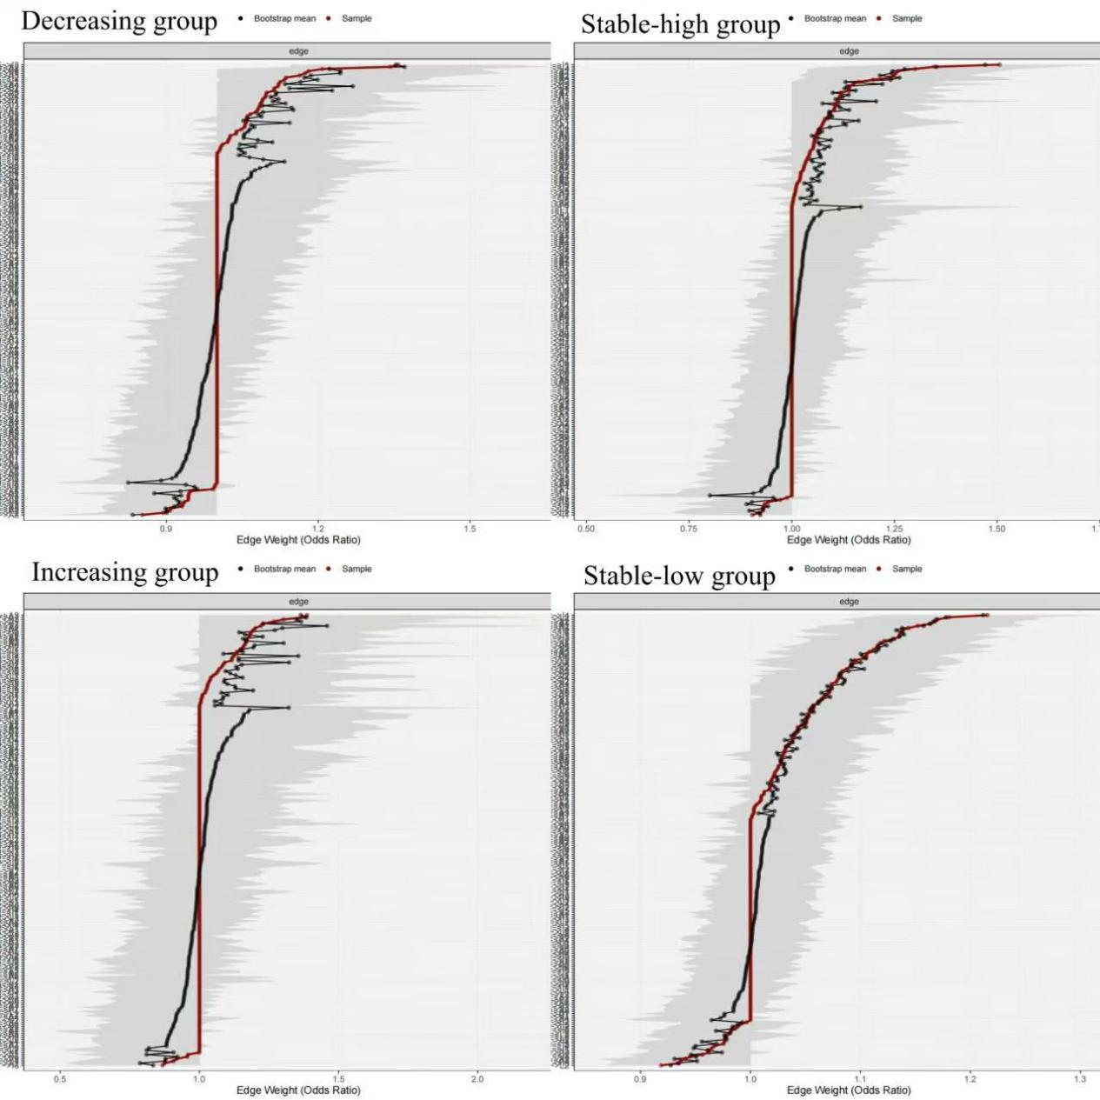Supplementary Fig. 1. Accuracy of edge-weight value estimation in the cross-lagged panel network cross distinct trajectories of loneliness symptoms. Each horizontal line represents an edge in the network. The red and gray dots on the line represent the sample values of the edge and the bootstrap mean of the edge-weight, respectively. The gray line on the horizontal line represents the bootstrapped confidence intervals (CIs) of the edge-weight, with narrower gray lines indicating higher accuracy for the edge-weight.
Note. A1=Nervousness, A2=Uncontrollable worrying, A3=Worry too much, A4=Trouble relaxing, A5=Restlessness, A6=Irritability, A7=Feeling afraid, I1=Salience, I2=Excessive use, I3=Neglect work, I4=Anticipation, I5=Lack of control, I6=Neglect social life, L1=Social Isolation, L2=Social Disconnectedness.

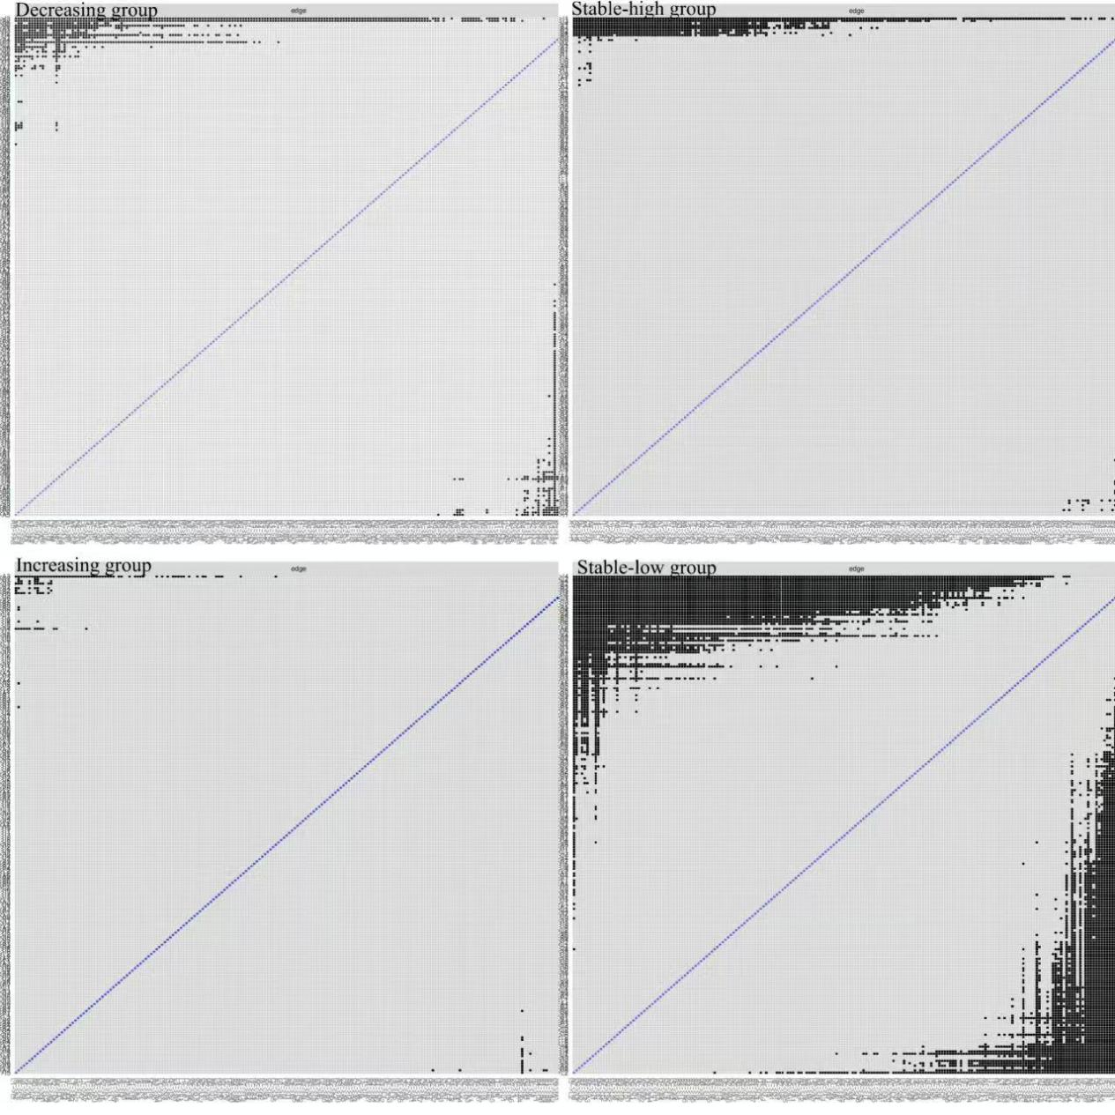Supplementary Fig. 2. Bootstrapped difference test for edges in the cross-lagged panel network (α = 0.05) cross distinct trajectories of loneliness symptoms. Gray boxes indicate no significant difference between edges-weight, while black boxes indicate significant differences between edges-weight.
Note. A1=Nervousness, A2=Uncontrollable worrying, A3=Worry too much, A4=Trouble relaxing, A5=Restlessness, A6=Irritability, A7=Feeling afraid, I1=Salience, I2=Excessive use, I3=Neglect work, I4=Anticipation, I5=Lack of control, I6=Neglect social life, L1=Social Isolation, L2=Social Disconnectedness.

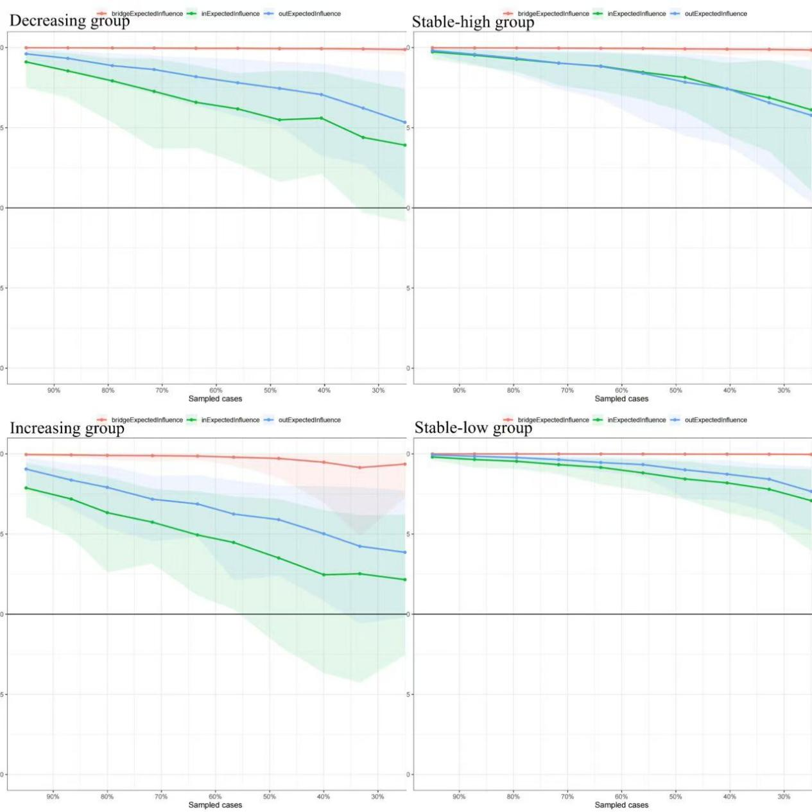Supplementary Fig. 3. Stability of centrality metrics in the cross-lagged panel network cross distinct trajectories of loneliness symptoms. The x-axis represents the percentage of case exclusions from the original sample, while the y-axis represents the correlation between the remaining sample and the original sample. The line represents the mean, while the shaded area indicates the range from the 2.5th percentile to the 97.5th percentile.

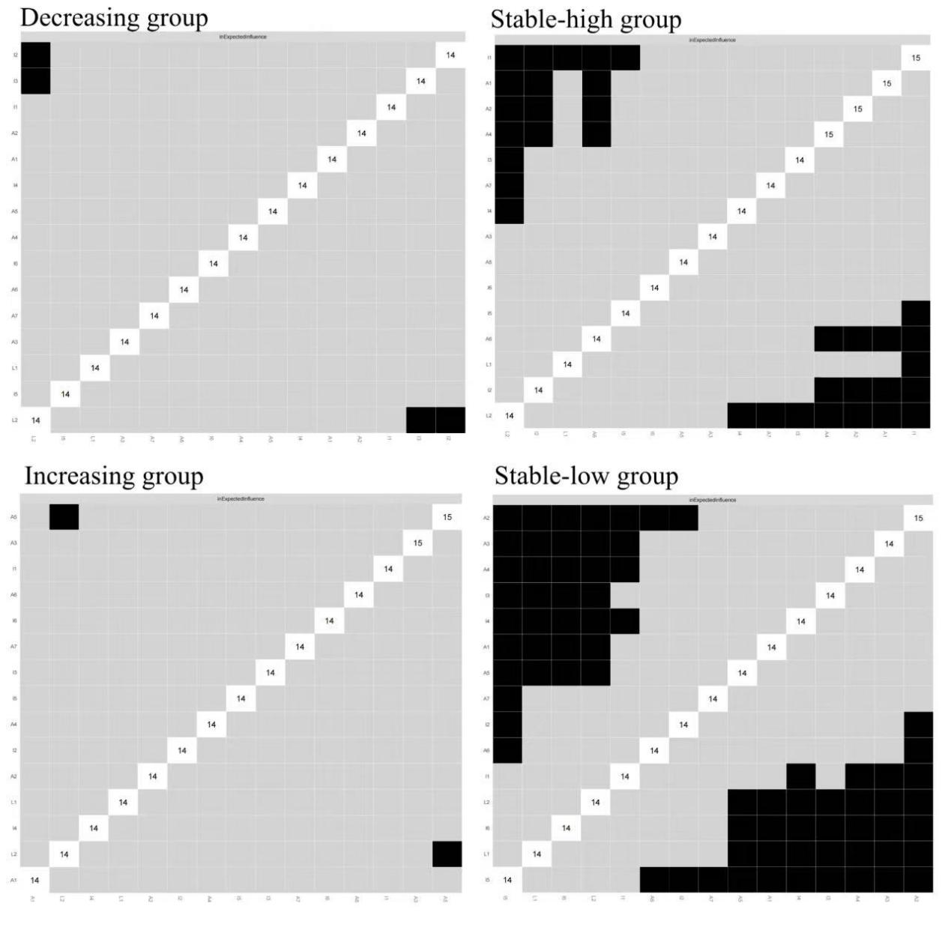Supplementary Fig. 4. Bootstrapped difference test for in-expected influence of nodes in the cross-lagged panel network cross distinct trajectories of loneliness symptoms. Gray boxes indicate no significant difference, while black boxes indicate significant differences (p < 0.05).
Note. A1=Nervousness, A2=Uncontrollable worrying, A3=Worry too much, A4=Trouble relaxing, A5=Restlessness, A6=Irritability, A7=Feeling afraid, I1=Salience, I2=Excessive use, I3=Neglect work, I4=Anticipation, I5=Lack of control, I6=Neglect social life, L1=Social Isolation, L2=Social Disconnectedness.

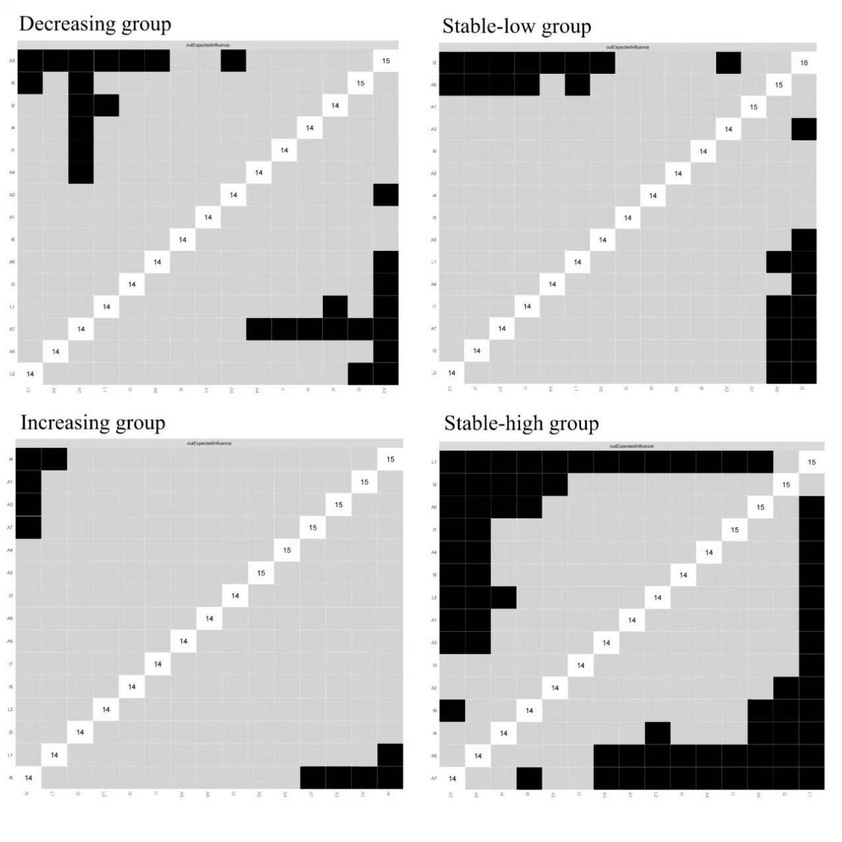Supplementary Fig. 5. Bootstrapped difference test for out-expected influence of nodes in the cross-lagged panel network cross distinct trajectories of loneliness symptoms. Gray boxes indicate no significant difference, while black boxes indicate significant differences (p < 0.05).
Note. A1=Nervousness, A2=Uncontrollable worrying, A3=Worry too much, A4=Trouble relaxing, A5=Restlessness, A6=Irritability, A7=Feeling afraid, I1=Salience, I2=Excessive use, I3=Neglect work, I4=Anticipation, I5=Lack of control, I6=Neglect social life, L1=Social Isolation, L2=Social Disconnectedness.

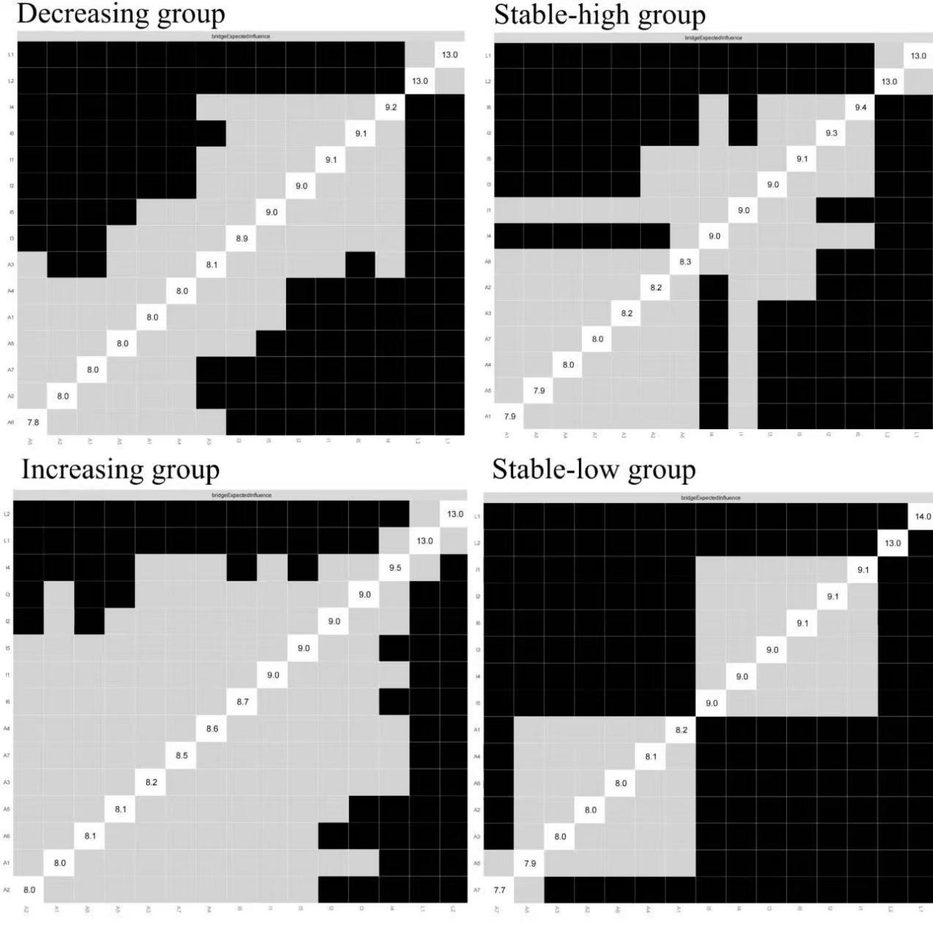Supplementary Fig. 6. Bootstrapped difference test for bridge-expected influence of nodes in the cross-lagged panel network cross distinct trajectories of loneliness symptoms. Gray boxes indicate no significant difference, while black boxes indicate significant differences (p < 0.05).
Note. A1=Nervousness, A2=Uncontrollable worrying, A3=Worry too much, A4=Trouble relaxing, A5=Restlessness, A6=Irritability, A7=Feeling afraid, I1=Salience, I2=Excessive use, I3=Neglect work, I4=Anticipation, I5=Lack of control, I6=Neglect social life, L1=Social Isolation, L2=Social Disconnectedness.

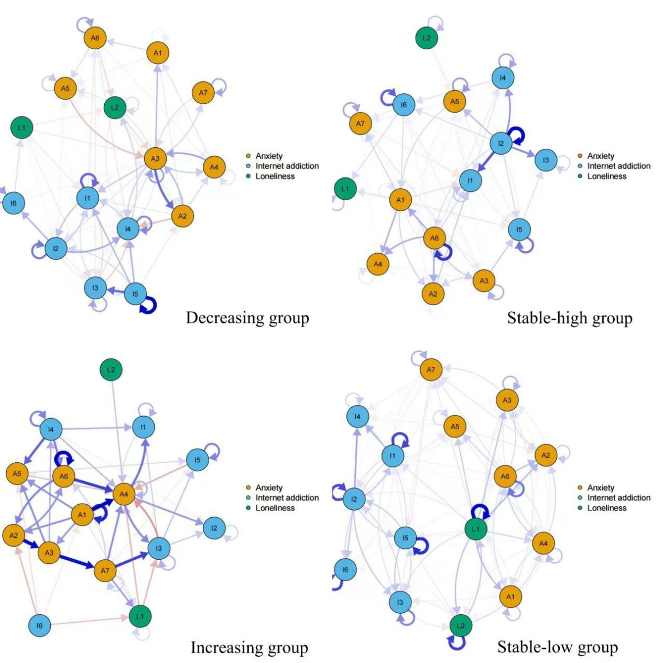Supplementary Fig. 7. Cross-lagged panel network of Internet addiction, loneliness, and anxiety symptoms from 2024 to 2025. Blue edges represent positive correlations (i.e., odds ratios greater than 1), and red edges represent negative correlations (i.e., odds ratios less than 1) The thickness of the edges represents the strength of OR, with thicker edges indicating stronger relationships. The Fig. includes autoregressive edges.
Note. A1=Nervousness, A2=Uncontrollable worrying, A3=Worry too much, A4=Trouble relaxing, A5=Restlessness, A6=Irritability, A7=Feeling afraid, I1=Salience, I2=Excessive use, I3=Neglect work, I4=Anticipation, I5=Lack of control, I6=Neglect social life, L1=Social Isolation, L2=Social Disconnectedness.

