Fig. S1 The experimental and simulated XRD patterns of [Ce₂(2,6-dipic)₄Ni(H₂O)₈]·8H₂O
Fig. S2 The experimental and simulated XRD patterns of [Pr₂(2,6-dipic)₄Ni(H₂O)₈]·8H₂O
Fig. S3 The experimental and simulated XRD patterns of [Nd₂(2,6-dipic)₄Ni(H₂O)₈]·8H₂O
Fig. S4 The experimental and simulated XRD patterns of [Sm₂(2,6-dipic)₄Ni(H₂O)₈]·8H₂O

Table S1 Selected bond lengths [Ã] and angles [°] of [Ce₂(2,6-dipic)₄Ni(H₂O)₈]·8H₂O

[Ce₂Ni(2,6-dipic)₄ (H₂O)₈]·4H₂O
Ce1-O7  Ce1-O4  Ce1-O9  Ce1-O5  Ce1-O2  Ce1-O2^{i}  O7-Ce1-O4  O7-Ce1-O9  O4-Ce1-O9  O7-Ce1-O5  O4-Ce1-O5  O9-Ce1-O5  O7-Ce1-O2  O4-Ce1-O2  O9-Ce1-O2  O5-Ce1-O2  O7- Ce1-O2^{i}  O4- Ce1-O2^{i}  O9- Ce1-O2^{i} | 2.489(4)  2.513(5)  2.517(5)  2.518(5)  2.531(4)  2.552(4)  78.14 (15)  82.62 (15)  73.78 (16)  123.79 (16)  81.98 (15)  139.49 (16)  154.07 (16)  123.59 (15)  89.99 (15)  76.89 (15)  101.70 (15)  154.43 (15)  131.77 (15) | Ce1-O10  Ce1-N2  Ce1-N1  O1-C1  N1-O11^{ii}  Ni1-O8  O5- Ce1-O2^{i}  O2- Ce1-O2^{i}  O7- Ce1-O10  C4- Ce1-O10  O9- Ce1-O10  O5- Ce1-O10  O2- Ce1-O10  O2^{i} - Ce1-O10  O7- Ce1-N2  O4- Ce1-N2  O9- Ce1-N2  O5-Ce1-N2  O2- Ce1-N2 | 2.594(5)  2.611(5)  2.618(5)  1.224(9)  2.055(5)  2.059(5)  76.99 (15)  65.33 (17)  74.67 (16)  134.39 (16)  67.02 (16)  143.62 (16)  79.55 (15)  68.08 (15)  61.91 (15)  70.25 (16)  133.38 (16)  61.91 (15)  134.81 (15)
Note: i Represents the position (1/2-X, 1/2-Y, 1-Z); ii Represents the position (1-X, +Y, 3/2-Z).

Table S2 Selected bond lengths [Ã] and angles [°] of [Nd₂(2,6-dipic)₄Ni(H₂O)₈]·8H₂O

[Nd₂Ni(2,6-dipic)₄ (H₂O)₈]·4H₂O
Nd1-N1  Nd1-O2^{i}  Nd1-O2  Nd1-N2  Nd1-O5  Nd1-O4  O2-Nd1-N1  O2^{i} -Nd1-N1  O2-Nd1-O2^{i}  O2^{i} -Nd1-N2  O2-Nd1-N2  O2-Nd1-O10  O2^{i} -Nd1-O10  N2-Nd1-N1  O5-Nd1-N1  O5-Nd1-O2  O5-Nd1-O2^{i}  O5-Nd1-N2  O5-Nd1-O10  O4-Nd1-N1  O4-Nd1-O2^{i}  O4-Nd1-O2  O4-Nd1-N2  O4-Nd1-O5 | 2.579(5)  2.532(4)  2.509(4)  2.577(5)  2.488(4)  2.481(4)  62.24(13)  122.83(14)  65.40(15)  85.93(13)  134.94(14)  79.36(14)  68.50(14)  116.48(14)  70.98(14)  77.10(13)  76.70(14)  62.34(14)  143.72(14)  62.94(14)  153.64(13)  125.05(13)  70.13(14)  82.33(14) | Nd1-O9  Nd1-O7  Nd1-O10  C1-O1  C1-O2  Ni1-O8^{ii}  O4-Nd1-O9  O4-Nd1-O10  O9-Nd1-N1  O9-Nd1-O2  O9-Nd1-O2^{i}  O9-Nd1-N2  O9-Nd1-O5  O9-Nd1-O10  O7-Nd1-N1  O7-Nd1-O2^{i}  O7-Nd1-O2  O7-Nd1-N2  O7-Nd1-O5  O7-Nd1-O4  O7-Nd1-O9  O7-Nd1-O10  O10-Nd1-N1  O10-Nd1-N2 | 2.485(4)  2.464(4)  2.547(4)  1.228(8)  1.275(8)  1.506(8)  73.55(14)  133.95(14)  69.23(14)  90.65(14)  132.71(13)  132.92(14)  139.56(14)  67.27(14)  135.78(14)  101.39(13)  152.55(13)  62.76(14)  125.06(13)  77.81(14)  81.24(14)  73.30(14)  120.27(15)  122.99(15)
Note: i Represents the position (1/2-X, 1/2-Y, 1-Z); ii Represents the position (1-X, +Y, 3/2-Z).

Table S3 Selected bond lengths [Ã] and angles [°] of [Sm₂(2,6-dipic)₄Ni(H₂O)₈]·8H₂O

[Sm₂Ni(2,6-dipic)₄ (H₂O)₈]·4H₂O
Sm1-N1  Sm1-O2  Sm1-O2^{i}  Sm1-N2  Sm1-O5  Sm1-O3  O2-Sm1-N1  O2^{i} -Sm1-N1  O2-Sm1-O2^{i}  O2^{i} -Sm1-N2  O2-Sm1-N2  O2-Sm1-O10  O2^{i} -Sm1-O10  N2-Sm1-N1  O5-Sm1-N1  O5-Sm1-O2^{i}  O5-Sm1-O2  O5-Sm1-N2  O5-Sm1-O9  O5-Sm1-O10  O3-Sm1-N1  O3-Sm1-O2  O3-Sm1-O2^{i}  O10-Sm1-N1 | 2.539(9)  2.493(7)  2.504(7)  2.532(9)  2.460(8)  2.458(7)  62.6(3)  123.4(3)  65.7(3)  85.0(3)  135.1(3)  79.3(3)  68.4(3)  117.2(3)  70.7(3)  77.0(3)  77.3(2)  62.9(3)  139.9(3)  143.9(3)  64.1(3)  126.7(3)  153.4(3)  120.6(3) | Sm1-O7  Sm1-O9  Sm1-O10  C1-O1  N1-C2  Ni1-O8^{ii}  O3-Sm1-N2  O3-Sm1-O5  O3-Sm1-O9  O3-Sm1-O10  O7-Sm1-N1  O7-Sm1-O2^{i}  O7-Sm1-O2  O7-Sm1-N2  O7-Sm1-O5  O7-Sm1-O3  O7-Sm1-O9  O7-Sm1-O10  O9-Sm1-N1  O9-Sm1-O2  O9-Sm1-O2^{i}  O9-Sm1-N2  O9-Sm1-O10  O10-Sm1-N2 | 2.448(7)  2.463(8)  2.524(8)  1.239(14)  1.344(14)  1.355(14)  70.2(3)  83.0(3)  73.3(3)  133.1(3)  136.1(3)  100.5(3)  151.1(3)  63.3(3)  126.2(3)  77.3(3)  79.9(3)  71.9(3)  70.0(3)  91.3(2)  132.9(3)  132.5(3)  67.1(3)  122.0(3)
Note: i Represents the position (1/2-X, 1/2-Y, 1-Z); ii Represents the position (1-X, +Y, 3/2-Z).

Fig. S5 The experimental IR spectrum of the pure ligand
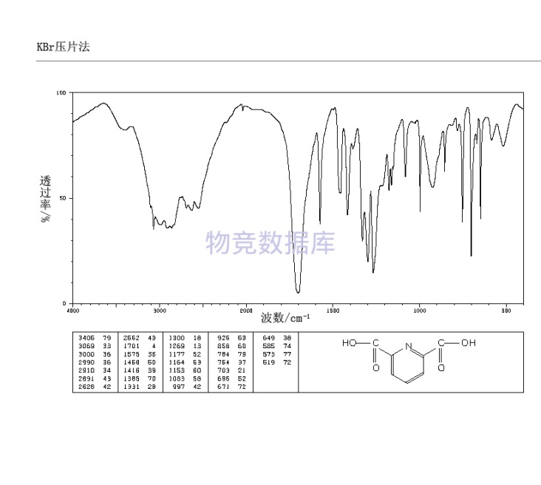
Fig. S6 The standard IR spectrum of the pure ligand from http://www.basechem.org/

