Supplementary material
Table S1. Performance Metrics of Prediction Models without Boruta
Models | AUC-ROC | Precision | Specificity | Recall | F1 | MCC
Xgboost | 0.722 | 0.787 | 0.922 | 0.429 | 0.556 | 0.416
Catboost | 0.724 | 0.768 | 0.912 | 0.434 | 0.555 | 0.405
Lightgbm | 0.714 | 0.705 | 0.854 | 0.520 | 0.599 | 0.401
Random Forest | 0.715 | 0.802 | 0.925 | 0.449 | 0.576 | 0.440
Logistic regression | 0.675 | 0.678 | 0.871 | 0.404 | 0.506 | 0.316
Best threshold (0.40)
Xgboost |  | 0.639 |  | 0.591 | 0.614 | 0.377
Catboost |  | 0.625 |  | 0.606 | 0.615 | 0.363
LightGBM* |  | 0.587 |  | 0.626 | 0.606 | 0.327
Random Forest |  | 0.611 |  | 0.611 | 0.611 | 0.349
Logistic regression |  | 0.458 |  | 0.823 | 0.588 | 0.183

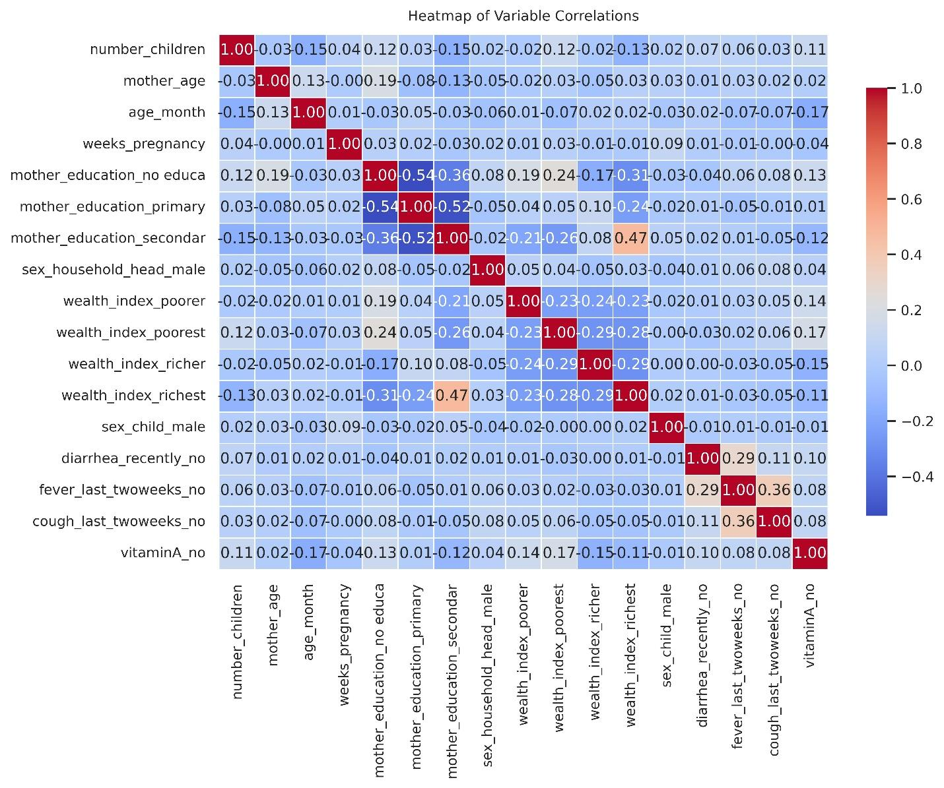

Figure S1. Correlation of variables after the creation of dummies and standardization

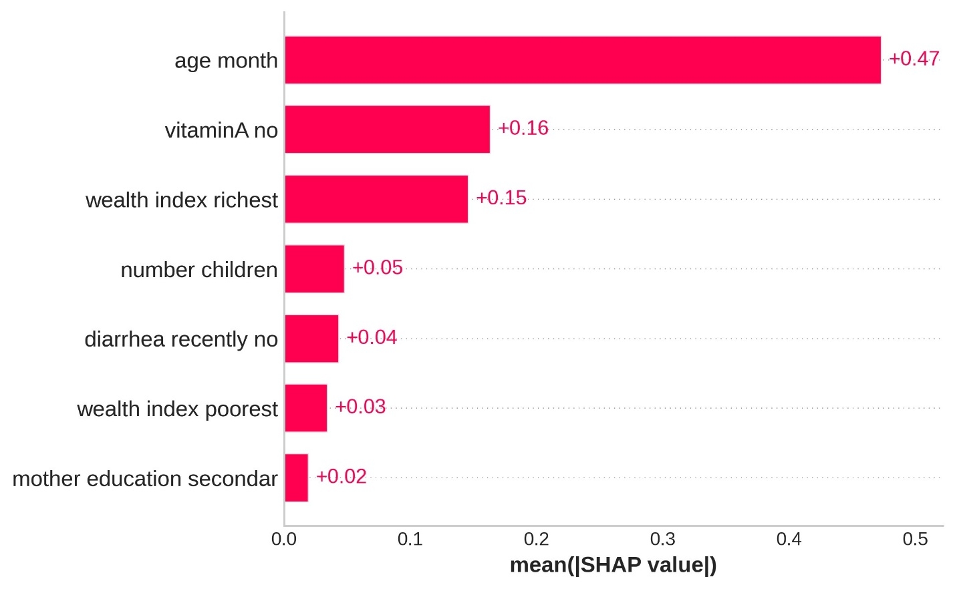
Figure S2. Average feature importance in predicting anemia in children under 5 years old (SHAP values)

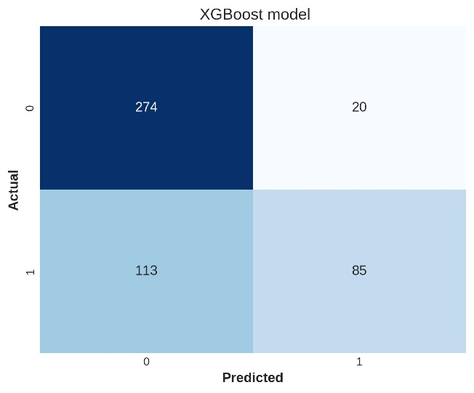

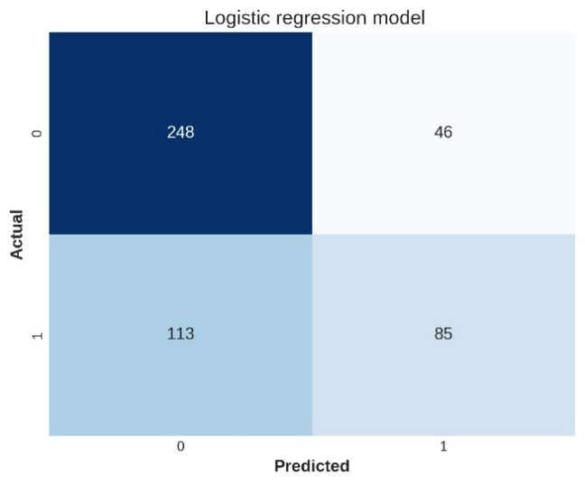

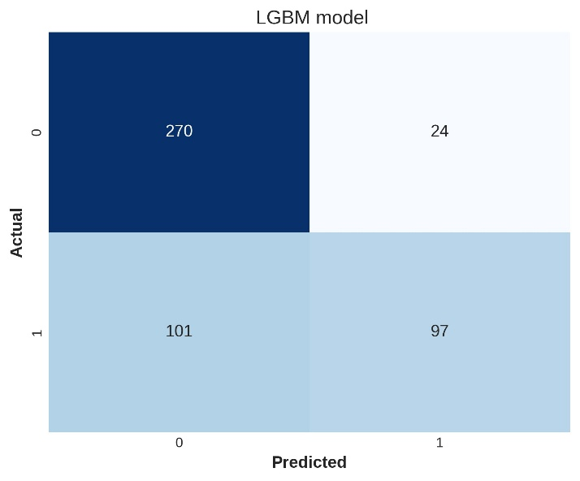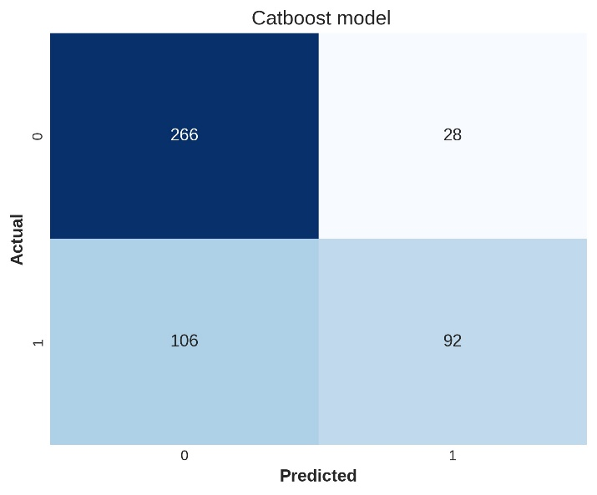
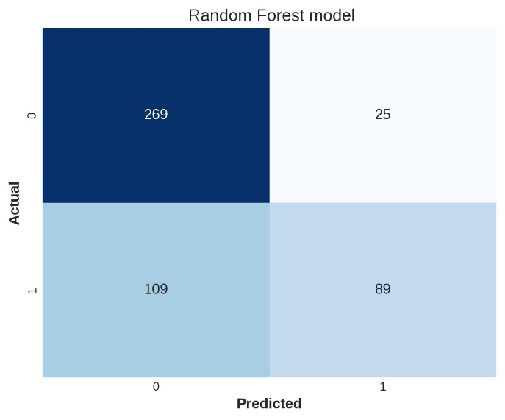

Figure S3. Confusion Matrix for predicting anemia in children under 5 years old

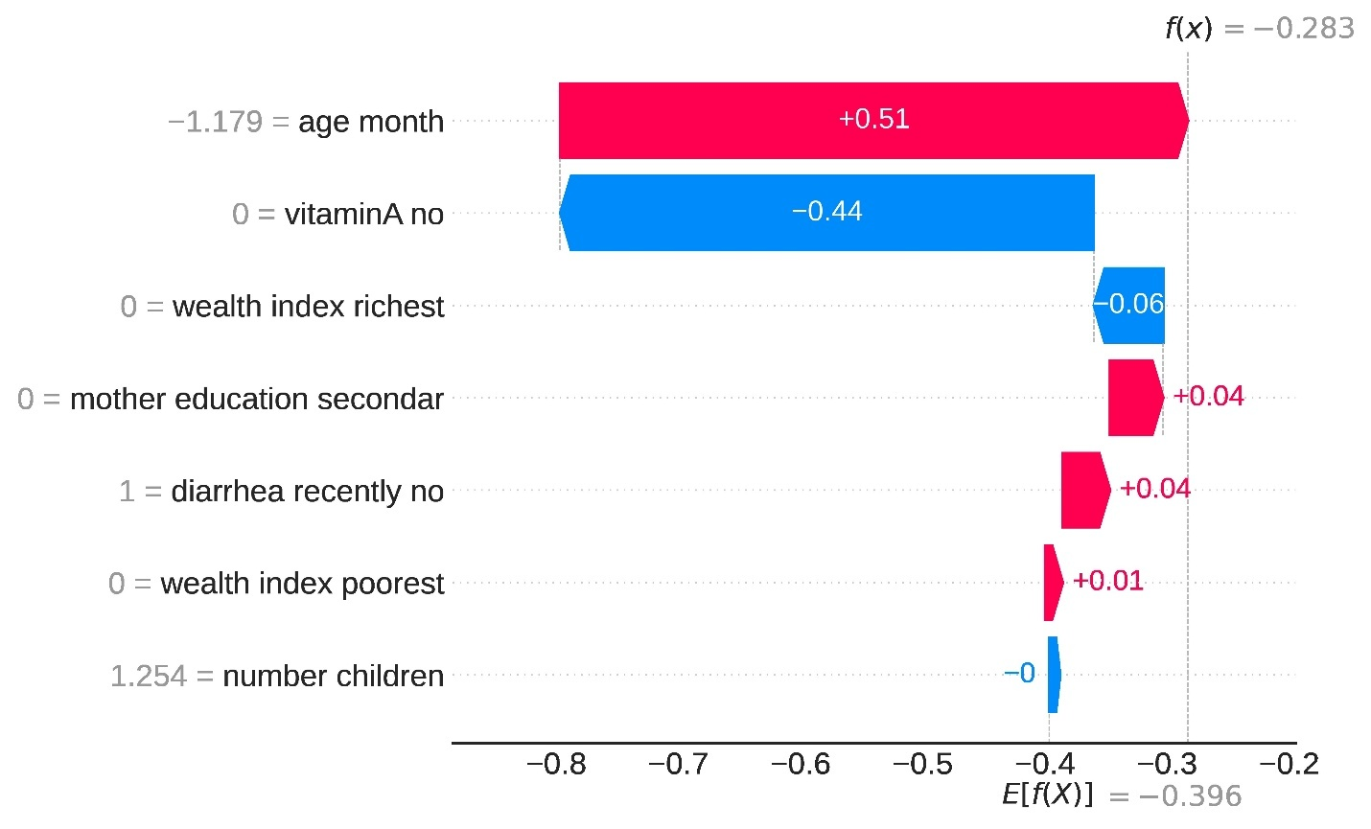 Figure S4. SHAP waterfall plot for variable contributions to the individual prediction of anemia

