Supplementary material:

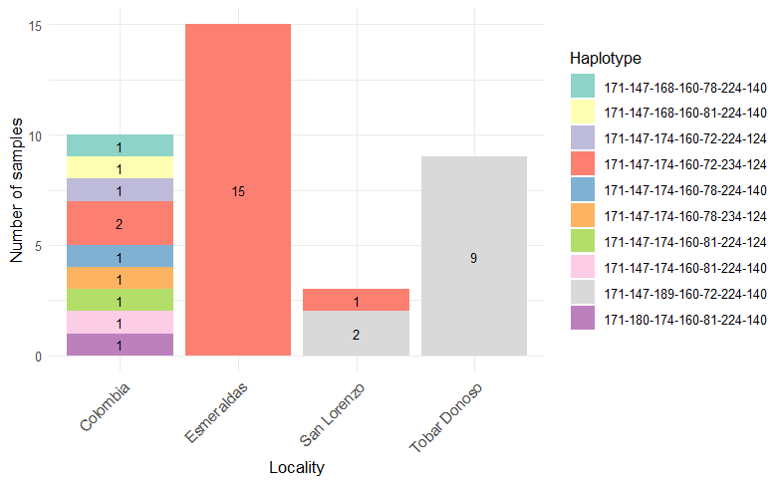
Supplementary figure 1. Complete haplotypes identified in this study. Microsatellite markers identified a small number of full haplotypes in Ecuadorian samples.

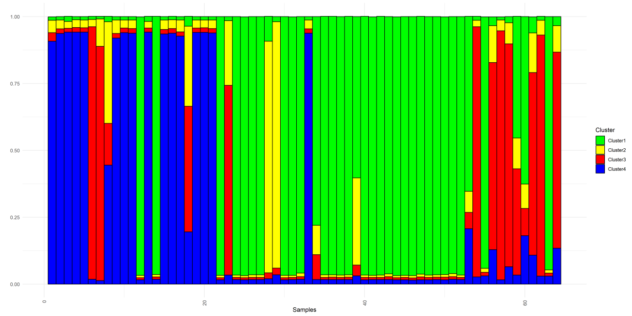
Supplementary figure 2. Population inference scheme of Plasmodium falciparum isolates from Esmeraldas and Carchi provinces, Ecuador (2019 – 2021) using Structure software. The analysis incorporated samples from Tobar Donoso (2019 – 2020; Samples: 0 to 4, 6 to 11, 13, 16, 17, 19 to 21, and 113), Esmeraldas (2019 – 2020; Samples: 25 to 32, and 35 to 52), and San Lorenzo (2019 – 2021; Samples: 5, 12, 15, 22, and 56), as well as Colombian samples collected in the north coast of Ecuador (Samples: 14, 18, 23, 24, 34, 53 to 55, and 57 to 64), between 2019 and 2022. Each color stands for a distinct genetic group.
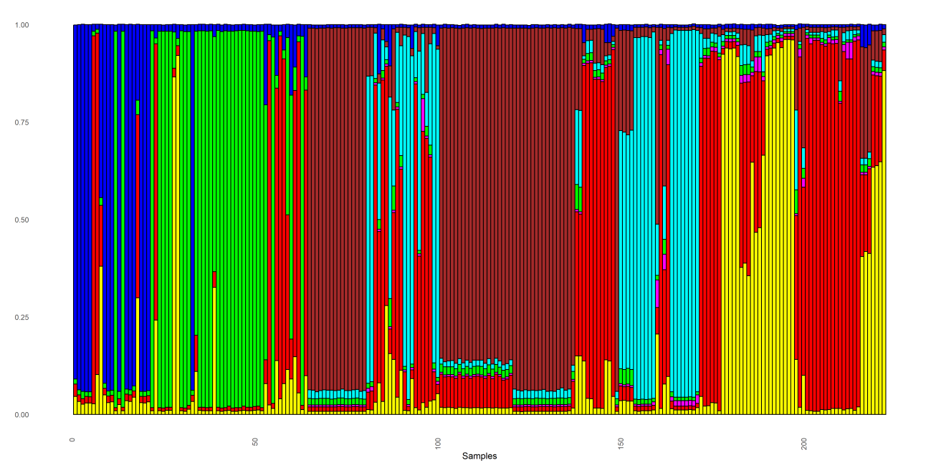
Supplementary figure 3. Population inference scheme of Plasmodium falciparum isolates from Ecuador (2019 – 2021) and Colombia (2008 - 2012 and 2018) using Structure Software. Comparative analyses included Ecuadorian isolates described in Supplementary Figure 2 (Samples 0 to 64), as well as Colombian samples from Antioquia (2012; Samples 65 to 100), Chocó (2018; Samples 101 to 148), Córdoba (2008 – 2009; Samples 149 to 163), Nariño (2008 – 2009; Samples 164 to 197), and Valle (2008 – 2009; Samples 198 to 222). Each color corresponds to a different genetic group.

