SUPPLEMENTARY MATERIALS

Phenoxazinone Synthase Functional Mimic Activity of Mixed-ligand Copper(II) Complexes of L-proline and Diimine Ligands Conjugated with Chitosan

Liji Muthirakalayil Abraham,ª Manikandan Varadhan,ª Kugan Mahalingam,ª Thangaraja Chinnathangavel,^{b} and Venugopal Rajendiran,*ª

ªDepartment of Chemistry, School of Basic and Applied Sciences, Central University of Tamil Nadu, Thiruvarur 610101, India
^{b}Department of Chemistry, Anna University Regional Campus, Madurai 625019, India
*Corresponding Author: Venugopal Rajendiran, Email: rajendiran@cutn.ac.in

Sl.No. | Content | Page No.
1 | Figure S1. ¹H NMR spectra of (a) and (b) correspond to Boc-Proline-chitosan and chito-pro, respectively. (c) and (d) correspond to ¹³C NMR spectrum of Boc-Proline-chitosan and chito-pro, respectively, in D₂O. | S3
2 | Figure S2. FT-IR Spectrum of Ligand(L) | S5
3 | Figure S3. FT-IR Spectrum of Complex 1 | S5
4 | Figure S4. FT-IR Spectrum of Complex 2 | S6
5 | Figure S5. ¹H NMR of APX | S6
6 | Figure S6. HR-MS spectrum of APX | S7
7 | Table S1. Comparison of FT-IR Data | S8

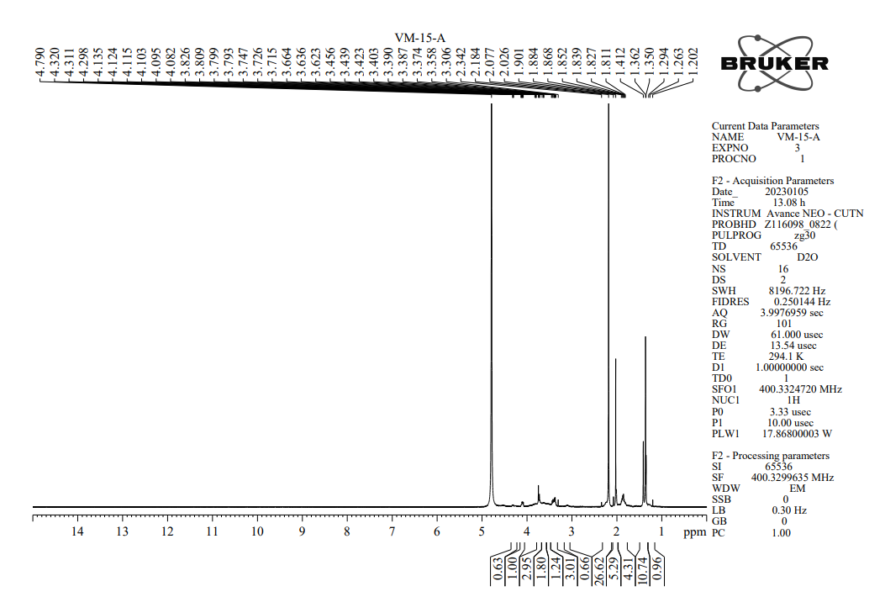

(a)
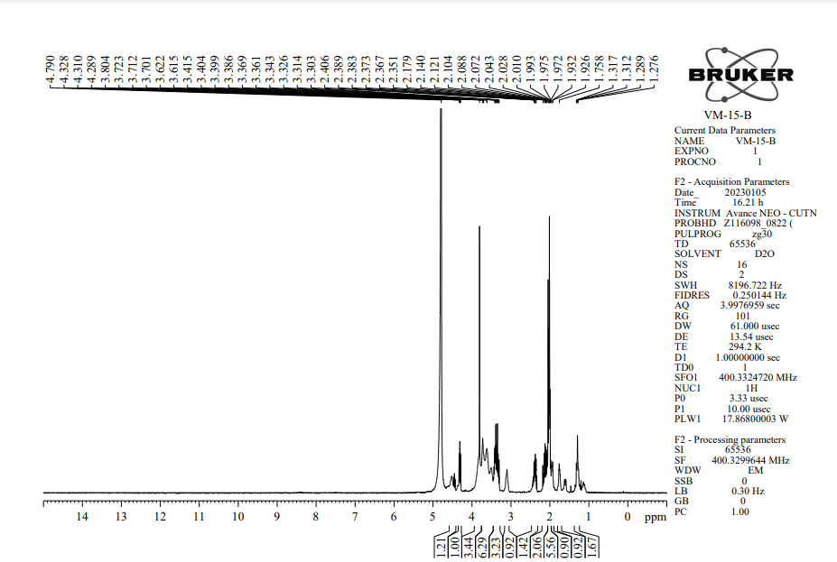

(b)
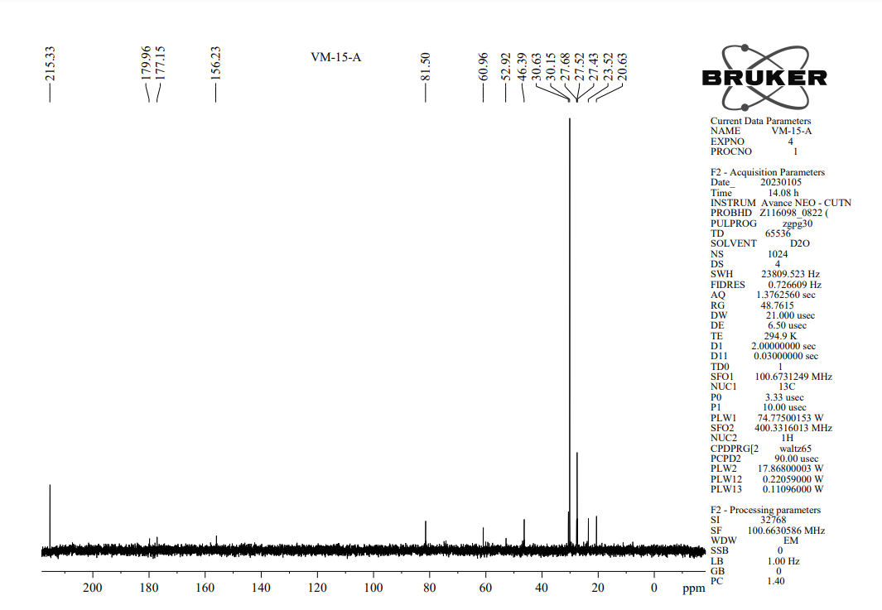

(c)
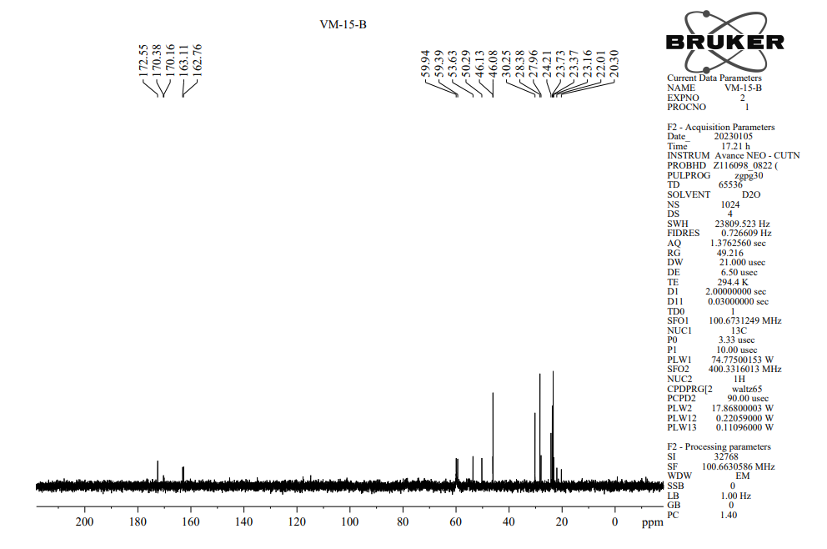

(d)
Figure S1. ¹H NMR spectra of (a) and (b) correspond to Boc-Proline-chitosan and chito-pro, respectively. (c) and (d) correspond to ¹³C NMR spectrum of Boc-Proline-chitosan and chito-pro, respectively, in D₂O.
Figure S2. FT-IR Spectrum of Ligand(L)
Figure S3. FT-IR Spectrum of Complex 1
Figure S4. FT-IR Spectrum of Complex 2
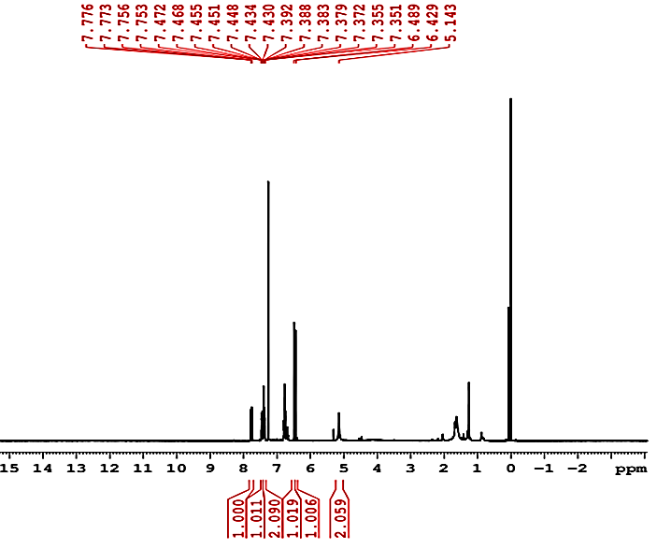
Figure S5. ¹H NMR of APX

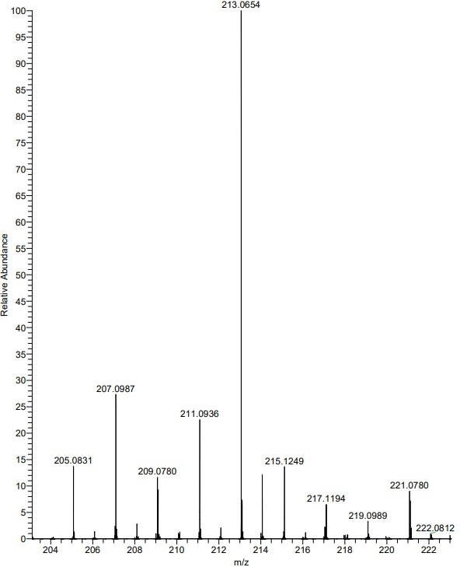
Figure S6. HR-MS spectrum of APX

Table S1. Comparison of FT-IR Data
Functional groups | L  (cm⁻¹) | 1  (cm⁻¹) | 2  (cm⁻¹)
ν(N-H) | 3268 | 3081 | 2897
ν(C=N) | - | 1566 | 1598
ν(-OH)_{bend} | 1406 | 1425 | 1449
ν(C-H)_{S} | 2935 | 3081 | 2897
ν(C=O) | 1699 | 1610 | 1601
ν(Cu-N) | - | 430 | 413
ν(O-C-O) | 1092 | 1082 | 1092
ν(C-H)_{out of plane} | 612 | 619 | 618

