APPENDIX

Appendix Figure 1: CoMET® analytics provide risk estimates for multiple adverse outcomes to be displayed for any patient in the hospital.
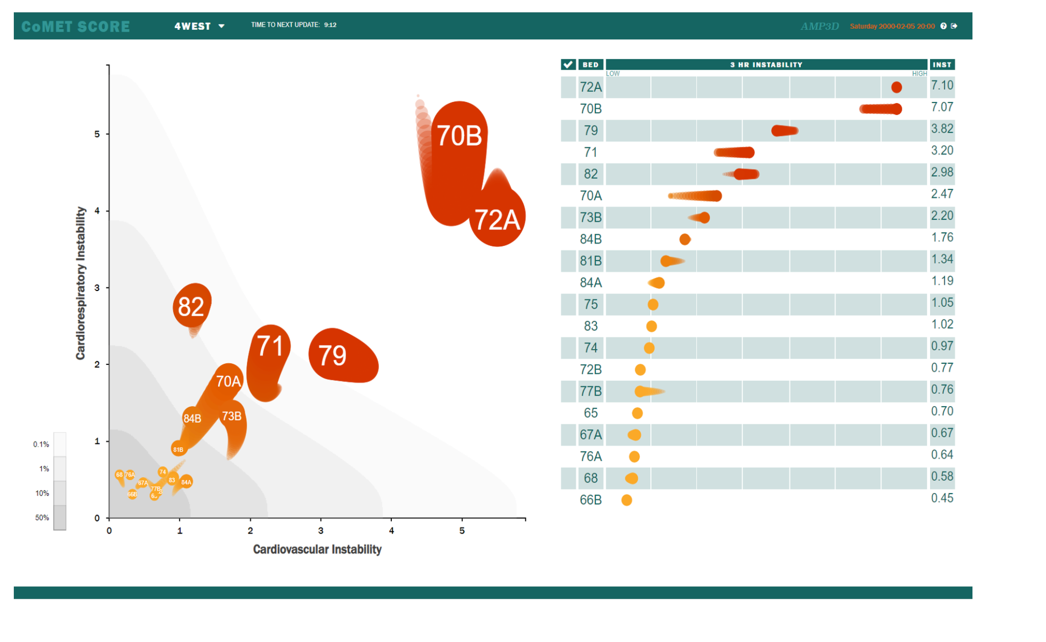

Appendix Figure 2: Total charges on the logarithmic scale among the full study cohort and the at-risk subgroup

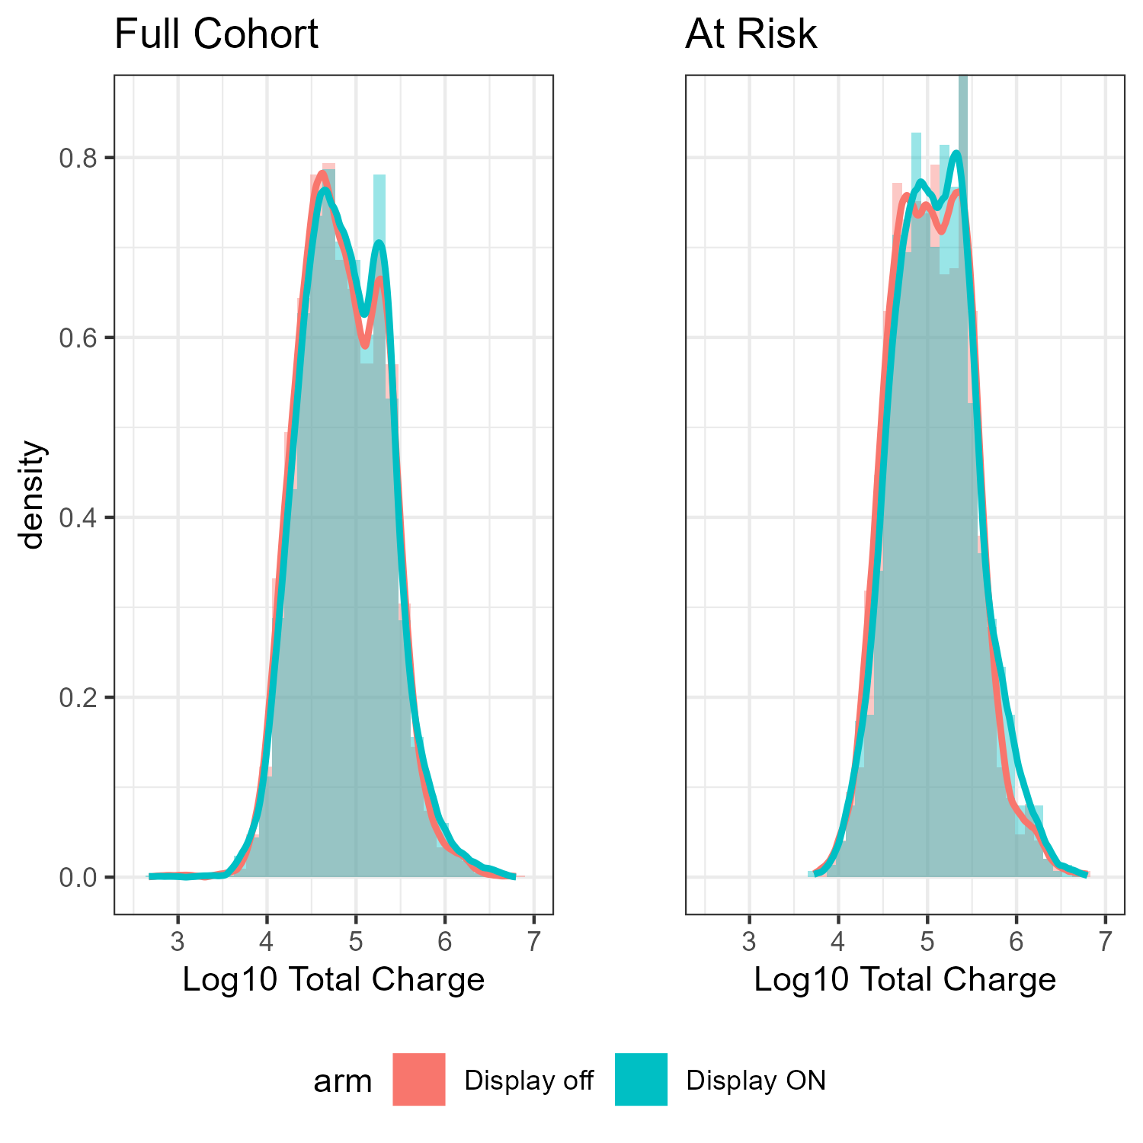

Appendix Figure 3: Costs (log 10) shown for each payor. The intervention and standard of care group demonstrated similar distributions.

