Supplementary materials
of
Localization of micron-scale lithium polysulfide-rich phases causes anode heterogeneity in lean-electrolyte lithium–sulfur batteries

Supplementary Figure 1. Configuration and discharge profile of the fabricated 3-stacked pouch cell with FN electrolyte. a, Schematic illustration of the 3-stacked pouch cell consisting of two sulfur (S) cathodes and three Li metal anodes separated by propylene (PP) separators. b, The first discharge voltage profile at 0.05 C of the pouch cell.

Supplementary Figure 2. Statistical size distribution of the domains with LiPS residues on the Li anode at an E/S ratio of 2.3 μL mg_{s}⁻¹.

Supplementary Figure 3. Discharge profile of the fabricated 8-stacked pouch cell with FN electrolyte. The first discharge voltage profile of the pouch cell at 0.05 C, representing a discharge capacity of 0.7 Ah.

Supplementary Figure 4. Specific charge–discharge voltage profiles of the Li–S pouch cells at selected cycles. a, 5 μL mg_{s}⁻¹, b, 3.5 μL mg_{s}⁻¹ and c, 2.3 μL mg_{s}⁻¹. After two activation cycles at 0.05 C and 0.1 C, respectively, the cell was operated at 0.2 C from the 5th cycle onward.

Supplementary Note 1.
To quantify the concentration of LiPS in the electrolyte, we conducted a series of experiments using a prototype pouch cell assembled at an E/S ratio of 2.3 μL mg_{s}⁻¹. The cell was cycled at a rate of 0.05 C for three activation cycles, after which it was discharged to 2.1 V—corresponding to the potential at which Li₂S₄ reaches its maximum concentration, prior to the precipitation of insoluble Li₂S. The cell was then rested for 36 hours to allow the electrolyte to reach a steady-state and maximum LiPS concentration. Following the rest period, the cell was disassembled, and the separator was collected and thoroughly washed to recover the electrolyte for ultraviolet–visible (UV–Vis) spectroscopy analysis. Electrolyte resides within the pores of the separator. The recovered solution was diluted 10⁴-fold before measurement.

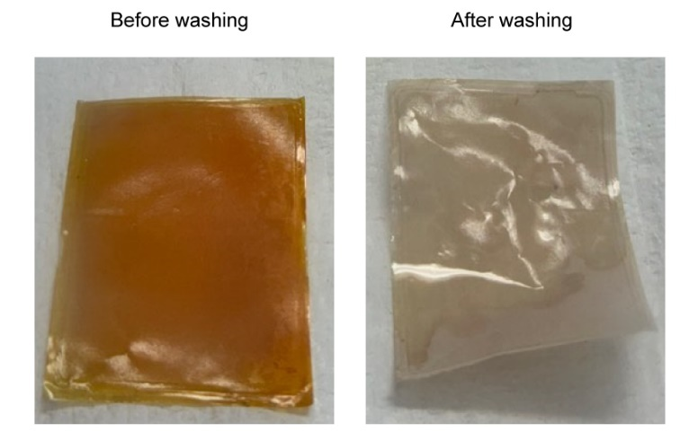
Supplementary Figure 5. Digital photographs of the separator before and after washing with 1,2-dimethoxylethane. The separator was extracted from the pouch cell after the discharge to 2.1 V (Supplementary Note 1).

Supplementary Figure 6. ⁷Li Nuclear Magnetic Resonance (NMR) spectra of FN and Li₂S₄-containing FN electrolytes with various Li₂S₄ concentrations. The ⁷Li NMR peak gradually shifted to a lower chemical shift (upfield) with increasing Li₂S₄ concentration in the catholyte.

Supplementary Figure 7. Coordination numbers of various electrolyte components in FN electrolyte and Li₂S₄-containing catholytes. a, FN b, FN + 0.2M Li₂S₄ c, FN + 0.5M Li₂S₄ d, FN + 0.8M Li₂S₄ e, FN + 1.0M Li₂S₄. Here, S_{ter} denotes the S atoms in S₄²⁻ that coordinate with Li⁺.

Supplementary Figure 8. Initial Coulombic efficiency (CE) for Li plating/stripping in FN and Li₂S₄-containing FN electrolytes.

Supplementary Figure 9. The structure of the SEI layer formed in FN + 0.5 M Li₂S₄ electrolyte. a, High-resolution cryo-TEM image of the SEI layer on the Li surface. b, Corresponding fast Fourier transform (FFT) pattern highlighting the structural features of the SEI.

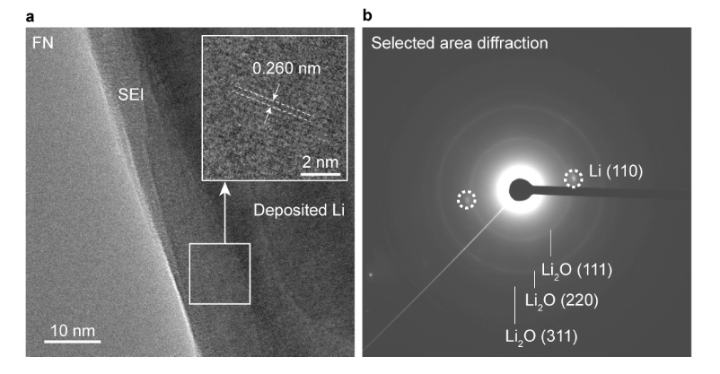
Supplementary Figure 10. The structure of the SEI layer formed in FN electrolyte. a, High-resolution cryo-TEM image of the SEI layer on the Li surface. b, Corresponding FFT pattern highlighting the structural features of the SEI.

Supplementary Figure 11. SEM images of Li electrode collected from Li|Ni half cell operated for 15 cycles at 1 mA cm⁻² / 1 mAh cm⁻² in Li₂S₄-containing FN electrolytes. a, FN + 0.2 M Li₂S₄ b, FN + 0.5 M Li₂S₄ and c, FN + 0.8 M Li₂S₄. The (F + N)/S ratios obtained from EDS analysis at the dendritic regions are indicated in each image. The decreasing (F + N)/S ratio with increasing Li₂S₄ concentration suggests a reduced contribution of fluorine- and nitrogen-containing species relative to sulfur-rich components at the lithium surface.

Supplementary Figure 12. Snapshot from MD simulation conducted after 5nm simulation. a, FN electrolyte b, FN + 0.2 M Li₂S₄ c, FN + 0.5 M Li₂S₄ d, FN + 0.8 M Li₂S₄. e, FN + 1.0 M Li₂S₄. Electrolyte components other than LiPS species were depicted as lines to better illustrate the formation of LiPS-rich phases.

Supplementary Figure 13. Magnified snapshot images of single-linkage LiPS and multi-linkage LiPS from MD simulation. a, (Li⁺ - S₄²⁻)₁ - Li⁺ b, (Li⁺ - S₄²⁻)₂ - Li⁺ c, (Li⁺ - S₄²⁻)₃ - Li⁺ (Lithium: purple, Sulfur: yellow, scarlet and brown). Supplementary Fig. 8 and 13 shows that as the LiPS concentration in the electrolyte increases, LiPS species increasingly aggregate, forming interconnected networks unlike those observed at lower concentrations. As a result, LiPS species with multiple linkages emerge, suggesting the formation of localized LiPS-rich phases.

Supplementary Figure 14. Number of salt anions and PS coordinated to Li⁺ for various LiPS aggregate structures. The coordination number was calculated by averaging the number of species coordinated to Li⁺ during the MD simulation. When more PS species coordinate with Li⁺, larger LiPS clusters are formed, leading to reduced anion participation and the emergence of anion-deficient structures.

Supplementary Figure 15. SEM images and sulfur EDS mapping of Li electrodes collected from Li|Ni half cells after 15 cycles at 1 mA cm⁻² / 1 mAh cm⁻². a, FN + 0.5 M Li₂S₈ and b, FN + 0.67 M Li₂S₆. The LiPS concentration was adjusted to 14 wt% to reflect their actual level in Li─S full cells.

Supplementary Figure 16. CE measurements of the Li|Ni cells with FN + 0.5 M Li₂S₈, FN + 0.67 M Li₂S₆, and FN + 1.0 M Li₂S₄. b, Average CE measurements obtained using the modified Aurbach method. a, Initial CE measurements.

Supplementary Figure 17. Snapshot from MD simulation conducted after 5nm simulation and magnified snapshot of multi-linkage Li₂S₆ from MD simulation. a, FN + 0.5M Li₂S₈ a, FN + 0.67M Li₂S₆ c, (Li⁺ - S₆⁻²)₂. Electrolyte components other than LiPS species were depicted as lines to better illustrate the formation of LiPS-rich phases.

Supplementary Figure 18. Coordination numbers of various electrolyte components in FN electrolyte containing Li₂S₈ and Li₂S₆. a, FN + 0.5 M Li₂S₈ and b, FN + 0.67 M Li₂S₆. The lower coordination of S₆²⁻ and S₈²⁻ compared to S₄²⁻ indicates a weaker tendency to form LiPS-rich phases.

Supplementary Figure 19. LiPS-rich phases in the Li₂S₈ and Li₂S₆-containing electrolytes. a, FN + 0.5 M Li₂S₈ and b, FN + 0.67 M Li₂S₆.

Supplementary Figure 20. DFT calculation of Li⁺ binding energy for FSI⁻, NO₃⁻ and I⁻ anions.

Supplementary Figure 21. Comparison of ⁷Li NMR spectra of FNF, FNN, and FNI electrolytes with and without 1.0 M Li₂S₄ of from various electrolytes. a, FNF b, FNN c, FNI.

Supplementary Figure 22. Calculation of ionic conductivities among electrolytes from SUS-SUS symmetric cell, captivated at Polypropylene separator. a, Ohmic resistance from SUS-SUS symmetric cell b, calculated ionic conductivities of various electrolytes, captivated at polypropylene (PP) separator.

Supplementary Figure 23. Initial CE measurement of the Li|Ni cells with FNF + 1.0 M Li₂S₄, FNN + 1.0 M Li₂S₄, and FNI + 1.0 M Li₂S₄.

Supplementary Figure 24. CE measurements of the Li|Ni cells with FNI. a, Initial CE measurements. b, Average CE measurements obtained using the modified Aurbach method.

Supplementary Figure 25. SEM images, sulfur EDS maps and (fluorine + nitrogen) / sulfur ratio comparison between two points of Li anodes retrieved from 0.27 Ah pouch cells (E/S ratio = 2.3 μL mg_{s}⁻¹) after 20 cycles at a rate of 0.2 C. a, FNF, b, FNN, c, FNI. Two regions of the Li anodes were selected to represent the granular region (point 1) and the dendritic region (point 2).

Supplementary Figure 26. Cycling performance of high-energy density Li─S pouch cell. a, Cycling performance of the assembled cell. b, Weight fraction of the cell components.

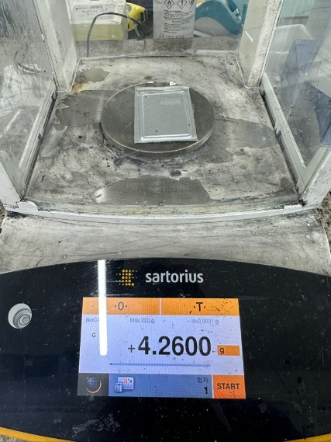
Supplementary Figure 27. Weight of the assembled 8-stack pouch cells. Exterior packages (tabs and Al packages), calculated from subtracting total weight and cell weight, was 1.401g.

Double-side coated Sulfur electrode (slurry + Al current collector) | 1.276 g
Li metal | 0.282 g
Separator (PP 2400) | 0.356 g
Electrolyte (E/S ratio = 1.5) | 0.945 g
Capacity | 706.7 mAh
Average discharge voltage | 2.12 V
Energy density (Without tab/packages) | 524 Wh kg⁻¹
Energy density (With tab/packages) | 352 Wh kg⁻¹

Supplementary Table 1. Weight information for calculating energy densities of the 8-stacked pouch-cell.

