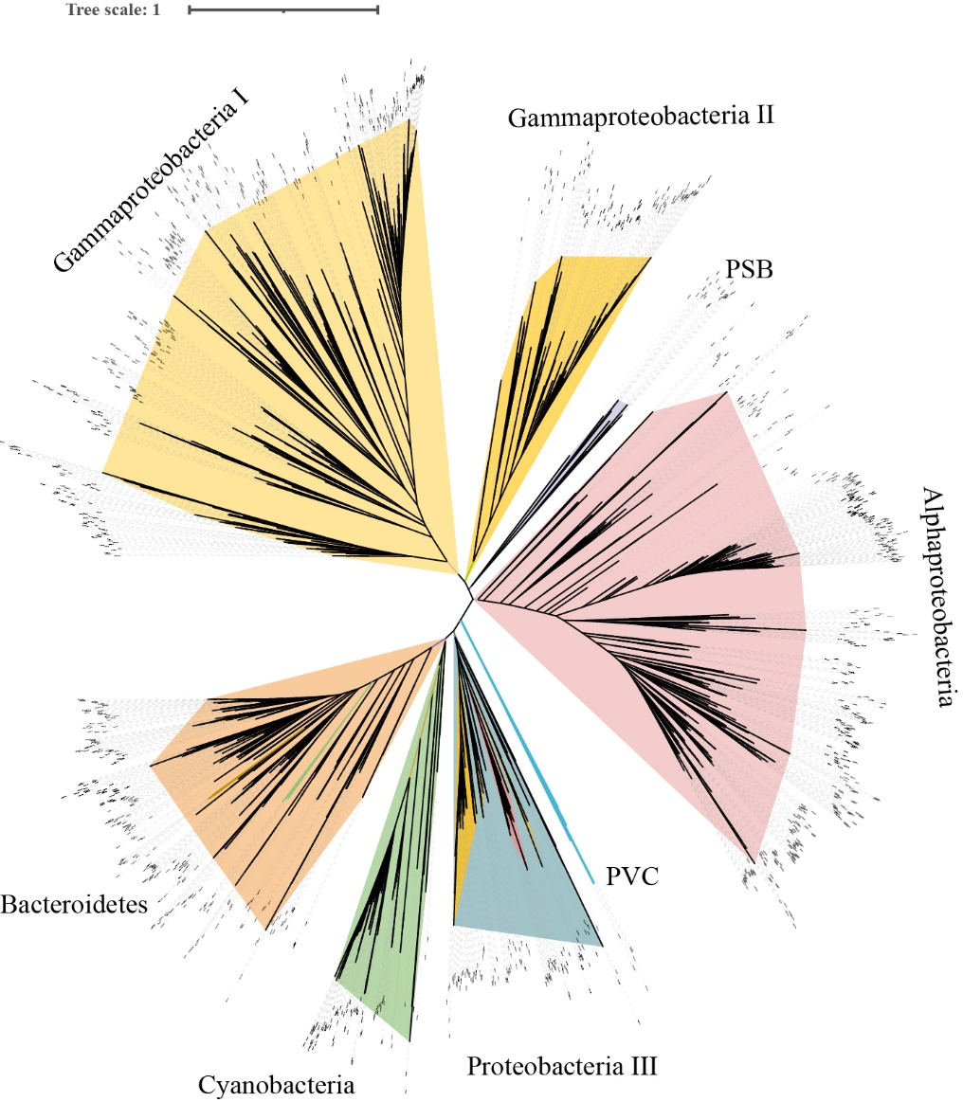
Extended Data Figures.

Extended Data Fig. 1
Unrooted maximum-likelihood phylogeny of SufE homologues from the NCBI Non-Redundant database. Branch colours denote the dominant taxonomic composition of each clade: pale yellow, gammaproteobacteria I; yellow, gammaproteobacteria II; light purple, purple sulfur bacteria (PSB); pink, alphaproteobacteria; blue, PVC superphylum; slate blue, Proteobacteria III (a mixed clade comprising alphaproteobacteria III and gammaproteobacteria III); green, cyanobacteria; ochre, Bacteroidota. The tree was inferred with IQ-TREE from an amino-acid alignment and is shown as an unrooted topology.

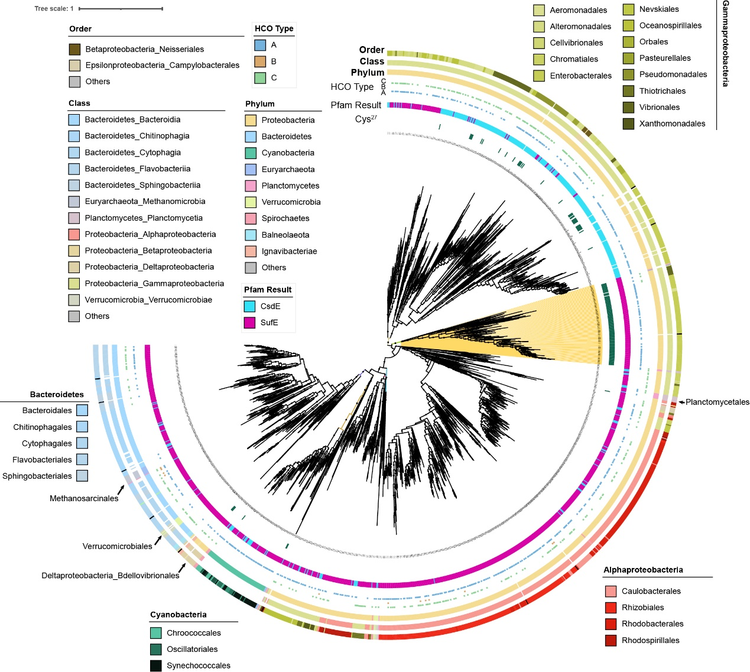
Extended Data Fig. 2
Pruned maximum-likelihood phylogeny of SufE homologues with HCO (heme-copper oxidase) annotations. No outgroup was used; the tree was rooted with the MinVar method and visualized in iTOL. The yellow-shaded clade marks the target lineage for molecular dating. Six concentric annotation rings are shown from the innermost to the outermost: 1) Presence of Cys at alignment position 27 in dark green. 2) Pfam HMM validation, CsdE in blue and SufE in magenta. 3) HCO repertoire, presence of oxygen‑reducing A, B1, and C type heme-copper oxidases. 4) Phylum, Proteobacteria (pale yellow), Cyanobacteria (green), Bacteroidetes (blue). 5) Class, Alphaproteobacteria (red), Gammaproteobacteria (pale green), Bacteroidetes classes in graded light‑blue hues; Cyanobacteria lack a stable class‑level assignment here and are detailed at the order level. 6) Order, color brightness modulated within each class to distinguish orders (see key on the figure).

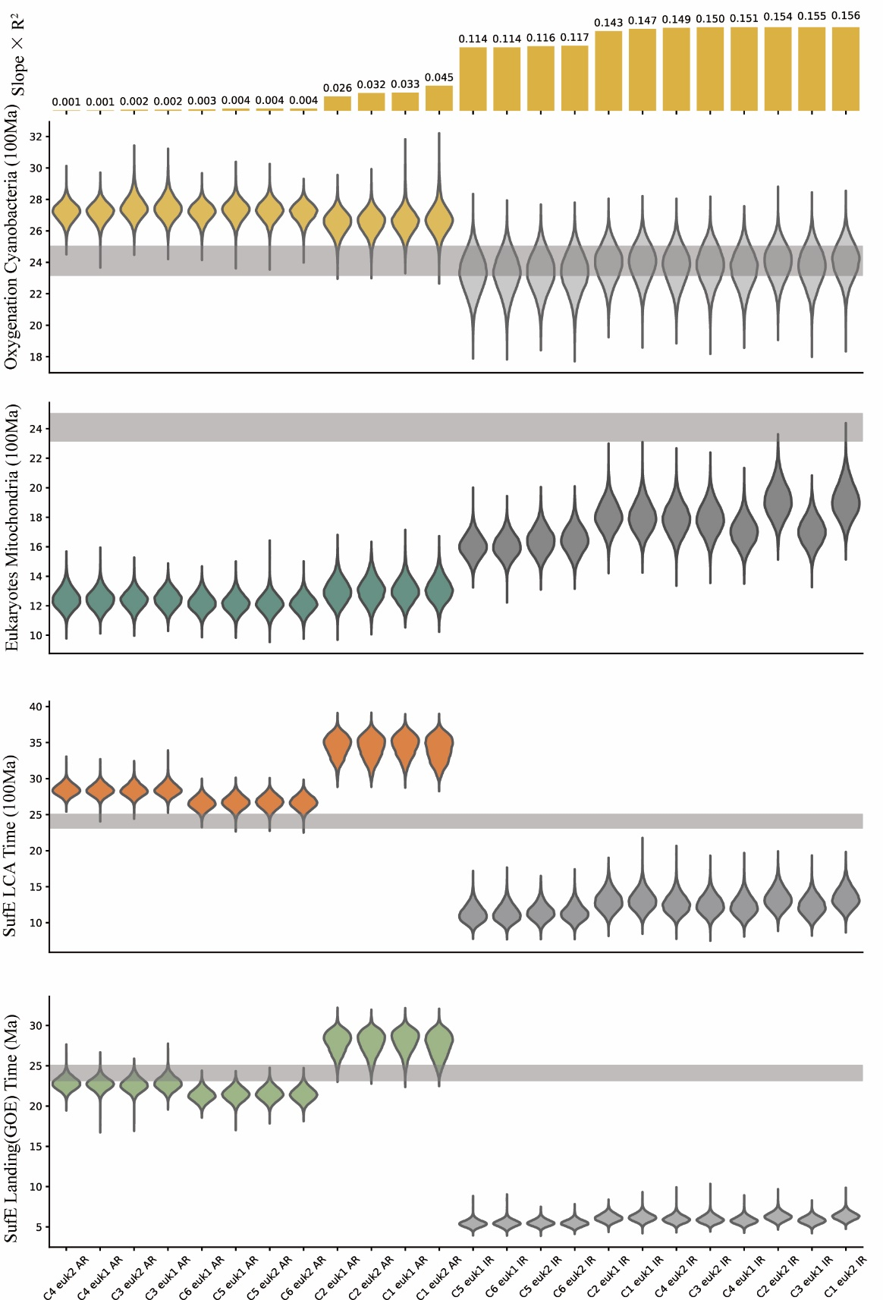
Extended Data Fig. 3
Violin plots of divergence time estimate for key nodes. Results are shown for the mitochondria-alphaproteobacteria topology 1 (TP1) ⁵⁹ only (Supplementary Information Table S1, S2, Method). The top panel reports the product of the fitted linear slope and R² from the infinite-sites test; the smaller values indicate better compliance with the infinite-sites expectation and are arranged left-to-right in ascending order. The four violin plots compare auto-correlated rate (AR) models (left) with independent rate (IR) models (right, in grey). The grey band marks 2.32-2.50 Ga, the interval of the Great Oxygenation Event (GOE) ². The IR results, consistent with their lower marginal likelihoods, perform worse than AR (Supplementary Information Table S2). In particular, the IR analyses place the origin of oxygenic Cyanobacteria overlapping, or even lagging, the GOE, contrary to prevailing consensus⁸² implying that IR estimates for SufE origin and related nodes may be biased. By contrast, AR models date oxygenic Cyanobacteria to 2.7-2.8 Ga, in line with geological constraints and within the calibration bounds specified in Supplementary Information Table S1, and place eukaryote origins at 1.2-1.4 Ga, consistent with prior molecular and fossil evidence^{60,83}. Although these two nodes are most sensitive to calibration choices, their posterior ranges vary little across settings, underscoring the stability of the AR dating framework.

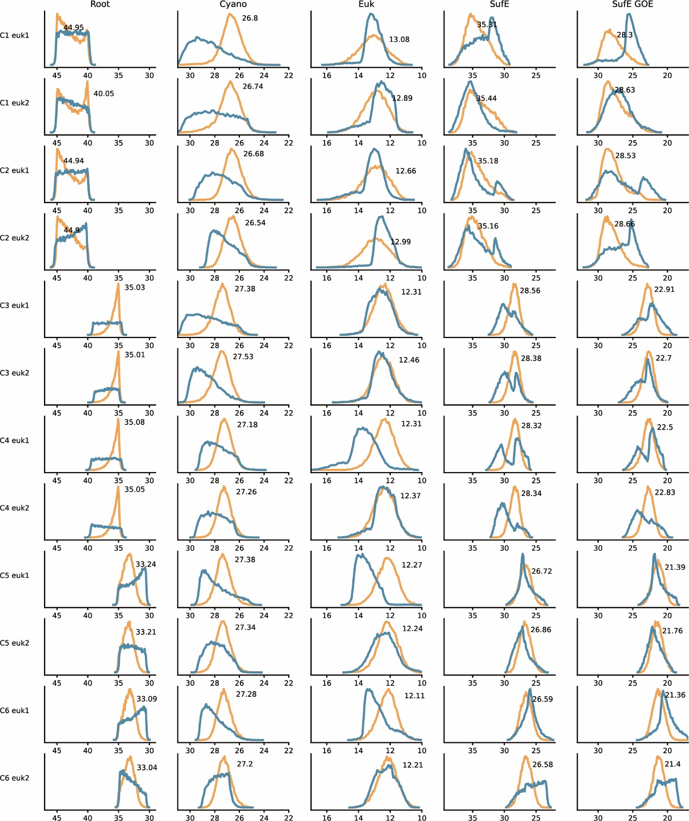
Extended Data Fig. 4
Posterior versus prior age distributions for key nodes. The X-axis is in 100 Ma unit; within each column the X-axis range is identical. The orange curves show posterior age densities; the blue curves show prior densities. The number in each panel denotes the posterior mode (age at maximum density). Rows correspond to alternative calibration schemes; columns correspond to focal nodes: Root, Cyanobacteria, Eukaryotes, SufE, and SufE-LJE (the SufE node dated within the Lomagundi-Jatuli Event interval). When the Root was constrained in C1/C2 (Calibration for prokaryotes 1 and 2) (4.0-4.5 Ga), posteriors were broad and unstable relative to C3-C6, with bimodal Root posteriors mirroring the priors, indicating that the sequence data provided little effective information and that the Bayesian estimates are unreliable under these settings. We therefore exclude C1/C2 from interpretation. In C3/C4 (3.5-4.0 Ga), the Root posterior is right-skewed and concentrated near 3.5 Ga, a consequence of the strong upper-lower bounds imposed on the root. By contrast, C5/C6 (3.0-3.5 Ga) yield well-behaved Root posteriors that are approximately normal and centered near 3.3 Ga. Under C5/C6, other key nodes are consistent across calibrations: oxygenic Cyanobacteria ~2.73 Ga, Eukaryotes ~1.22 Ga, SufE ~2.67 Ga, and SufE-LJE ~2.14 Ga. Notably, Euk1 versus Euk2 alters the prior on eukaryote origin but leaves the posterior essentially unchanged, demonstrating that the sequence data dominate the estimate. For SufE, the near-overlap of prior and posterior peaks indicates concordance between calibrations and molecular signal. Given the overall agreement and statistical performance, we adopt C5 Euk1, which also has the highest marginal likelihood, for presentation of the dated phylogeny.

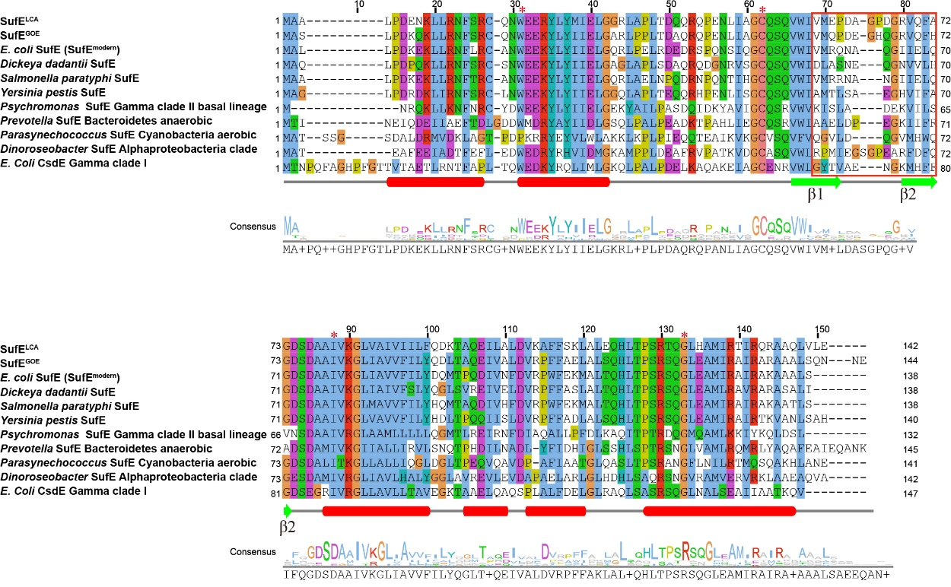
Extended Data Fig. 5
Sequence alignment of ancestral and modern SufE proteins. Multiple sequence alignment of representative SufE: SufE^{LCA} is the ancestor sequence of last common ancestor, SufE^{GOE} is the ancestor sequence at GOE, and E. coli K12 SufE^{modern}. Other clades sequences are also included such as gammaproteobacteria clade II: Dickeya dadantii, Salmonella paratyphi, Yersinia pestis, Psychromonas (the basal one); Anaerobic Bacteroidetes: Prevotella; Aerobic Cyanobacteria: Parasynechococcus; Alphaproteobacteria clade: Dinoroseobacter and E. coli CsdE gene (gammaproteobacteria Calde I). The color of residues in alignment is in the ClustalX shading model. The secondary structures are annotated by E. coli K12 SufE AlphaFold3 predicted result and implied below the columns: red bar means alpha helix; green arrow means beta sheet. The red star symbols at the top of alignment columns denote sites of SufE that interact with SufS. The red rectangular sites mean the mutation site between and within two beta sheets. Bayesian and maximum-likelihood (ML) ancestral sequence reconstruction yielded highly confident sequences (mean site posterior probability 0.84 and 0.90 for LCA and GOE, respectively), with more than 95% site identity between PAML, IQ-TREE, and FastML replicates⁸⁴. AlphaFold3 models predicted the accuracy of the entire structure with predicted template modeling (pTM) score higher than 0.93.

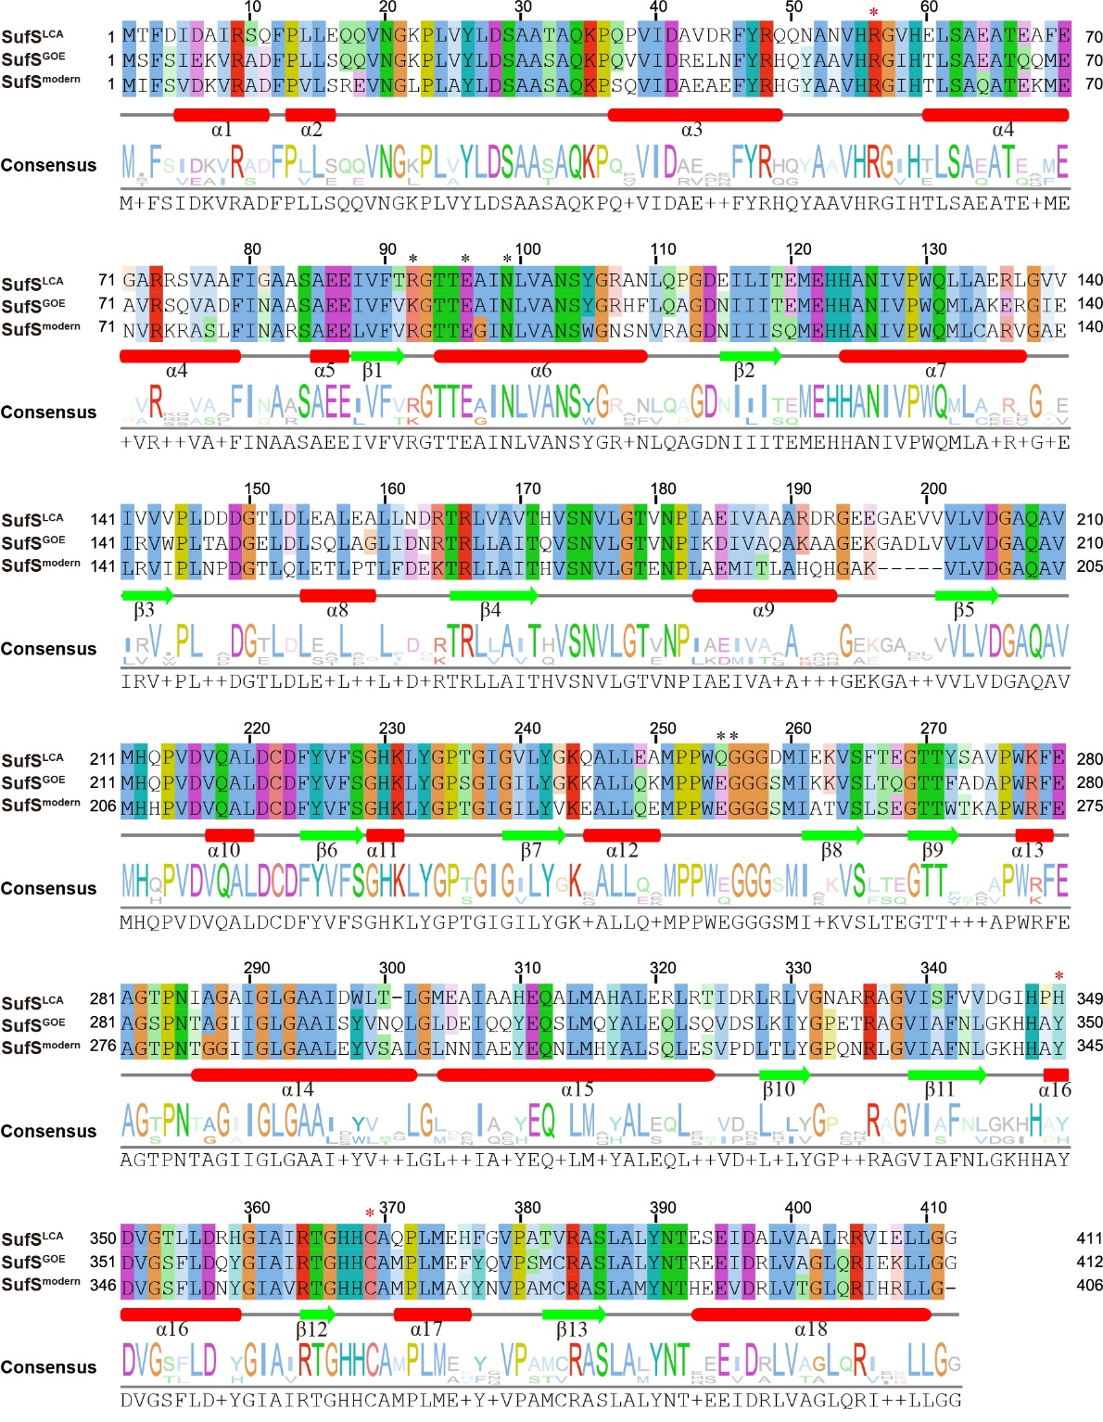
Extended Data Fig. 6
Sequence alignment of ancestral and modern SufS proteins. Multiple sequence alignment of representative SufS: SufS^{LCA} is the reconstructed last common ancestor sequence of SufS. SufS^{GOE} is the ancestor sequence at GOE; and E. coli K12 SufS^{modern}. The color of residues in alignment is in the ClustalX shading model. The secondary structures are annotated by Alphafold3 and implied below the columns: red rectangular means alpha helix, green arrow means beta sheet. As with SufE, the key catalytic residues of SufS are invariant: the 5’-pyridoxal-phosphate (PLP) cofactor-binding histidine (H123) and the catalytic cysteine residue of SufS (corresponding to C368 in SufS^{LCA}, C369 in SufS^{GOE} or C364 in SufS^{modern}) are conserved in both ancestral and modern sequences⁸⁵. This conservation underscores that the basic mechanism of sulfur removal from cysteine has been maintained since the origin of SufS. As for the residues interacting with SufE, R56 remained unchanged, but H349 in SufS^{LCA} was mutated to Y350 in SufS^{GOE} (Y345 in SufS^{modern}).

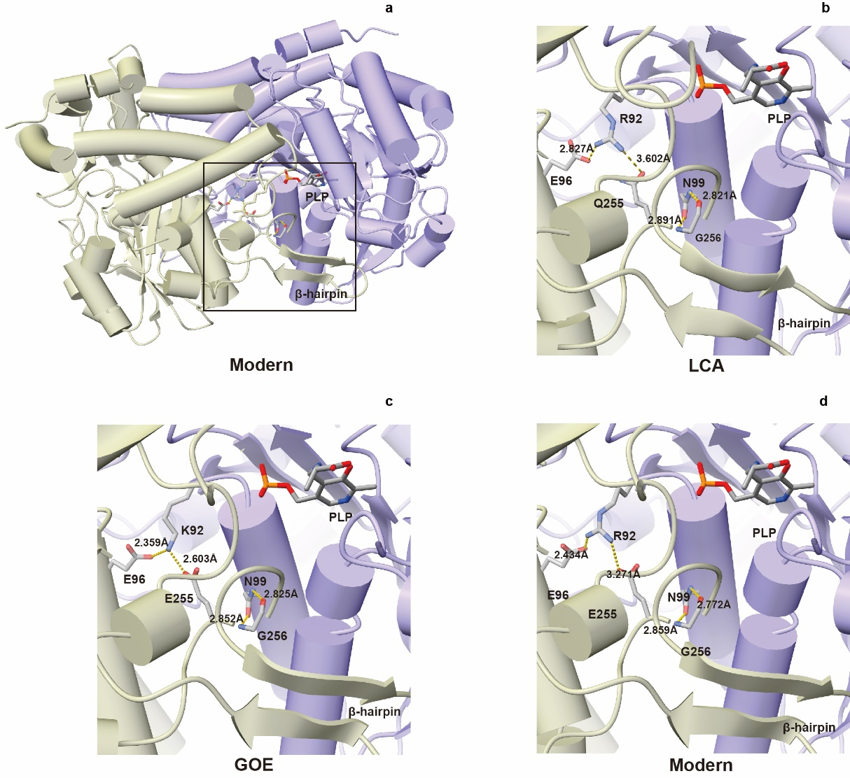
Extended Data Fig. 7
A structure model of the β-latch interface in the SufS homodimer. All structures were generated using AlphaFold3 (a) A model of the E. coli K-12 SufS homodimer, with the two protomers coloured tan and violet. The 5′-pyridoxal-phosphate (PLP) cofactor, imported from the crystal structure PDB 5XT6, is shown as sticks. The boxed region in (a) is enlarged in (b-d). (b-d) Close-up views of the β-latch, with key residues and inter-atomic distances (Å) labelled. (b) SufS^{LCA} reconstruction: R92 interacts with E96 and Q254. (c) SufS^{GOE} reconstruction: K92 interacts with E96 and E255. (d) SufS^{modern}: R92 forms salt-bridge contacts with E96 and E250 on the opposite protomer. These distances, highlighted here and quantified in the main text, reveal how substitutions at position 92 and its partner acidic residues modulate the stability of the β-latch across evolutionary time.

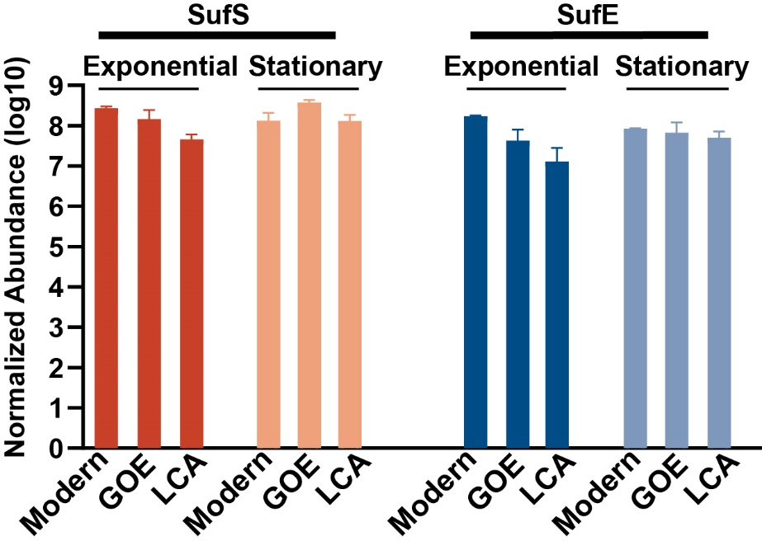
Extended Data Fig. 8
Parallel reaction monitoring (PRM) quantification of complemented proteins across growth phases in WO539. WO539 (E. coli MG1655 ΔiscU-fdx ΔsufSE::cm^{R} MVA⁺-kan^{R}-1) strains carrying the indicated complementation constructs were grown in Super Broth supplemented with 0.4% (w/v) glucose, 0.2% (w/v) L-arabinose, 50 mg L⁻¹ chloramphenicol, 50 mg L⁻¹ kanamycin, 50 mg L⁻¹ ampicillin, and 300 µM MVA at 37 °C. Samples were collected at exponential phase (OD₆₀₀ = 0.4) and at stationary phase (after overnight culture). Protein expression levels of the complemented constructs are shown for the two growth stages. Quantification was achieved by calculating the ratio of SufS or SufE feature peptides to stable isotope-labeled standard peak areas.

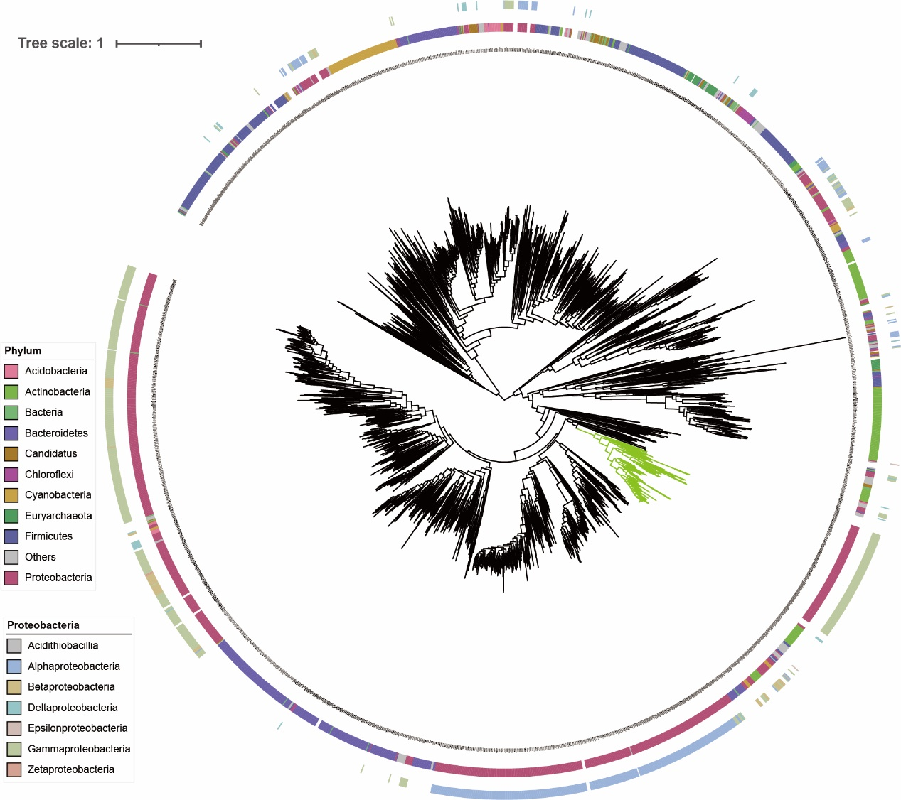
Extended Data Fig. 9
Phylogeny of SufS homologues from the NCBI NR database. Clades highlighted in green denote SufS lineages, similar to the gammaproteobacteria II target clade of SufE. Taxonomic composition is shown as coloured bands encircling the tree: the inner ring indicates phylum-level assignments, and the outer ring resolves class-level taxonomy within Proteobacteria.

