SUPPLEMENTARY MATERIAL

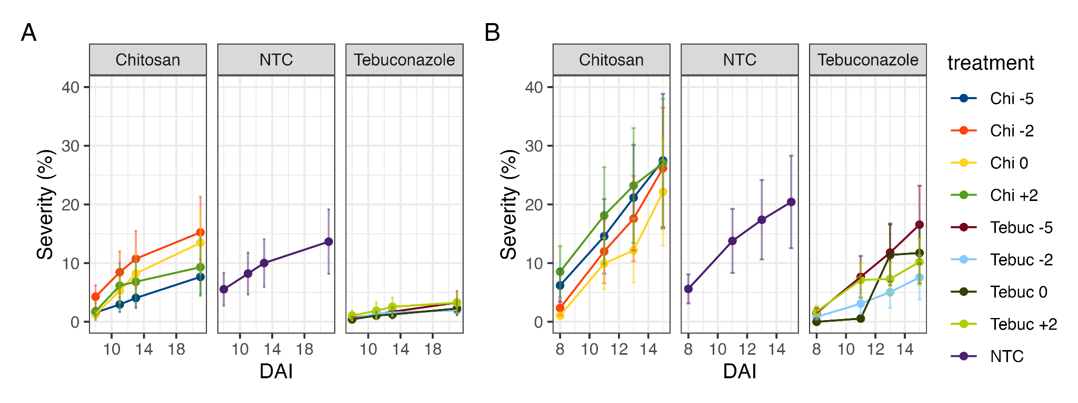
Figure S1. (A) Progress of mean Fusarium head blight severity and respective standard error in wheat heads sprayed at different timings in the first and (B) second trial. Treatments: NTC = Nontreated check, Chi = chitosan oligosaccharide and Tebuc = tebuconazole. Chi or Tebuc followed by: -5 = applied 5 days before inoculation, -2 = applied 2 days before inoculation, 0 = chitosan oligosaccharide applied on the day of inoculation, and +2 applied 2 days after inoculation.

Table S1. Means values from pH and conductivity values of chitosan oligosaccharide in different concentrations.
Dose mg/L | pH | Electrical conductivity (ds m⁻¹)
0 | 6.54 | 103.73
500 | 5.87 | 133.97
1000 | 5.62 | 162.30
2000 | 5.45 | 238.00
4000 | 5.39 | 369.00
8000 | 5.36 | 615.67
16000 | 5.37 | 1118.33
32000 | 5.34 | 1647.67

Table S2. Mean values of plant height (cm) for the effect of different chitosan oligosaccharide concentrations sprayed on inoculated wheat heads under greenhouse conditions.
Treatments | Concentrations (mg/L) | Trial 1 | Trial 2
Chitosan oligosaccharide | 500 | 75.80^{ns} | 76.95^{ns}
Chitosan oligosaccharide | 1000 | 77.30 | 80.30
Chitosan oligosaccharide | 2000 | 76.50 | 78.65
Chitosan oligosaccharide | 3000 | 79.50 | 77.60
Tebuconazole | 2.5 | 78.20 | 78.85
Mock |  | 76.80 | 76.10
Nontreated check |  | 81.10 | 81.50
^{ns} Means not differ from each other at 5% of significance by Tukey test.

Table S3. Mean values of plant height (cm) for the effect of different timing of chitosan oligosaccharide and tebuconazole sprays in relation to the inoculation on inoculated wheat heads under greenhouse conditions.
Treatments | Timing of sprays | Trial 1 |  | Trial 2
Treatments | Timing of sprays | Inoculated | Non inoculated | Inoculated | Non inoculated
Chitosan oligosaccharide | -5 | 70.93^{ns} | 69.35^{ns} | 80.65^{ns} | 81.70^{ns}
Chitosan oligosaccharide | - 2 | 74.73 | 69.35 | 83.90 | 82.00
Chitosan oligosaccharide | 0 | 71.10 | 71.70 | 79.80 | 83.15
Chitosan oligosaccharide | +2 | 73.00 | 68.30 | 83.25 | 79.01
Tebuconazole | -5 | 69.80 | 70.65 | 80.75 | 78.75
Tebuconazole | -2 | 72.68 | 74.95 | 83.90 | 80.40
Tebuconazole | 0 | 73.13 | 71.80 | 84.10 | 80.20
Tebuconazole | +2 | 68.15 | 73.25 | 81.40 | 80.35
Nontreated Check |  | 73.24 | 72.25 | 82.45 | 84
^{ns} Means not differ from each other at 5% of significance by Tukey test.

Table S4. Mean values of Fusarium-damaged kernels (FDK, %) for the effect of different timing of chitosan oligosaccharide and tebuconazole sprays in relation to the inoculation on inoculated wheat heads under greenhouse conditions.
Treatments | Timing of sprays | Trial 1 | Trial 2
Chitosan oligosaccharide | -5 | 25 abc | 36.50 c
Chitosan oligosaccharide | - 2 | 26 abc | 36 c
Chitosan oligosaccharide | 0 | 29.50 bc | 21 bc
Chitosan oligosaccharide | +2 | 38.50 c | 25 bc
Tebuconazole | -5 | 10 ab | 23 bc
Tebuconazole | -2 | 9.5 ab | 17 ab
Tebuconazole | 0 | 7 a | 1 a
Tebuconazole | +2 | 12 ab | 10 ab
Nontreated Check |  | 45.50 c | 33.50 c
The means followed by the lowercase letters in the columns did not differ from each other at 5% of significance by Tukey test. The not inoculated treatments did not present FDK values.

Table S5. Mean values of Fusarium-damaged kernels (FDK, %) for the effect of different chitosan oligosaccharide concentrations sprayed on inoculated wheat heads under greenhouse conditions.
Treatments | Concentrations (mg/L) | Trial 1 | Trial 2
Chitosan oligosaccharide | 500 | 49.50 b | 35.50 bc
Chitosan oligosaccharide | 1000 | 45.50 b | 34.00 b
Chitosan oligosaccharide | 2000 | 44.50 b | 35.50 bc
Chitosan oligosaccharide | 3000 | 47.50 b | 49.50 bc
Tebuconazole | 2.5 | 0 a | 8.00 a
Mock |  | 0 a | 0 a
Nontreated check |  | 53.50 b | 57.00 c
The means followed by the lowercase letters in the columns differ from each other at 5% of significance by Tukey test. The not inoculated treatments did not present FDK values.

Table S6. Mean values of Fusarium-damaged kernels (FDK, %) for the effect of different timing of chitosan oligosaccharide and tebuconazole sprays in relation to the inoculation on inoculated wheat heads under field conditions.
Treatments | Timing of sprays | Inoculated | Non inoculated
Chitosan oligosaccharide | -5 | 4 abA | 0.50 aA
Chitosan oligosaccharide | - 2 | 8 abB | 0 aA
Chitosan oligosaccharide | 0 | 6 abA | 1.5 aA
Chitosan oligosaccharide | +2 | 10.5 cB | 0 aA
Tebuconazole | -5 | 1 aA | 0 aA
Tebuconazole | -2 | 2 aA | 0 aA
Tebuconazole | 0 | 0 aA | 0 aA
Tebuconazole | +2 | 1.5 aA | 0 aA
Nontreated Check |  | 6 abA | 1 aA
The means followed by the lowercase letters in the columns and not followed by uppercase letters in the columns did not differ from each other at 5% of significance by Tukey test.

Table S7. Mean values of thousand-kernels weight (TKW, g) for the effect of different timing of chitosan oligosaccharide and tebuconazole sprays in relation to the inoculation on inoculated wheat heads under greenhouse conditions.
 |  | Trial 1 |  | Trial 2
Treatments | Timing of sprays | Inoculated | Non inoculated | Inoculated | Non inoculated
Chitosan oligosaccharide | -5 | 37.90 abcB | 50.05 aA | 25.80 dB | 46.50 aA
Chitosan oligosaccharide | - 2 | 35.50 bcB | 48.80 aA | 28.20 dB | 43.60 aA
Chitosan oligosaccharide | 0 | 33.50 bcB | 48.40 aA | 34.20 bcdB | 47.50 aA
Chitosan oligosaccharide | +2 | 32.75 cB | 49.80 aA | 31.90 cdB | 47.10 aA
Tebuconazole | -5 | 47.90 abA | 44.75 aA | 33.80 bcdB | 46.10 aA
Tebuconazole | -2 | 46.40 abcA | 48.75 aA | 37.70 abB | 48.25 aA
Tebuconazole | 0 | 51.80 aA | 46.60 aA | 53.20 aA | 48.10 aA
Tebuconazole | +2 | 45.50 abcA | 51.65 aA | 41.80 bB | 51.80 aA
Nontreated Check |  | 33.90 bcB | 49.70 aA | 29.80 cdB | 44.40 aA
The means followed by the lowercase letters in the columns and not followed by uppercase letters in the lines did not differ from each other at 5% of significance by Tukey test.

Table S8. Mean values of thousand-kernels weight (TKW, g) for the effect of different chitosan oligosaccharide concentrations sprayed on inoculated wheat heads under greenhouse conditions.
Treatments | Concentrations (mg/L) | Trial 1 | Trial 2
Chitosan oligosaccharide | 500 | 17.90 b | 28.50 b
Chitosan oligosaccharide | 1000 | 23.65 b | 27.10 b
Chitosan oligosaccharide | 2000 | 24.25 b | 27.70 b
Chitosan oligosaccharide | 3000 | 26.10 b | 25.15 b
Tebuconazole | 2.5 | 45.10 a | 42.35 a
Mock |  | 40.45 a | 50.85 a
Nontreated check |  | 21.85 b | 25.45 b
The means followed by the lowercase letters in the columns differ from each other at 5% of significance by Tukey test.

Table S9. Mean values of thousand-kernels weight (TKW, g) for the effect of different timing of chitosan oligosaccharide and tebuconazole sprays in relation to the inoculation on inoculated wheat heads under field conditions.
Treatments | Timing of sprays | Inoculated | Non inoculated
Chitosan oligosaccharide | -5 | 34.75 aA | 38.50 abA
Chitosan oligosaccharide | - 2 | 32.10 aA | 33.65 bcA
Chitosan oligosaccharide | 0 | 32.90 aA | 28.90 cA
Chitosan oligosaccharide | +2 | 38 aA | 30.85 bcB
Tebuconazole | -5 | 38.90 aA | 43.85 aA
Tebuconazole | -2 | 34.95 aA | 29 cB
Tebuconazole | 0 | 34.45 aA | 38.55 abA
Tebuconazole | +2 | 30.25 aB | 38 abA
Nontreated Check |  | 33.40 aA | 30.60 bcA
The means followed by the lowercase letters in the columns and not followed by uppercase letters in the lines did not differ from each other at 5% of significance by Tukey test.

