Mafic-ultramafic igneous rocks as a source of reactive phosphorus for the origin of life

Abu Saeed Baidya¹, Craig R. Walton^{2,3}, Joanna Kalita¹, Kristoffer Szilas⁴, Marco Viccaro⁵, Paul Savage¹, Stuart Allison¹, Euan Nisbet⁶, Sami Mikhail¹, Eva E. Stüeken¹

¹School of Earth and Environmental Sciences, University of St. Andrews, St Andrews KY16 9TS, United Kingdom
²Department of Earth and Planetary Sciences, ETH Zurich, Sonneggstrasse 5, 8092 Zurich, Switzerland
³Trinity College, University of Cambridge, Cambridge CB2 1TQ, United Kingdom
⁴Department of Geosciences and Natural Resource Management, University of Copenhagen, Copenhagen, Denmark
⁵Department of Biological, Geological and Environmental Sciences, University of Catania, Italy
⁶Department of Earth Sciences, Royal Holloway, University of London, Egham TW20 0EX, UK

Corresponding Author: Abu Saeed Baidya (asb27@st-andrews.ac.uk)

This File contains:
Supplementary Notes
Supplementary Figures with captions
Supplementary Table 1
Supplementary Notes
Basalt samples (n=6) were collected from the Canary Islands, Spain (n=1), Kilbourne Hole, USA (n=2), and Mount Etna, Italy (n=1). In addition, previously published data from basalts from the Moodies Group, South Africa (n=2), were incorporated¹ (Supplementary Table 1). Overall, major- and trace-element compositions overlap with those of ocean-island basalts (OIB) and mid-ocean-ridge basalts (MORB) in MgO–Ni, MgO–CaO and MgO–P₂O₅ space (Fig. S1a–c). Consistent with this, previous studies report that basalts from the Canary Islands and Kilbourne Hole are OIB-like^{2,3}. A positive U–K₂O correlation indicates minimal alteration (Fig. S1d). We therefore consider these basalts as representative of early-Earth ocean-floor lavas and use them in models estimating phosphite concentrations in ocean and prebiotic-lake settings.
Olivine samples (n = 4) comprise one from a pallasite meteorite, one fayalite from the Lasigkulla mine (Sweden), one from lherzolite, and one from Hawaiian basalt. Among them, the last two are considered as ‘olivine separates’. The fayalite sample may contain minor accessory phases. Regarding peridotite samples (n= 15), one is harrisite from the Isle of Rum (Scotland), one is harzburgite, and the rest are dunite (Supplementary Table 1). The harrisite specimen shows intergrowths of olivine and plagioclase. These rocks show no petrographic or geochemical evidence of alteration, and their CaO and Al₂O₃ contents are consistent with magmatic differentiation (Supplementary Fig. S3).
Komatiite samples were collected from the Belingwe greenstone belt, Zimbabwe, and show no or minor alteration⁴.

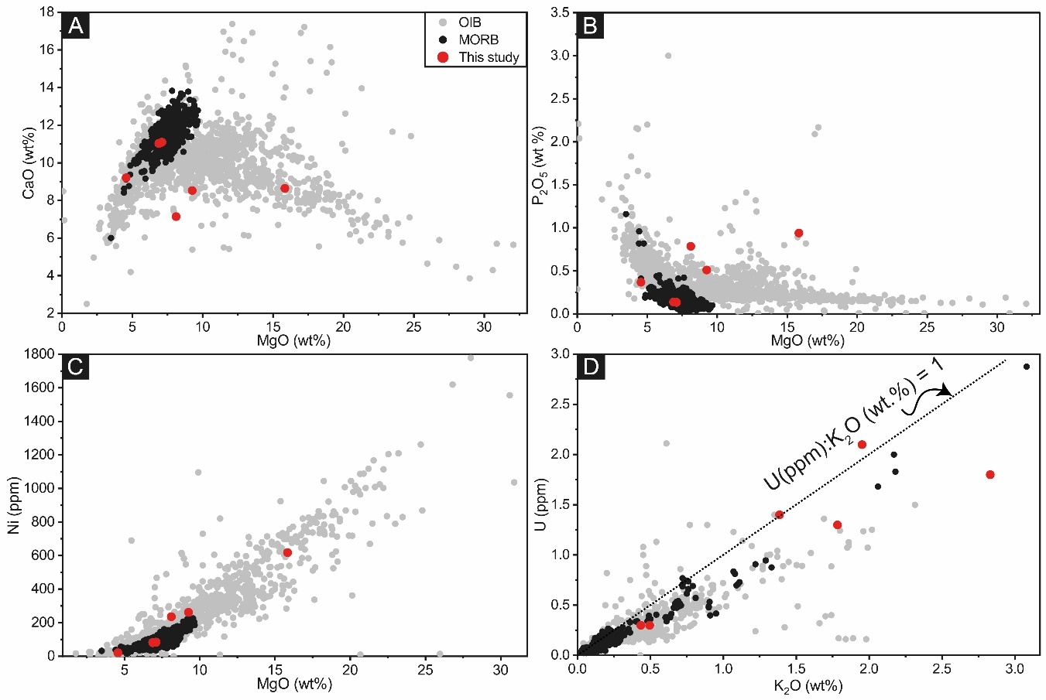
Fig. S1: Comparison of the studied basalts with ocean-island basalts (OIB) and mid-ocean-ridge basalts (MORB). MORB and OIB data are from Stracke et al.⁵ (A) MgO versus CaO; (B) MgO versus P₂O₅; and (C) MgO versus Ni. In A–C, samples span both OIB and MORB compositional fields. (D) K₂O and U are positively correlated, indicating minimal alteration.

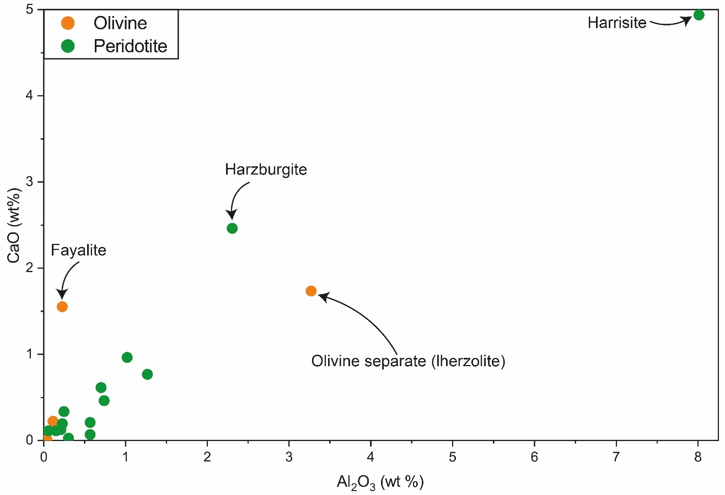
Fig. S2: Olivine and peridotite samples show a positive correlation between calcium oxide (CaO) and aluminium oxide (Al₂O₃); this trend suggests magmatic differentiation. Harrisite is an intergrowth of olivine and plagioclase while fayalite sample contain some unidentified phases, which may explain relatively higher Al and/or Ca contents in these samples. The olivine separates from lherzolite may contain some pyroxene grains or inclusion, which explains relatively higher Al and Ca contents.

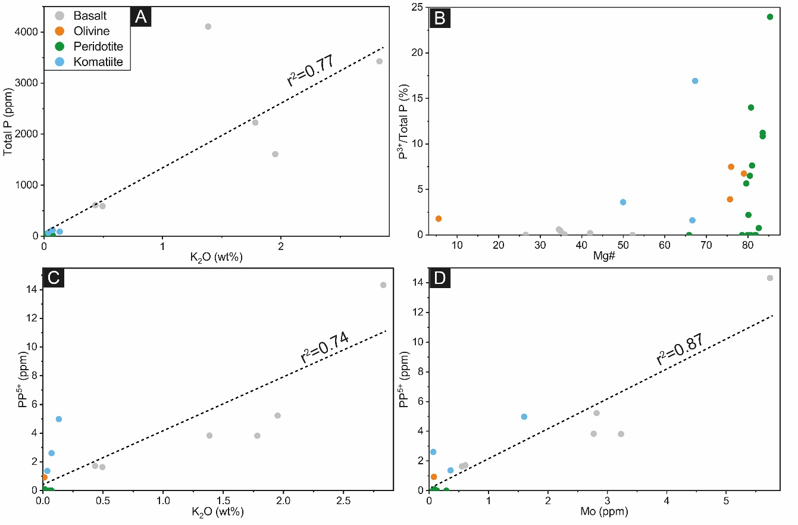
Fig. S3: Phosphorus chemistry and its correlations with major and trace elements in the studied samples. (A) Phosphorus (P) versus potassium oxide (K₂O) shows a positive correlation consistent with co-enrichment during magmatic differentiation. (B) Samples with higher magnesium number (Mg#) exhibit greater phosphite [P(III)] to total phosphorus (ΣP) percentages. (C–D) Pyrophosphate (PP(V)) correlates positively with potassium oxide (K₂O) and with molybdenum (Mo), respectively.

Supplementary Table 1- List and description of the samples
Samples | Rock/mineral type | Location and description
E03-Ba | Basalt | Xenolith host, Kilbourne Hole
A02-Ba | Basalt | Xenolith Host, Kilbourne Hole
A07-Ba | Basalt | Xenolith Host, Canary Island
A11-Ba | Basalt | Volcanics, Mount Etna
B22-Ba | Basalt | Moodies Group Intrusive
B23-Ba | Basalt | Moodies Group Intrusive
B4 | Komatiite | Belingwe greenstone belt, Zimbabwe
ZV 10 | Komatiite | Belingwe greenstone belt, Zimbabwe
ZV 14 | Komatiite | Belingwe greenstone belt, Zimbabwe
ZV 15 | Komatiite | Belingwe greenstone belt, Zimbabwe
ZV 79 | Komatiite | Belingwe greenstone belt, Zimbabwe
A08-Ol | Peridotite | olivine-plagioclase intergrowth, Rhum Island
A07-Ol | Peridotite | Dunite peridotite, Canary Island
E03-Ol | Peridotite | Dunite peridotite, Kilbourne Hole
A02-Ol | Peridotite | Dunite peridotite, Kilbourne Hole
A10-Ol | Peridotite | Dunite peridotite, Ubekendt Island
E01-Ol | Peridotite | Dunite peridotite, San Carlos, Arizona (?)
A09-Ol | Peridotite | Peridotite, Unknown origin
A01-Ol | Peridotite | Dunite peridotite, San Carlos, Arizona
A05-Ol | Peridotite | Dunite peridotite, Jiaohe peridotite, Jihin Province
A06-Ol | Peridotite | Dunite peridotite, Kohistan Arc Pakistan
E02-Peri | Peridotite | Dunite, Gustal olivine pit, Norway
A12A-Peri | Peridotite | Dunite, Seqi Mine, Norway
A12B-Peri | Peridotite | Dunite, Seqi Mine, Norway
A12C-Peri | Peridotite | Dunite, Seqi Mine, Norway
A14-Peri | Peridotite | Harzburgite, Balmuccia, Italy
A03-Ol | Olivine separates | Basalt-hosted olivine, Hawaii
A13-Ol | Olivine separates | Lherzolite-hosted, Kilbourne Hole
A16-Ol | Fayalite | Lastigkulla, Sweden
A04-Ol | Olivine separates | Admire pallasite meteorite, Arizona

References
1. Baidya, A. S., Gehringer, M. M., Savaniu, C., Heubeck, C. & Stüeken, E. E. Magmatic and thermally produced reactive phosphorus 3.2 billion years ago and its implications for early life. Commun. Earth Environ. Accepted, (2025).
2. Thomas, L. E., Hawkesworth, C. J., Van Calsteren, P., Turner, S. P. & Rogers, N. W. Melt generation beneath ocean islands: a U-Th-Ra isotope study from Lanzarote in the Canary Islands. Geochim. Cosmochim. Acta 63, 4081–4099 (1999).
3. Thompson, R. N. et al. Source of the Quaternary Alkalic Basalts, Picrites and Basanites of the Potrillo Volcanic Field, New Mexico, USA: Lithosphere or Convecting Mantle? J. Petrol. 46, 1603–1643 (2005).
4. Nisbet, E. G. et al. Uniquely fresh 2.7 Ga komatiites from the Belingwe greenstone belt, Zimbabwe. Geology 15, 1147–1150 (1987).
5. Stracke, A., Willig, M., Genske, F., Béguelin, P. & Todd, E. Major and trace element concentrations and Sr, Nd, Hf, Pb isotope ratios of global mid ocean ridge and ocean island basalts. GFZ Data Services (2022) doi:https://doi.org/10.5880/digis.e.2024.008.

