Supplementary Information

Urbanization Reduces Hospital Accessibility Inequality in China

 | Gini_pop | Gini | gdp_pc_usd_2020 | age65_share_2020 | urbanization_rate_2020
Gini_pop | 1.0 | 0.872 | -0.591 | -0.404 | -0.701
Gini | 0.872 | 1.0 | -0.466 | -0.53 | -0.568
gdp_pc_usd_2020 | -0.591 | -0.466 | 1.0 | 0.225 | 0.817
age65_share_2020 | -0.404 | -0.53 | 0.225 | 1.0 | 0.438
urbanization_rate_2020 | -0.701 | -0.568 | 0.817 | 0.438 | 1.0
Table S1. Pearson Correlation Matrix of Key Variables (2020)
Legend: This table presents the Pearson correlation coefficients between all pairs of variables. The values quantify the strength and direction of linear relationships. The strong negative correlation (-0.701) between urbanization rate and Gini_pop provides initial, substantive evidence for the core relationship investigated. The high positive correlation (0.817) between GDP per capita and urbanization indicates significant multicollinearity, which helps explain the attenuated independent effect of GDP in the multivariate model.

 | Statistic | Urbanization coefficient (LOO)
0 | Mean | -0.00724
1 | SD | 0.00091
2 | Min | -0.01105
3 | Max | -0.00482
Table S2. Leave-One-Out (LOO) Robustness Check for the Urbanization Coefficient
Legend: This table summarizes the leave-one-out sensitivity analysis. The statistics (mean, SD, min, max) describe the distribution of the urbanization coefficient when each province is iteratively excluded. The stability of the mean coefficient around -0.00724, with a small standard deviation, means that the estimated negative association is robust and not unduly influenced by any single data point, lending credibility to the finding despite its lack of conventional statistical significance.

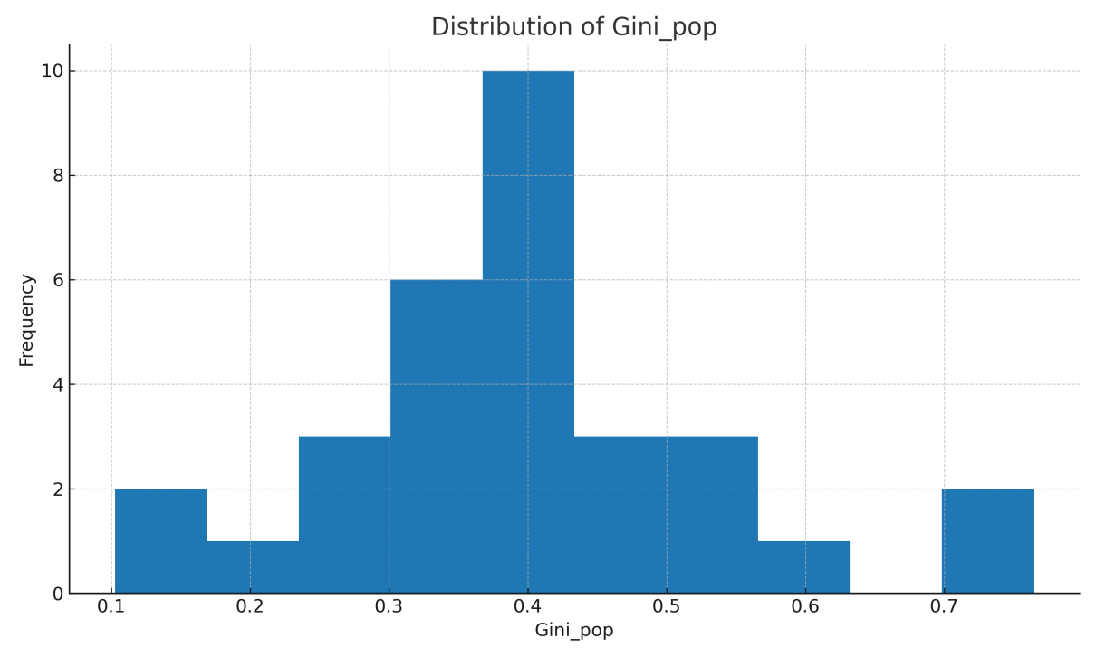
Figure S1. Distribution of the Population-Weighted Hospital Accessibility Gini Index (Gini_pop) Across Provinces, 2020
Legend: This histogram visualizes the distribution of the dependent variable. The position of each bar along the x-axis represents a range of inequality values, while its height shows the number of provinces within that range. The spread of values across a wide spectrum (from ~0.1 to ~0.76) means that provinces experience fundamentally different levels of spatial equity, graphically justifying the need for an analysis of underlying determinants like urbanization.

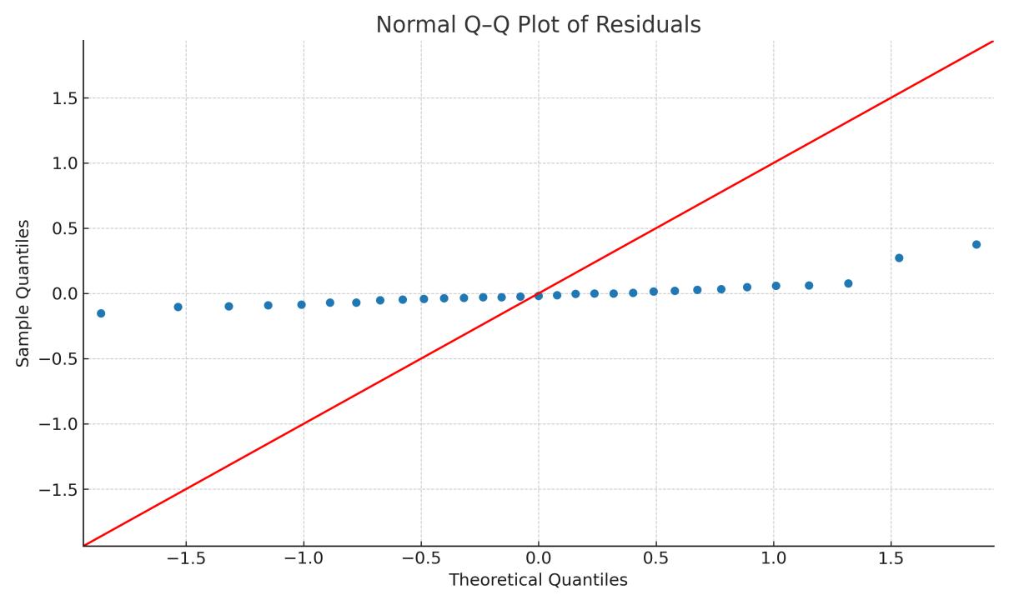
Figure S2. Normal Q-Q Plot of Regression Residuals
Legend: This Q-Q plot assesses the normality of the regression residuals. The position of each point compares the quantile of the actual residual distribution to the quantile of a theoretical normal distribution. The close alignment of points to the dashed 45-degree line means that the residuals' distribution does not substantially deviate from normality. This validates the use of statistical inference based on OLS assumptions for interpreting the regression results.

