Supplementary information
Supplementary statistical analysis
Model 1 <- glm (melanisation ~ sex * season, data)
Model 2 <- glm (cbind (endo, endo_no_parasite) ~ sex * season, family = binomial, data)
Model 3 <- glm (melanisation ~ monthly average temperature + rainfall + relative humidity, data)
Model 4 <- glm (gregarine prevalence ~ monthly average temperature + rainfall + relative humidity, data)
Model 5 <- glm (melanisation ~ infection status, data)
Model 6 <- glm (gregarine prevalence ~ melanisation + monthly average temperature, data)

We further applied the DurgaDiff function of the Durga R package to calculate mean differences of melanisation between gregarine-infected and non-infected damselflies across seasons (Khan and McLean, 2024). Please see supplementary results and figure (Fig. S1) below.

Supplementary results
Melanisation across months
Melanisation was highest in December (Female, December, GLM, estimate = 44.52 ± 5.2, t = 8.54, p < 0.0001; Male, December, GLM, estimate = 42.81 ± 5.05, t = 8.47, p < 0.0001).

Melanisation and gregarine prevalence across seasons
Melanisation was higher in summer than spring and lower in autumn for both sexes ((Female, Summer - Autumn, GLM, estimate = -26.53 ± 3.2, t = -8.28 p < 0.0001, Summer - Spring, GLM, estimate = -1.34 ± 2.86, t = -0.47, p = 0.63; Fig. 2b); (Male, Summer - Autumn, GLM, estimate = -20.72 ± 3.23, t = -6.41, p < 0.0001, Summer – Spring, GLM, estimate = -9.6 ± 3.03, t = -3.16 p = 0.001, Fig. 2c)).

Gregarine prevalence was relatively higher during spring and autumn than summer ((Female, Spring, GLM, estimate = 0.52 ± 0.87, t = 0.59, p = 0.55, Summer, GLM, estimate = -0.47 ± 0.78, t = -0.6, p = 0.54; Fig. 2d); Male, Spring, GLM, estimate = 0.55 ± 0.58, t = 0.95, p = 0.33, Summer, GLM, estimate = -1.16 ± 0.76, t = -1.52, p = 0.12; Fig. 2e)).

Infection status and melanisation across seasons
Infected females had better melanisation all over the seasons (Female, Autumn, non-infected-infected: -7.9, 95% CI [-26.71, 22.38]; Spring: -6.02, 95% CI [-13.16, 1.56]; Summer: -6.26, 95% CI [-20.36, 8.86]; Fig. S1a). However, infected males had stronger responses during spring than summer (Male, Autumn: 7.67, 95% CI [-15.12, 27.96]; Spring: -11.72, 95% CI [-23.34, -0.01]; Summer: -0.29, 95% CI [-20.27, 13.26]; Fig. S1b).

Correlation of melanisation, monthly temperature, and their interaction with gregarine prevalence
In females, we found no significant effect of melanisation (GLM, estimate = –0.006 ± 0.01, t = -0.33, p = 0.73), monthly average temperature (GLM, estimate = –0.08 ± 0.09, t = -0.94, p = 0.35), or their interaction (GLM, estimate = 0.0005 ± 0.0009, t = 0.56, p = 0.57) on gregarine prevalence. Although the coefficients suggested a slight decline in gregarine prevalence with increasing melanisation and monthly average temperature, the effects were not statistically significant.
Similarly in males, melanisation (GLM, estimate = –0.007 ± 0.02, t = -0.25, p = 0.8), monthly average temperature (GLM, estimate = –0.03 ± 0.12, t = -0.25, p = 0.8), and their interaction (GLM, estimate = 0.0003 ± 0.001, t = 0.24, p = 0.81) had no effects on gregarine prevalence.

Supplementary figures
Figure S1: Melanisation response (Grey value) of gregarine non-infected and infected female and male I. heterosticta damselflies across seasons. Melanisation response of (a) gregarine non-infected and infected females and (b) males across seasons. In the upper panel of (a) and (b) black circle represents the mean, and the vertical bar represents the melanisation difference between non-infected and infected damselflies across seasons. In (a) and (b), coloured dots represent melanisations of non-infected and infected females and males, and each coloured circle represents a sampling event. In the lower panel, the triangle represents the mean difference, and the vertical line represents the 95% CI of the mean difference from 1000 bootstraps.
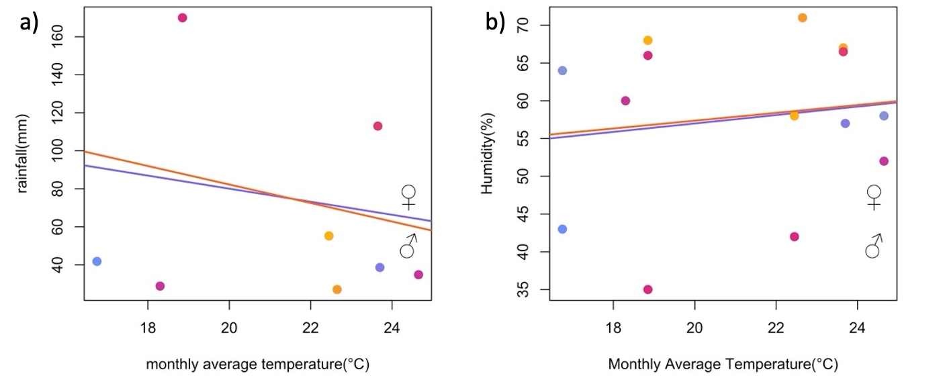
Figure S2: Correlation of monthly average temperature with rainfall and relative humidity across three seasons, represented by coloured dots in both sexes of I. heterosticta damselflies. Monthly temperatures were negatively correlated with rainfall but positively correlated with humidity for both sexes.

