Supplementary Figures
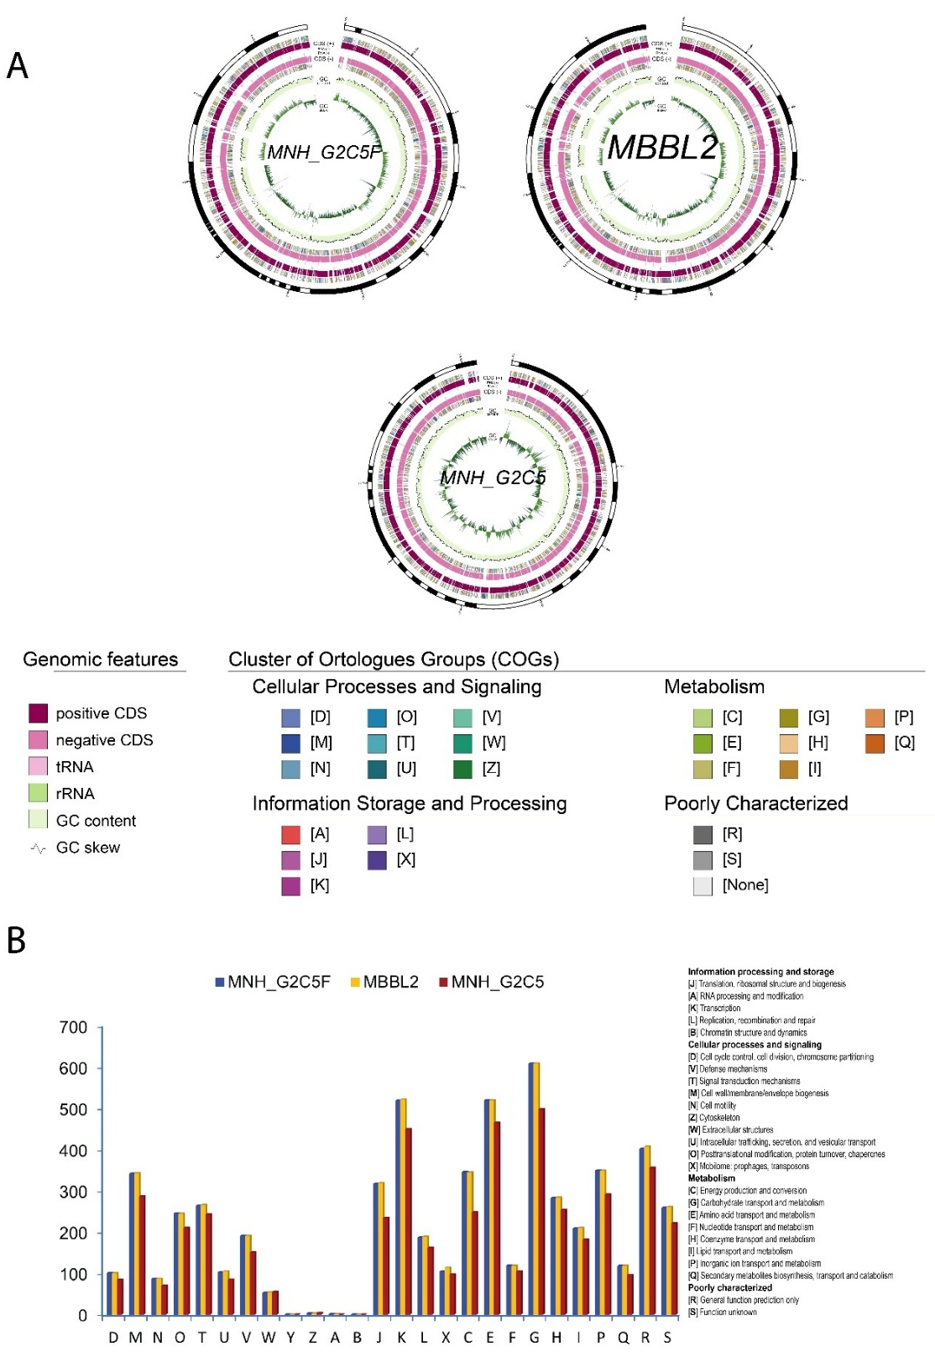
Figure S1. Genome visualization and functional annotation of Klebsiella pneumoniae strains MBBL2, MNH_G2C5, and MNH_G2C5F. (A) Circular genome maps of the three strains. From outer to inner rings: contigs, coding sequences (CDSs) on the forward strand with clusters of orthologous groups (COG) annotations, tRNA and rRNA genes, CDSs on the reverse strand with COG annotations, GC content, and GC skew. Features are highlighted in distinct colors as indicated in the legend. (B) Distribution of functional COG categories in the three genomes. Blue bars represent MNH_G2C5F, yellow bars indicate MBBL2, and crimson bars correspond to MNH_G2C5.
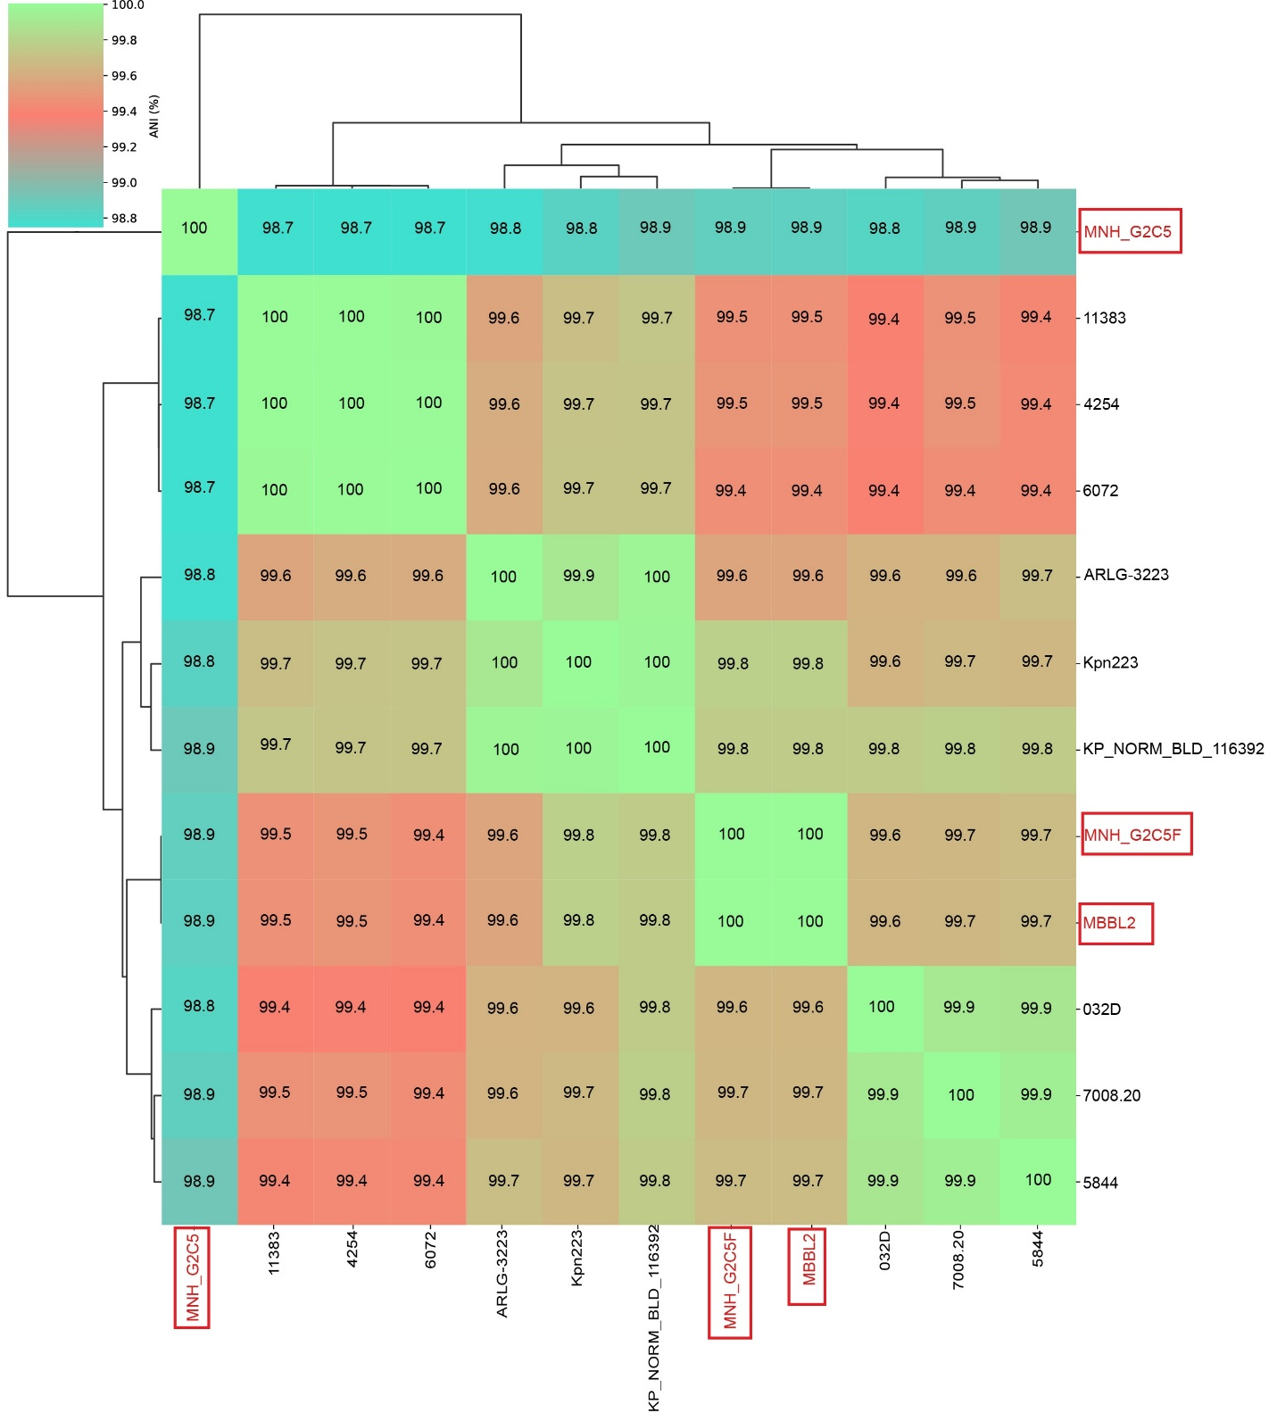
Figure S2. Overview of average nucleotide identity (ANI) analysis of 12 closely related K. pneumoniae strains. Genomes of MBBL2, MNH_G2C5, and MNH_G2C5F were compared with nine reference K. pneumoniae genomes, with ANI values highlighting their genomic relatedness and clustering patterns. Genomes of MBBL2, MNH_G2C5, and MNH_G2C5F are highlighted in red boxes.
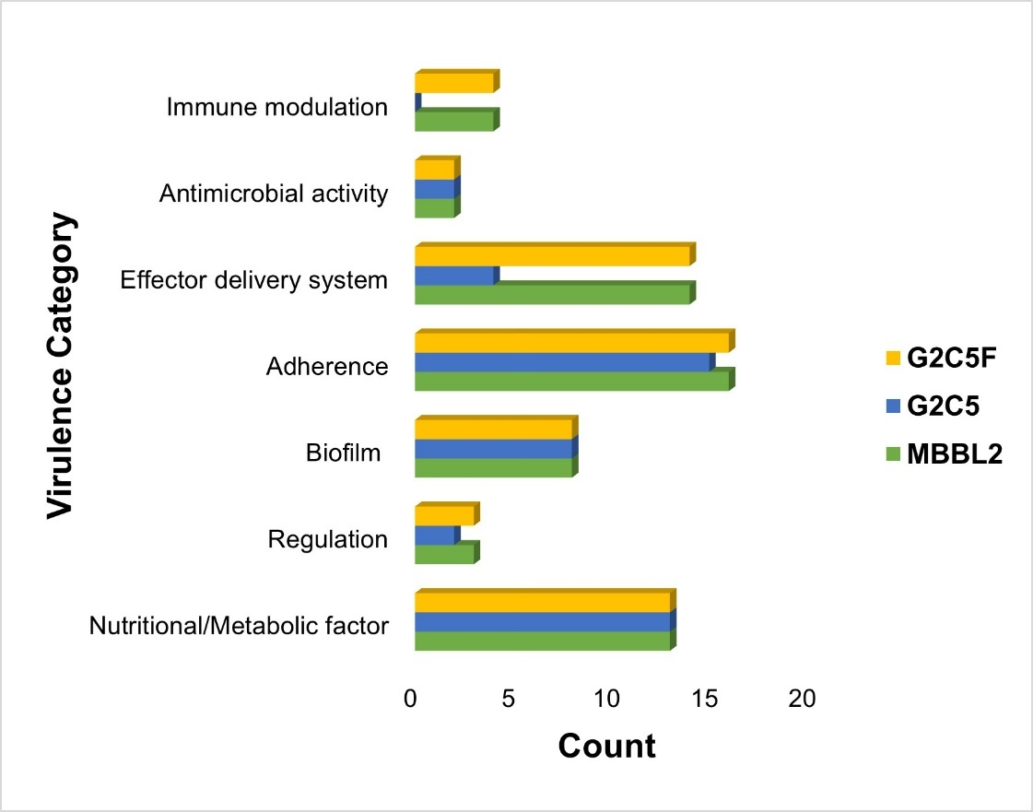
Figure S3. Virulence functional potentials of K. pneumoniae strains MBBL2, MNH_G2C5 and MNH_G2C5F. Bar graphs showing number of virulence genes against seven virulence categories. Yellow bar indicates MNH_G2C5F genome while blue and green bar indicates MNH_G2C5 and MBBL2 genome, respectively.
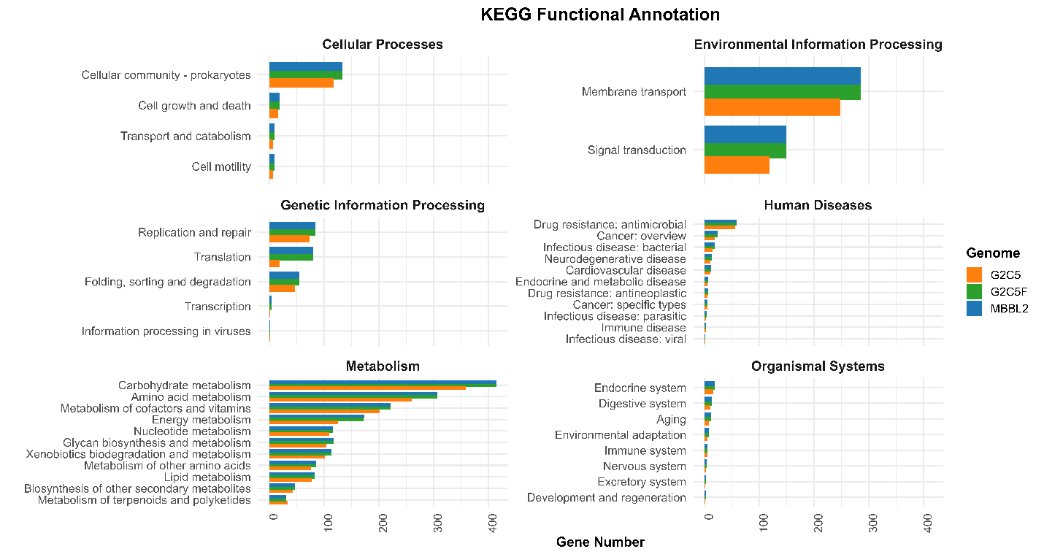
Figure S4. Metabolic functional potentials of the K. pneumoniae strains MBBL2, MNH_G2C5 and MNH_G2C5F. Metabolic features were annotated through the Kyoto Encyclopedia of Genes and Genomes (KEGG). Detailed representation of the functional classes belonging to six main functional categories. Each genome was represented by different colors as follows: orange for MNH_G2C5, green for MNH_G2C5f and blue for MBBL2.
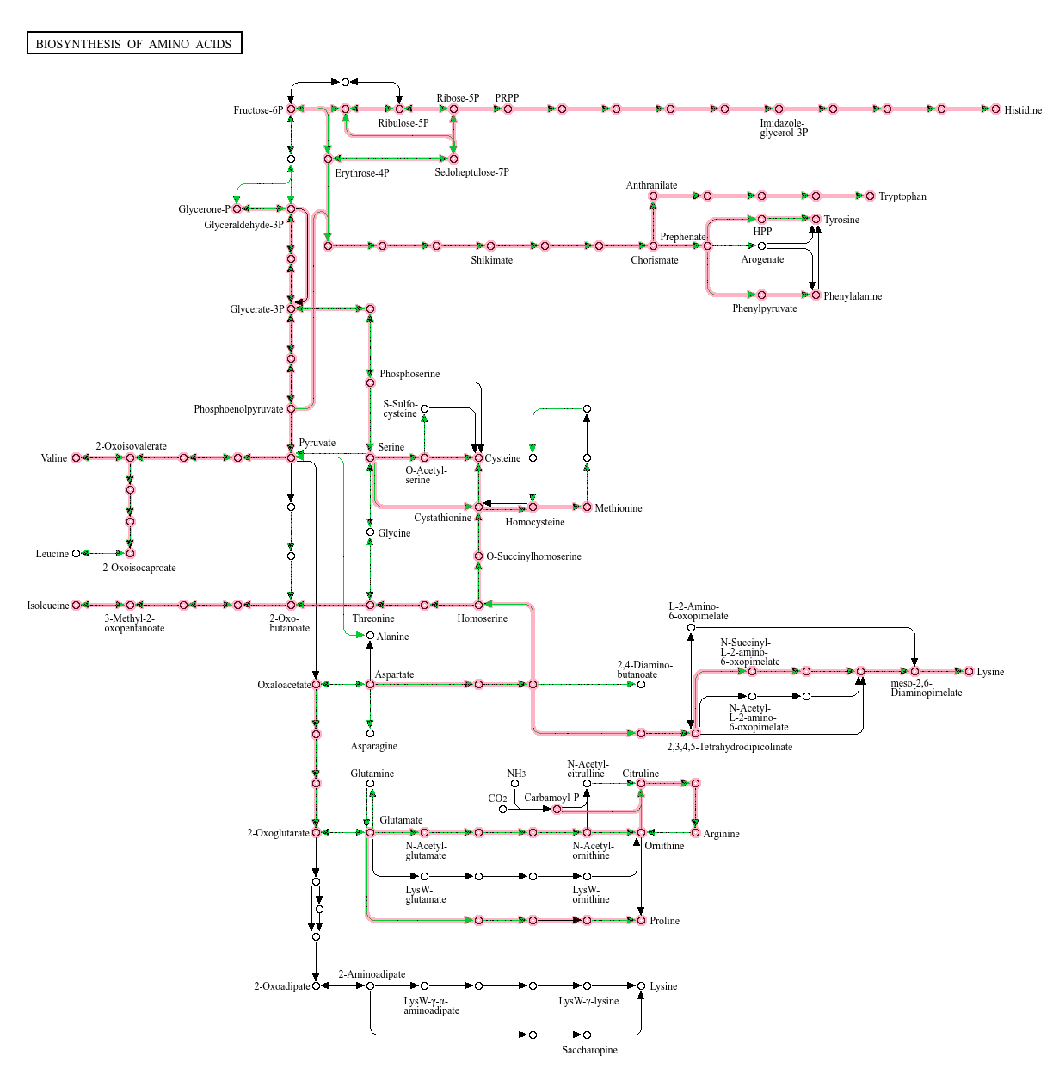
Figure S5. Complete set of biosynthesis of amino acid (Biogenic amine) pathway in K. pneumoniae MBBL2, MNH_G2C5 and MNH_G2C5F.

Supplementary Tables

Table S1. General genomic features of K. pneumoniae MBBL2, MNH_G2C5, and MNH_G2C5F.
Genomic features | K. pneumoniae strains
Genomic features | MBBL2 | MNH_G2C5 | MNH_G2C5F
GenBank accession | JBINJS000000000 | JAQLOG000000000 | JAULSG000000000
BioSample accession | SAMN44249570 | SAMN32317800 | SAMN36448984
SRA accession | SRR30951066 | SRR23757280 | SRR25276878
Assembled genome size (bp) | 5,39,1382 | 4,589,728 | 53,81,832
GC % | 57.5 | 57.5 | 57.5
Coverage (x) | 100 | 65.5 | 85
Genome completeness (%) | 98.55 (0.82% contamination) | 80.93 (2.35% contamination) | 98.55% (0.82% contamination)
Number of chromosomes | 0 | 1 | 4
N₅₀ value (bp) | 260,342 | 149,790 | 260,342
Number of contigs | 84 | 36 | 65
Genes (total) | 5,341 | 4,478 | 5,311
CDSs (total) | 5,252 | 4,437 | 5,224
Genes (coding) | 5,131 | 4,314 | 5,104
CDSs (with protein) | 5,131 | 4,314 | 5,104
Genes (RNA) | 89 | 63 | 87
rRNAs | 1, 1, 1 (5S, 16S, 23S) | 1, 1, 1 (5S, 16S, 23S) | 1, 1, 1 (5S, 16S, 23S)
Complete rRNAs | 1, 1 (5S, 16S) | 1, 1,1 (5S, 16S, 23S) | 1, 1 (5S, 16S)
tRNAs | 74 | 34 | 72
ncRNAs | 12 | 4 | 12
Pseudo genes (total) | 121 | 123 | 120
CDSs (without protein) | 121 | 123 | 120
Pseudo genes (ambiguous residues) | 0 of 121 | 0 of 123 | 0 of 120
Pseudo genes (frameshifted) | 59 of 121 | 35 of 123 | 54 of 120
Pseudo genes (incomplete) | 67 of 121 | 89 of 123 | 68 of 120
Pseudo genes (internal stop) | 24 of 121 | 15 of 123 | 27 of 120
Pseudo genes (multiple problems) | 25 of 121 | 12 of 123 | 28 of 120
CRISPR arrays | 1 | 0 | 1
Number of ARGs | CARD=48, Amrfinderplus=30 | CARD=39, Amrfinderplus=41 | CARD=47,  Amrfinderplus=29
Number of VFGs | VFDB= 60 | VFDB= 44 | VFDB= 60
Number of subsystems | 393 | 341 | 395
PathogenFinder score | 0.901 | 0. 911 | 0.901
Matched with pathogenic families | 322 | 255 | 322

Table S2. K. pneumoniae genomes (n=12) selected for ANI and pangenome analysis.
SL. No. | Strain | ST | Source | Country | Host/origin
1 | KP_NORM_BLD_116392 | 273 | Blood | Norway | Human
2 | Kpn223 | 273 | Habitat | USA | Environment
3 | 4254 | 438 | Patient | China | Human
4 | ARLG-3223 | 273 | Respiratory | USA | Human
5 | 7008.2 | 147 | Rectal swab | Switzerland | Human
6 | 6072 | 438 | Patient | China | Human
7 | 5844 | 147 | Clinical isolate | Italy | Human
8 | 11383 | 438 | Patient | China | Human
9 | 032D | 147 | Blood | Indonesia | Human
10 | MBBL2 | 273 | Mastitis milk | Bangladesh | Cow
11 | MNH_G2C5 | 101 | Mastitis milk | Bangladesh | Cow
12 | MNH_G2C5F | 273 | Feces of mastitic cow | Bangladesh | Cow

Table S3. Gene repertoire of K. pneumoniae genomes (n=12) used ANI and pangenome analysis.
SL. No. | Genome | Core_Genes | Accessory_Genes | Strain_Specific_Genes
1 | 032D | 2791 | 885 | 10
2 | 11383 | 2791 | 950 | 1
3 | 4254 | 2791 | 900 | 1
4 | 5844 | 2791 | 878 | 3
5 | 6072 | 2791 | 941 | 0
6 | 7008.20. | 2791 | 945 | 23
7 | ARLG.3223 | 2791 | 911 | 31
8 | KP_NORM_BLD_116392 | 2791 | 820 | 6
9 | Kpn223. | 2791 | 864 | 8
10 | MBBL2 | 2791 | 826 | 1
11 | MNH_G2C5 | 2791 | 234 | 123
12 | MNH_G2C5F | 2791 | 826 | 0

Table S4. EPS and capsule biosynthesis gene clusters in K. pneumoniae strains MBBL2, MNH_G2C5 and MNH_G2C5F.
MBBL2_C1
Protein ID | Gene Symbol | Protein Description
MFH5890472.1 | ugd | UDP-glucose 6-dehydrogenase
MFH5890473.1 | gndA | NADP-dependent phosphogluconate dehydrogenase
MFH5890474.1 | Wzx | Polysaccharide biosynthesis C-terminal domain-containing protein
MFH5890475.1 | - | Hypothetical protein
MFH5890476.1 | - | Hypothetical protein
MFH5890477.1 | GH43 | Glycoside hydrolase family 43 protein
MFH5890478.1 | IS630 | IS630 family transposase
MFH5890479.1 | EpsG | EpsG family protein
MFH5890480.1 | GT | Glycosyltransferase
MFH5890481.1 | GT2 | Glycosyltransferase family 2 protein
MFH5890482.1 | GT | Glycosyltransferase
MFH5890483.1 | GT4 | Glycosyltransferase family 4 protein
MFH5890484.1 | wbaP | Undecaprenyl-phosphate galactose phosphotransferase WbaP
MFH5890485.1 | wzc | Polysaccharide biosynthesis tyrosine autokinase
MFH5890486.1 | wzb | Protein tyrosine phosphatase
MFH5890487.1 | wza | Polysaccharide export protein
MFH5890488.1 | Wzi | Capsule assembly Wzi family protein
MFH5890489.1 | wcaJ | Phosphatase PAP2 family protein
- | galF | GalU regulator GalF (pseudo)
MBBL2_C2
MFH5890999.1 | wecG | Lipopolysaccharide N-acetylmannosaminouronosyltransferase
MFH5891000.1 | wzyE | ECA oligosaccharide polymerase
MFH5891001.1 | wecF | TDP-N-acetylfucosamine:lipid II N-acetylfucosaminyltransferase
MFH5891002.1 | wzxE | Lipid III flippase WzxE
MFH5891003.1 | rffA | dTDP-4-amino-4,6-dideoxygalactose transaminase
MFH5891004.1 | rffC | dTDP-4-amino-4,6-dideoxy-D-galactose acyltransferase
MFH5891005.1 | rfbA | Glucose-1-phosphate thymidylyltransferase RfbA
MFH5891006.1 | rffG | dTDP-glucose 4,6-dehydratase
MFH5891007.1 | wecC | UDP-N-acetyl-D-mannosamine dehydrogenase
MFH5891008.1 | wecB | Non-hydrolyzing UDP-N-acetylglucosamine 2-epimerase
MFH5891009.1 | wzzE | ECA polysaccharide chain length modulation protein
MFH5891010.1 | wecA | UDP-N-acetylglucosamine--undecaprenyl-phosphate N-acetylglucosaminephosphotransferase
MFH5891011.1 | rho | Transcription termination factor Rho
MNH_G2C5-C1
WP_002883293.1 | rho | Transcription termination factor Rho
WP_002883295.1 | wecA | UDP-N-acetylglucosamine--undecaprenyl-phosphate N-acetylglucosaminephosphotransferase
WP_002883296.1 | wzzE | ECA polysaccharide chain length modulation protein
WP_002883297.1 | wecB | UDP-N-acetylglucosamine 2-epimerase (non-hydrolyzing)
WP_004186361.1 | wecC | UDP-N-acetyl-D-mannosamine dehydrogenase
WP_019704851.1 | rffG | dTDP-glucose 4,6-dehydratase
WP_002883307.1 | rfbA | Glucose-1-phosphate thymidylyltransferase RfbA
WP_004146507.1 | rffC | dTDP-4-amino-4,6-dideoxy-D-galactose acyltransferase
WP_032418224.1 | rffA | dTDP-4-amino-4,6-dideoxygalactose transaminase
WP_004150424.1 | wzxE | Lipid III flippase WzxE
WP_032418223.1 | wecF | TDP-N-acetylfucosamine:lipid II N-acetylfucosaminyltransferase
WP_004886822.1 | wzyE | ECA oligosaccharide polymerase
WP_004177935.1 | rffM | Lipopolysaccharide N-acetylmannosaminouronosyltransferase
MNH_G2C5-C2
WP_004188137.1 | GT2 | Glycosyltransferase family 2 protein
WP_002922461.1 | tdh | L-threonine 3-dehydrogenase
WP_272040634.1 | kbl | Glycine C-acetyltransferase
WP_002922463.1 | rfaD | ADP-glyceromanno-heptose 6-epimerase
WP_002922465.1 | rfaF | ADP-heptose--LPS heptosyltransferase RfaF
WP_032418273.1 | rfaC | Lipopolysaccharide heptosyltransferase RfaC
WP_002922468.1 | waaZ | Sugar glycosyltransferase
WP_164849030.1 | waaL | O-antigen ligase family protein
WP_002922472.1 | GT9 | Glycosyltransferase family 9 protein
WP_002922494.1 |  | Polysaccharide deacetylase family protein
WP_004181527.1 | rfaQ | Putative lipopolysaccharide heptosyltransferase III
WP_002922496.1 | GT4 | Glycosyltransferase family 4 protein
WP_004150194.1 | GT | Glycosyltransferase
WP_004173909.1 | GT | Glycosyltransferase
WP_032418272.1 | waaA | Lipid IV(A) 3-deoxy-D-manno-octulosonic acid transferase
WP_004145264.1 | GT2 | Glycosyltransferase family 2 protein
MNH_G2C5F-C1
WP_023328477.1 | ugd | UDP-glucose 6-dehydrogenase
WP_023328476.1 | gndA | NADP-dependent phosphogluconate dehydrogenase
WP_228284073.1 | - | hypothetical protein
WP_323053734.1 | - | hypothetical protein
WP_023328474.1 | GH43 | glycoside hydrolase family 43 protein
WP_072000346.1 | IS630 | IS630 family transposase
WP_072198505.1 | EpsG | EpsG family protein
WP_064141386.1 | GT | glycosyltransferase
WP_050484904.1 | GT2 | glycosyltransferase family 2 protein
WP_032411936.1 | GT | glycosyltransferase
WP_071953808.1 | GT4 | glycosyltransferase family 4 protein
WP_023328467.1 | wbaP | undecaprenyl-phosphate galactose phosphotransferase WbaP
WP_023328466.1 | wzc | polysaccharide biosynthesis tyrosine autokinase
WP_031592319.1 | wzb | protein-tyrosine-phosphatase
WP_032411939.1 | wza | polysaccharide export protein
WP_015958714.1 | Wzi | capsule assembly Wzi family protein
WP_004151150.1 | wcaJ | phosphatase PAP2 family protein
- | galF | GalU regulator GalF (pseudo)
MNH_G2C5F-C2
WP_004177935.1 | wecG | lipopolysaccharide N-acetylmannosaminouronosyltransferase
WP_004186365.1 | wzyE | ECA oligosaccharide polymerase
WP_004146501.1 | wecF | TDP-N-acetylfucosamine:lipid II N-acetylfucosaminyltransferase
WP_032433737.1 | wzxE | lipid III flippase WzxE
WP_002883310.1 | rffA | dTDP-4-amino-4,6-dideoxygalactose transaminase
WP_004146507.1 | rffC | dTDP-4-amino-4,6-dideoxy-D-galactose acyltransferase
WP_023301353.1 | rfbA | glucose-1-phosphate thymidylyltransferase RfbA
WP_002883303.1 | rffG | dTDP-glucose 4,6-dehydratase
WP_004186361.1 | wecC | UDP-N-acetyl-D-mannosamine dehydrogenase
WP_002883297.1 | wecB | non-hydrolyzing UDP-N-acetylglucosamine 2-epimerase
WP_002883296.1 | wzzE | ECA polysaccharide chain length modulation protein
WP_002883295.1 | wecA | UDP-N-acetylglucosamine--undecaprenyl-phosphate N-acetylglucosaminephosphotransferase
WP_002883293.1 | rho | transcription termination factor Rho

