Stacking pattern effect on the energy storage performance of relaxor-ferroelectric/antiferroelectric PLZT-based multilayer film capacitors prepared by sol-gel methods
Chang Gao^{1#}, Lijuan Huang^{1#}, Qi Liu², Shize Wu³, Zedong Xu⁴, Chunlin Zhao¹, Xiao Wu¹, Min Gao¹*, Cong Lin^{1*}
1 College of Materials Science and Engineering, Fuzhou University, Fuzhou 350108, China
2 Department of Physics, Southern University of Science and Technology, Shenzhen 518055, China
3 School of Materials Science and Engineering, Tiangong University, Tianjin 300387, China.
4 Institute of Quantum Materials and Devices, School of Electronics and Information Engineering, Tiangong University, Tianjin 300387, China.
#Chang Gao and Lijuan Huang are co-first authors of the article.
*Corresponding authors
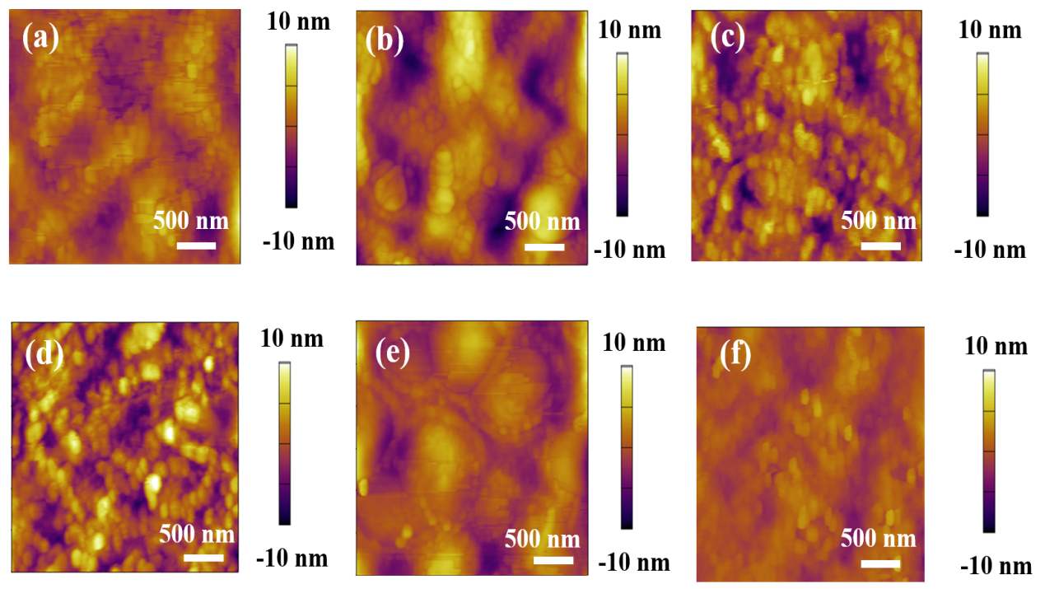
Figure S1. AFM height image of the (a) R₆, (b) A₆, (c) (RA)₃, (d) (RA)₂, (e) (RAA)₂, and (f) (RAAA)₂.
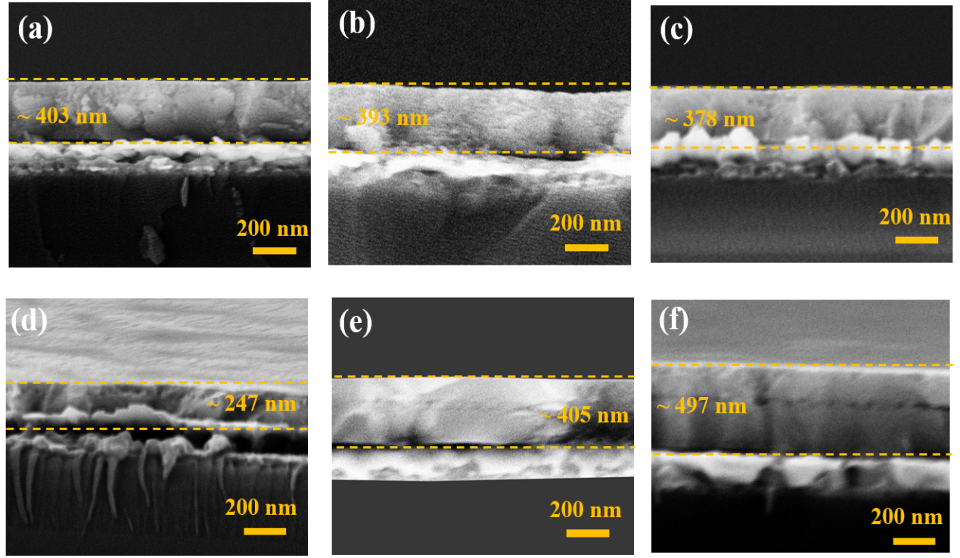
Figure S2. Cross-sectional SEM images of the (a) R₆, (b) A₆, (c) (RA)₃, (d) (RA)₂, (e) (RAA)₂, and (f) (RAAA)₂.
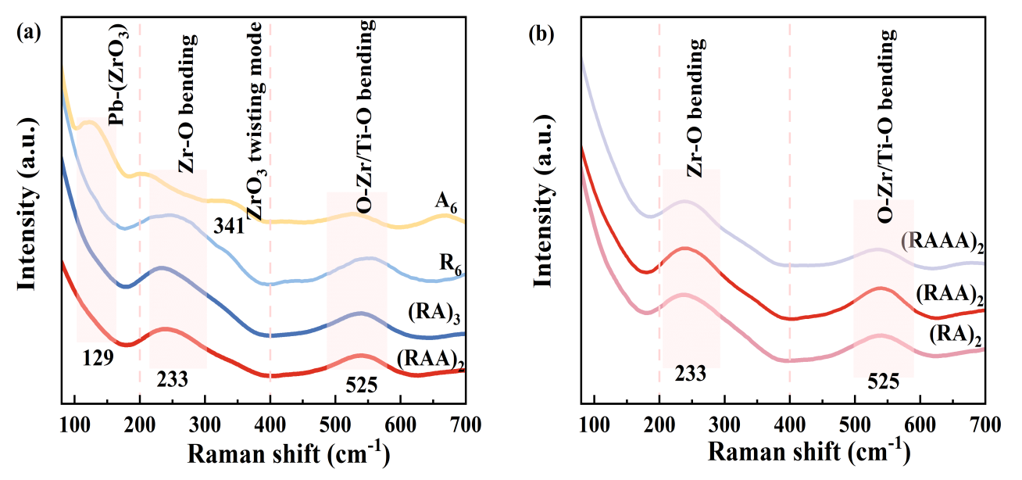
Figure S3. Raman spectrums of all samples. (a) A₆, R₆, (RA)₃, and (RAA)₂, (b) (RA)₂, (RAA)₂, (RAAA)₂.

