Supporting Information

Strain-inversion Strategy Achieving 53μm-ultra-thick, Stress-free III-nitride Heteroepitaxy by MOCVD

Junkang Wu¹, Xuelin Yang^{1,2,}*, Faquan Wu¹, Xingyu Fu¹, Hongcai Yang¹, Zhenghao Chen¹, Lin Yao¹, Beile Chen¹, Han Yang¹, Yingming Song¹, Yuxia Feng⁴, Fujun Xu¹, Ning Tang^{1,2}, Xinqiang Wang^{1,2,3}, Weikun Ge¹, and Bo Shen^{1,2,3,}*

¹State Key Laboratory of Artificial Microstructure and Mesoscopic Physics, Nano-optoelectronics Frontier Center of Ministry of Education, School of Physics, Peking University, Beijing, China
²Peking University Yangtze Delta Institute of Optoelectronics, Nantong, Jiangsu, China
³Collaborative Innovation Center of Quantum Matter, Beijing, China
⁴The Key Laboratory of Optoelectronics Technology, Ministry of Education, Beijing University of Technology, Beijing, China

E-mail: xlyang@pku.edu.cn, bshen@pku.edu.cn

Detailed derivation process and expression of the strain-inversion strategy: we treat the 4H-SiC/AlN compliant layer and the GaN epilayer as two elastically coupled plates (Fig. S1). ¹⁻³ For biaxial strain in the plane of the interface, the system must obey: ^{4, 5}
(1) force balance on every plane parallel to the interface:
$$\begin{aligned}M_{f}ε_{f}t_{f}+M_{s}ε_{s}t_{s}=0 \#\left(S1\right)\end{aligned}$$
(2) kinematic compatibility (total in-plane strain):
$$\begin{aligned}ε_{f}-ε_{s}=ε_{m} \#\left(S2\right)\end{aligned}$$
Solving Eq.(S1) and Eq.(S2) gives the strain partition effect in Eq. (1).

The total strain ε_{m} is composed of thermal mismatch strain ε_{CTE} and lattice mismatch strain ε_{lattice}. The lattice mismatch strain relaxes with the increasing of the film thickness t_{f} through the generation of misfit dislocations: ⁶
$$\begin{aligned}ε_{m}=ε_{CTE}+{R\left(t_{f}\right)∙ε}_{lattice} \#\left(S3\right)\end{aligned}$$
The thermal mismatch strain is fixed by the thermal expansion coefficient of substrate layer α_{s} and film α_{f}, as well as the growth temperature T_{growth} and room temperature T_{room}:
$$\begin{aligned}ε_{CTE}=\int_{T_{growth}}^{T_{room}}{\left(α_{s}\left(T\right)-α_{f}\left(T\right)\right)dT}≈∆α∙∆T \#\left(S4\right)\end{aligned}$$
The lattice mismatch strain depends on the in-plane lattice constants of the substrate a_{s} and film a_{f}:
$$\begin{aligned}ε_{lattice}=\frac{a_{s}-a_{f}}{a_{f}} \#\left(S5\right)\end{aligned}$$
The relaxing rate of the lattice mismatch strain follows: ^{7, 8}
$$\begin{aligned}\log{R\left(t_{f}\right)}=-k\log{t_{f}}+C \#\left(S6\right)\end{aligned}$$
By combining the Eq. (S3) ~ (S6), we establish the relationship between the total strain and the films thickness. This comprehensive analysis enables the determination of partitioned strain in the substrate layer and film.

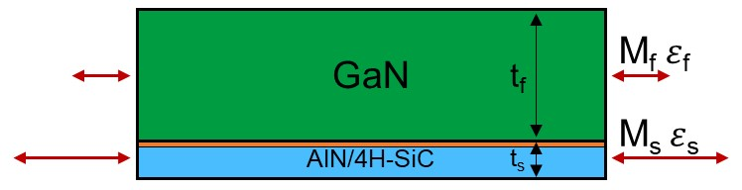

Fig. S1 Schematic diagram of the strain-inversion strategy system. A thin AlN/4H-SiC substrate stack (thickness t_{s}, biaxial modulus M_{s}) is elastically coupled to the GaN epilayer (t_{f}, M_{f}). The total strain ε_{m} is partitioned so that the substrate stack accommodates most of the deformation (ε_{s}), leaving the GaN film nearly strain-free (ε_{f}).

X-ray reciprocal-space mapping demonstrates complete coherence between the AlN nucleation layer and the underlying 4H-SiC substrate across all measured thicknesses (1~10 µm). The GaN epilayer remain essentially stress-free, as corroborated by subsequent Raman measurements. The corresponding in-plane reciprocal-lattice vector (Q_{x}) shifts for AlN and 4H-SiC are extracted and plotted in Fig. 2(b).

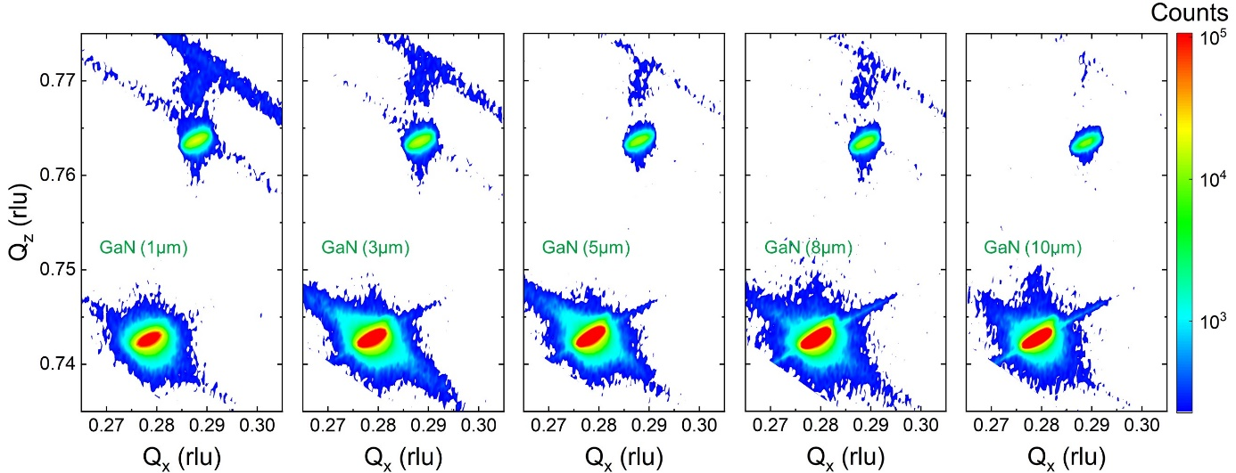

Fig. S2 (-1015) RSM of GaN films with thicknesses of 1~10 µm.

The polycrystalline ceramic-AlN (bottom) exhibits a characteristic grain-stack morphology, whereas the overlying single-crystal GaN forms a continuous, uniform layer. Sharp, defect-free interfaces and the absence of cracks across the entire imaged area corroborate effective stress management within the strain-inversion strategy.

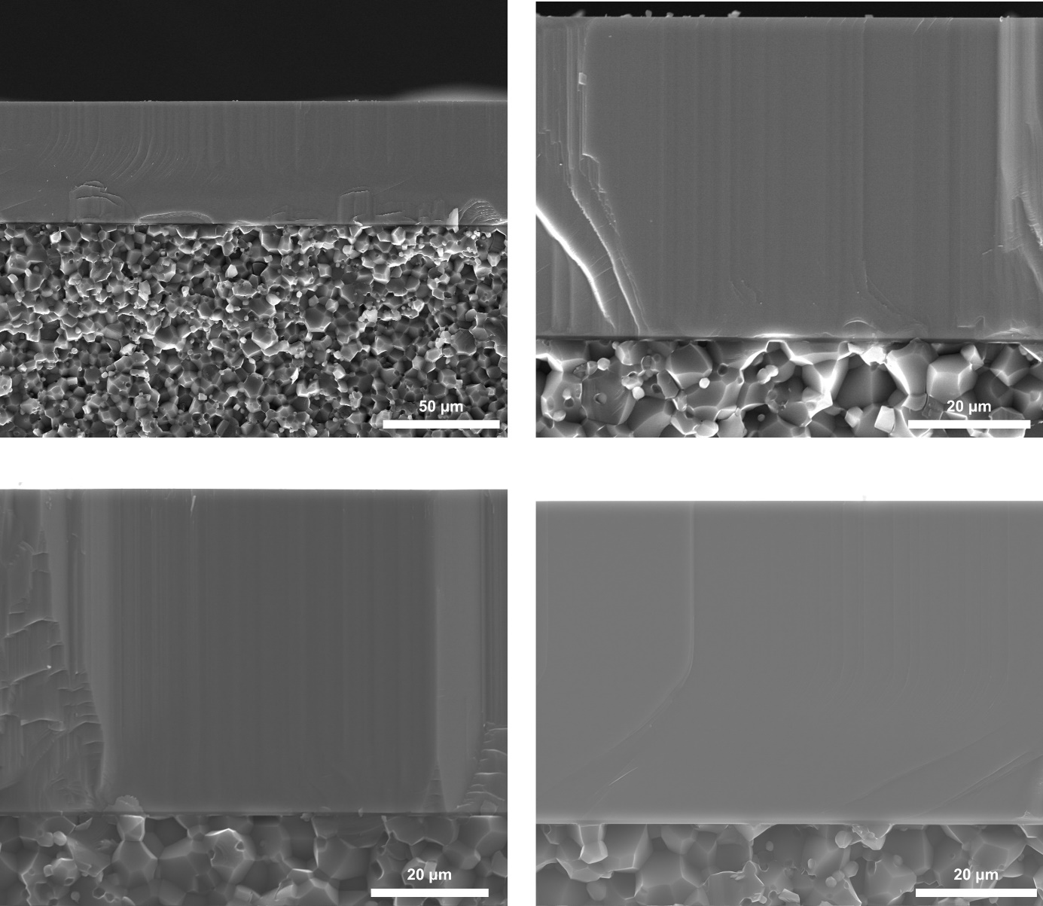

Fig. S3 Additional cross-sectional SEM images of the 53 μm GaN film.

Real-time in-situ reflectance during the growth of the 53 µm sample. It gives the growth sequence that the 53 µm GaN was grown directly after the 50 nm AlN nucleation layer. Without any strain-control buffer, the average amplitude turned out to be a constant, leading to the conclusion of steady surface morphology during the whole growth procedure.

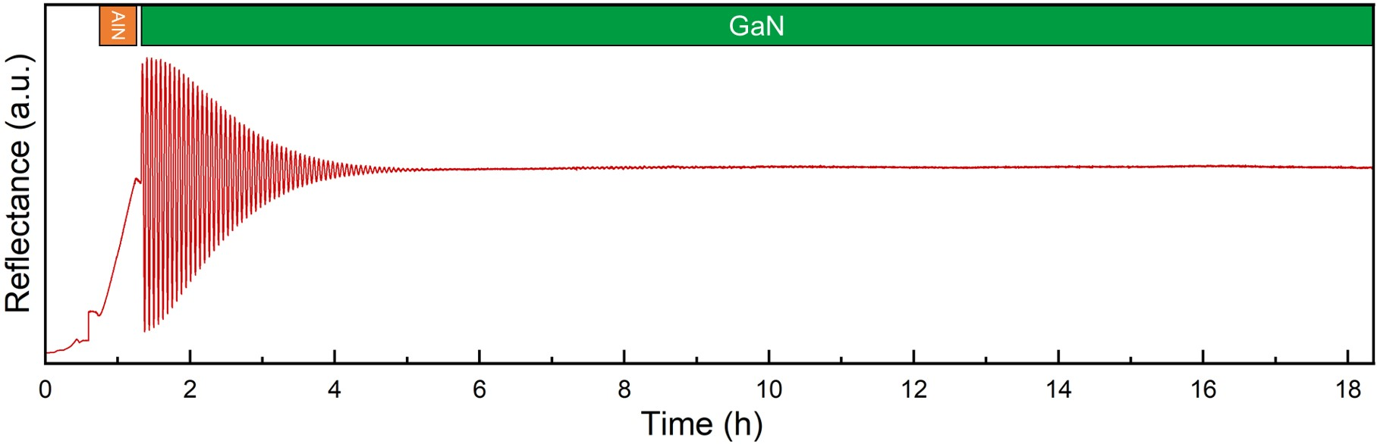

Fig. S4 In-situ reflectance monitoring during the growth of the 53 µm GaN film. The consistent average amplitude indicates stable surface morphology throughout the entire deposition process.

References
1. Jiang Q, Liu C, Lu Y, Chen KJ. 1.4-kV AlGaN/GaN HEMTs on a GaN-on-SOI Platform. IEEE Electron Device Letters 34, 357-359 (2013).
2. Cao J, Pavlidis D, Park Y, Singh J, Eisenbach A. Improved quality GaN by growth on compliant silicon-on-insulator substrates using metalorganic chemical vapor deposition. J Appl Phys 83, 3829-3834 (1998).
3. Vohra A, et al. Epitaxial buffer structures grown on 200 mm engineering substrates for 1200 V E-mode HEMT application. Appl Phys Lett 120, (2022).
4. Freund LB, Nix WD. A critical thickness condition for a strained compliant substrate/epitaxial film system. Appl Phys Lett 69, 173-175 (1996).
5. Li MD, et al. An extended Stoney's formula including nonlinear deformation for large size wafer of multilayers with arbitrary thicknesses. Scripta Materialia 186, 29-32 (2020).
6. Barghout K, Chaudhuri J. Calculation of residual thermal stress in GaN epitaxial layers grown on technologically important substrates. Journal of Materials Science 39, 5817-5823 (2004).
7. Lim YS, Lee JY, Kim TW. The strain relaxation in a lattice-mismatched heterostructure. J Cryst Growth 200, 421-426 (1999).
8. Dunstan DJ, et al. Plastic relaxation of metamorphic single layer and multilayer InGaAs/GaAs structures. Appl Phys Lett 65, 839-841 (1994).

