SUPPLEMENTARY INFORMATION

Characterization and third order non-linear optical properties study of the MXene/PVA composite nanofibers

Shermineh Galehdarvand, Hossein Mahmoudi Chenari*

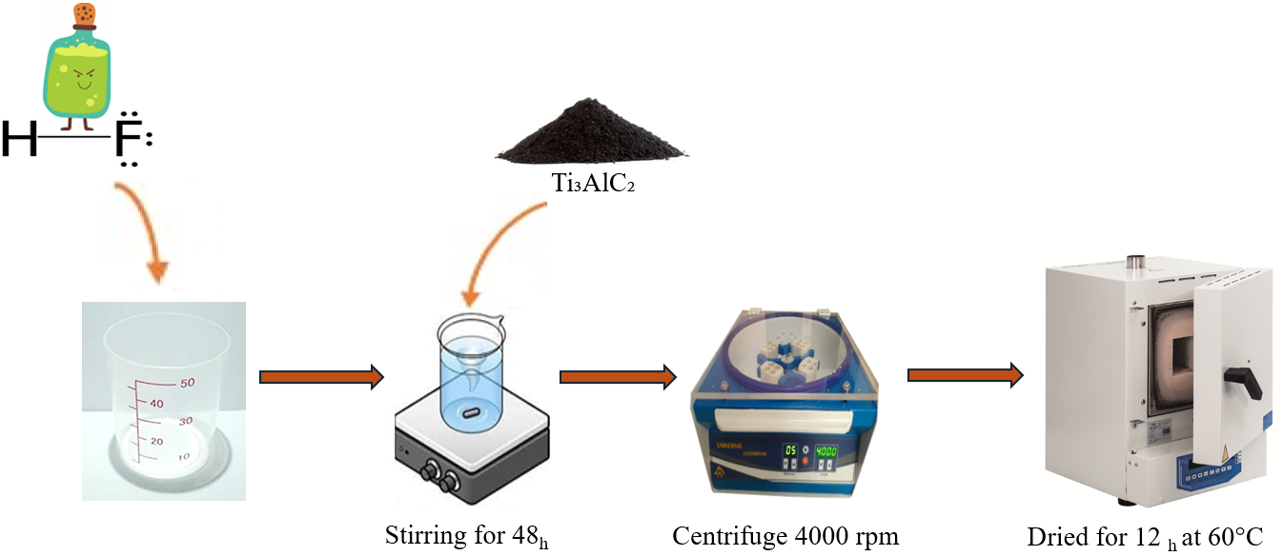

Supplementary Fig.1. Schematic of the MXene synthesis process.

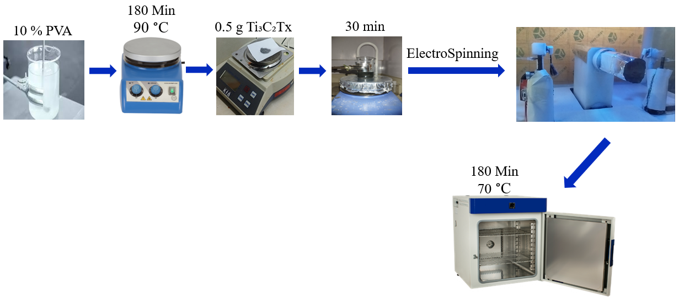
Supplementary Fig.2. Schematic of Mxene/PVA nanofiber fabrication

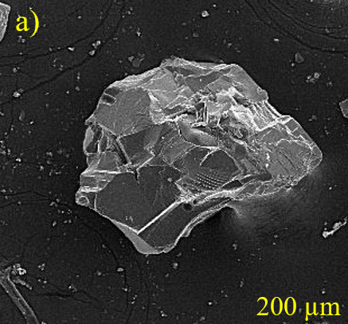
Supplementary Fig. 4(a). FESEM images at different magnification of Ti₃AlC₂ at 200 μm

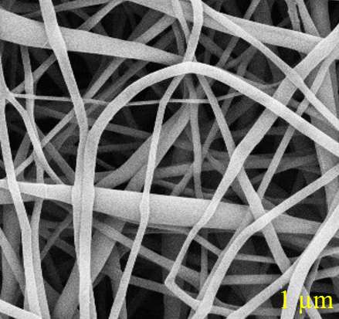

Supplementary Fig.5. FESEM images at different magnification of MXene/PVA nanofibers.

