Table S1. Quantitative polymerase chain reaction for calibration curve
Target | Cq (∆Rn) | Tm Product 1 (-Rn'(T)) (℃) | CFU
Enterococcus faecalis | 15.18 | 82.5 | 2.008×10⁶
Enterococcus faecalis | 18.79 | 82.5 | 2.008×10⁵
Enterococcus faecalis | 21.79 | 82.5 | 2.008×10⁴
Enterococcus faecalis | 27.96 | 82.5 | 2.008×10³
Enterococcus faecalis | 34.18 | 82.5 | 2.008×10²
The Cq value corresponding to CFU of E. faecalis was measured. CFU, colony forming unit; Cq, quantification cycle; -Rn’/dT, derivative fluorescence; ∆Rn, change in normalized reporter signal; Tm, melting temperature.
Note: Cq values represent the cycle number at which the fluorescence signal exceeds the threshold, based on ∆Rn. Tm values represent the temperature at which 50% of the polymerase chain reaction product is denatured.

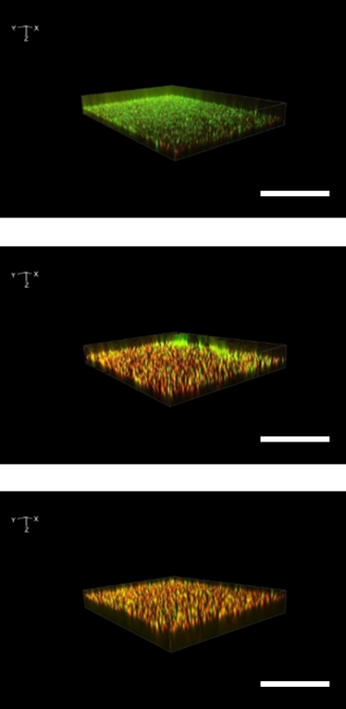
Supplementary Figure 1. Live/dead staining of bacteria after treatment with Actril
Triplicated images obtained after treatment with Actril at 100× magnification. Green fluorescence indicates live bacteria, and red fluorescence indicates dead bacteria. Scale bar =100 µm.

