Supplementary Materials (Tables):
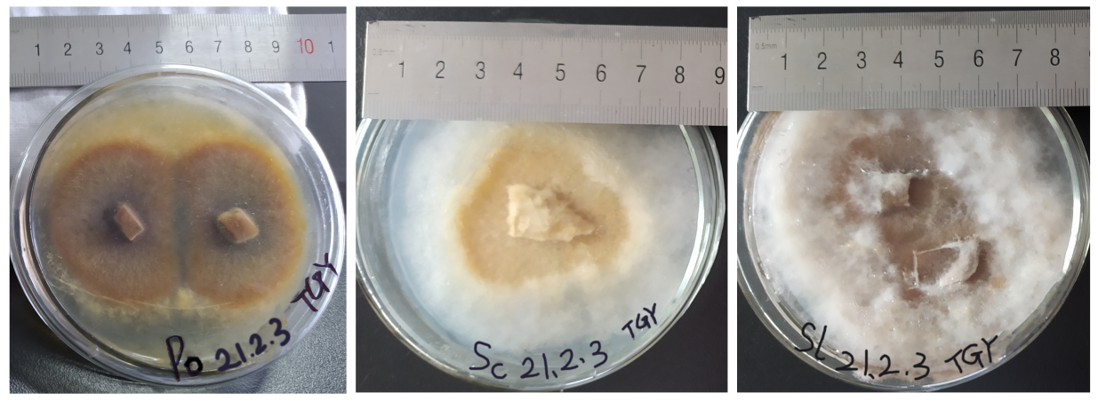
Fig. S1 This is a diagram of the growth status of the three strains used in this experiment in a flat solid petri dish, from left to right Pisolithus orientalis (Po), Scleroderma citrinum (Sc), Suillus luteus (Sl).

Fig. S2 Correlation heatmaps of growth factors of donor (A) and receiver (B) plants, D: Donor plant; r: Root; s: Stem; l: Leaf; TN: Total Nitrogen; TP: Total phosphorus; TK: Total potassium; biomass: Biomass; ECM Infiltration: ectomycorrhizal colonization ratio; N acquired: Nitrogen absorption; Distribution: ¹⁵N allocation [%]; ¹⁵N acquired: ¹⁵N absorption; Use: The ¹⁵N use ratio; Transmissibility: The ¹⁵N transfer ratio; *: P < 0.05, **: P < 0.01.

Fig.S3 Effect of ectomycorrhizal fungi on the height of donor and receiver P. massoniana seedlings under different nitrogen levels
Note: N0、N2、N4、N6 were 0、2、4、6 g/L, respectively, nitrogen levels treatment; NE was not inoculated, Sm was inoculated; Different lowercase letters indicate significant differences among nitrogen treatments within each inoculation status, whereas different capital letters indicate significant differences between inoculation statuses within each nitrogen treatment (P < 0.05).

