Supplementary Information

In-silico screening and molecular dynamics analysis to uncover mechanistic of natural SARS-CoV-2 inhibitors present in four medicinal plants

Vinay Kumar Yadav*¹, Manjari Shukla¹, Sushobhan Maji¹, Arvind Singh Bhati¹, Mitali Mukerji¹ and Sudipta Bhattacharyya¹

Corresponding author: Dr. Sudipta Bhattacharyya, Department of Bioscience and Bioengineering, IIT Jodhpur, Rajasthan (342030), India. Tel: +91291-280-1213; E-mail: sudipta@iitj.ac.in.
¹Department of Bioscience and Bioengineering, Indian Institute of Technology, Jodhpur, Rajasthan (342030), India.

Table of Contents

 | Title | Page No.
Table 1 | Total phytochemicals from AYUSH-64 medicinal plants | 2-8
Table 2 | Compounds binding at active sites of different target proteins | 10
Table 3 | Interacting residues of the target proteins with their respective docked ligands | 11-12
Table 4 | List of the variant of concern of SARS-CoV-2 and respective mutations | 12
Figure 1 | 2D interaction profile of 3CL^{pro} with control ligand SDZ224015 and top three ligands | 13
Figure 2 | 2D interaction profile of RdRp with control ligand suramin and top three ligands | 14
Figure 3 | 2D interaction profile of PL^{pro} with control ligand Y95 and top three ligands | 15
Figure 4 | 2D interaction profile of RBD with control ligand tamoxifen and top three ligands | 16
Figure 5 | MD simulation trajectory analysis of PL^{pro} with and without ligands and prediction of amino acid conservation in the protein | 17
Figure 6 | MD simulation trajectory analysis of RBD with and without ligands and prediction of amino acid conservation in the protein | 18
Figure 7 | Salt bridge analysis from simulation trajectory for all four target proteins in apo form and with ligands | 19
Figure 8 | Chemical structure of the top three phytoconstituents for each of the four target proteins | 20

Table 1. Total phytochemicals from AYUSH-64 medicinal plants

S.No. | Phytochemical | Plants source | Reference
1 | Echitamine | Alstonia scholaris | 1
2 | Nareline | Alstonia scholaris | 1
3 | Strictamine | Alstonia scholaris | 1
4 | Picrinine | Alstonia scholaris | 1
5 | Scholarisine A | Alstonia scholaris | 1
6 | N-Demethylechitamine | Alstonia scholaris | 1
7 | 17-O-acetylechitamine | Alstonia scholaris | 1
8 | Echitaminic acid | Alstonia scholaris | 1
9 | 10-demethoxyvincorine N(4)-oxide | Alstonia scholaris | 1
10 | 17-formyl-10-demethoxyvincorine N(4)-oxide | Alstonia scholaris | 1
11 | Narelin-methylether | Alstonia scholaris | 1
12 | O-acetyl-narelin | Alstonia scholaris | 1
13 | Narelin-monoxim | Alstonia scholaris | 1
14 | Dihydronarelin | Alstonia scholaris | 1
15 | O,O’ -diacetyl-dihydro-narelin | Alstonia scholaris | 1
16 | Tetrahydronarelin | Alstonia scholaris | 1
17 | N,O,O` -triacetyl-tetrahydronarelin | Alstonia scholaris | 1
18 | Nareline ethyl ether | Alstonia scholaris | 1
19 | 5-epi-nareline ethyl ether | Alstonia scholaris | 1
20 | Scholarisines H | Alstonia scholaris | 1
21 | 5-methoxystrictamine (methyl (5β,16R,19E)-5-methoxyakuammilan-17-oate) | Alstonia scholaris | 1
22 | Methyl (16R,19E)-1,2-dihydro-16- (hydroxymethyl)-5-oxoakuammilan-17-oate | Alstonia scholaris | 1
23 | Methyl (2β,16R,19E)-4,5-didehydro-1,2-dihydro-2- hydroxy-16-(hydroxymethyl) akuammilan-4-ium-17-oate chloride | Alstonia scholaris | 1
24 | 3-epi-dihydrocorymine-17- acetate | Alstonia scholaris | 1
25 | 16-formyl-5α-methoxystrictamine | Alstonia scholaris | 1
26 | 17-nor-excelsinidine | Alstonia scholaris | 1
27 | Normavacurine-21-one | Alstonia scholaris | 1
28 | Alstobrogaline | Alstonia scholaris | 1
29 | Pseudo (ψ) akuammigine | Alstonia scholaris | 1
30 | Akuammiginone | Alstonia scholaris | 1
31 | Scholarisine B | Alstonia scholaris | 1
32 | Scholarisine C | Alstonia scholaris | 1
33 | Scholarisine D | Alstonia scholaris | 1
34 | Scholarisine E | Alstonia scholaris | 1
35 | Scholarisine F | Alstonia scholaris | 1
36 | 19-E-picrinine | Alstonia scholaris | 1
37 | Scholarisine Q | Alstonia scholaris | 1
38 | Scholarisine R | Alstonia scholaris | 1
39 | Picralinal | Alstonia scholaris | 1
40 | Alschomine | Alstonia scholaris | 1
41 | Iso-alschomine | Alstonia scholaris | 1
42 | N_{a}-methylburnamine | Alstonia scholaris | 1
43 | 5-methoxyaspidophylline | Alstonia scholaris | 1
44 | N1-methoxymethyl picrinine | Alstonia scholaris | 1
45 | Alstomaline | Alstonia scholaris | 1
46 | 5-hydroxy-19,20- E-alschomine | Alstonia scholaris | 1
47 | 5-hydroxy-19,20-Z-alschomine | Alstonia scholaris | 1
48 | Alstoniascholarine L | Alstonia scholaris | 1
49 | Alstoniascholarine M | Alstonia scholaris | 1
50 | Alstoniascholarine N | Alstonia scholaris | 1
51 | Burnamine | Alstonia scholaris | 1
52 | Alistonitrine A | Alstonia scholaris | 1
53 | Alstolactine A | Alstonia scholaris | 1
54 | Alstolactine B | Alstonia scholaris | 1
55 | Alstolactine C | Alstonia scholaris | 1
56 | Scholarisine K | Alstonia scholaris | 1
57 | Scholarisine L | Alstonia scholaris | 1
58 | Scholarisine M | Alstonia scholaris | 1
59 | Scholarisine I | Alstonia scholaris | 1
60 | Scholarisine J | Alstonia scholaris | 1
61 | Scholarisine P | Alstonia scholaris | 1
62 | Scholarisine T | Alstonia scholaris | 1
63 | Scholarisine U | Alstonia scholaris | 1
64 | Scholarisine V | Alstonia scholaris | 1
65 | Scholarisine W | Alstonia scholaris | 1
66 | 19,20-Z-vallesamine | Alstonia scholaris | 1
67 | E-vallesamine | Alstonia scholaris | 1
68 | Vallesamine N-oxide | Alstonia scholaris | 1
69 | Demethylated vallesamine | Alstonia scholaris | 1
70 | Methyl vallesamine | Alstonia scholaris | 1
71 | Scholarisine N | Alstonia scholaris | 1
72 | Alstoniascholarine A | Alstonia scholaris | 1
73 | Alstoniascholarine B | Alstonia scholaris | 1
74 | Alstoniascholarine C | Alstonia scholaris | 1
75 | Alstoniascholarine D | Alstonia scholaris | 1
76 | Alstonamine | Alstonia scholaris | 1
77 | Angustilobine B acid | Alstonia scholaris | 1
78 | Losbanine (6,7-seco-6-nor-angustilobine B) | Alstonia scholaris | 1
79 | 6,7-seco angustilobine B | Alstonia scholaris | 1
80 | N-4-methyl angustilobine B | Alstonia scholaris | 1
81 | Angustilobine B N-4-oxide | Alstonia scholaris | 1
82 | Alstoscholarisine A | Alstonia scholaris | 1
83 | Alstoscholarisine B | Alstonia scholaris | 1
84 | Alstoscholarisine C | Alstonia scholaris | 1
85 | Alstoscholarisine D | Alstonia scholaris | 1
86 | Alstoscholarisine E | Alstonia scholaris | 1
87 | Alstoscholarisine H | Alstonia scholaris | 1
88 | Alstoscholarisine I | Alstonia scholaris | 1
89 | Alstoscholarisine J | Alstonia scholaris | 1
90 | Alstoscholarisine G | Alstonia scholaris | 1
91 | Akuammicine | Alstonia scholaris | 1
92 | Echitamidine | Alstonia scholaris | 1
93 | Scholarine (12-methoxyechitamidine) | Alstonia scholaris | 1
94 | Lochneridine (+) | Alstonia scholaris | 1
95 | Scholaricine (demethylscholarine) | Alstonia scholaris | 1
96 | Lagunamine (19-hydroxytubotaiwine) | Alstonia scholaris | 1
97 | Tubotaiwine oxide | Alstonia scholaris | 1
98 | 19-epi-scholaricine | Alstonia scholaris | 1
99 | N-methylscholaricine | Alstonia scholaris | 1
100 | Scholarine-N(4)-oxide | Alstonia scholaris | 1
101 | 20-epi-19-oxodihydroakuammicine | Alstonia scholaris | 1
102 | N-formylscholarine | Alstonia scholaris | 1
103 | 12-hydroxyechitamidine N-oxide | Alstonia scholaris | 1
104 | Demethylated-19-epi-scholarisine | Alstonia scholaris | 1
105 | Dehydrated scholaricine | Alstonia scholaris | 1
106 | Alstoniascholarine F | Alstonia scholaris | 1
107 | Alstoniascholarine G | Alstonia scholaris | 1
108 | Alstoniascholarine H | Alstonia scholaris | 1
109 | Alstoniascholarine I | Alstonia scholaris | 1
110 | Alstoniascholarine J | Alstonia scholaris | 1
111 | Alstoniascholarine K | Alstonia scholaris | 1
112 | Alstoniascholarine O | Alstonia scholaris | 1
113 | Alstoniascholarine P | Alstonia scholaris | 1
114 | Alstoniascholarine Q | Alstonia scholaris | 1
115 | Echitamidine-N-oxide 19-O-β-D-glucopyranoside | Alstonia scholaris | 1
116 | Echitamidine N-oxide | Alstonia scholaris | 1
117 | N-demethylalstogustine N-oxide | Alstonia scholaris | 1
118 | N-demethylalstogustine | Alstonia scholaris | 1
119 | Tubotaiwine | Alstonia scholaris | 1
120 | Akuammicine-N-oxide | Alstonia scholaris | 1
121 | Akuammicine-N-methiodide | Alstonia scholaris | 1
122 | 18-hydroxy-19,20-dihydroakuammicine | Alstonia scholaris | 1
123 | Alstoniasidine A | Alstonia scholaris | 1
124 | Alstoniasidine B | Alstonia scholaris | 1
125 | Scholarisine I | Alstonia scholaris | 1
126 | Scholarisine II | Alstonia scholaris | 1
127 | Crebanine | Alstonia scholaris | 1
128 | Dicentrine | Alstonia scholaris | 1
129 | Corypalmine | Alstonia scholaris | 1
130 | Discretamine | Alstonia scholaris | 1
131 | Scholarisine O | Alstonia scholaris | 1
132 | Venoterpine | Alstonia scholaris | 1
133 | Scholarisine G | Alstonia scholaris | 1
134 | Leuconoxine | Alstonia scholaris | 1
135 | 19-epi-ajmalicine | Alstonia scholaris | 1
136 | Alstonlarsine A | Alstonia scholaris | 1
137 | Alstonlarsine B | Alstonia scholaris | 1
138 | Alstonlarsine C | Alstonia scholaris | 1
139 | Alstonlarsine D | Alstonia scholaris | 1
140 | akuammidine | Alstonia scholaris | 1
141 | (20S)-19, 20-di-hydrocondylocarpine | Alstonia scholaris | 1
142 | Rhazimanine | Alstonia scholaris | 1
143 | Manilamine (18-hydroxy-19,20-dehydro-7,21-seco-uleine) | Alstonia scholaris | 1
144 | E-alstoscholarine | Alstonia scholaris | 1
145 | Z-alstoscholarine | Alstonia scholaris | 1
146 | Akuammidine-N-oxide | Alstonia scholaris | 1
147 | Cantleyine | Alstonia scholaris | 1
148 | Isogentialutine | Alstonia scholaris | 1
149 | Salutaridine | Alstonia scholaris | 1
150 | Vallesiachotamine | Alstonia scholaris | 1
151 | Methoxygelsemamide | Alstonia scholaris | 1
152 | N(b)-demethylalstophyllal oxindole | Alstonia scholaris | 1
153 | Affinisine | Alstonia scholaris | 1
154 | Alloyohimbine | Alstonia scholaris | 1
155 | Pseudoyohimbine | Alstonia scholaris | 1
156 | Alstoniascholarine E | Alstonia scholaris | 1
157 | Alstorisine A | Alstonia scholaris | 1
158 | Melosline A | Alstonia scholaris | 1
159 | Melosline B | Alstonia scholaris | 1
160 | 1-[2-[2-(carboxymethyl)indole-3-yl] ethyl]-3-ethylpyridinium hydroxide | Alstonia scholaris | 1
161 | Alstoscholarisine F | Alstonia scholaris | 1
162 | Leuconolam | Alstonia scholaris | 1
163 | Epi-leuconolam | Alstonia scholaris | 1
164 | Strictosamide | Alstonia scholaris | 1
165 | (16R)-E-isositsnikine | Alstonia scholaris | 1
166 | Scholarisine R | Alstonia scholaris | 1
167 | Alstoscholactine | Alstonia scholaris | 1
168 | Alstolaxepine | Alstonia scholaris | 1
169 | 10-methoxyalstiphyllanine H | Alstonia scholaris | 1
170 | Alstonoside 1 | Alstonia scholaris | 1
171 | Scholarein A | Alstonia scholaris | 1
172 | Scholarein B | Alstonia scholaris | 1
173 | Scholarein C | Alstonia scholaris | 1
174 | Scholarein D | Alstonia scholaris | 1
175 | Isoboonein | Alstonia scholaris | 1
176 | Alyxialactone | Alstonia scholaris | 1
177 | Loganin | Alstonia scholaris | 1
178 | Loganetin | Alstonia scholaris | 1
179 | Lupeol | Alstonia scholaris | 1
180 | β-amyrin | Alstonia scholaris | 1
181 | Ursolic acid | Alstonia scholaris | 1
182 | Alstonic acids A | Alstonia scholaris | 1
183 | Alstonic acids B | Alstonia scholaris | 1
184 | Megastigmane-3β,4α,9-triol | Alstonia scholaris | 1
185 | 7-megastigmene-3,6,9-triol | Alstonia scholaris | 1
186 | Betulin | Alstonia scholaris | 1
187 | Betulinic acid | Alstonia scholaris | 1
188 | Alstoprenyol, (3-β-hydroxy-28-β-acetoxy-5-olea triterpene) | Alstonia scholaris | 1
189 | 3,28-β-diacetoxy-5-olea-triterpene | Alstonia scholaris | 1
190 | Alstoprenylene (3-β-acetate-24-nor-urs-4,12,20-triene ester triterpene) | Alstonia scholaris | 1
191 | 3β-acetate-24-nor-urs-4,12-diene ester triterpene | Alstonia scholaris | 1
192 | 3β-hydroxy-24-nor-urs-4,12,28-triene triterpene | Alstonia scholaris | 1
193 | Sweroside | Alstonia scholaris | 1
194 | α-amyrin acetate | Alstonia scholaris | 1
195 | β-sitosterol | Alstonia scholaris | 1
196 | β-sitosterol-3-O-β-D-glucopyranoside | Alstonia scholaris | 1
197 | Lupeol acetate | Alstonia scholaris | 1
198 | Erythrodiol | Alstonia scholaris | 1
199 | Oleanolic acid | Alstonia scholaris | 1
200 | Uvaol | Alstonia scholaris | 1
201 | 3-hydroxy-11-ursen-28,13-olide | Alstonia scholaris | 1
202 | α-amyrin | Alstonia scholaris | 1
203 | 2β,3β,28-lup-20-(29)-ene-triol | Alstonia scholaris | 1
204 | Poriferasterol | Alstonia scholaris | 1
205 | Epi-campesterol | Alstonia scholaris | 1
206 | 6-β-hydroxy-4-stigmasten-3-one | Alstonia scholaris | 1
207 | Ergosta-7,22-diene-3β,5α,6β-triol | Alstonia scholaris | 1
208 | Quercetin 3-O-β-D-xylopyranosyl (1’’’ – 2’)-β-D-galactopyranoside | Alstonia scholaris | 1
209 | (-)-lyoniresinol 3α-O-β-D-glucopyranoside | Alstonia scholaris | 1
210 | (+)-lyoniresinol 3α-O-β-D-glucopyranoside | Alstonia scholaris | 1
211 | Kaempferol | Alstonia scholaris | 1
212 | Quercetin | Alstonia scholaris | 1
213 | Isorhamnetin | Alstonia scholaris | 1
214 | Kaempferol-3-O-β-D-galactopyranoside | Alstonia scholaris | 1
215 | Quercetin-3-O-β-D-galactopyranoside | Alstonia scholaris | 1
216 | Isorhamnetin-3-O-β-D-galactopyranoside | Alstonia scholaris | 1
217 | Formononetin 7-O-β-D-apiofuranosyl-(1 - 6)-β-D-glucopyranoside | Alstonia scholaris | 1
218 | Biochanin A 7-O-β-D-apiofuranosyl-(1 - 6)-β-D-glucopyranoside | Alstonia scholaris | 1
219 | 1,2–Benzenedicarboxylic acid, 1,2–bis(2-ethylhexyl)ester | Caesalpinia crista | 2
220 | 2–Hexadecen–1–ol, 3,7,11,15_tetramethyl | Caesalpinia crista | 2
221 | 2–Hexadecen–1–ol, 3,7,11,15–tetramethyl-, [R-[R*,R*-(E)]] | Caesalpinia crista | 2
222 | 2–Pentadecanone, 6,10,14–trimethyl | Caesalpinia crista | 2
223 | 3',4'-Methylenedioxy-5,7-dimethylepicatechin | Caesalpinia crista | 2
224 | 4,8,12,16–Tetramethylheptadecan–4–olide | Caesalpinia crista | 2
225 | 6-Hydroxykaempferol 7-(6''-(E)-caffeylglucoside) | Caesalpinia crista | 2
226 | 6-O-methylcaesalpinianone | Caesalpinia crista | 3
227 | 8-Prenylquercetin 4'-methyl ether 3-rhamnoside | Caesalpinia crista | 2
228 | 9,12,15–Octadecatrienoic acid, 2,3–dihydroxypropyl ester, (Z,Z,Z) | Caesalpinia crista | 2
229 | Acacetin 7-(4-acetyl-rutinoside) | Caesalpinia crista | 2
230 | Alpha caesalpinin | Caesalpinia crista | 3
231 | Bonducelpins A | Caesalpinia crista | 3
232 | Caesalpinianone | Caesalpinia crista | 3
233 | Cholesta–9(11), 20(22)–diene–3, 23–dione, 6-hydroxy-(5.alpha, 6. alpha) | Caesalpinia crista | 2
234 | 2 , 8 – D i m e t h y l – 2 – ( 4 , 8 , 1 2 –trimethyltridecyl)–6–chromanol | Caesalpinia crista | 2
235 | Chrysosplenol C 6,4'-diglucoside | Caesalpinia crista | 2
236 | Resorcinol | Caesalpinia crista | 2
237 | Serine | Caesalpinia crista | 3
238 | Aspartic acid | Caesalpinia crista | 3
239 | Lysine | Caesalpinia crista | 3
240 | Leucine | Caesalpinia crista | 3
241 | Methionine | Caesalpinia crista | 3
242 | Threonine | Caesalpinia crista | 3
243 | Arginine | Caesalpinia crista | 3
244 | Hexadecanoic acid methyl ester | Caesalpinia crista | 2
245 | citruline | Caesalpinia crista | 3
246 | 2,3-Dihydrobenzofuran | Caesalpinia crista | 2
247 | Neophytadiene | Caesalpinia crista | 2
248 | Decane | Caesalpinia crista | 2
249 | Cysteic acid | Caesalpinia crista | 3
250 | Brazilin | Caesalpinia crista | 3
251 | Diosgenin | Caesalpinia crista | 3
252 | (-)-Epicatechin 3-O-gallate | Caesalpinia crista | 2
253 | Proline | Caesalpinia crista | 3
254 | Vasicionolone | Caesalpinia crista | 2
255 | Pinitol | Caesalpinia crista | 3
256 | Hematoxylin | Caesalpinia crista | 3
257 | Catechin-7-O-gallate | Caesalpinia crista | 2
258 | Squalene | Caesalpinia crista | 2
259 | Phytol | Caesalpinia crista | 2
260 | 3-O- methyl quercetin | Caesalpinia crista | 2
261 | Crysosplenol D | Caesalpinia crista | 2
262 | Myricetin 5-methyl ether | Caesalpinia crista | 2
263 | Stereochenol A (Sterequinone F) | Caesalpinia crista | 3
264 | 6-Methoxykaemperol | Caesalpinia crista | 2
265 | 2', 4-dihydroxy 4'-methoxychalcone | Caesalpinia crista | 3
266 | Megastigmatrienone | Caesalpinia crista | 2
267 | Epicatechin 5,7,3'-Trimethyl Ether | Caesalpinia crista | 2
268 | Epigallocatechin 3-O-(3,5-di-O-methylgallate) | Caesalpinia crista | 2
269 | Caesaldekarin C | Caesalpinia crista | 3
270 | Caesalpinin C | Caesalpinia crista | 3
271 | Quercetin 7,4'-Diglucoside | Caesalpinia crista | 2
272 | Bonducellin | Caesalpinia crista | 3
273 | Caesalpinin | Caesalpinia crista | 3
274 | Catechin 5,7,4'-Trimethyl Ether | Caesalpinia crista | 2
275 | Derriobtusone A | Caesalpinia crista | 2
276 | Myricetin 3-Rutinoside | Caesalpinia crista | 2
277 | Myricetin 3,3',4'-Trimethylether | Caesalpinia crista | 2
278 | Demethoxyisogemichalcone C | Caesalpinia crista | 2
279 | hexacontane | Caesalpinia crista | 2
280 | hexatriacontane | Caesalpinia crista | 2
281 | Inositol | Caesalpinia crista | 2
282 | isoleucine | Caesalpinia crista | 3
283 | Kaempferol 3-(3'',4''-diacetylrhamnoside) | Caesalpinia crista | 2
284 | Kaempferol 3-(4'',6''-diacetylglucoside)-7-rhamnoside | Caesalpinia crista | 2
285 | Kaempferol 3,7,4’-tri-O-sulfate | Caesalpinia crista | 2
286 | Kaempferol 3-neohesperidoside-7-(6''-malonylglucoside) | Caesalpinia crista | 2
287 | Kaempferol 7,4’-dimethyl ether | Caesalpinia crista | 2
288 | n–Propyl 9,12–octadecadienoate | Caesalpinia crista | 2
289 | Octadecanoic acid, ethyl ester | Caesalpinia crista | 2
290 | Prephytoenediphosphate | Caesalpinia crista | 2
291 | Quercetin 3-(2'',3'',4''-triacetylgalactoside) | Caesalpinia crista | 2
292 | Quercetin 3-(2'''-p-coumaryl sambubioside)- 7- glucoside | Caesalpinia crista | 2
293 | Quercetin 7-(6''-galoylglucoside) | Caesalpinia crista | 2
294 | Stigmasteryl ester | Caesalpinia crista | 2
295 | Tetrapentacontane | Caesalpinia crista | 2
296 | Vanillic acid | Picrorhiza kurroa | 4
297 | Kutkin | Picrorhiza kurroa | 4
298 | Apocyanin | Picrorhiza kurroa | 4
299 | Picroside-I | Picrorhiza kurroa | 4
300 | Picroside-II | Picrorhiza kurroa | 4
301 | Kutkoside | Picrorhiza kurroa | 4
302 | Picroside-III | Picrorhiza kurroa | 4
303 | 25-Acetoxy-2-β-glucosyloxy-3,16,20-trihydroxy-9-methyl-18-norlanost-5,23-dien-22-one | Picrorhiza kurroa | 4
304 | Picroside -V | Picrorhiza kurroa | 4
305 | Veronicoside | Picrorhiza kurroa | 4
306 | Minecoside | Picrorhiza kurroa | 4
307 | Picein | Picrorhiza kurroa | 4
308 | 6-feruloylcatalpol | Picrorhiza kurroa | 4
309 | Androsin | Picrorhiza kurroa | 4
310 | 25-acetoxy-2-β-glucosyloxy-16,20-dihydroxy-9-methyl-19-norlanosta-5,23-diene-3,11,22-trione (2-O-glycolside of cucurbitacin B) | Picrorhiza kurroa | 4
311 | 25-acetoxy-2-β-glucosyloxy-16, 20-dihydroxy-9- methyl-19-norlanost-5-ene-3,11,22-trione (2-0-glucoside of 23, 24 dihyro cucurbitacin B) | Picrorhiza kurroa | 4
312 | 2-β-glucosyloxy-3,16,20,25-tetrahydroxy-9-methyl-19-norlanosta-5, 23-diene-22-one | Picrorhiza kurroa | 4
313 | 2-β -glucosyloxy-3,16, 20,25-tetrahydroxy-9-methyl-19-norlanost-5-ene-22-one | Picrorhiza kurroa | 4
314 | 25-acetoxy-2- β-glucosyloxy -3,16, 20-trihydroxy-9-methyl-19-norlanosta-5,23-diene-11,22-dione (2-O-glucoside cucurbitacin) | Picrorhiza kurroa | 4
315 | 2-β-glucosyloxy-16,20-dihydroxy-9-methyl-19-norlanosta -5, 24-diene-3,11,22-trione (2-O-glucoside deacetoxy cucurbitacin B) | Picrorhiza kurroa | 4
316 | arvenin III | Picrorhiza kurroa | 4
317 | 2 β-glucosyloxy-3,16,20,25-tetrahydroxy-9-methyl-19-norlanosta-5,23-diene -11,22-dione | Picrorhiza kurroa | 4
318 | 2- β-glucosyloxy-16,20,22-trihydroxy-9-methyl-19-norlanosta-5,24-diene-3,11dione | Picrorhiza kurroa | 4
319 | (23E)-25-acetoxy-2- β -D-glucosyloxy-3β-16ɑ-dihydroxy-9β-methyl-19-nor-10ɑ-lanosta-5,23-dien-22-one | Picrorhiza kurroa | 4
320 | (20R, 23Z)25-acetoxy-2-β -D-glucosyloxy-3β-,16ɑ-20-tri hydroxyl-9β-methyl-19-nor-10ɑ-lanosta-5, 23-dien-22-one | Picrorhiza kurroa | 4
321 | 2- β-D-glucosyloxy-3β,16ɑ-dihydroxy-4,4,9β,14ɑ-tetra methyl-19-nor-10ɑ-pregn-5-en-20-one | Picrorhiza kurroa | 4
322 | (20R)-25-acetoxy-2-β -D-glucosyloxy-3β-6ɑ,20-trihydroxy- 9β-methyl-19-norlanost -5-en-22-one | Picrorhiza kurroa | 4
323 | 25-(acetyloxy)-2-(β-D-glucopyranosloxy)-3,16,-dihydr oxy-9-methyl-19-norlanosta-5,23-dien-22-one | Picrorhiza kurroa | 4
324 | 25-(acetyloxy)-2-(β-D-glucopyranosyloxy)-3,16,20-trihydr oxy-9-methyl-19-nor lanosta-5, 23(Z)-dien-22-one | Picrorhiza kurroa | 4
325 | 25-(acetyloxy)-2-( β-D-glucopyranosyloxy)-3,16,20-trihy droxy-9-methyl-19-norlanost-5-en-22-one | Picrorhiza kurroa | 4
326 | 2-(β-D-glucopyranosyloxy)-3,16,20 trihydroxy-9-methyl-19-norlanosta-5, 24-dien-22-one | Picrorhiza kurroa | 4
327 | 2-(β-D-glucopyranosyloxy)-3,16-dihydroxy-4,4,9,14-tetra methyl-19-norpregn-5-en-20-one | Picrorhiza kurroa | 4
328 | 2,3,16,20,25-pentahydroxy-9-methyl-19-norlanost-5-en-22-one | Picrorhiza kurroa | 4
329 | 2-(6-O-cinnamoyl-β-D-glucopyranosyloxy)-3,16,20, 25 -tetrahydroxy-9-methyl-19-norlanost-5-en-22-on | Picrorhiza kurroa | 4
330 | (2β,9β,10α,16 α,20ϵ,24 ϵ)-20, 24-epoxy-2-(β-D-glucopyranosyloxy)-16,25-dihydroxy-9-methyl-19-norl anost-5-ene-3,11-dione | Picrorhiza kurroa | 4
331 | 2 β,3β,9β,10α,16α,20ϵ, 24ϵ)-20,24 epoxy-2-(β-Dglucopyranosyloxy)3,16,25-trihydroxy-9-methyl-19-norla nosta-5-ene-11-one | Picrorhiza kurroa | 4
332 | (2β,9 β,10α,16α,20ϵ,24ϵ)-20,24-epoxy-2-(β -D-glucopyrano-syloxy)-16,25,26-trihydroxy-9-methyl-19-norlanost-5-en-3,11-dione | Picrorhiza kurroa | 4
333 | (2β,3β,9β,10α,16α, 20ϵ,24ϵ)-20,24-epoxy-2-(β-D-glucopyranosyloxy)-3,16, 25, 26-tetrahydroxy-9-methyl-19-norlanost-5-en-11-one | Picrorhiza kurroa | 4
334 | (2β,9β,10α,16α,20β,24Z)-2-(β-D-glucopyranosyloxy)-16,20,26-trihydroxy-9-methyl-19-norlanost-5,24-diene-3,11-dione | Picrorhiza kurroa | 4
335 | (2 β,9β,10α,16α,20β,24Z)-2-(β-D-glucopyranosyloxy)-3,16,20, 26-tetrahydroxy-9-methyl-19-norlnost-5,24-diene-11-one | Picrorhiza kurroa | 4
336 | Pikuroside | Picrorhiza kurroa | 4
337 | Picrorhiza acid | Picrorhiza kurroa | 4
338 | Picrorhizoside A | Picrorhiza kurroa | 4
339 | Picrorhizoside B | Picrorhiza kurroa | 4
340 | Picrorhizoside C | Picrorhiza kurroa | 4
341 | (-)- shikimic acid | Picrorhiza kurroa | 4
342 | Gallic acid | Picrorhiza kurroa | 4
343 | Ellagic acid | Picrorhiza kurroa | 4
344 | Isocorilagin | Picrorhiza kurroa | 4
345 | 1-O-galloyl-β-D-glucose | Picrorhiza kurroa | 4
346 | 1-O,3-O,6-O-trigalloyl β-D-glucose | Picrorhiza kurroa | 4
347 | 1-O,2-O,3-O,4-O,6-O-pentagalloyl-β-D-glucose | Picrorhiza kurroa | 4
348 | Isochebulic acid | Picrorhiza kurroa | 4
349 | 2α,3β,19β,23-tetrahydroxylean-12-en-28-O-β-D-glucoside | Picrorhiza kurroa | 4
350 | 2α,3β,19β,23-tetra hydroxylolean-12-en-28-oic acid | Picrorhiza kurroa | 4
351 | 2α,3β,23-trihydroxyolean-12-en-28-O-β-D-glucoside | Picrorhiza kurroa | 4
352 | 2α,3β,19β, trihydroxyolean-12-en-28-oic acid | Picrorhiza kurroa | 4
353 | 2α,3β,19β-trihydroxyolean-12-en-28-oic acid | Picrorhiza kurroa | 4
354 | 2α,3β,6β-23-tetrahydroxyolean-12-en-28-oic acid | Picrorhiza kurroa | 4
355 | 2α,3β,23,2’,3’4’6’-hepta-aetoxyl-19α-hydroxy-olean-12 -en-28-O-β-Dglucoside | Picrorhiza kurroa | 4
356 | 2α,3β,23-triacetoxyl -19α hydroxyl-olean-12-en-28-oic acid | Picrorhiza kurroa | 4
357 | 4-Fluoro-2-methoxyphenol | Picrorhiza kurroa | 5 & 6
358 | 5-Epideoxyloganic acid | Picrorhiza kurroa | 5 & 6
359 | 10-Deoxygeniposidic acid | Picrorhiza kurroa | 5
360 | Aucubin | Picrorhiza kurroa | 5
361 | Bartsioside | Picrorhiza kurroa | 5
362 | Boschnaloside | Picrorhiza kurroa | 5
363 | Catapol | Picrorhiza kurroa | 5
364 | Cinnamic Acid | Picrorhiza kurroa | 5
365 | Geniposidic acid | Picrorhiza kurroa | 5
366 | Cucurbitacin P | Picrorhiza kurroa | 5
367 | Cucurbitacin Q | Picrorhiza kurroa | 5
368 | Cucurbitacin R | Picrorhiza kurroa | 5
369 | Cucurbitacin F | Picrorhiza kurroa | 5
370 | Cucurbitacin O | Picrorhiza kurroa | 5
371 | Dodecylbenzene | Picrorhiza kurroa | 5
372 | Formocortal | Picrorhiza kurroa | 5
373 | Galactitol | Picrorhiza kurroa | 5
374 | Mussaenosidic Acid | Picrorhiza kurroa | 5
375 | Phytosterols | Picrorhiza kurroa | 5
376 | Picracin | Picrorhiza kurroa | 5
377 | Picrolonic Acid | Picrorhiza kurroa | 5
378 | Picroside IV | Picrorhiza kurroa | 5
379 | Pyrocatechol | Picrorhiza kurroa | 5
380 | Specioside | Picrorhiza kurroa | 5
381 | Verminoside | Picrorhiza kurroa | 5
382 | 1,3,8-Trihydroxy-5-methoxy-xanthen-9-one | Swertia | 6
383 | 1,5-Dihydroxy-3,8-dimethoxy xanthone (Chiratol) | Swertia | 6
384 | 1-Hydroxy-3,4,5-trimethoxyxanthone | Swertia | 7
385 | 1-hydroxy-3,5,8-trimethoxyxanthen-9-one | Swertia | 6
386 | 2,5-Dihydroxyterephthalic acid | Swertia | 6
387 | 21-α-H-hop-22(29)-en-3-β-ol | Swertia | 6
388 | α-mangostin | Swertia | 6
389 | Amarogentin | Swertia | 6
390 | Amaroswerin | Swertia | 6
391 | Bellidifolin | Swertia | 6
392 | Β-amyrin | Swertia | 6
393 | β-Sitosterol-3-β-D-glucoside | Swertia | 6
394 | Chiratanin | Swertia | 6
395 | Chiratenol | Swertia | 6
396 | Decussatin | Swertia | 6
397 | Desmethylbellidifolin (1,3,5,8-Tetrahydroxyxanthone) | Swertia | 6
398 | Enicoflavin | Swertia | 6
399 | Episwertenol | Swertia | 6
400 | Erythrodiol | Swertia | 6
401 | Ψ-taraxasterol | Swertia | 6
402 | Gammacer-16-en-3β-ol | Swertia | 6
403 | Gentianine | Swertia | 6
404 | Gentiocrucine | Swertia | 6
405 | Gentiopicroside | Swertia | 5
406 | Kairatenol | Swertia | 6
407 | Lupeol | Swertia | 6
408 | Mangiferin | Swertia | 6
409 | Methylswertianin | Swertia | 7
410 | Monohydroxyterephthaicacid | Swertia | 6
411 | Norswertianin (1,3,7,8-Tetrahydroxyxanthone) | Swertia | 6
412 | Oleanolic_acid | Swertia | 6
413 | Oleic Acid | Swertia | 5
414 | Palmitic Acid | Swertia | 5
415 | Pichierenol | Swertia | 6
416 | Swerchirin | Swertia | 6
417 | Sweroside 2'-O-(3'',3'',5''-trihydroxy-2''-biphenylcarboxylate) | Swertia | 5, 6 & 7
418 | Sweroside | Swertia | 6
419 | Swerta-7,9(11)-diene-3-β-ol | Swertia | 6
420 | Swertanone | Swertia | 6
421 | Swertenol | Swertia | 6
422 | Swertiamarin | Swertia | 6
423 | Swertianin | Swertia | 6
424 | Swertinin | Swertia | 6
425 | Syringaresinol | Swertia | 6
426 | Taraxerol | Swertia | 6
427 | Ursolic_acid | Swertia | 6

Reference for Supplementary Information
1: Pandey, Komal, et al. "Pharmaceutical perspective on bioactives from Alstonia scholaris: ethnomedicinal knowledge, phytochemistry, clinical status, patent space, and future directions." Phytochemistry reviews 19 (2020): 191-233.
2: Chethana, Kolambe, et al. "Phytochemical composition of Caesalpinia crista extract as potential source for inhibiting cholinesterase and β-amyloid aggregation: Significance to Alzheimer's disease." Asian Pacific Journal of Tropical Biomedicine 8.10 (2018).
3. Zaware, Bharati B., Ritu Gilhotra, and S. R. Chaudhari. "A Review on Therapeutic Potential of Caesalpinia crista." Research Journal of Pharmaceutical Biological and Chemical Sciences 9.5 (2018): 555-566.
4. Sah, Jit Narayan, and Vinay Kumar Varshney. "Chemical constituents of Picrorhiza genus." Am J Essent Oil 1.2 (2013): 22-37.
5. Mohanraj, Karthikeyan, et al. "IMPPAT: A curated database of Indian Medicinal Plants, Phytochemistry and Therapeutics." Scientific reports 8.1 (2018): 4329.
6. Vivek-Ananth, R. P., et al. "IMPPAT 2.0: an enhanced and expanded phytochemical atlas of Indian medicinal plants." ACS omega 8.9 (2023): 8827-8845.
7. Pant, Neerja, D. C. Jain, and R. S. Bhakuni. "Phytochemicals from genus Swertia and their biological activities." (2000).

Table 2. Compounds binding at active sites of different target proteins

1st Target: 3CL^{pro}
S.No. | Phytoconstituents | Plant Source |  | Binding Energy (Kcal/Mol) | pKd (-logKd)
1 | Picrorhizoside B | Picrorhiza kurroa |  | -8.5 | 10.58
2 | Chiratanin | Swertia chirata |  | -8 | 8.06
3 | Isorhamnetin-3-O-β-D-galactopyranoside | Alstonia scholaris |  | -7.3 | 7.49
4 | Sweroside 2'-O-(3,3',5-trihydroxy-2-biphenylcarboxylate) | Swertia chirata |  | -9 | 7.46
5 | Amarogentin | Swertia chirata |  | -8.7 | 7.23
6 | 1-O,3-O,6-O-trigalloyl β-D-glucose | Picrorhiza kurroa |  | -7 | 7.07
7 | Amaroswerin | Swertia chirata |  | -7.7 | 6.93
8 | Quercetin 3-O-β-D-xylopyranosyl (1''' 2')-β-D-galactopyranoside | Alstonia scholaris |  | -7.8 | 6.9
9 | Catechin-7-O-gallate | Caesalpinia crista |  | -8.2 | 6.82
10 | (-)-Epicatechin-3-O-gallate | Caesalpinia crista |  | -8.7 | 6.59
11 | Isocorilagin | Picrorhiza kurroa |  | -8.8 | 6.59
12 | Pikuroside | Picrorhiza kurroa |  | -8 | 6.43
13 | Scholarisine R | Alstonia scholaris |  | -7.4 | 5.89
14 | Picroside -V | Picrorhiza kurroa |  | -6.7 | 5.66
15 | Alloyohimbine | Alstonia scholaris |  | -7.8 | 5.29
16 | Strictosamide | Alstonia scholaris |  | -7.8 | 5.11
17 | Ellagic acid | Picrorhiza kurroa |  | -7.4 | 5.03
18 | 19-epi-ajmalicine | Alstonia scholaris |  | -7.3 | 4.87
19 | (20R)-25-acetoxy-2-β -D-glucosyloxy-3β-6ɑ,20-trihydroxy- 9β-methyl-19-norlanost -5-en-22-one | Picrorhiza kurroa |  | -7.8 | 4.82
2nd Target: RdRp
1 | Picrorhizoside B | Picrorhiza kurroa |  | -11.2 | 11.04
2 | Quercetin 3-(2'''-p coumaryl sambubioside)- 7- glucoside | Caesalpinia crista |  | -8.7 | 10.13
3 | Picrorhizoside C | Picrorhiza kurroa |  | -8.8 | 8.44
4 | Isocorilagin | Picrorhiza kurroa |  | -9.6 | 7.71
5 | 1-O,2-O,3-O,4-O,6-O-pentagalloyl-β-D-glucose | Picrorhiza kurroa |  | -9.8 | 7.65
6 | 2ɑ,3β,23,2’,3’4’6’-hepta-aetoxyl-19ɑ-hydroxy-olean-12 -en-28-O-β-Dglucoside | Picrorhiza kurroa |  | -7.9 | 6.48
7 | Picroside IV | Picrorhiza kurroa |  | -7.4 | 6.28
8 | Chrysosplenol C 6,4'-diglucoside | Caesalpinia crista |  | -7.1 | 6.06
9 | 2ɑ,3β,19β-trihydroxyolean-12-en-28-oic acid | Picrorhiza kurroa |  | -8 | 5.64
10 | Veronicoside | Picrorhiza kurroa |  | -7.2 | 5.1
3rd Target: RBD of SARS-CoV-2
1 | Alstoniasidine B | Alstonia scholaris |  | -8.7 | 8.89
2 | Acacetin 7-(4-acetyl-rutinoside) | Caesalpinia crista |  | -8.5 | 8.18
3 | 2 β-glucosyloxy-3,16,20,25-tetrahydroxy-9-methyl-19-norlanosta-5,23-diene -11,22-dione | Picrorhiza kurroa |  | -7.4 | 7.41
4 | Pikuroside | Picrorhiza kurroa |  | -7.5 | 6.23
5 | α-Amyrin | Alstonia scholaris |  | -7.2 | 5.06
6 | 1-O,3-O,6-O-trigalloyl β-D-glucose | Picrorhiza kurroa |  | -5.8 | 4.39
4th Target: PL^{pro}
1 | 6-Hydroxykaempferol 7-(6''-(E)-caffeylglucoside) | Caesalpinia crista |  | -8.6 | 7.69
2 | Sterequinone F | Caesalpinia crista |  | -7.8 | 5.61
3 | Globuxanthone | Swertia chirata |  | -7.8 | 4.68
4 | Derriobtusone A | Caesalpinia crista |  | -8.6 | 4.46
5 | Bellidifolin | Swertia chirata |  | -7.3 | 4.38

Table 3: Interacting residues of the target proteins with their respective docked ligands
The yellow shaded residue forms hydrogen bonding while rest of the residues interacts with hydrophobic bond.

S.No. | Ligand Name | Target protein | Interacting residues at 0 nanosecond of  MD simulation | Interacting residues at 30 nanoseconds of  MD simulation
1 | Ligand 1st (Picrorhizoside B) | 3CL^{pro} | 1)Thr25  2)Thr26  3)His41  4)Cys44  5)Thr45  6)Ser46  7)Asp48  8)Met49  9)Pro52  10)Asn142  11)Gly143  12)Glu166  13Asp187  14)Arg188  15)Gln189 | 1)His41  2)Ser46  3)Met49  4)Gly143  5)Glu166  6)Pro168  7)Asp187  8))Arg188  9)Gln189  10)Ala191  11)Gln192
2 | Ligand 2nd  (Chiratanin) | 3CL^{pro} | 1)Thr25  2)His41  3)Cys44  4)Met49  5)Asn142  6)His164  7)Met165  8)Glu166  9)Asp187  10)Arg188  11)Gln189 | 1)His41  2)Thr45  3)Ser46  4)Met49  5)Tyr54  6)Met165  7)Glu166  8)Asp187  9)Arg188  10)Gln189
3 | Ligand 3rd  ( Isorhamnetin-3-O-β-D-galactopyranoside) | 3CL^{pro} | 1)Thr25  2)His41  3)Cys44  4)Asp48  5)Met49  6)Asn142  7)Met165  8)Glu166  9)Gln189 | 1)Thr25  2)Thr26  3)Thr45  4)Ser46  5)Met49  6)Asn142  7)Gly143  8)Met165  9)Asp187  10)Gln189
4 | Ligand 1st  (Picrorhizoside B) | RdRP | 1)Met542  2) Lys545  3) Lys551  4)Arg553  5) Arg555  6)Thr556  7) Asp618  8) Tyr619  9)Pro620  10) Asp623  11) Arg624  12) Ser682  13) Asn691  14) Ser759  15) Asp760  16) Asp761  17) Cys813 | 1)His439  2)Ile548  3)Ser549  4)Lys551  5)Arg553  6)Ala554  7)Arg555  8)Lys621  9)Asp623  10)Arg624  11)Ser682
5 | Ligand 2nd  (Quercetin 3-(2'''-p-coumaryl sambubioside)- 7- glucoside) | RdRP | 1)Asp452  2)Arg553  3)Thr556  4)Gly590  5)Thr591  6)Asp618  7)Tyr619  8)Cys622  9)Asp623  10) Arg624  11) Ser682  12)Leu758  13) Asp760  14) Asp761  15) Cys813 | 1)Asp452  2)Arg553  3)Ala554  4)Arg555  5)Ile589  6)Lys593  7)Asp623  8)Arg624  9)Thr680  10)Ser681  11)Asp684  12)Thr687  13)Ala688  14)Asn691  15)Leu758  16)Ser759  17)Cys813  18)Ser814  19)Gln815
6 | Ligand 3rd  (Picrorhizoside C) | RdRP | 1)Met542  2)Lys545  3)Arg553  4)Arg555  5)Thr556  6)Cys622  7)Asp623  8) Arg624  9)Ser682  10)Leu758  11) Ser759  12) Asp760  13) Asp761  14) Cys813 | 1)Val588  2)Ile589  3)Gly590  4)Thr591  5)Trp598  6)Cys813  7)Ser814  8)Gln815
7 | Ligand 1st  (6-Hydroxykaempferol 7-(6''-(E)-caffeylglucoside | PL^{pro} | 1)Leu162  2)Gly163  3)Asp164  4) Arg166  5)Met208  6)Pro247  7)Pro248  8)Tyr264  9)Gly266  10) Tyr268  11) Gln269  12) Tyr273  13) Pro299  14) Thr301 | 1)Leu162  2)Gly163  3)Asp164  4) Arg166  5)Met208  6)Ser245  6)Pro247  7)Pro248  8)Tyr264  9)Gly266  10)Tyr268  12) Tyr273  14)Thr301  14)Asp302
S.No. | Variant of concern | Country first detected | Mutation
1 | α | U. K | N501Y
2 | β | South Africa | N501Y, K417N, E484K
3 | γ | Japan | N501Y, K417T, E484K
4 | ð | India | L452R, T478K
5 | ο | South Africa | N501Y, T478K, K417N, E484A, Q493R, G496S, S477N, Q498R, G446S, N440K, G339D, S373P, S371L, S375F, Y505H

Table 4. List of the variant of concern of SARS-CoV-2 and respective mutations.
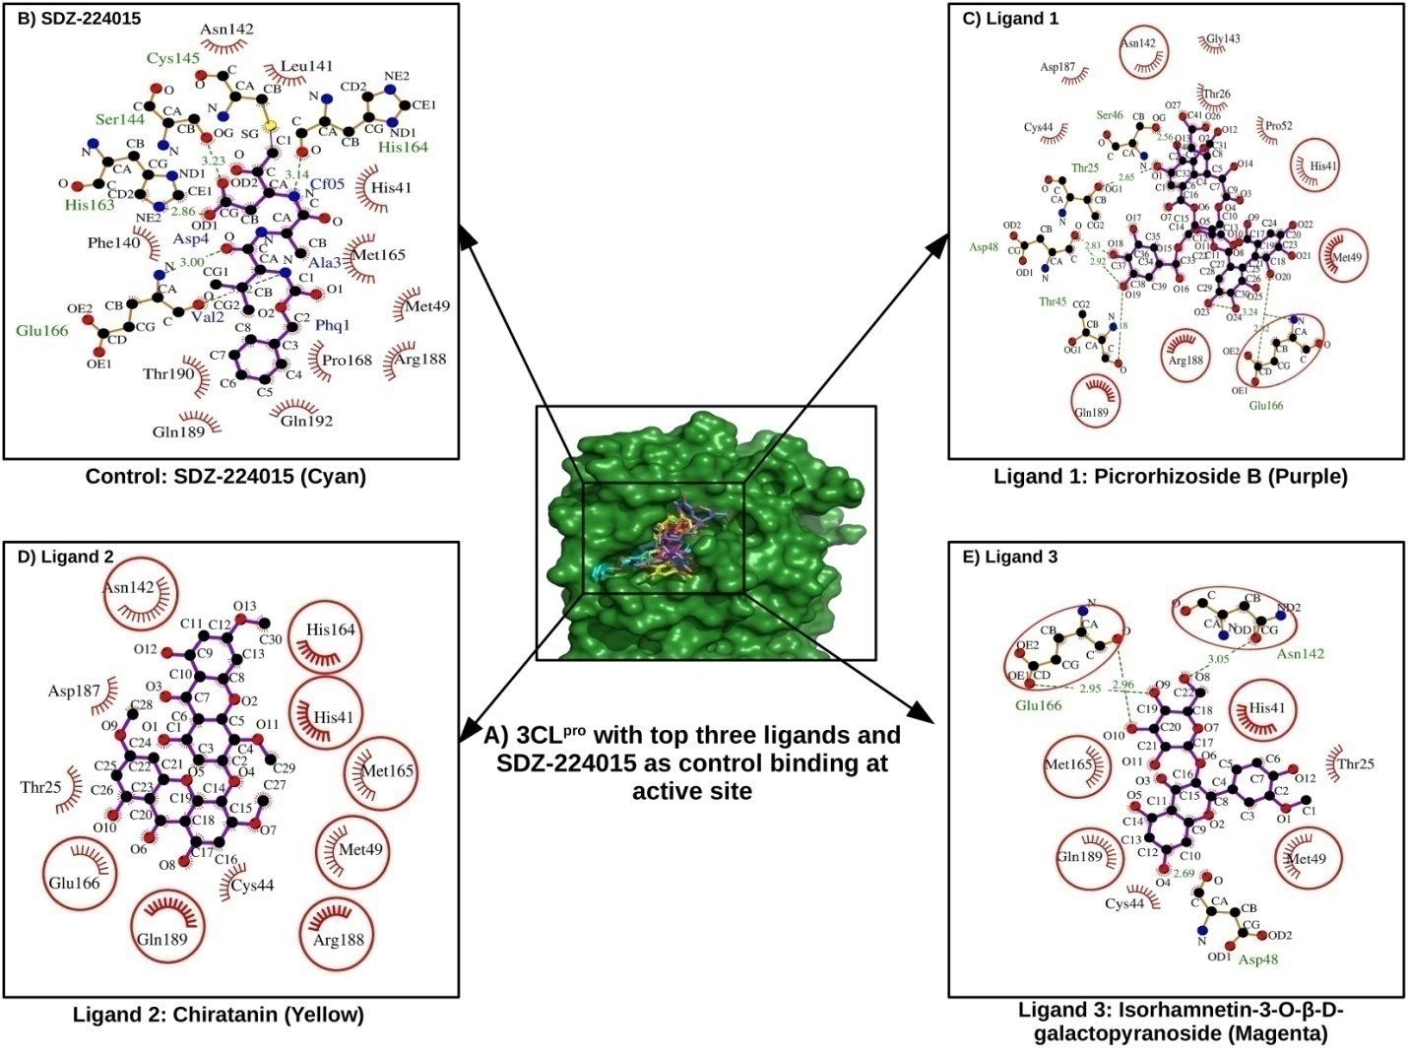
Figure 1. 2D interaction profile of 3CL^{pro} with top three ligands and SDZ224015 as control ligand. In this figure we have shown that the binding site of cocrystal ligand SDZ224015 (control ligand) and our top three ligands picrorhizoside B, chiratanin and isorhamnetin-3-O-β-D-galactopyranoside are the same that is active site of the 3CL^{pro} enzyme (Figure 1A) and identical residues of the protein interacting with control ligand as well as docked ligands are indicated in the red circles. The residue that are interacting with SDZ224015 are given in (Figure 1B), from this we have compare individually our ligands for picrorhizoside B (Figure 1C) total six residues are common (His41, Met49, Asn142, Glu166, Arg188 and Gln189) for chiratanin (Figure 1D) eight residues are common (His41, Met49, Asn142, His164, Met165, Glu166, Arg188 and Gln189) and for ligand isorhamnetin-3-O-β-D-galactopyranoside (Figure 1E) total six residues are common (His41, Met49, Asn142, Met165, Glu166, and Gln189). All these information corroborate the binding of proposed ligands at active site of the enzyme 3CL^{pro}.
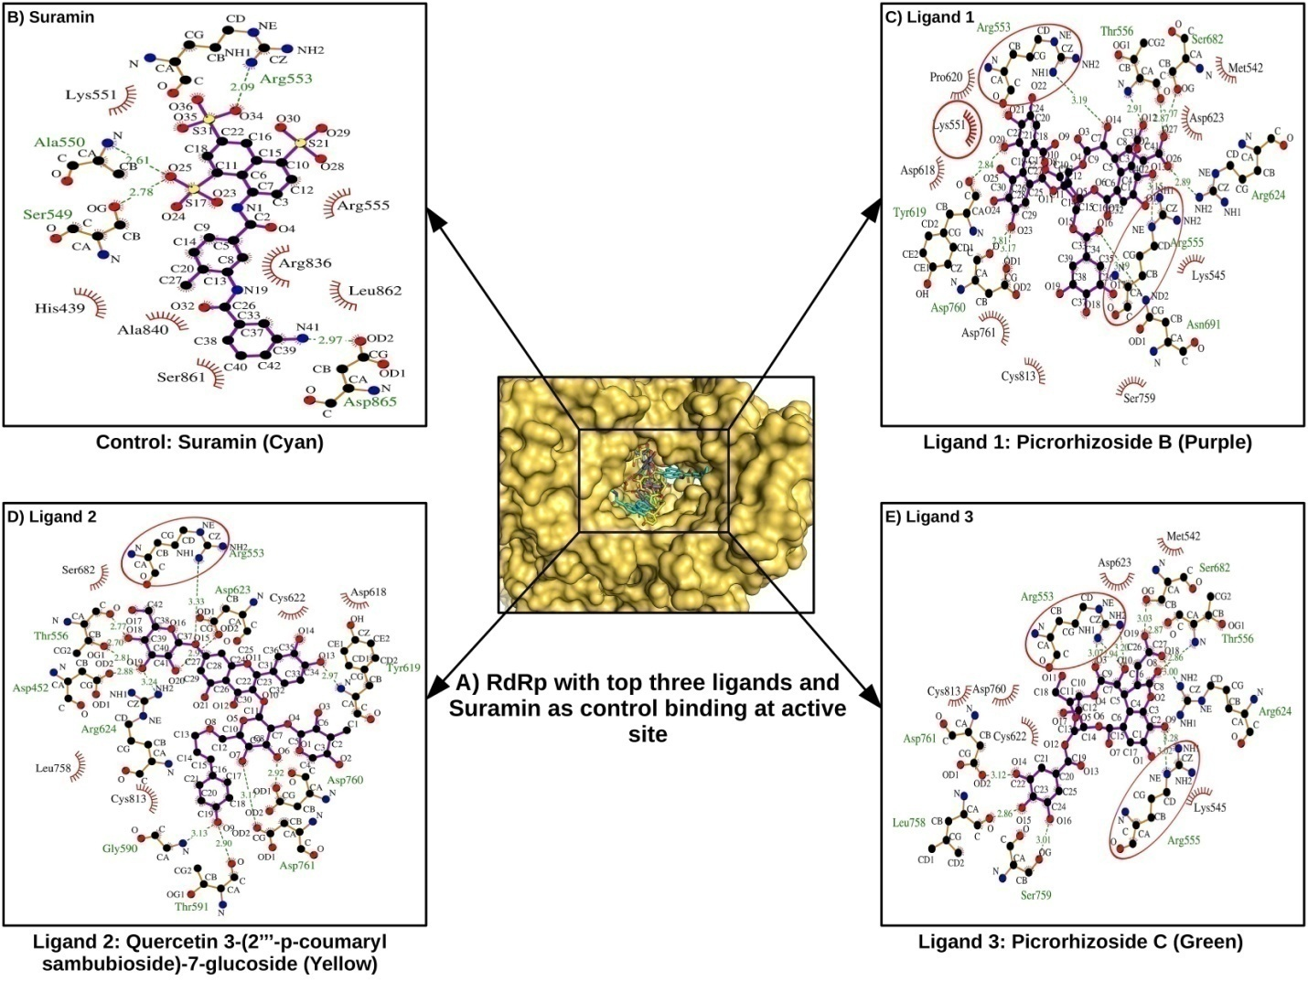
Figure 2: 2D interaction profile of RdRp with top three ligands and suramin as control ligand. In this figure we have shown that the binding site of cocrystal ligand suramin (control ligand) and our top three ligands picrorhizoside B, quercetin 3-(2'''-p coumaryl sambubioside)- 7- glucoside and picrorhizoside C are the same that is active site cleft of the enzyme RdRp (Figure 2A) and interacting residues of RdRp with docked ligands that are common with the control ligand are indicated in the red circles. The residue that are interacting with suramin are given in Figure 2B, from this we have compare individually our ligands for picrorhizoside B (Figure 2C) total 3 residues are common (Lys551, Arg553 and Arg555) for quercetin 3-(2'''-p coumaryl sambubioside)- 7- glucoside (Figure 2D) only one residues (Arg553) and for ligand picrorhizoside C (Figure 2E) total two residues are common ( Arg553 and Arg555). All these information corroborate the binding of proposed ligands at active site of the enzyme RdRp.
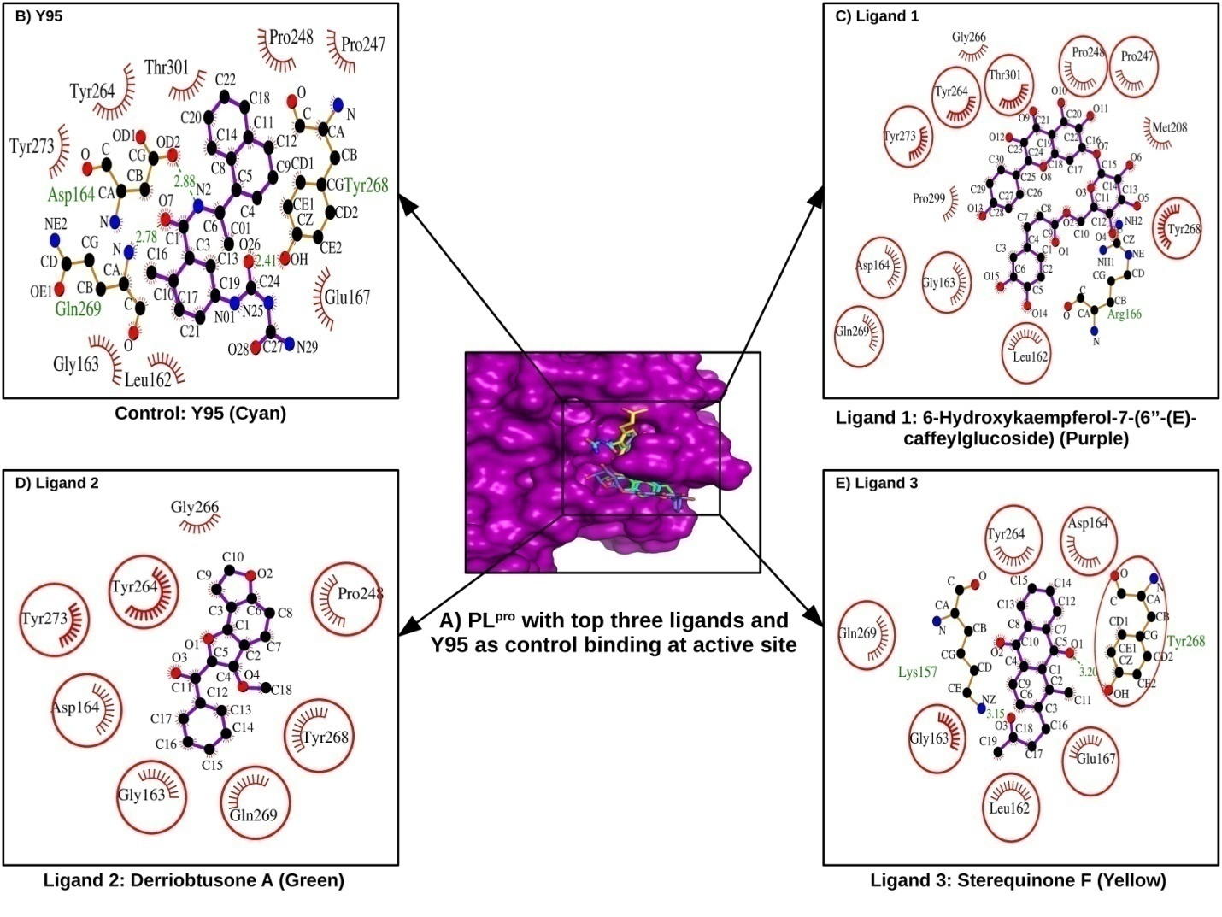
Figure 3: 2D interaction profile of PL^{pro} with top three docked ligands and Y95 as control ligand. In this figure we have shown that the binding site of cocrystal ligand Y95 (control ligand) and our top three ligands 6-Hydroxykaempferol 7-(6'' -(E)-caffeylglucoside), derriobtusone A and sterequinone F are the same that is active site cleft of the enzyme PL^{pro} (Figure 3A) and interacting residues that are common with the control ligand and docked ligands are indicated in the red circles. The residue that are interacting with Y95 are given in (Figure 3B), from this we have compare individually our ligands for 6-Hydroxykaempferol 7-(6'' -(E)-caffeylglucoside) (Figure 3C) total 10 residues are common (Leu162, Gly163, Asp164, Pro247, Pro248, Tyr264, Tyr268 and Gln269, Tyr273 and Thr301) for derriobtusone A (Figure 3D) seven residues (Gly163, Asp164, Pro248, Tyr264, Tyr268, Gln269 and Tyr273) and for ligand sterequinone F (Figure 3E) total seven residues are common (Leu162, Gly163, Asp164, Glu167, Tyr264, Tyr268 and Gln269). All these information corroborate the binding of proposed ligands at active site of the enzyme PL^{pro}.
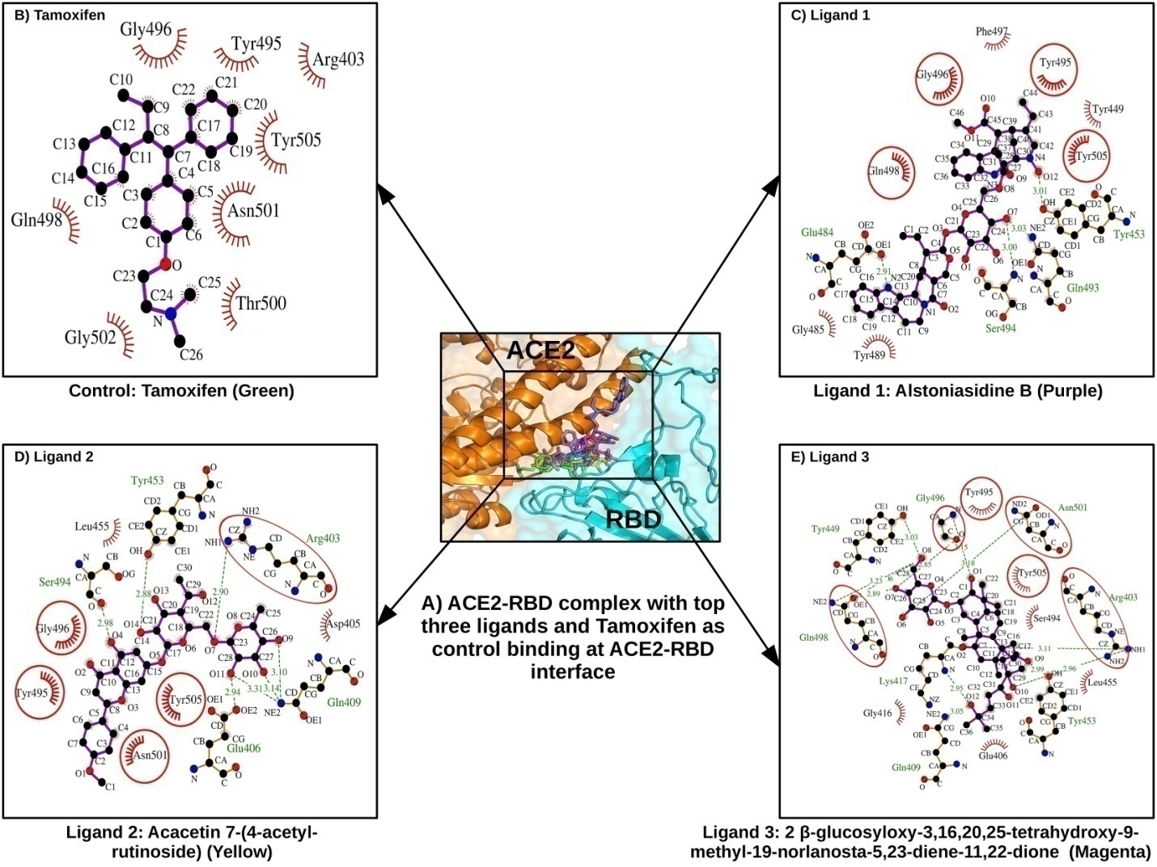
Figure 4: 2D interaction profile of RBD with top three ligands and tamoxifen as control ligand . In this figure we have shown that the binding site of cocrystal ligand tamoxifen (control ligand) and our top three ligands like alstoniasidine B, Acacetin 7-(4-acetyl-rutinoside) and 2 β-glucosyloxy-3, 16, 20, 25-tetrahydroxy-9-methyl-19-norlanosta-5,23-diene -11,22-dione are the same that interface of the RBD-ACE2 interaction (Figure 4A) and indentical residues interacting with control ligand as well as docked ligands are indicated in the red circles. The residue that are interacting with tamoxifen are given in (Figure 4B), from this we have compare individually our ligands for alstoniasidine B (Figure 4C) total four residues are common (Tyr495, Gly496 and Gln498 and Tyr505) for Acacetin 7-(4-acetyl-rutinoside) (Figure 4D) five residues (Arg403, Tyr495, Gly496, Asn501, and Tyr505) and for ligand 2 β-glucosyloxy-3, 16, 20, 25-tetrahydroxy-9-methyl-19-norlanosta-5,23-diene -11,22-dione (Figure 4E) total six residues are common (Arg403, Tyr495, Gly496, Gln498, Asn501, and Tyr505). All these information corroborate the binding of proposed ligands at interface of RBD and ACE2 receptor.

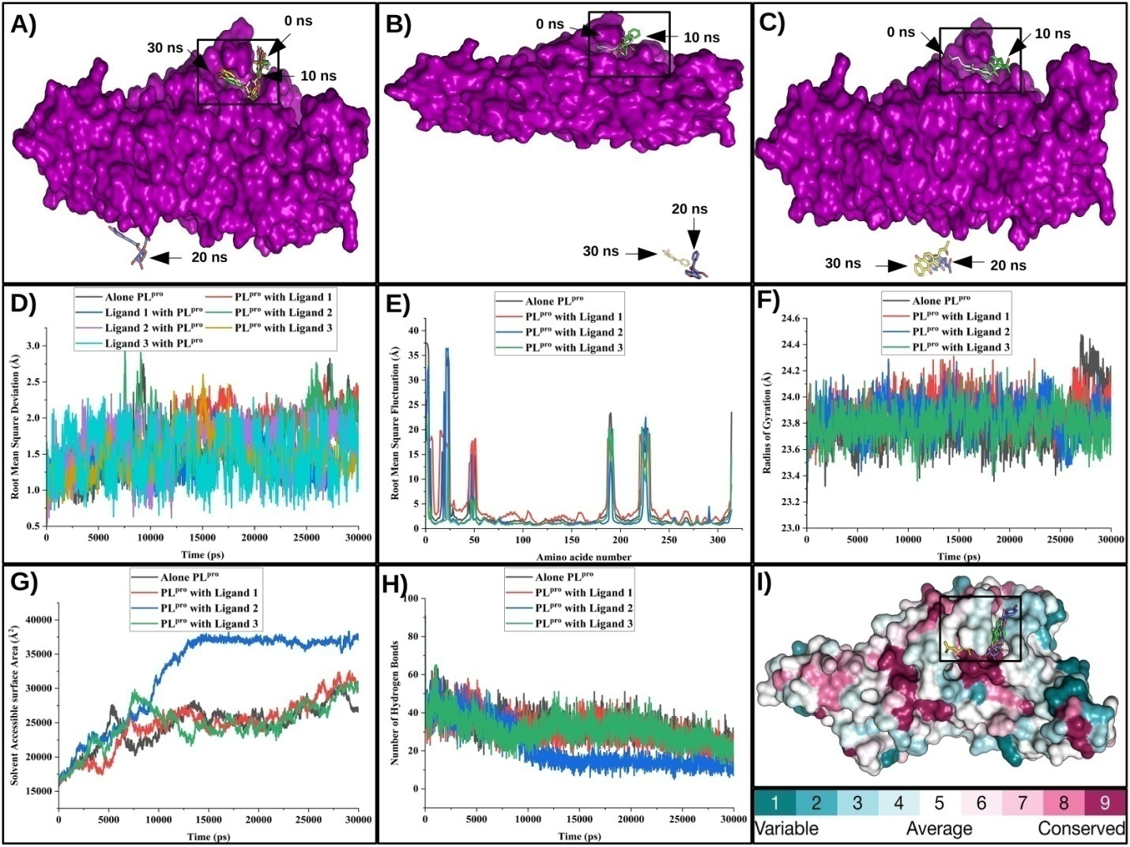
Figure 5: MD simulation trajectory analysis of PL^{pro} with and without ligands and prediction of amino acid conservation in protein. Figure 5A: MD simulation of Ligand 1st (6-Hydroxykaempferol 7-(6'' -(E)-caffeylglucoside)), with PL^{pro}, showing ligand positions at different time points, 0ns (white), 10ns (purple), 20ns (blue) and 30ns (yellow). Figure 5B: MD simulation of Ligand 2nd (derriobtusone A) with PL^{pro}, showing ligand positions at different time points, 0ns (white), 10ns (purple), 20ns (blue) and 30ns (yellow). Figure 5C: MD simulation of Ligand 3rd (sterequinone F) with PL^{pro}, showing ligand position at different time points, 0ns (white), 10ns (purple), 20ns (blue) and 30ns (yellow). Figure 5D: RMSD of PL^{pro} alone and with top 3 ligands, Figure 5E: RMSF of PL^{pro} alone and with top 3 ligands, Figure 5F: Radius of gyration of PL^{pro} alone and with top 3 ligands, Figure 5G: SASA of PL^{pro} alone and with top 3 ligands, and Figure 5H: Number of hydrogen bonds of PL^{pro} alone and with top 3 ligands.

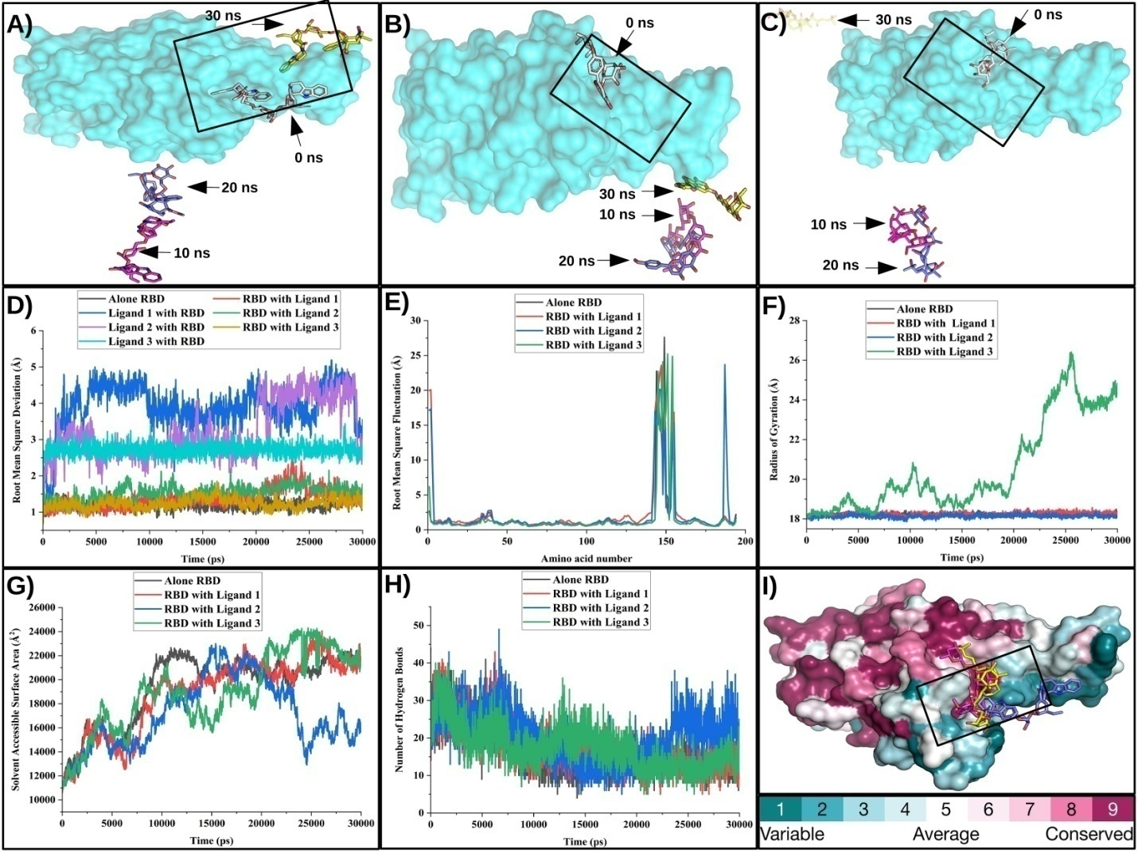
Figure 6: MD simulation trajectory analysis of RBD with and without ligands and prediction of amino acid conservation in the protein. Figure 6A: MD simulation of Ligand 1st (alstoniasidine B) with RBD, showing ligand positions at different time points, 0ns (white), 10ns (purple), 20ns (blue) and 30ns (yellow). Figure 6B: MD simulation of Ligand 2nd (Acacetin 7-(4-acetyl-rutinoside)) with RBD, showing ligand positions at different time points, 0ns (white), 10ns (purple), 20ns (blue) and 30ns (yellow). Figure 6C: MD simulation of Ligand 3rd (2 β-glucosyloxy-3, 16, 20, 25-tetrahydroxy-9-methyl-19-norlanosta-5, 23-diene -11, 22-dione) with RBD, showing ligand position at different time points, 0ns (white), 10ns (purple), 20ns (blue) and 30ns (yellow). Figure 6D: RMSD of RBD alone and with top 3 ligands, Figure 6E: RMSF of RBD alone and with top 3 ligands, Figure 6F: Radius of Gyration of RBD alone and with top 3 ligands, Figure 6G: SASA of RBD alone and with top 3 ligands, Figure 6H: Number of hydrogen bonds of RBD alone and with top 3 ligands.

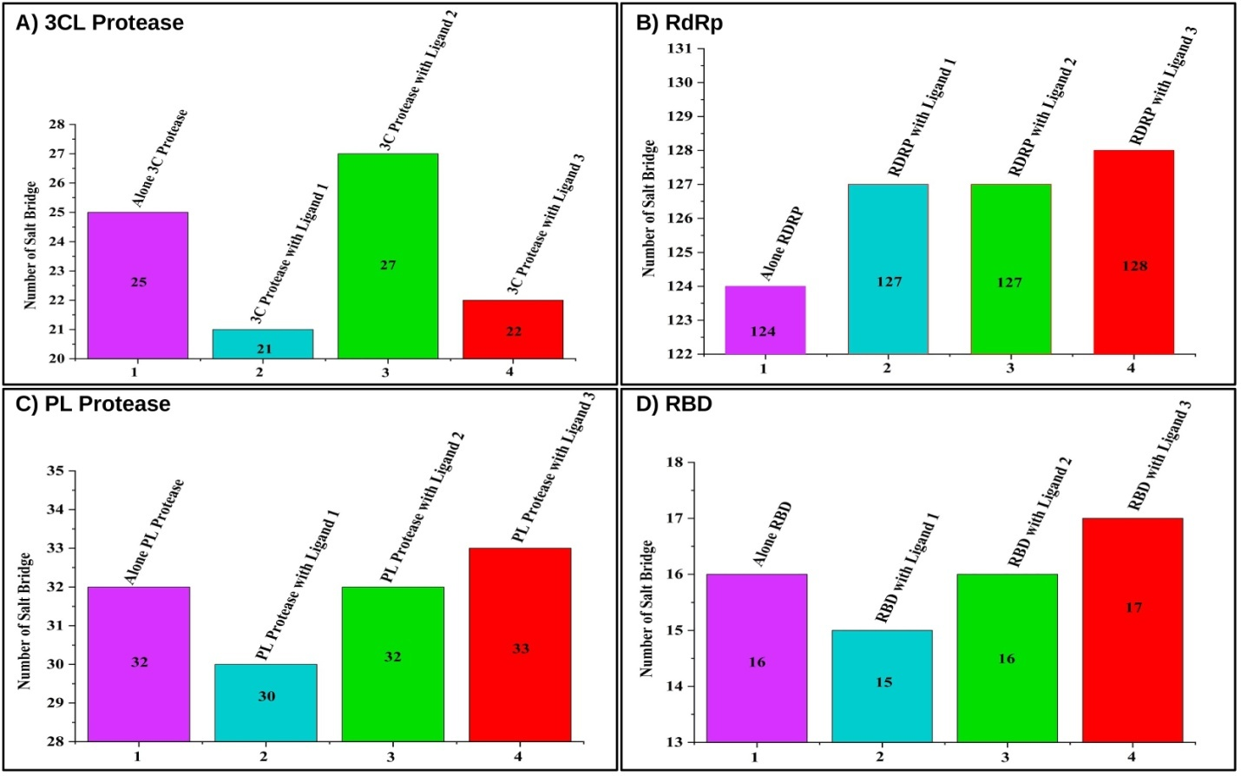
Figure 7: Salt bridge analysis from simulation trajectory for all four target proteins in apo form and with ligands. Figure 7A: Salt bridge profile of the 3CL^{pro} alone and in presence of different ligands, Figure 7B: Salt bridge profile of the RdRp alone and in presence of different ligands, Figure 7C: Salt bridge profile of the 3PL^{pro} alone and in presence of different ligands, Figure 7D: Salt bridge profile of the RBD alone and in presence of different ligands

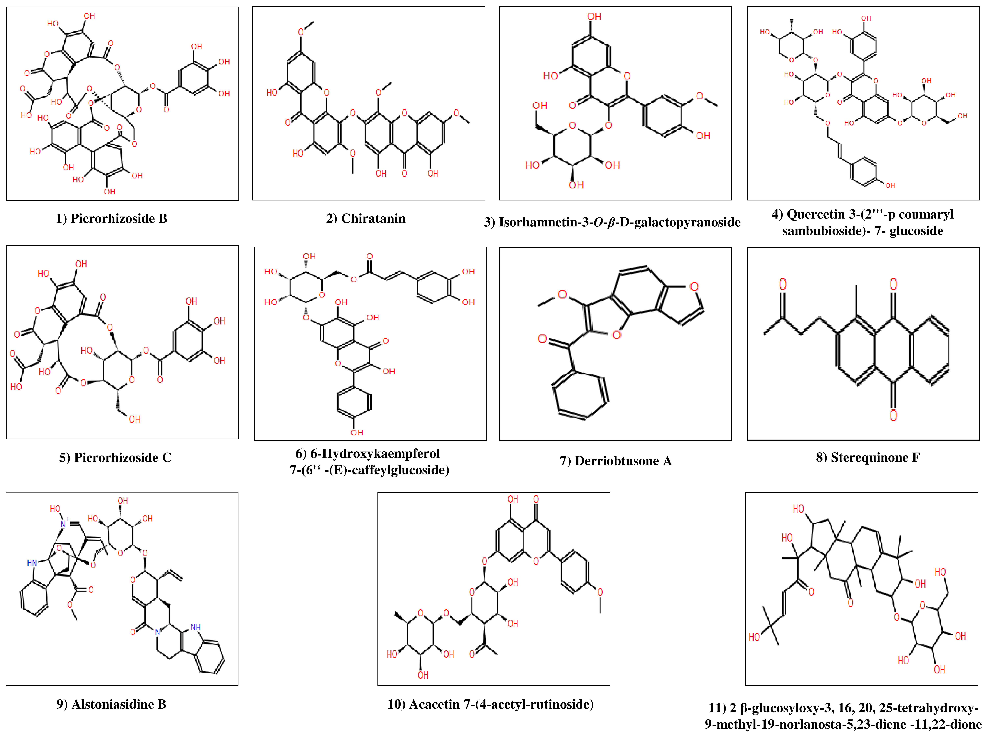
Figure 8: Chemical structure of the top three phytoconstituents for each of the four target proteins. Structure 1, 2 and 3 are the ligand binding at the active site of 3CL^{pro}, structure 1, 4 and 5 are the ligands binding at the active site (RNA template) binding site of the RdRp, structure 6, 7 and 8 are the ligands binding at the active site of the PL^{pro} and structure 9, 10 and 11 are the ligands that are binding at the interface of RBD-ACE2 receptor.

