Supplementary Information

Combined Impact of Jet Stream and Turbulence on Long-term Trans-Oceanic Flight Routes over North Atlantic Ocean Using ERA5 Reanalysis

Joon Hee Kim¹ and Jung-Hoon Kim¹

School of Earth and Environmental Sciences, Seoul National University, Seoul, South Korea¹

Correspondence to Jung-Hoon Kim
(jhkim99@snu.ac.kr)

Contents of this file
Figs. S1 to S9.

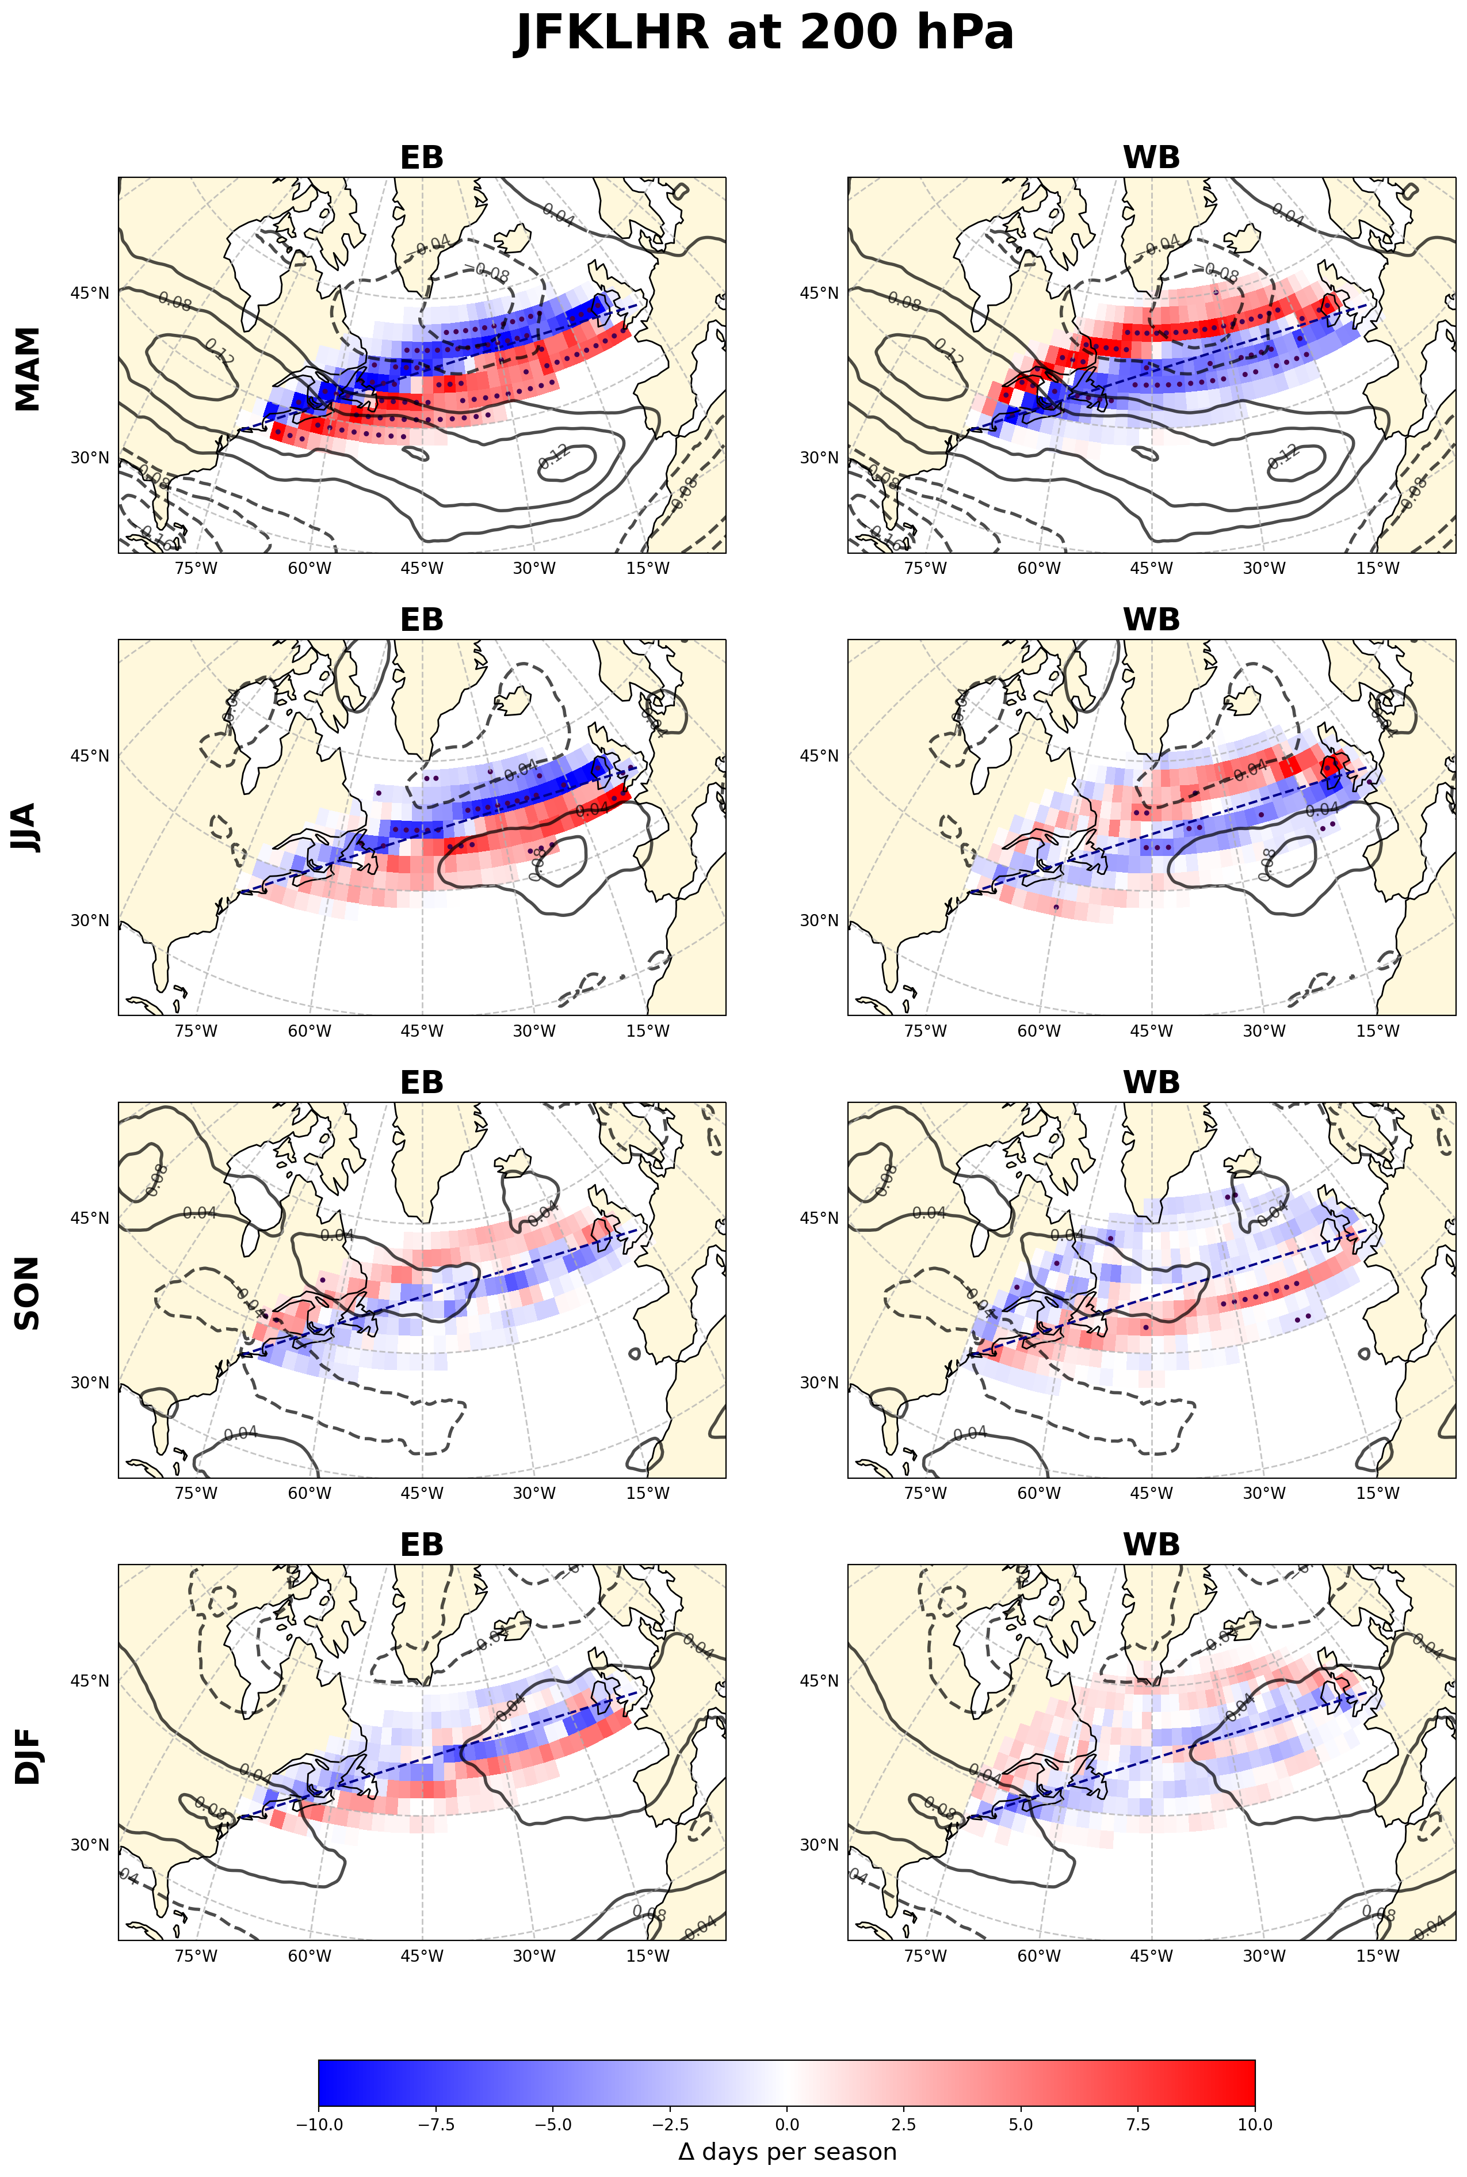
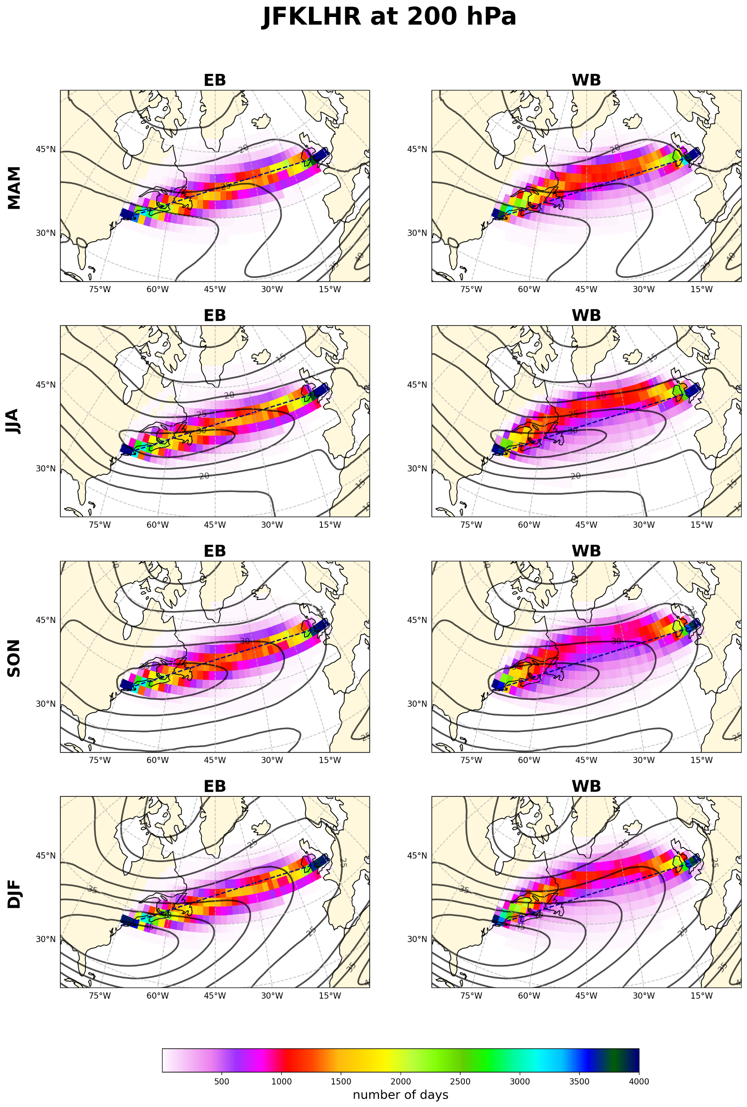
Fig. S1. Seasonal spatial distribution and long-term trends of WORs between JFK and LHR. Same as fig. 1 but for 200 hPa.
(a)
(b)

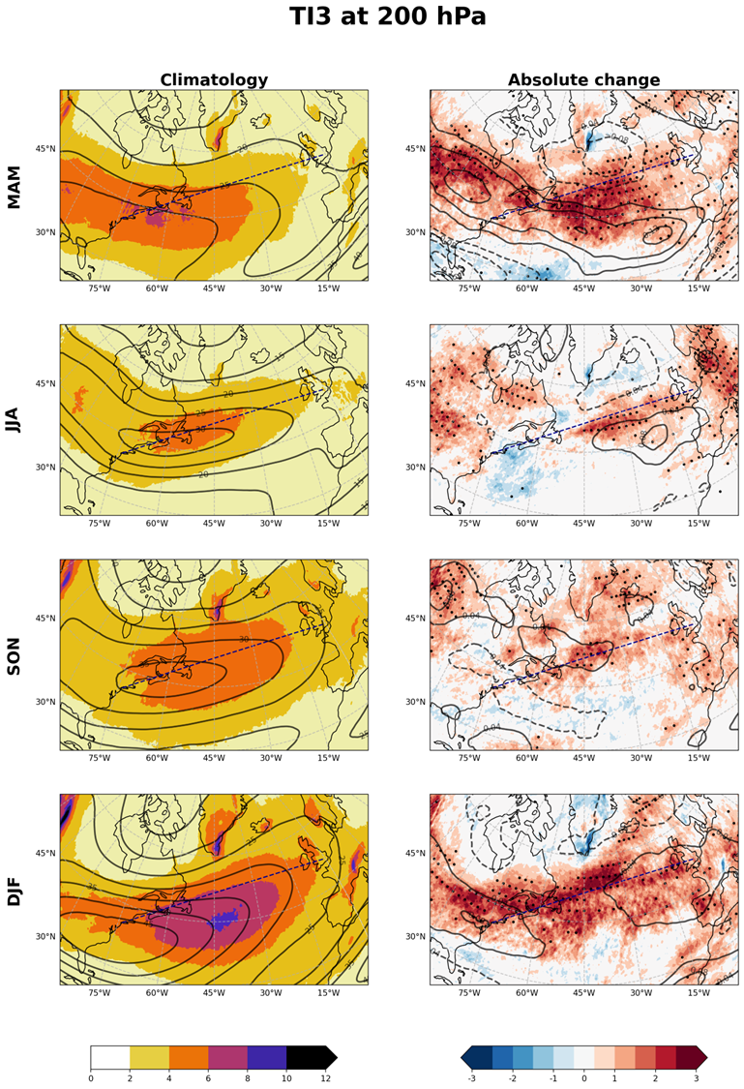
Fig. S2. Spatial distribution and long-term trends of MOG-level CAT occurrence. Same as Fig. 2 but for 200 hPa.

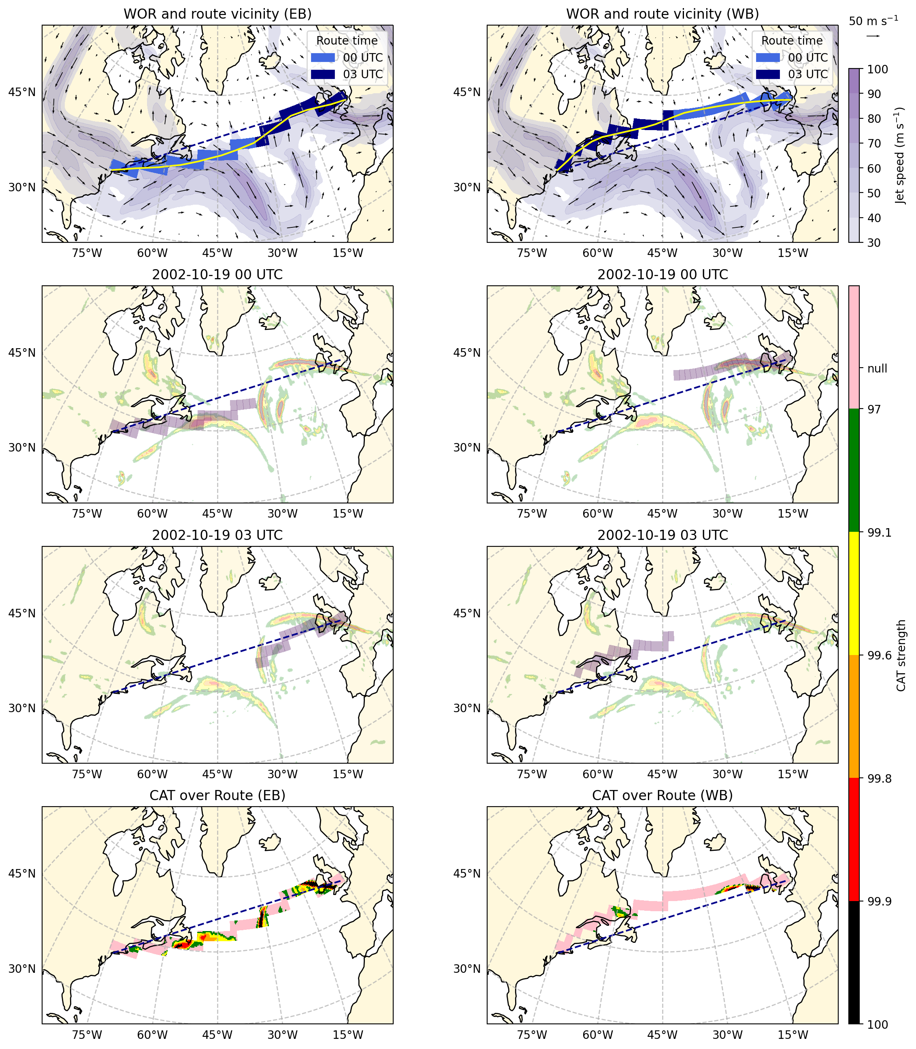
Fig. S3. Illustration of the procedure for calculating CAT area ratio along WORs. The left and right columns show results for eastbound (EB) and westbound (WB) transatlantic routes departing at 00 UTC on 19 October 2002. In all panels, the great-circle route between JFK and LHR is shown as a dashed line. The top row presents the 250 hPa wind field at departure time (vectors and shading), together with the WOR (yellow line). Its route vicinity, defined as the set of 2°×2° grid cells intersected by the WOR, is color-coded by the route-calculation time (00 UTC in light blue, 03 UTC in navy). The second and third rows show the CAT fields at 00 and 03 UTC, respectively, along with the corresponding WOR vicinity segments, highlighting grid cells where CAT is diagnosed. The bottom row displays the final outcome, where CAT occurrence is overlaid on each WOR vicinity. These steps form the basis for computing the MOG-CAT Area Ratio (MCAR), defined as the fraction of the route-vicinity area affected by MOG-CAT.
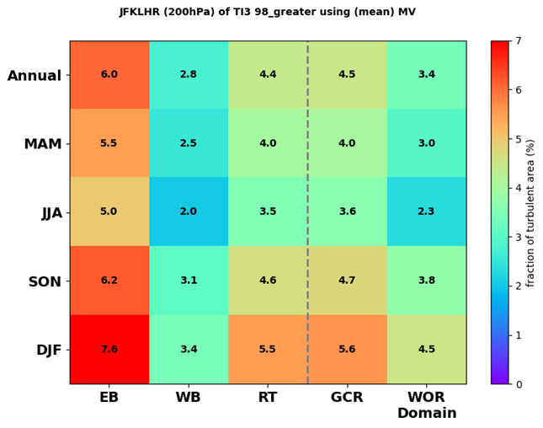
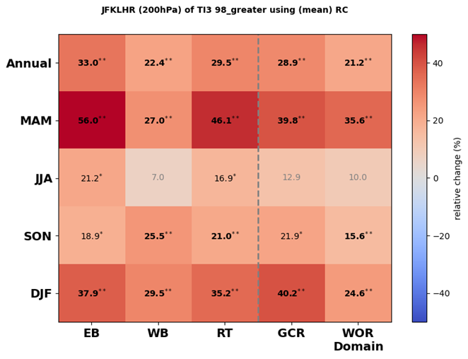
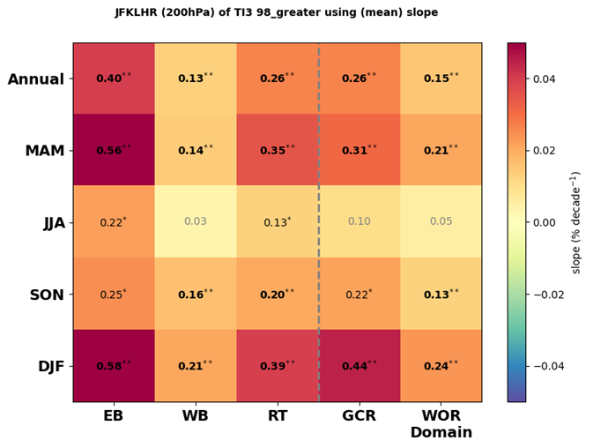
Fig. S4. Heatmap of CAT encounter probability along different routes and its long-term trends. Same as Fig. 4 but for 200 hPa.
(a)
(b)
(c)

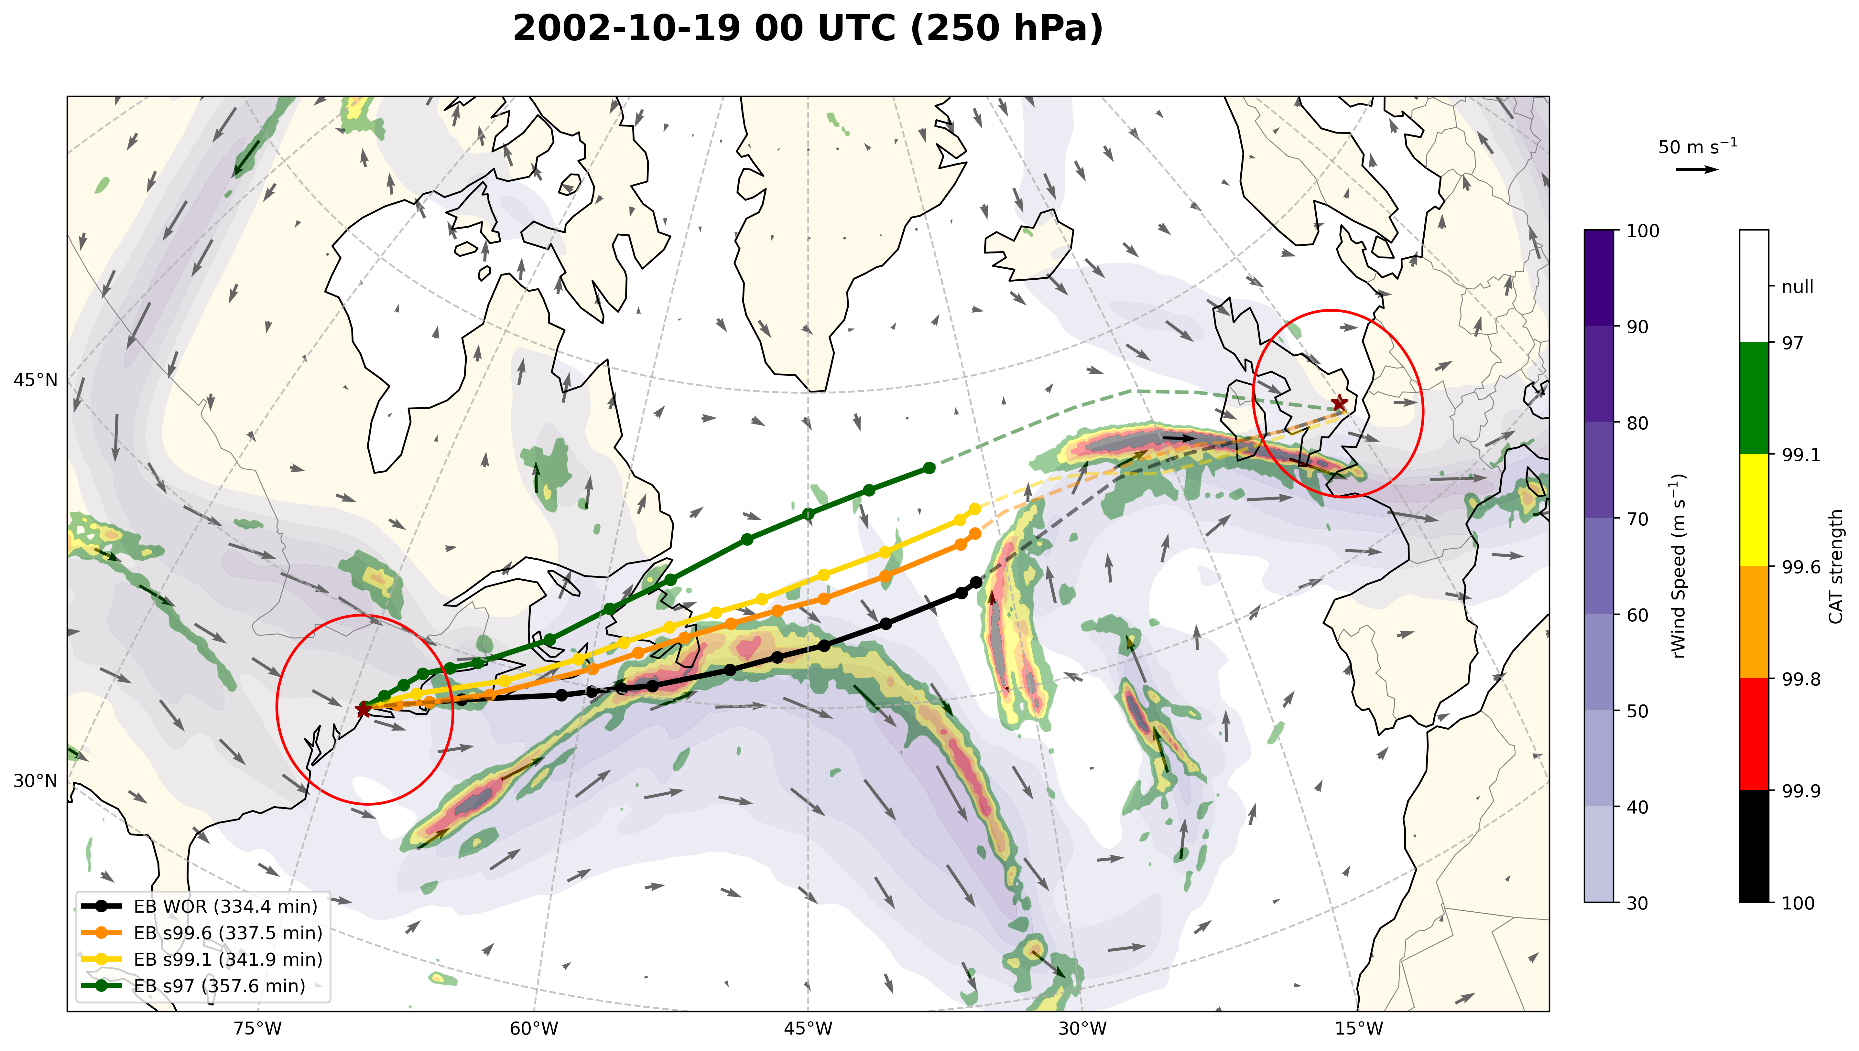
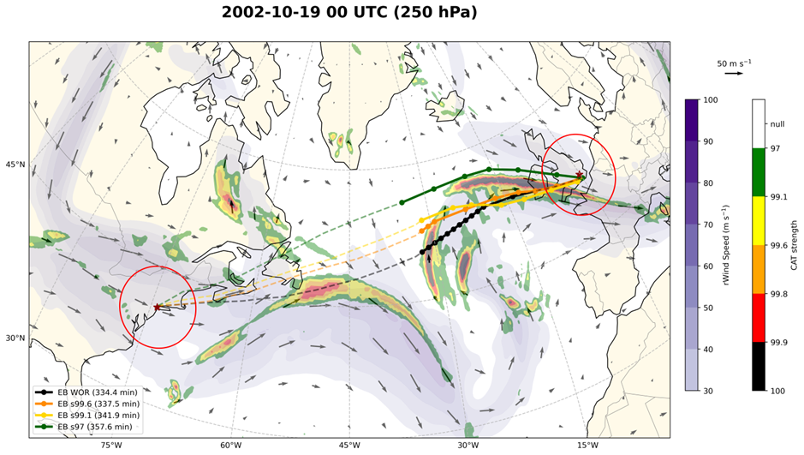
Fig. S5. Flight routes under different optimization constraints on February 5, 2010, at 00 UTC. All routes depart at 00 UTC on 19 October 2002. The label “s” denotes the minimum turbulence strength percentile used as the avoidance threshold (e.g., s99.6 avoids grid cells where the TI3 value exceeds the 99.6th percentile). (a) Snapshot at 00 UTC: solid lines show the portions of routes already flown, while dashed lines indicate the remaining segments. The routes are WOR (black), s99.6 (orange), s99.1 (yellow), and s97 (green). (b) Snapshot at 03 UTC: dashed lines indicate the segments already flown, with solid lines showing the remaining paths. Route times for the different routes are given in the legend.
(a)
(b)

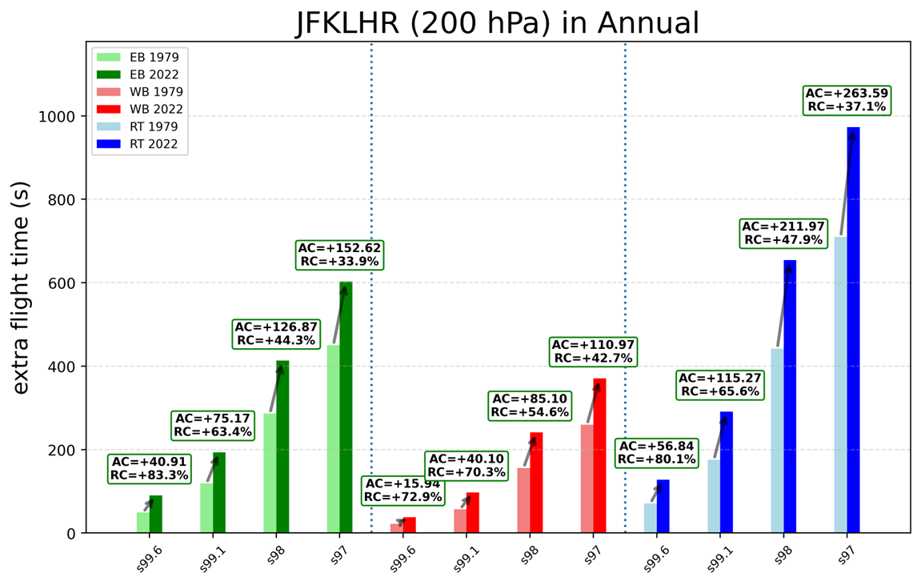
Fig. S6. Annual mean extra flight time required to avoid turbulence of varying intensities on transatlantic flight. Same as Fig. 7 but for 200 hPa.

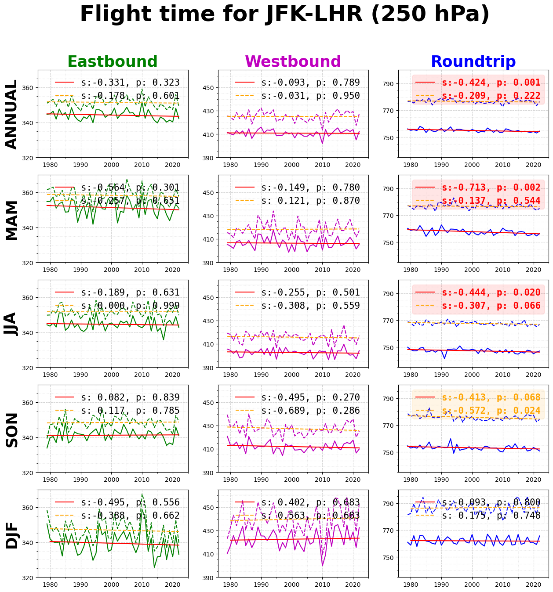
Fig. S7. Annual and seasonal mean flight time and its linear trend from 1979 to 2022. The annual and seasonal mean flight times for WOR and GCR are shown as solid and dashed lines, respectively. The legend includes the slope of the linear trend (s, s decade⁻¹) and the corresponding p-value (p). If both WOR and GCR exhibit statistically significant trends (p < 0.05), the legend background is shaded red, whereas if only GCR shows a significant trend, it is shaded yellow.
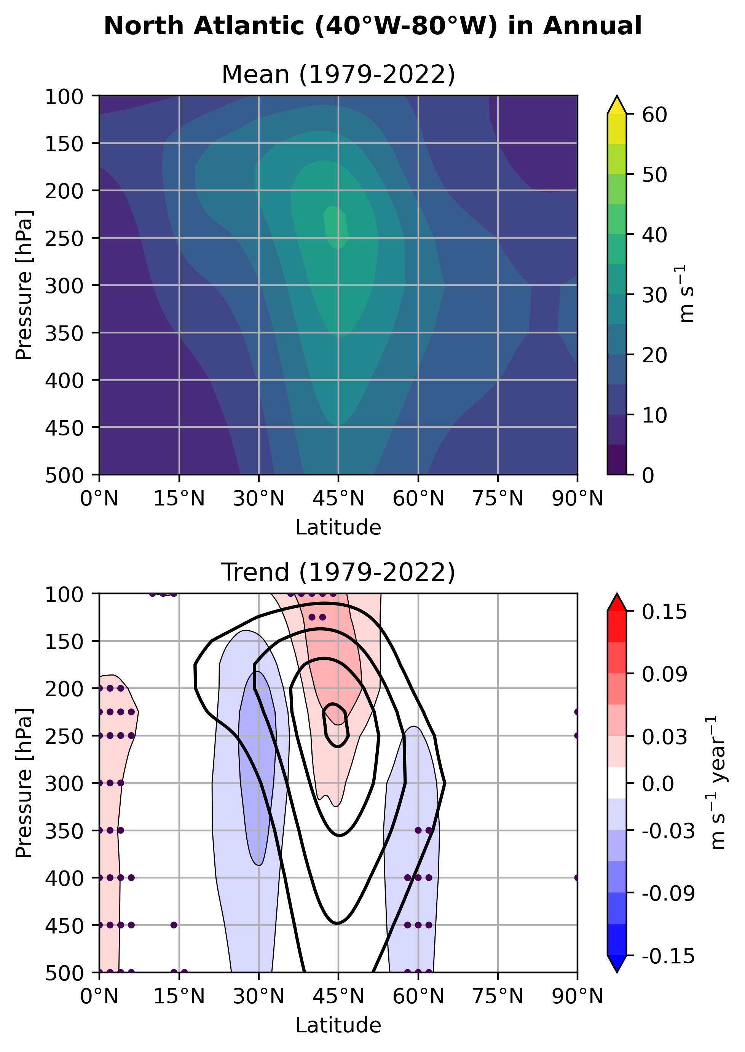
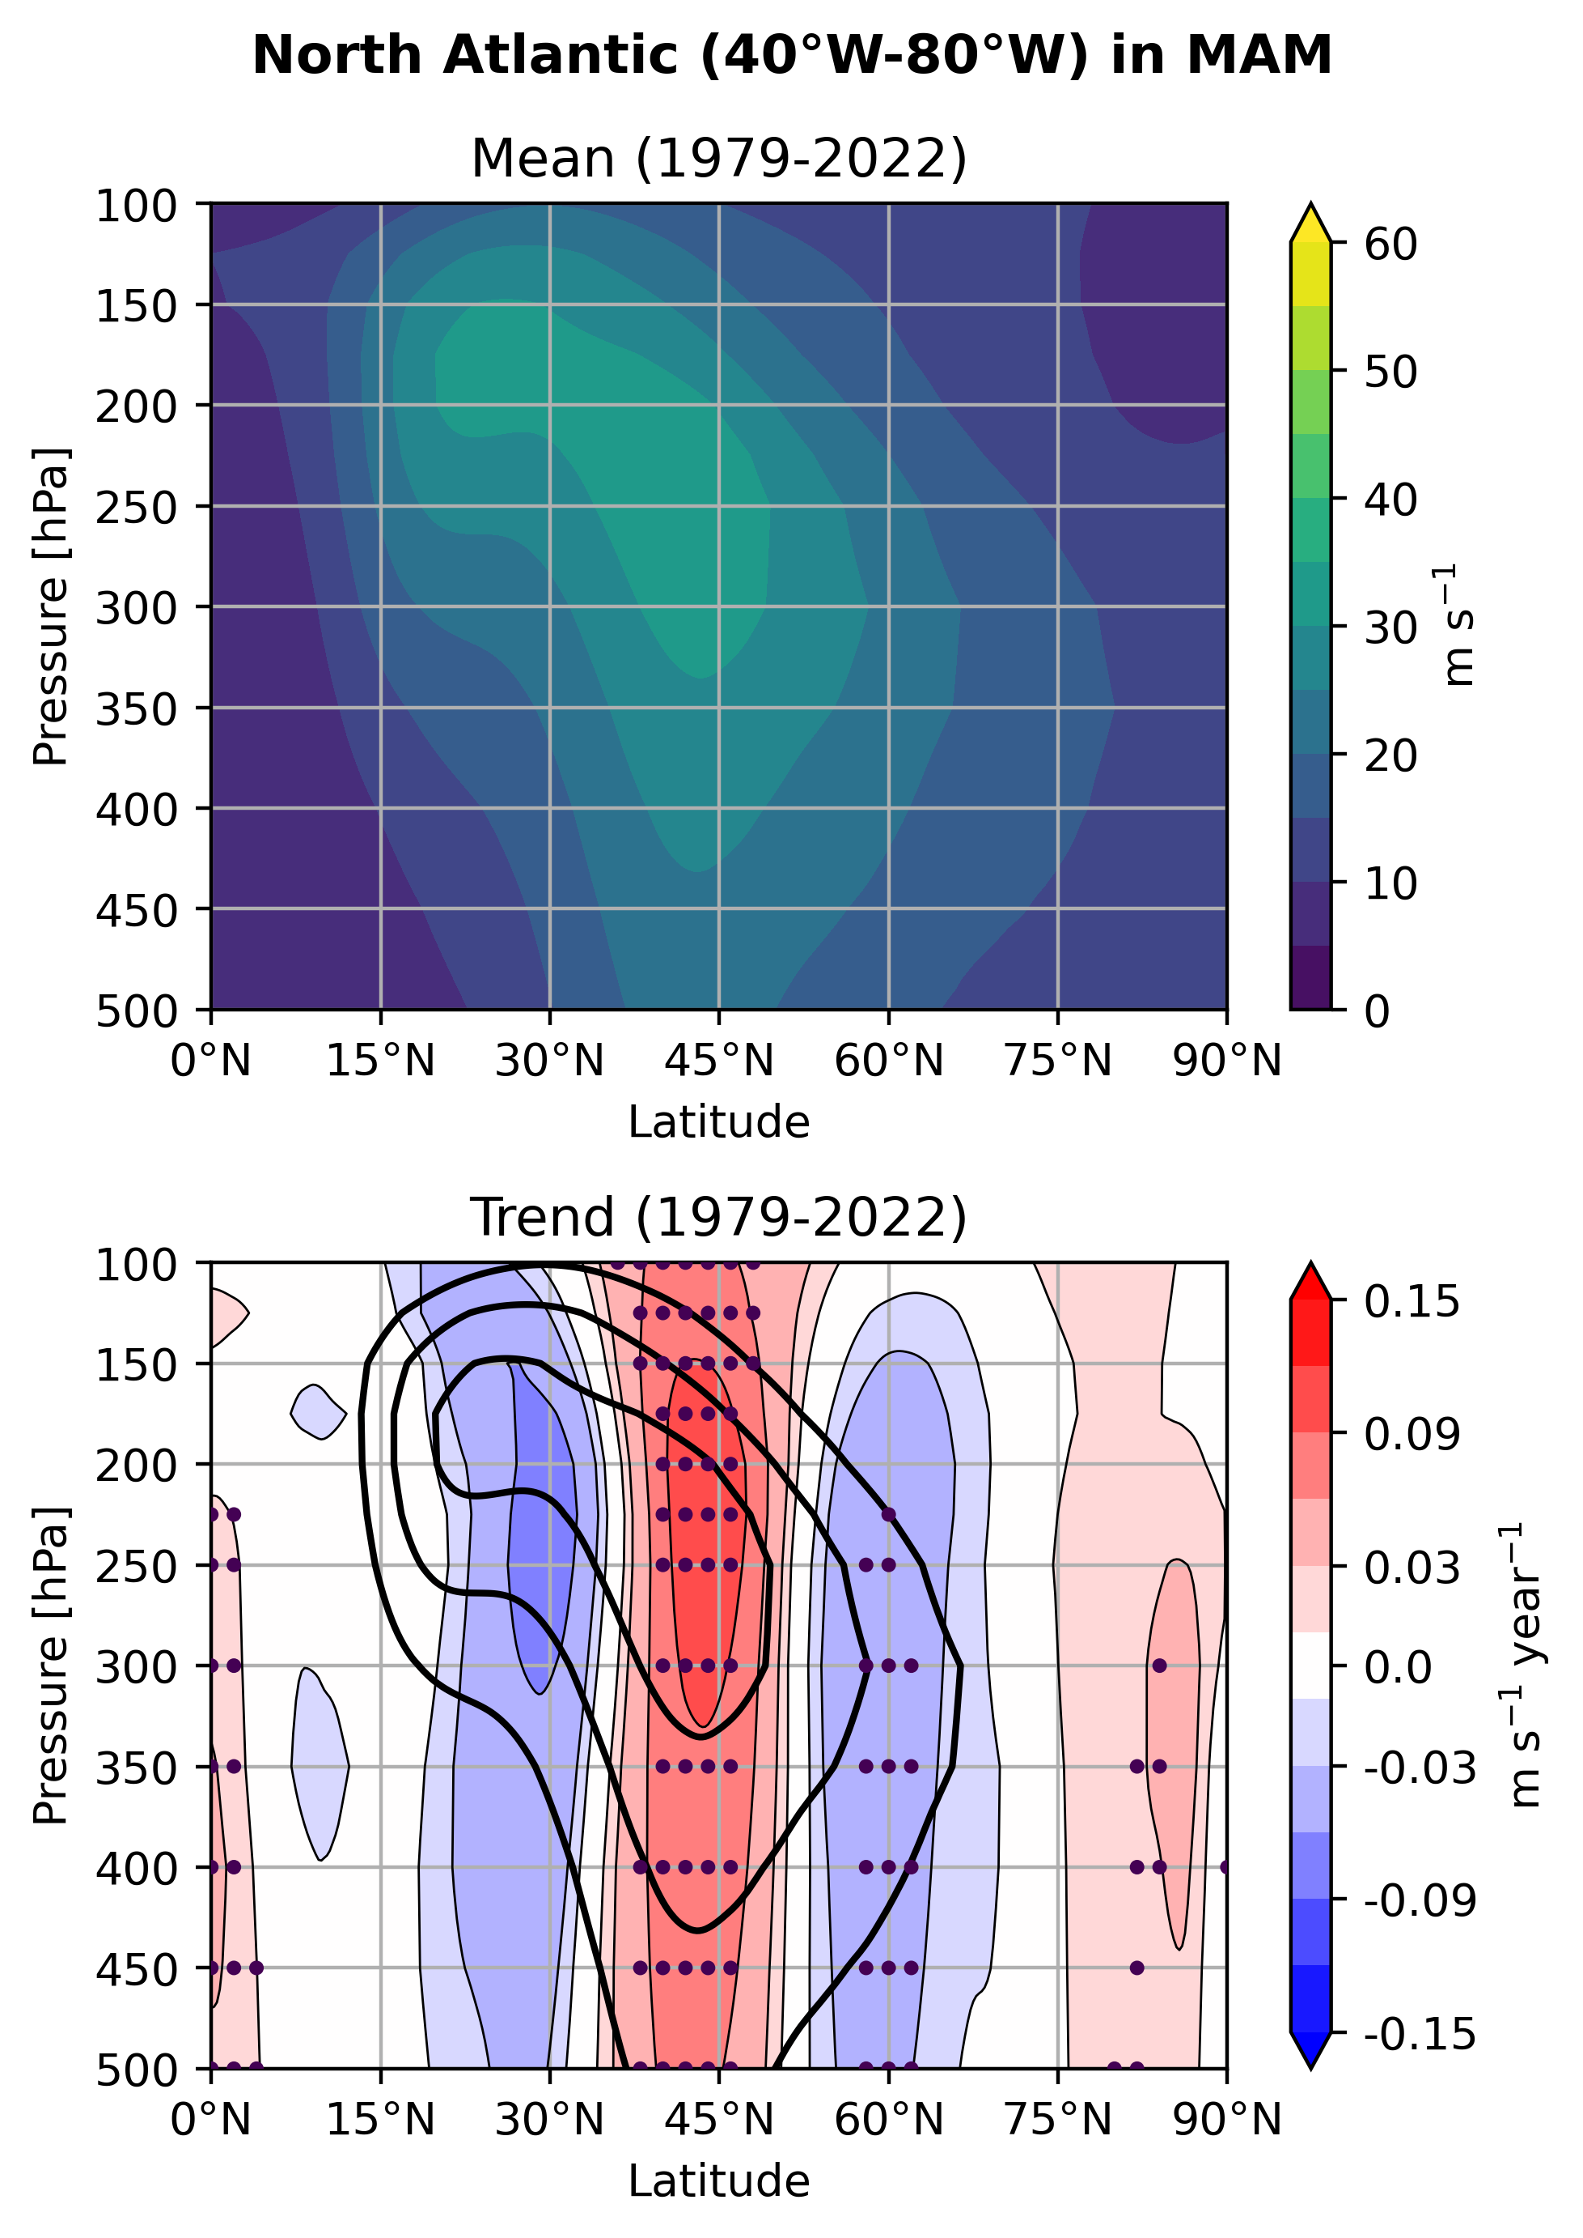
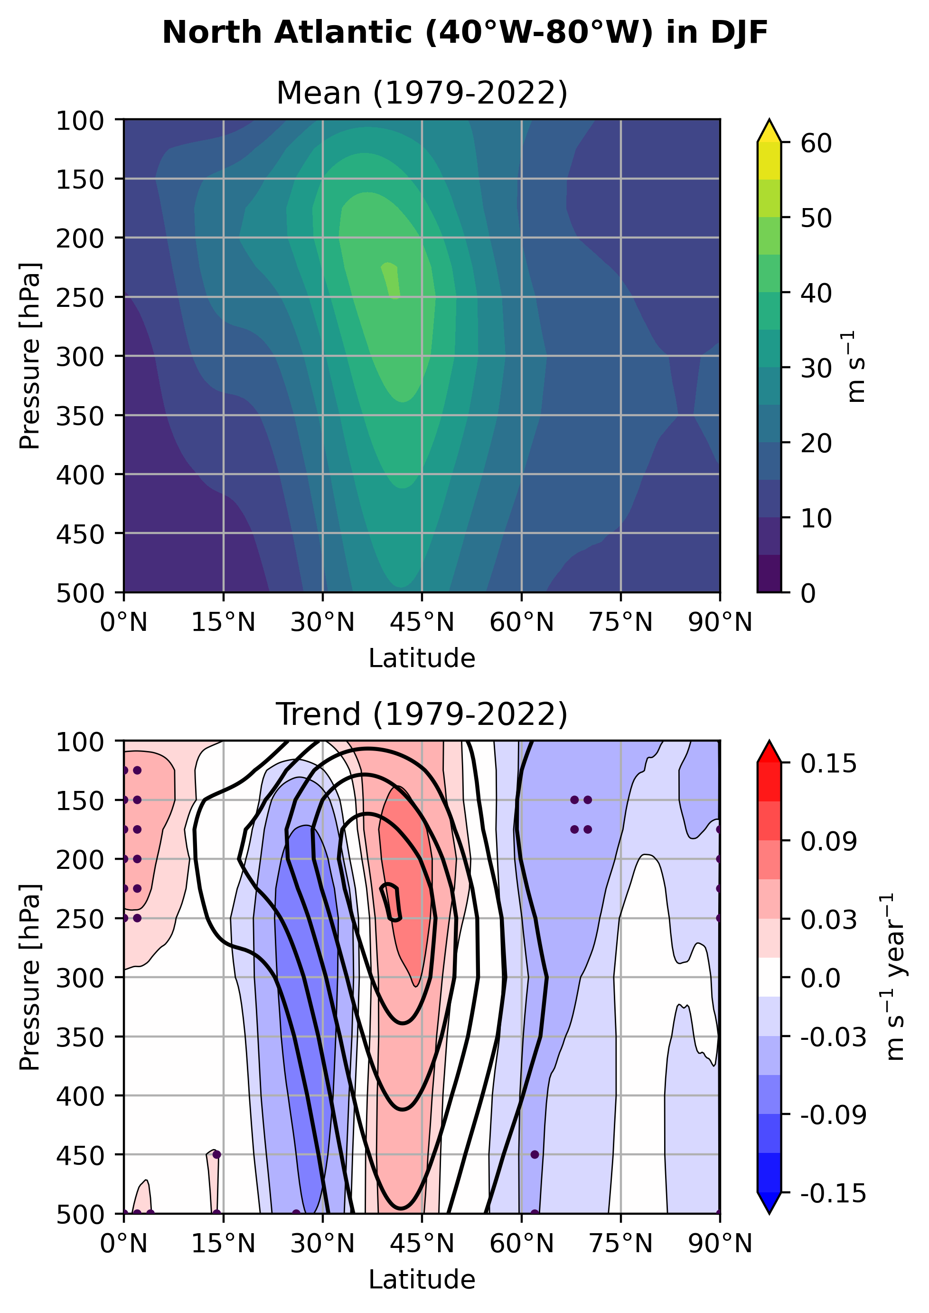
Fig. S8. Zonal-mean vertical cross-section of horizontal wind speed over the North Atlantic (40°W–80°W). The change of spatial distribution of WOR. The shadings represent the change of number of WOR passing over 2’x2’ grid box gained by subtracting value of 1979 from 2022.The values are inferred by linear regression model to drop out inter-annual variability. The solid (dashed) contour indicate the positive (negative) slope, inferred by linear regression, of wind speed during 1979-2022 with 0.03 m/s/year interval. Statistically significant trends (p < 0.05) are stippled.

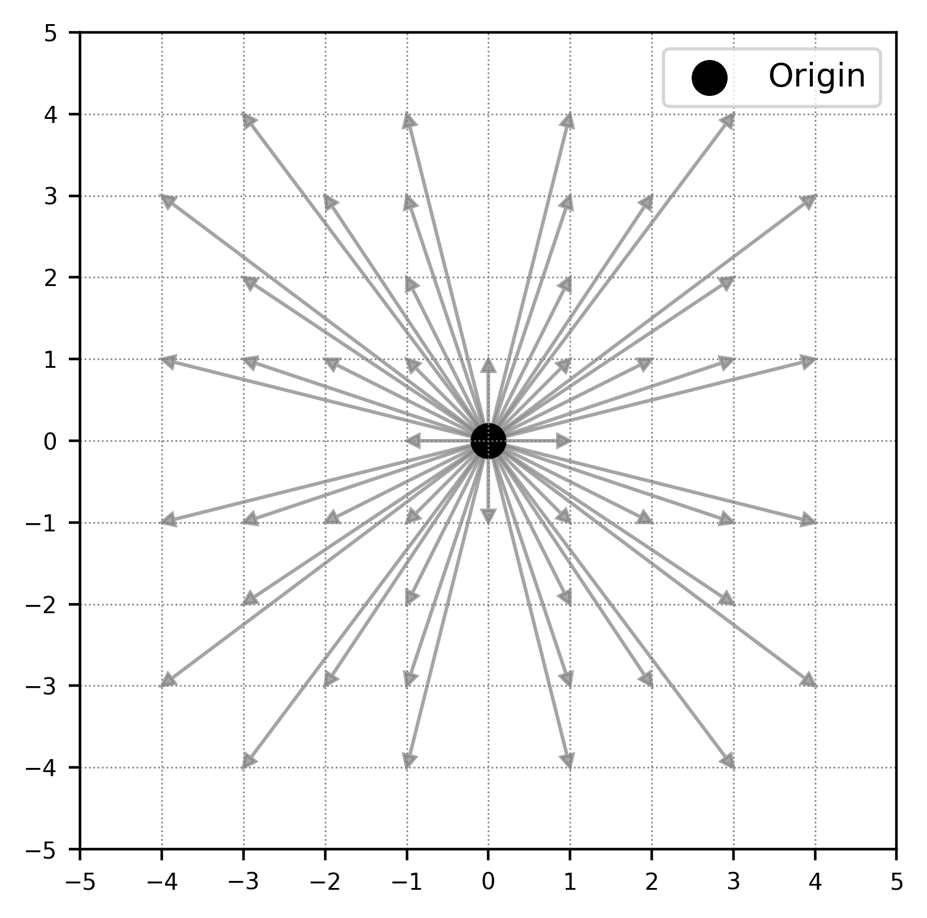
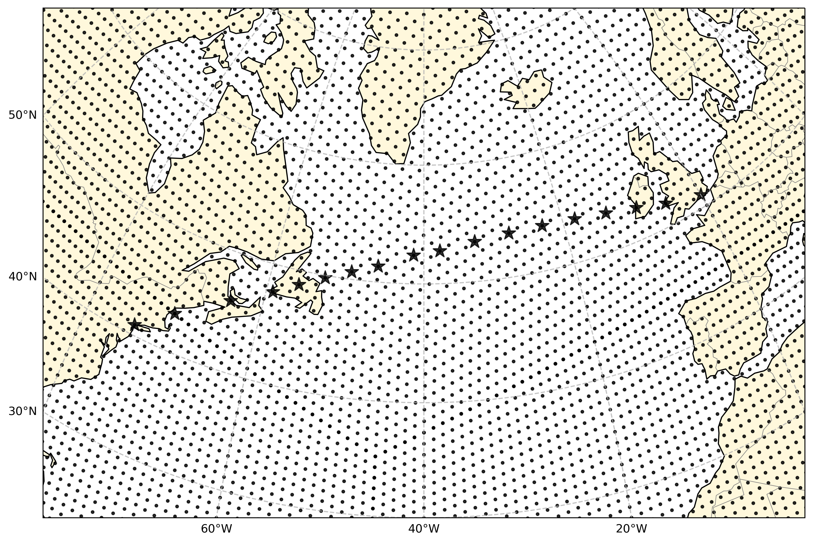
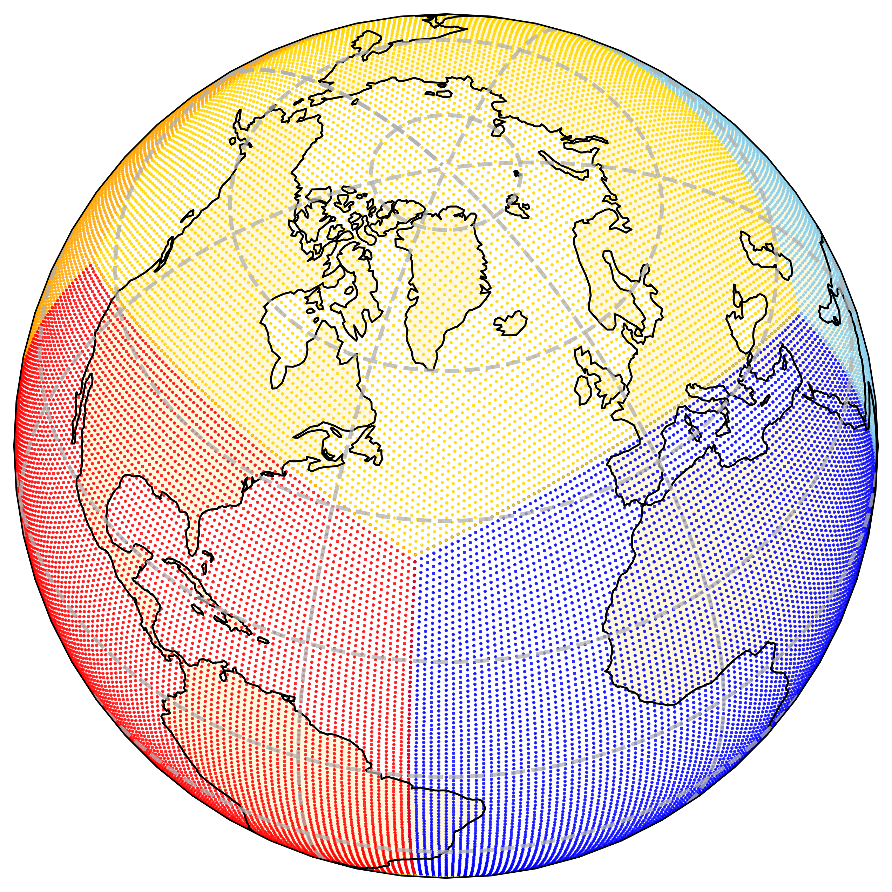
Fig. S9. Structure of the node network used for WOR computation. (a) The global structure of the node network, which is based on a Cubed-Sphere Grid. Node locations are represented as points, and each face of the cube is distinguished by different colors. The resolution of the node network is defined such that each face of the Cubed-Sphere Grid contains 91 nodes per edge. (b) The connectivity of the node network, where neighboring nodes are linked. (c) A zoomed-in view over the North Atlantic region, showing the nodes forming the great circle route (GCR) between JFK and LHR.
(b)
(a)
(c)

