Input Landscape Images
Description
The following images are cell-based raster representations of the landscapes entered into the individual-based dispersal model RangeShifter to derive the results presented in Anderson et al.
Each image shows the number and composition of a number of TartanGraph landscapes encoded into text files which RangeShifter uses as input for evaluating landscape structure. Three groups of text files used to conduct three different experiments investigating the effect of LLE number, orientation and width on the connectivity of TartanGraphs, measured as dispersal rates between the two rectangular habitat patches. The variable that each experimental set sought to answer were as follows:
First Experimental Set: Investigating the effect of connecting-edge number and transecting-edge number on TartanGraph connectivity – Inputs: 25 TartanGraphs across five text files.
Second Experimental Set: Investigating the effect of connecting-edge width and the number of both edge types on TartanGraph connectivity – Inputs: 48 TartanGraphs across four text files.
Third Experimental Set: Investigating the effect of transecting-edge width and the number of both edge types on TartanGraph connectivity – Inputs: 36 TartanGraphs across four text files.

First Experimental Set: Input 1 - Tartanset1.txt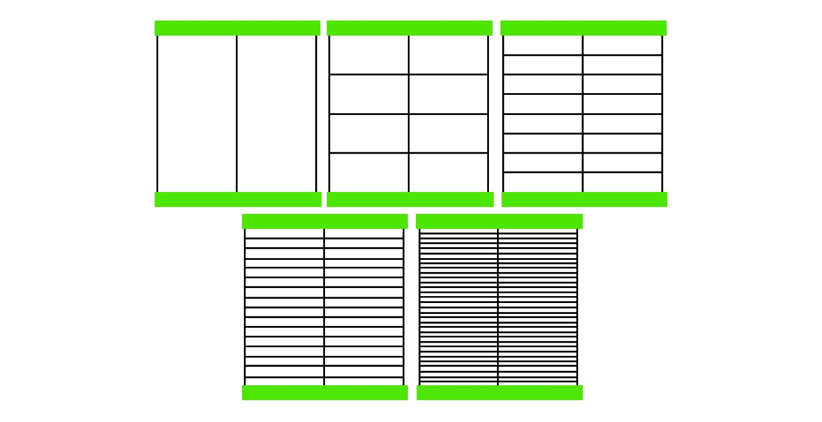
First Experimental Set: Input 2 - Tartanset2.txt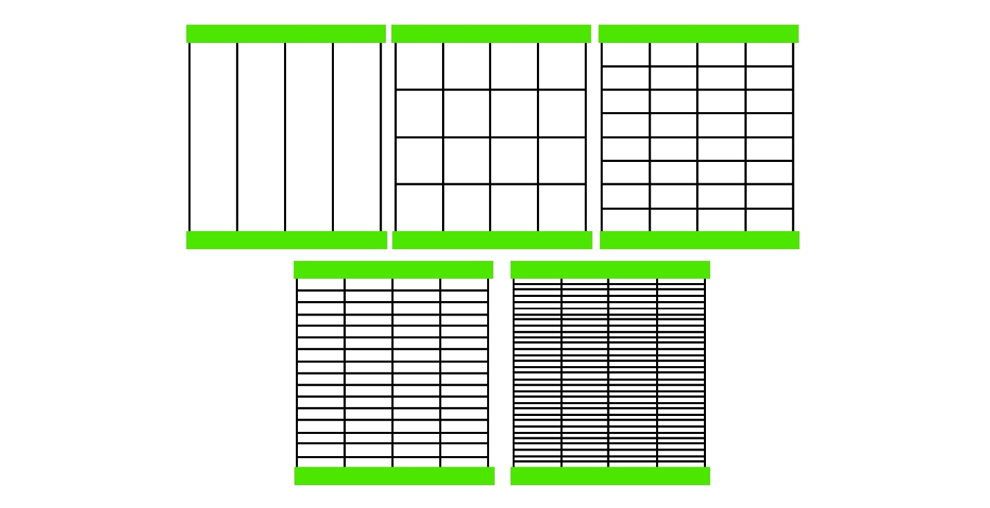

First Experimental Set: Input 3 - Tartanset3.txt
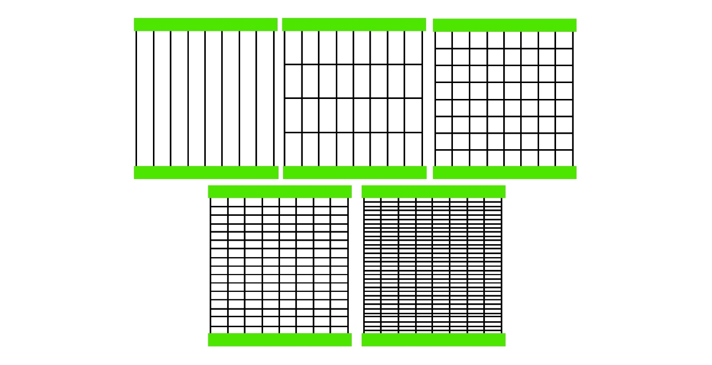
First Experimental Set: Input 4 - Tartanset4.txt
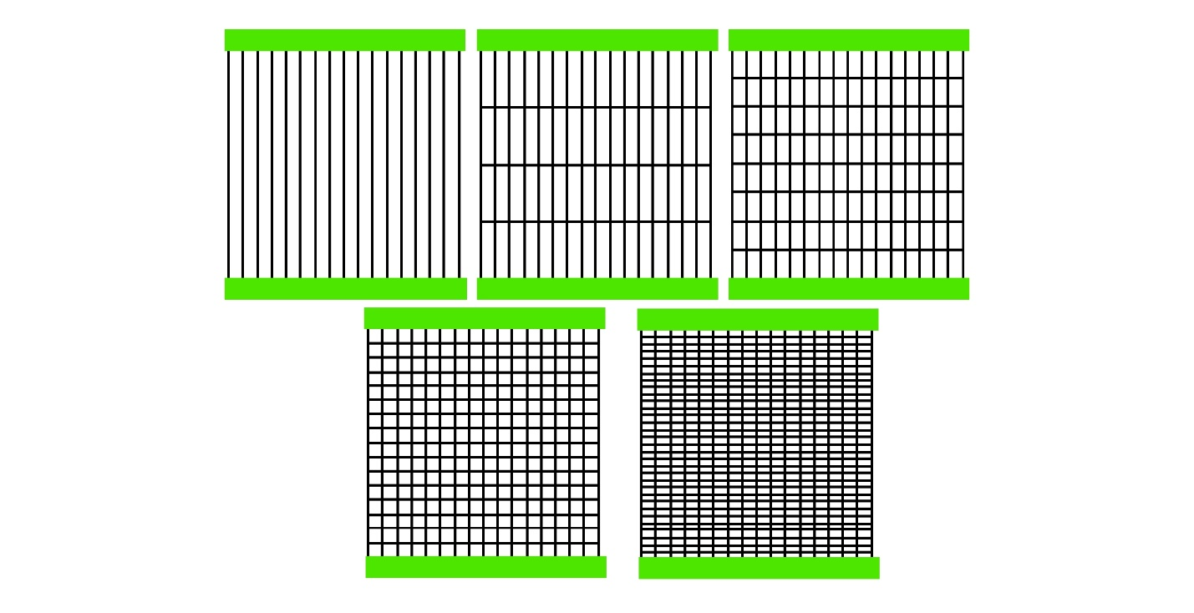
First Experimental Set: Input 5 - Tartanset5.txt
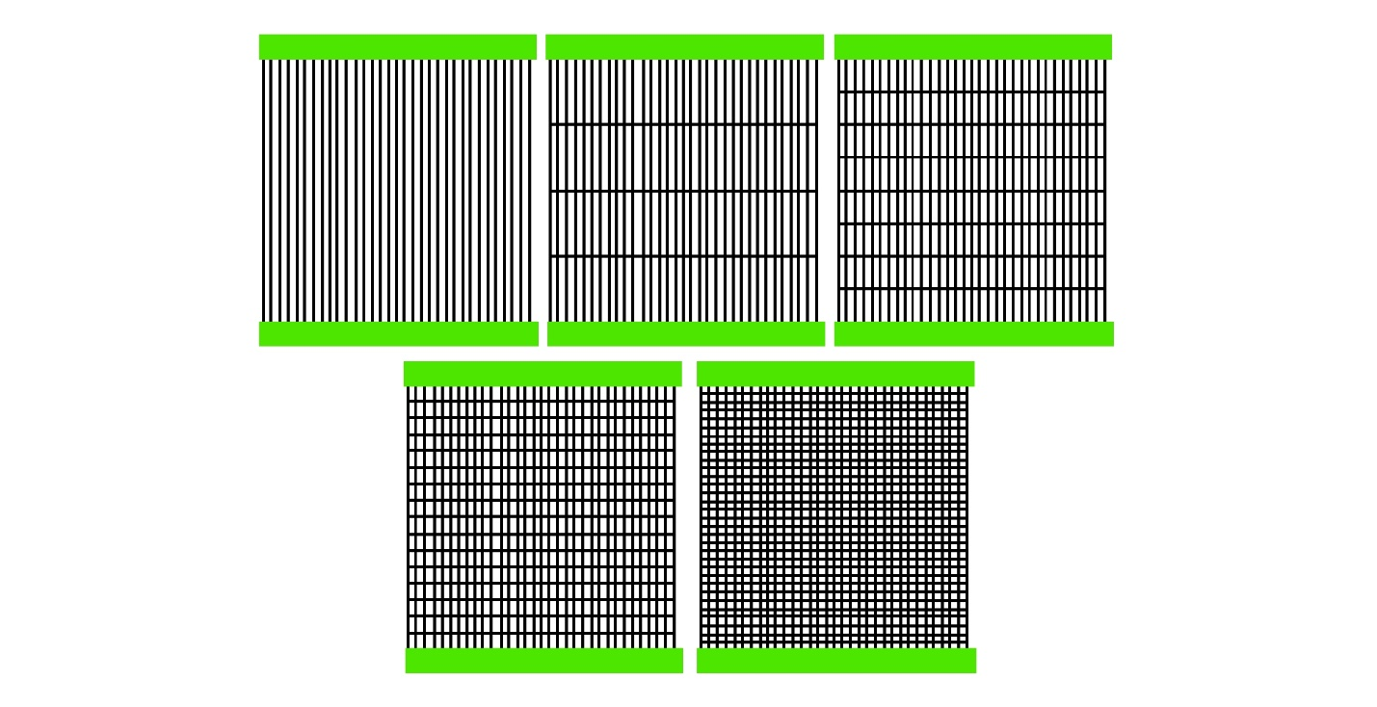
Second Experimental Set: Input 1 - Tartanset6.txt
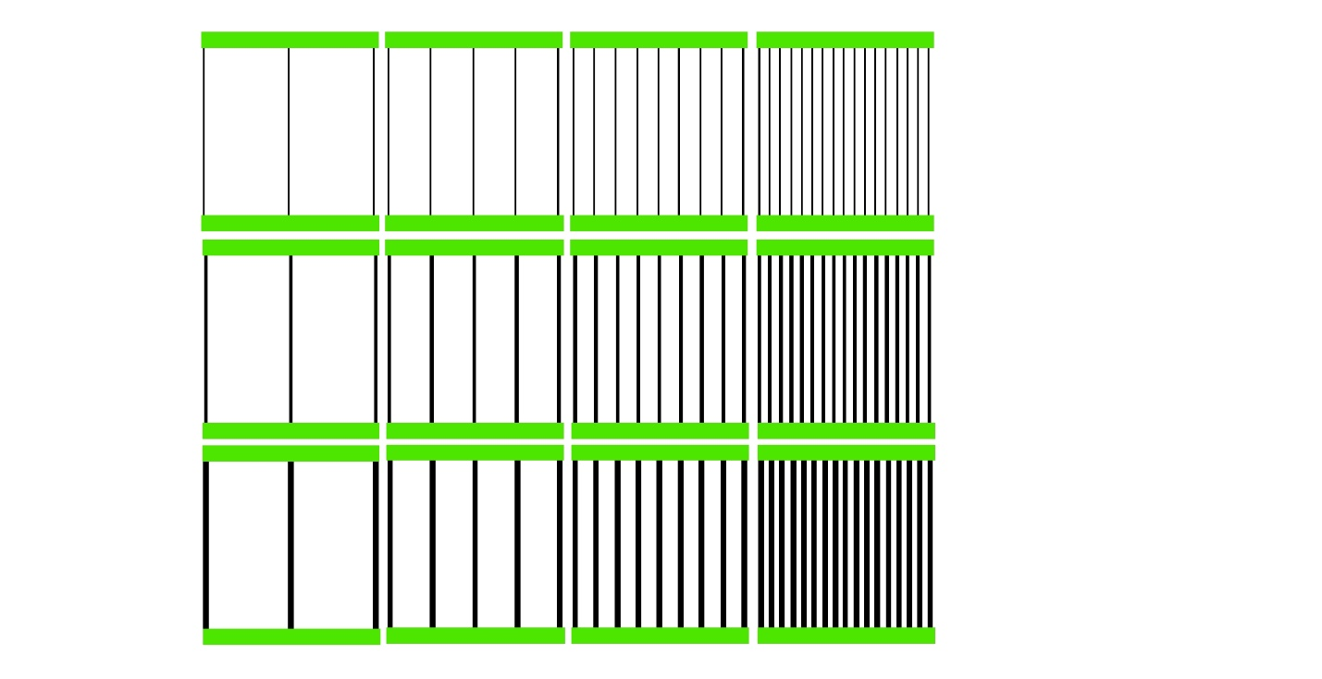
Second Experimental Set: Input 2 - Tartanset7.txt
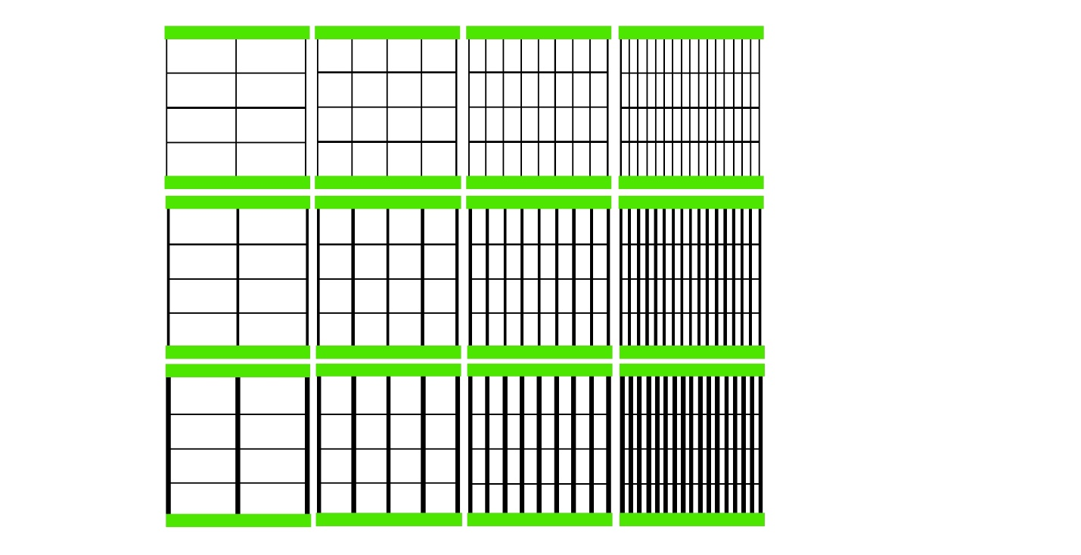
Second Experimental Set: Input 3 - Tartanset8.txt
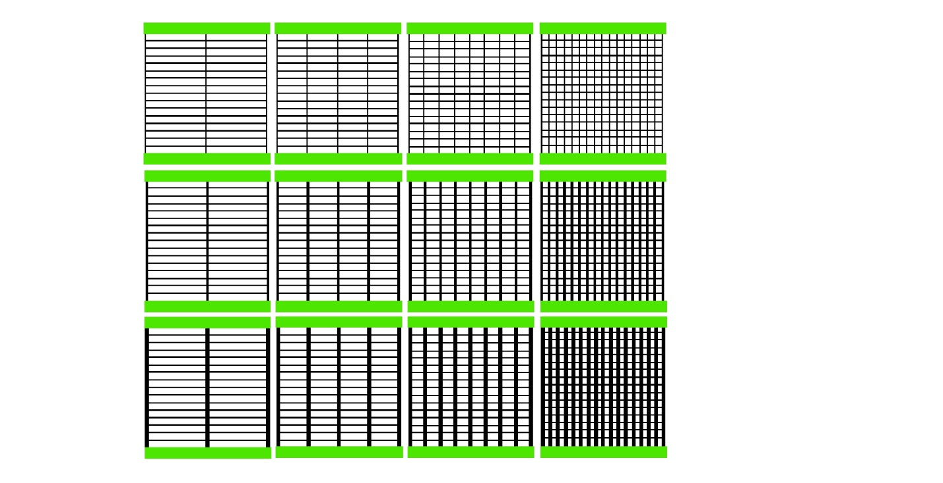
Second Experimental Set: Input 4 – Tartanset9.txt
Third Experimental Set: Input 1 – Tartanset10.txt
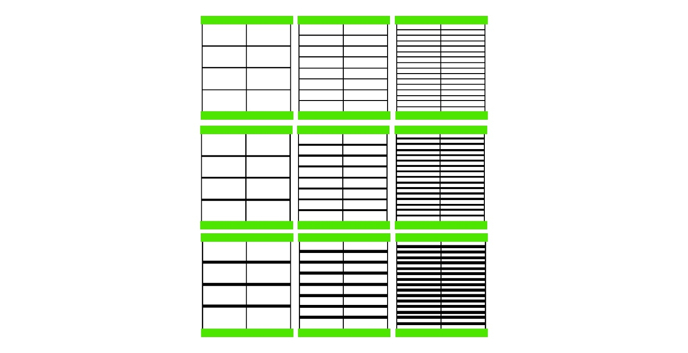
Third Experimental Set: Input 2 – Tartanset11.txt
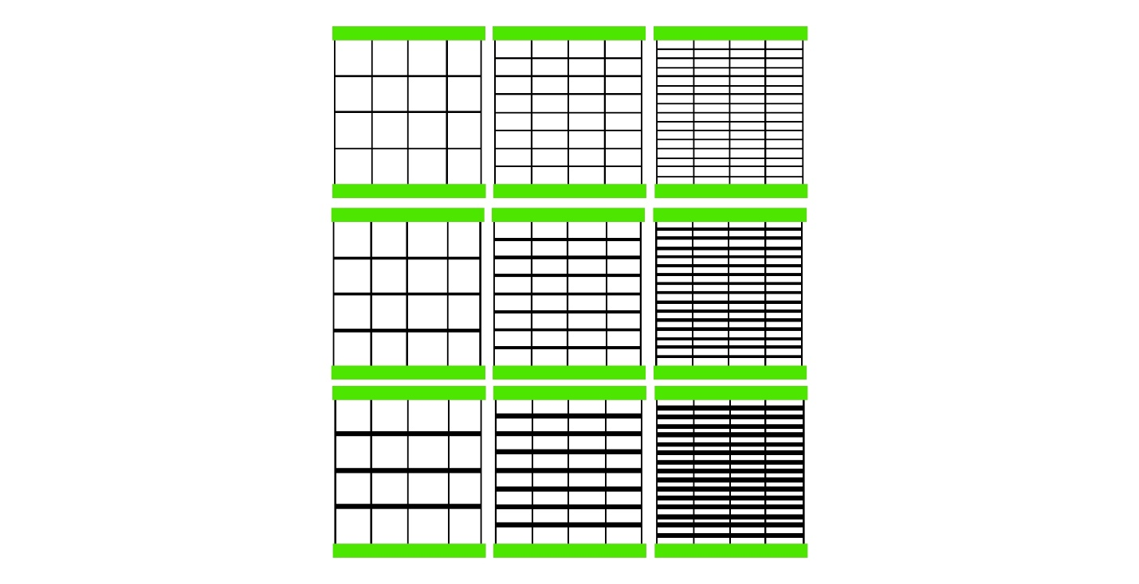
Third Experimental Set: Input 3 – Tartanset12.txt
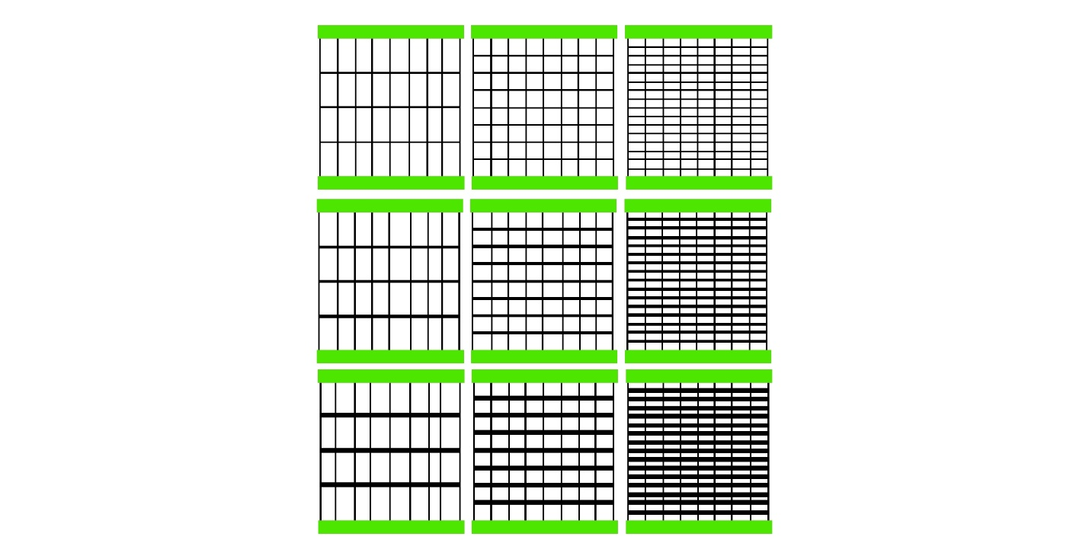
Third Experimental Set: Input 4 – Tartanset13.txt
