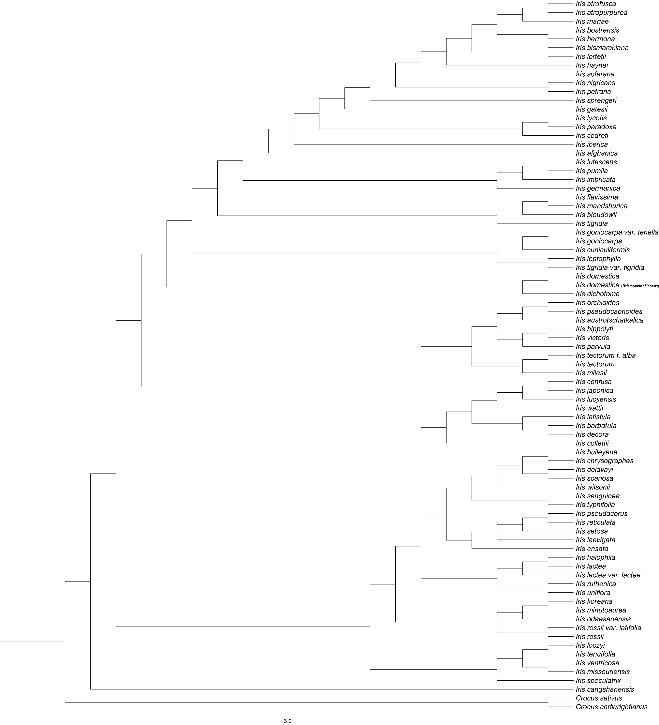

Figure S1 Phylogenetic tree of Iris inferred from complete plastomes based on maximum likelihood (ML)

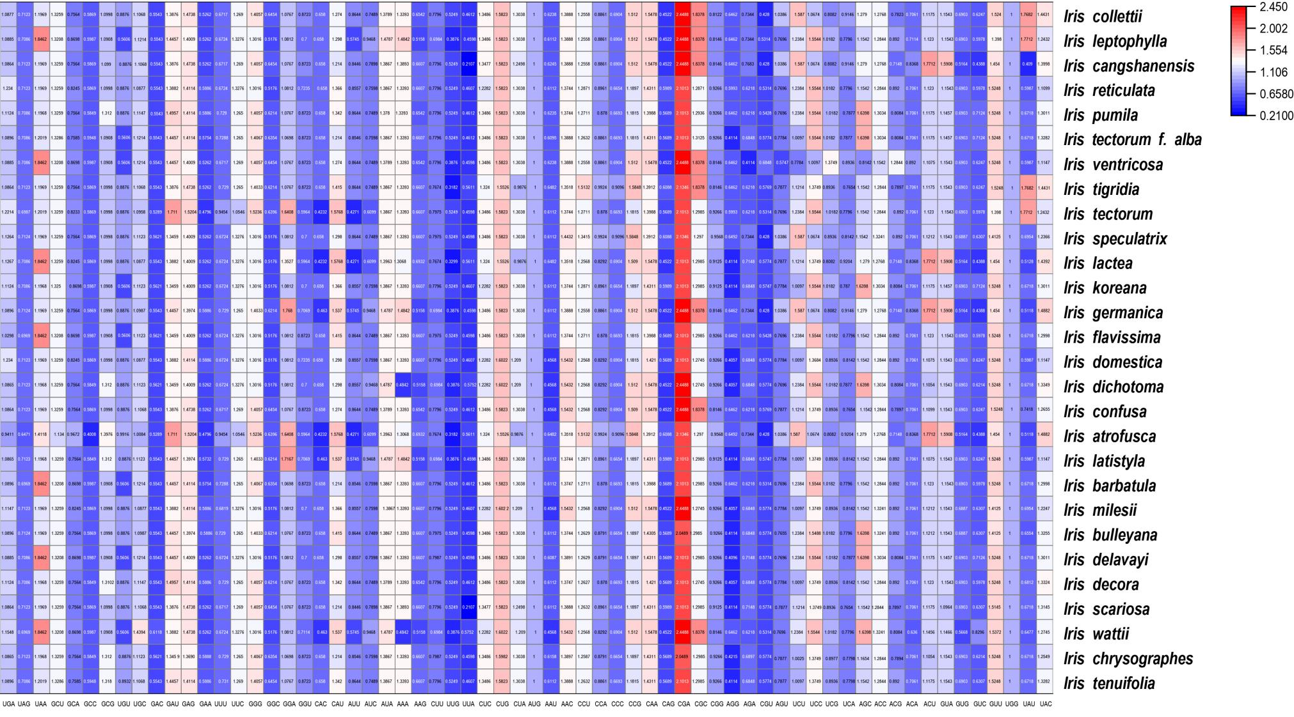

Figure S2 Heat map of codon usage for 28 Iris species

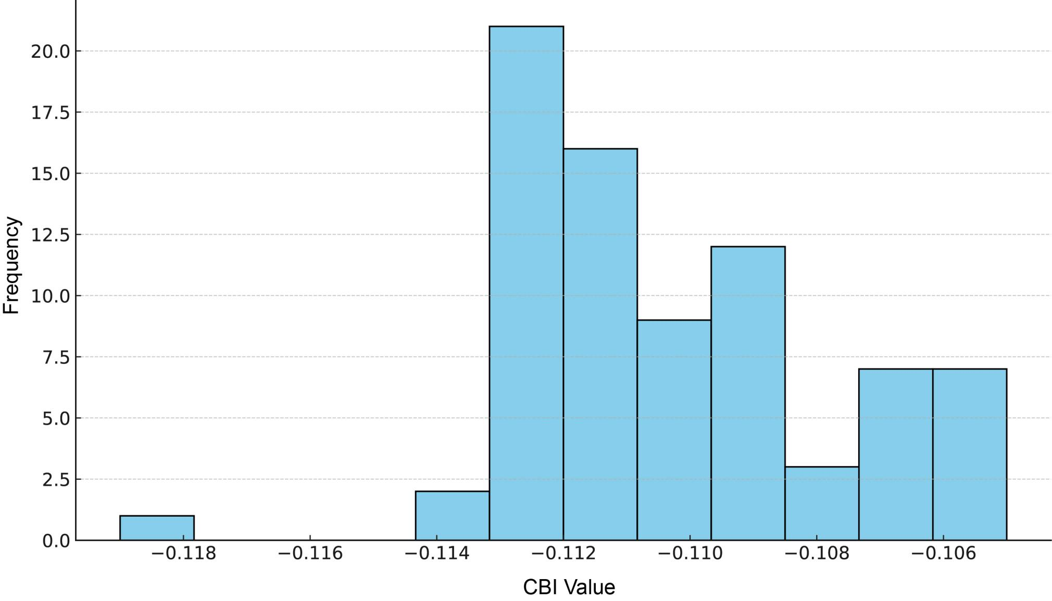

Figure S3 Distribution of codon bias index (CBI) values

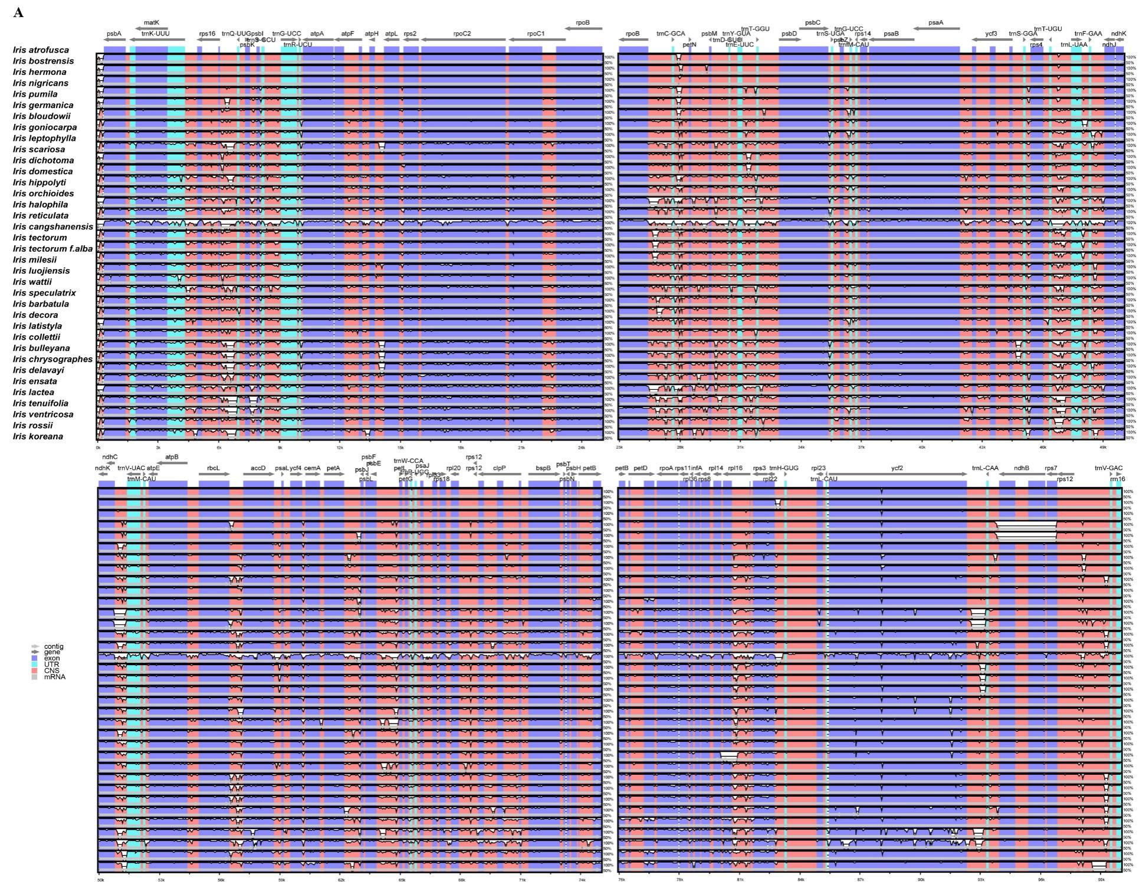
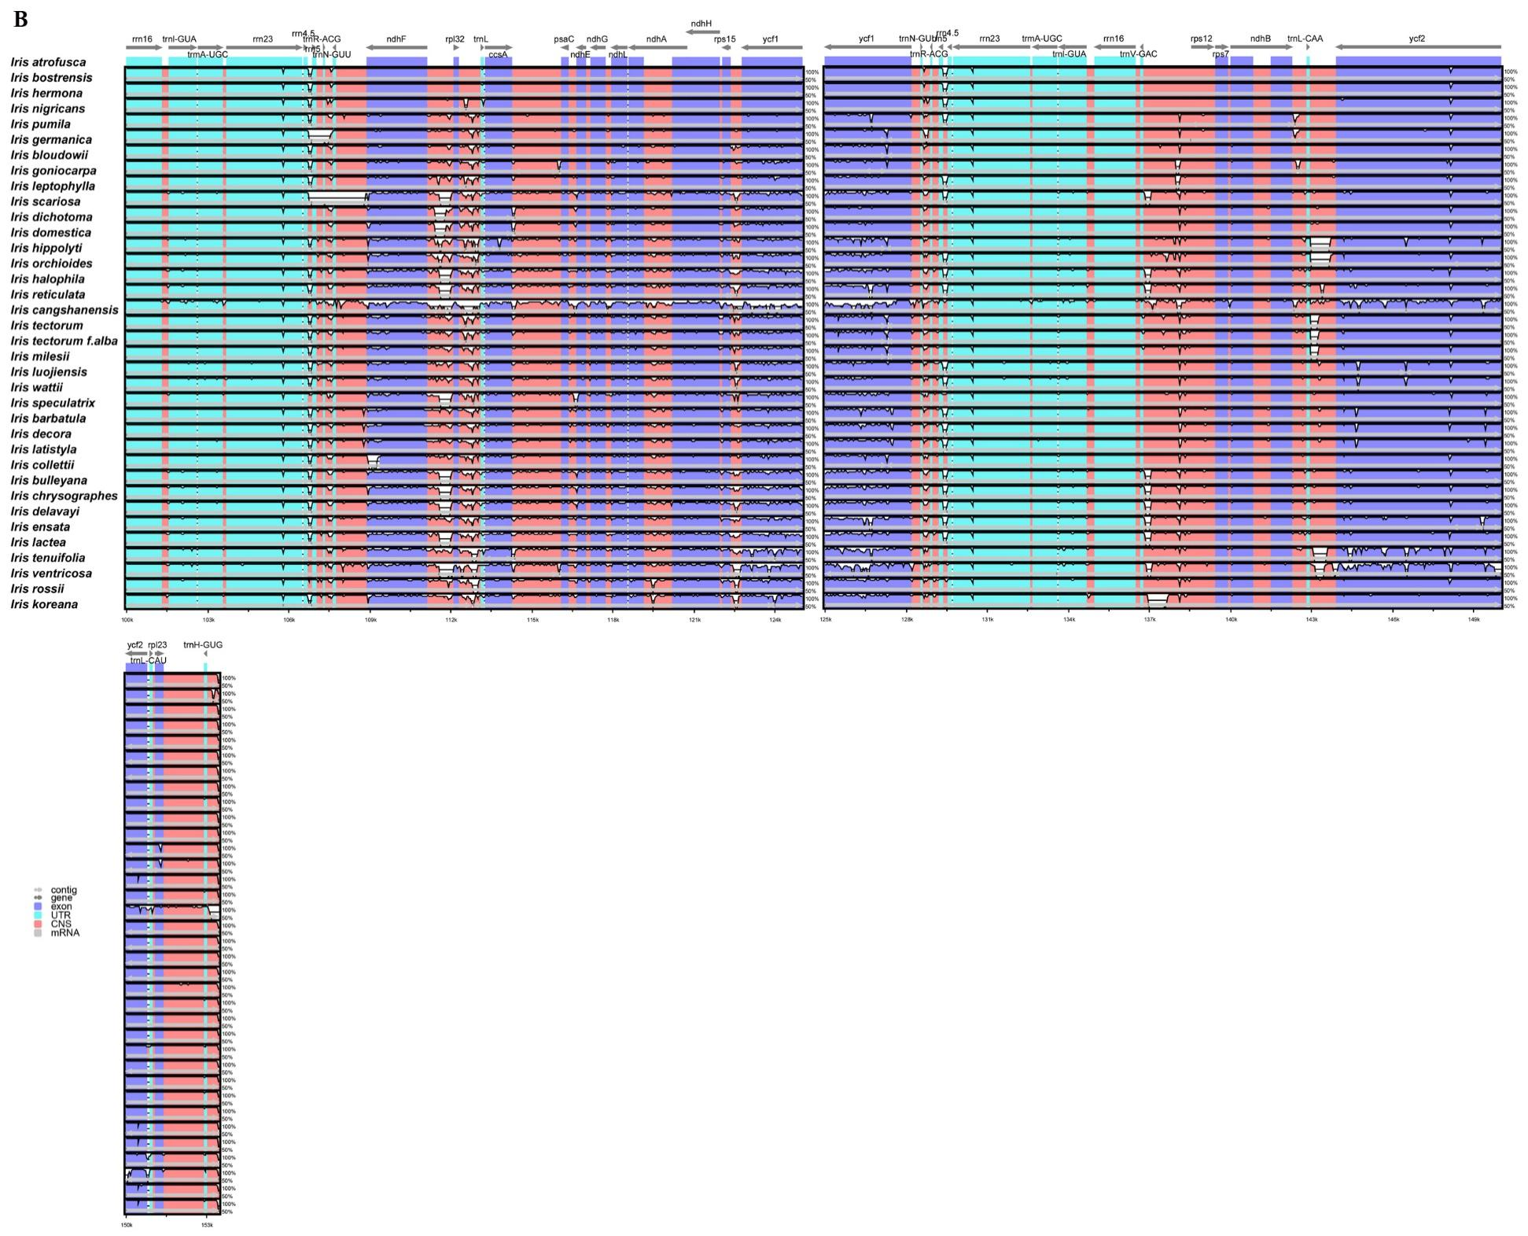
Figure S4 Sequence alignment of 36 plastome of Iris species using mVISTA and chloroplast genome of Iris germanica (NC_062594) as reference. The top arrow shows transcription direction, blue color indicates protein-coding regions, pink color shows non-coding sequences and light green indicates tRNAs and rRNAs. The x-axis represents the coordinates in the cp genome while y-axis represents percentage identity within 50–100%

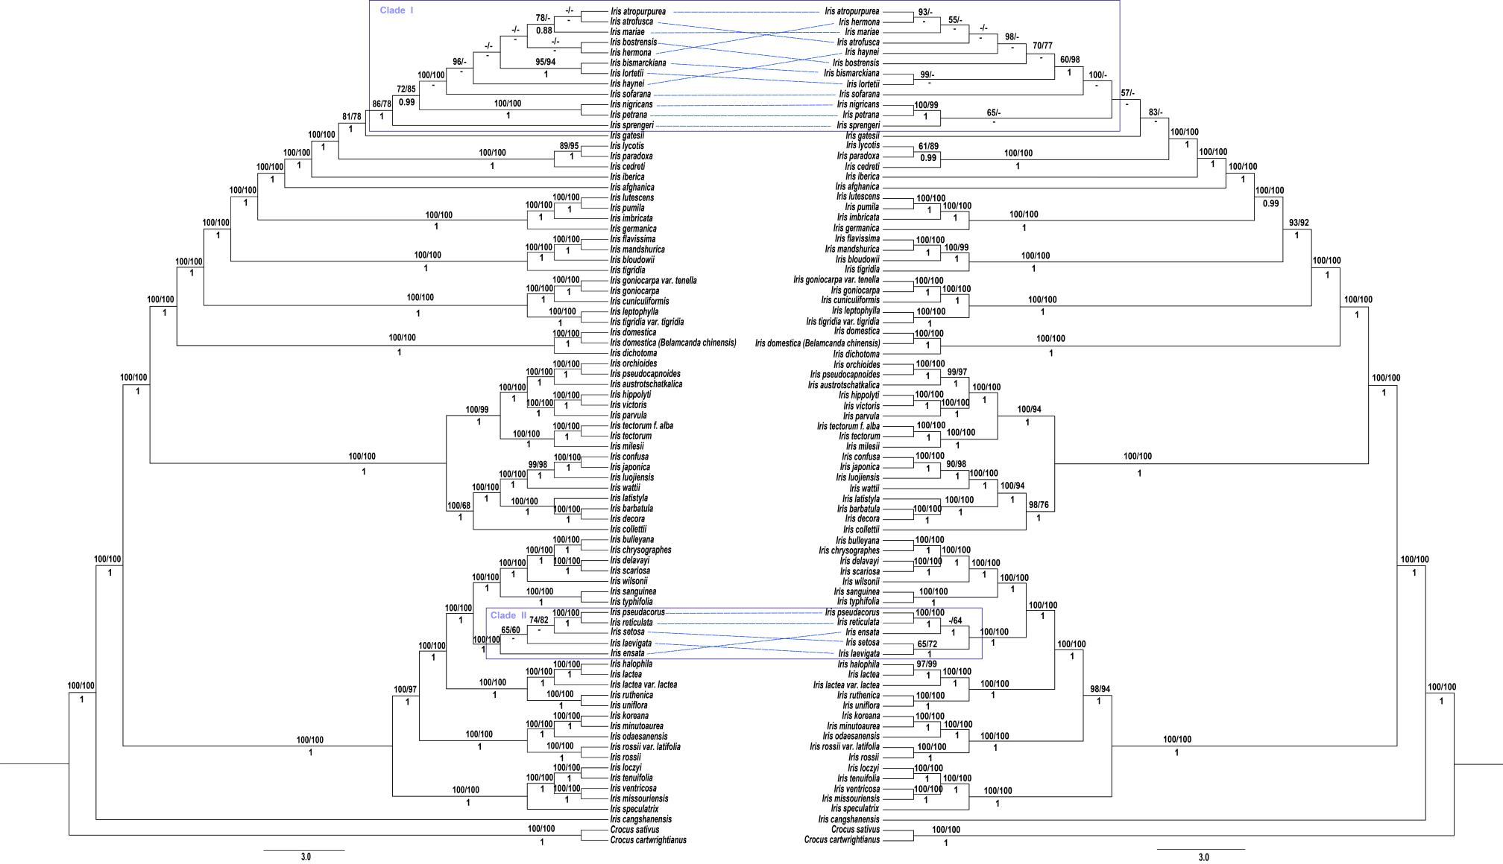
Figure S5 Topological comparison between the phylogenies inferred from (A) complete plastomes dataset and (B) CDSs dataset. ML/MP Bootstrap (BS) values and BI posterior probabilities (PP) are shown at nodes

