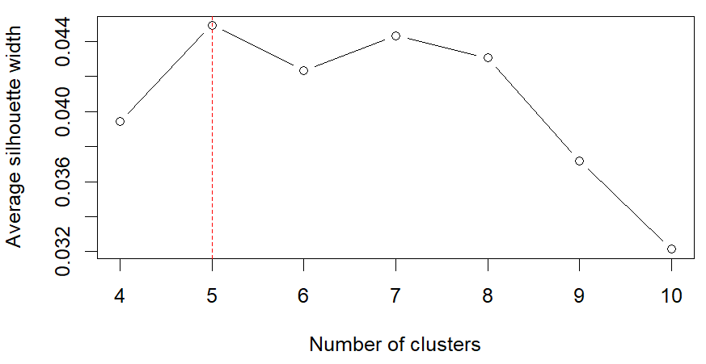

Supplementary Fig. S1. Average silhouette width for different numbers of clusters. Average silhouette widths for 4–10 clusters, with the maximum observed at five clusters, indicating the optimal solution.

