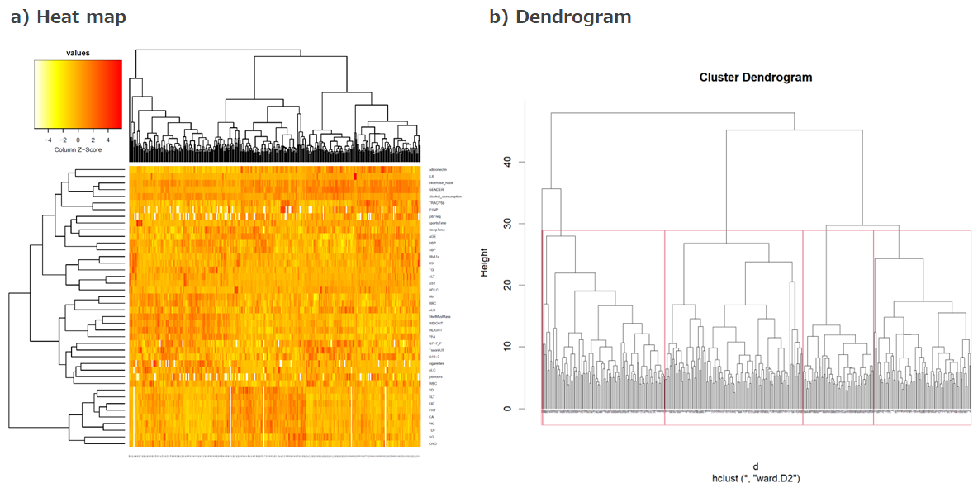

Supplementary Fig. S2. Cluster analysis was performed using the hierarchical Ward method for the standardized characteristics of the 352 participants with LS1. (a) Heatmap and clustering results for the matrix of attributes of the 352 samples. (b) Dendrogram showing clustering results with five clusters.

