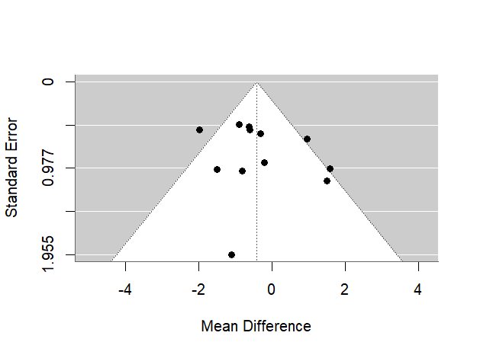
Figure 1: Funnel plot assessing potential publication bias in the BCVA outcomes for anti-VEGF biosimilars compared to their reference in the first 12 weeks.
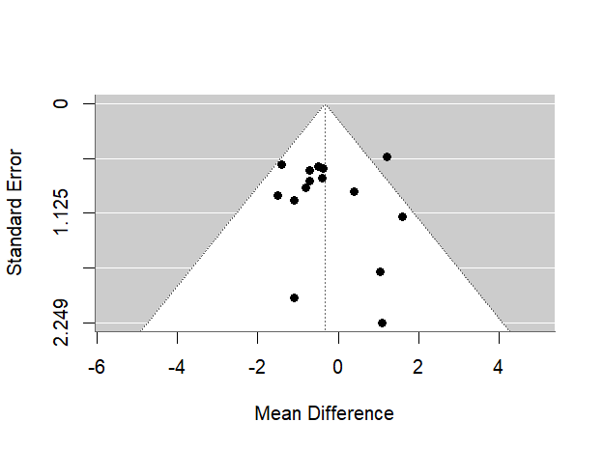
Figur 2: Funnel plot assessing potential publication bias in the BCVA outcomes for anti-VEGF biosimilars compared to their reference.
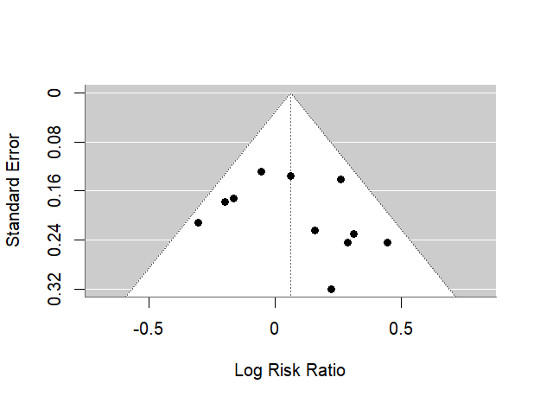
Figure 3: Funnel plot assessing potential publication bias in the responders’ rate for anti-VEGF biosimilars compared to their reference.
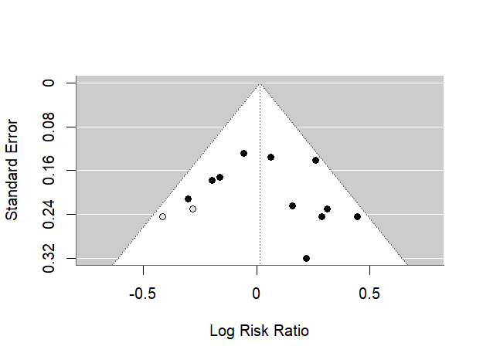
Figure 4: Adjusted funnel plot following the Trim and Fill imputation method for publication bias in the responders’ rate for anti-VEGF biosimilars compared to their reference.
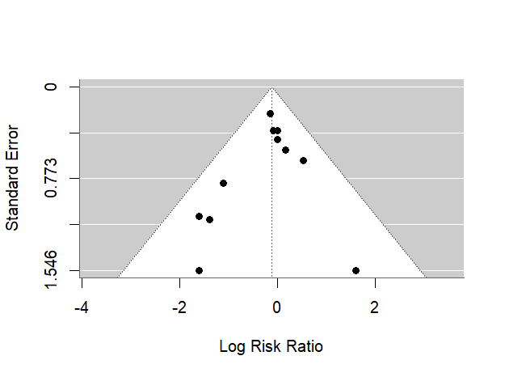
Figure 5: Funnel plot assessing potential publication bias in the incidence of Treatment-Emergent ADAs for anti-VEGF biosimilars compared to their reference.
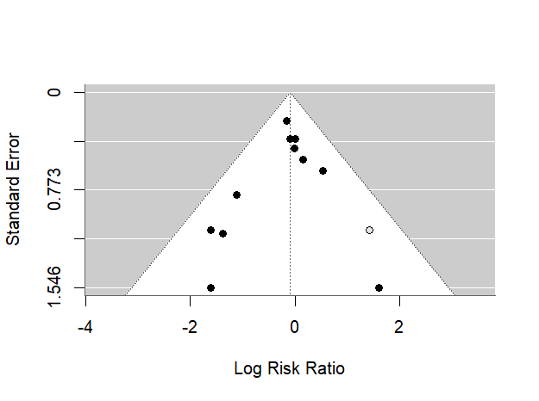
Figure 6: Adjusted funnel plot following the Trim and Fill imputation method for publication bias in the incidence of Treatment-Emergent ADAs for anti-VEGF biosimilars compared to their reference.

