Appendix

Assessment
Suturing is assessed in three domains. The raters (three expert surgeons and two aspiring surgeons – were asked to scrutinise photographs of every banana and then individually score each. Definitions and a template emerged from the scoring process. The scorers did not converse or share interpretation but were asked to iteratively review pictures, to gain clarity of process.
- MUSH: The percentage area of the banana flesh that has been disrupted. Banana flesh is naturally white with a subtle texture. Banana that has been touched by the needle or the needle holder loses this appearance and is considered MUSHED. The surface area of the mushed banana is given as a percentage of the total area of the two-centimetre diameter punch hole. The centre of the circle is last to be disputed, and edges always have a degree of discolouration, approximating to 2.5 % total surface area. A clean banana has this rim but considered 100% clean.
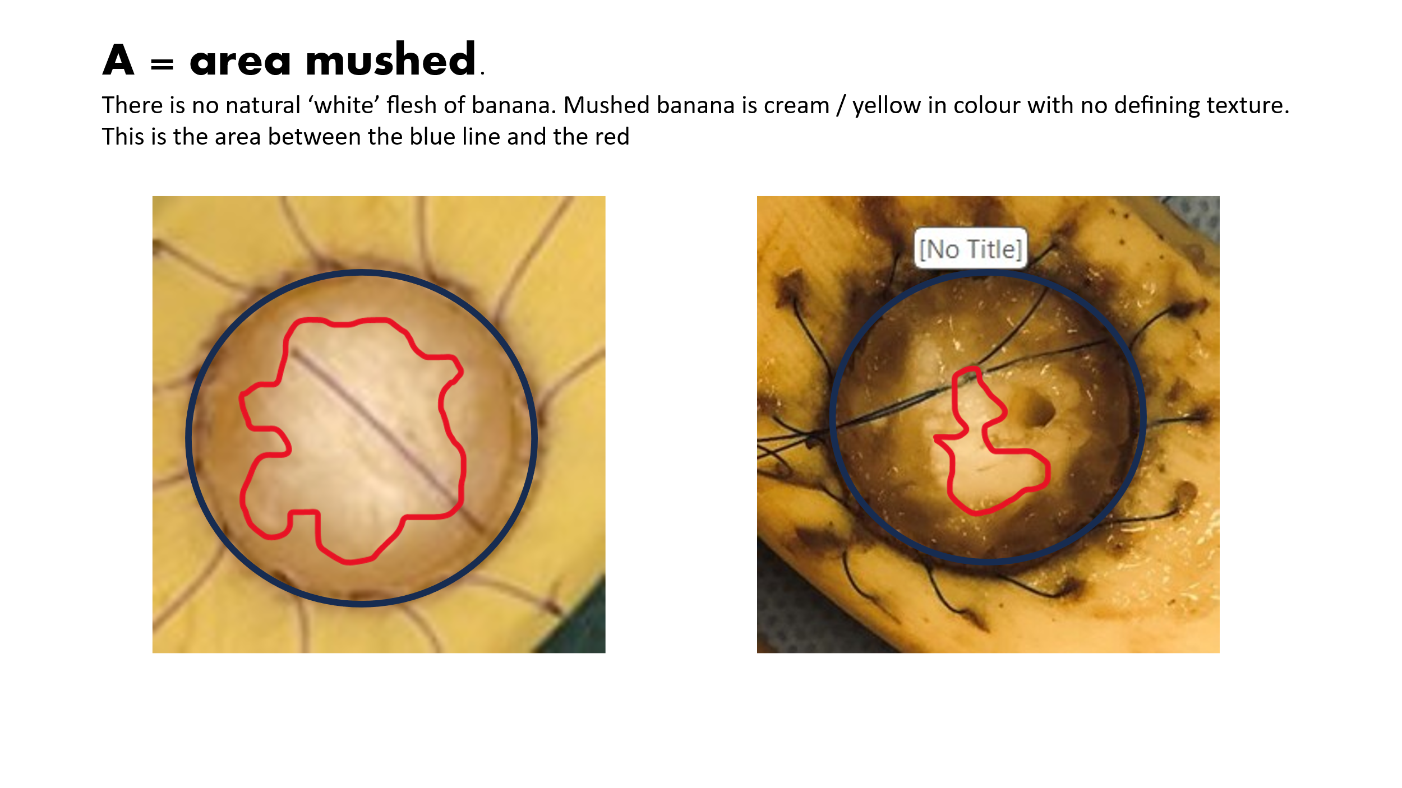
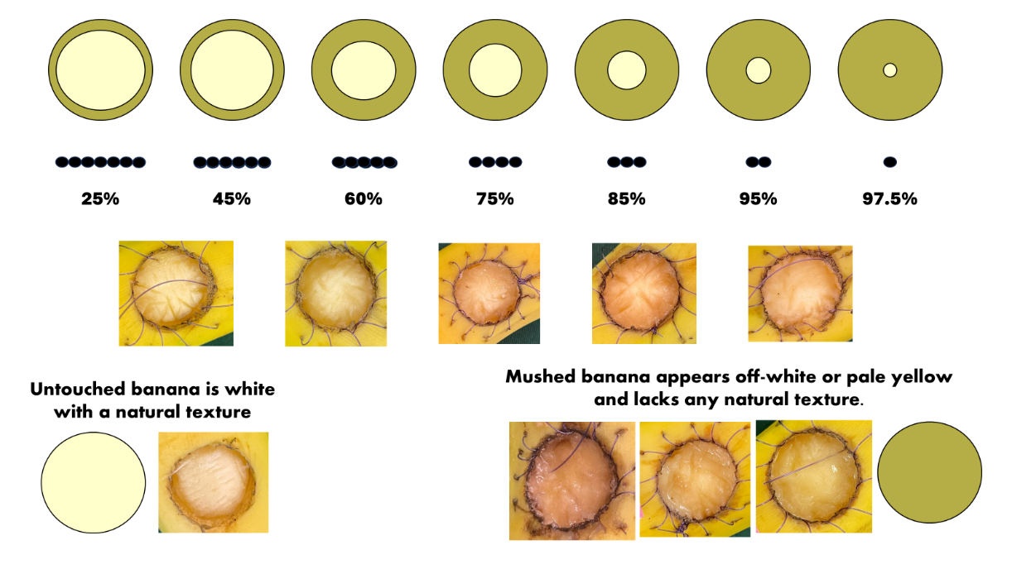

- This element has three parts.
- TOTAL NUMBER OF SUTURES: All sutures have been included, although attempts with more than twelve sutures may be disqualified. Nonetheless, other aspects of stitching were observed to be excellent. Each suture was evaluated based on the following criteria.
- NOT RADIAN / EQUALLY SPACED: Sutures are evenly spaced around the circumference, like hours on a clock for twelve sutures. Templates with fourteen and sixteen sutures were used for reference. Uneven spaces between sutures were noted, focusing on exit points rather than suture direction.
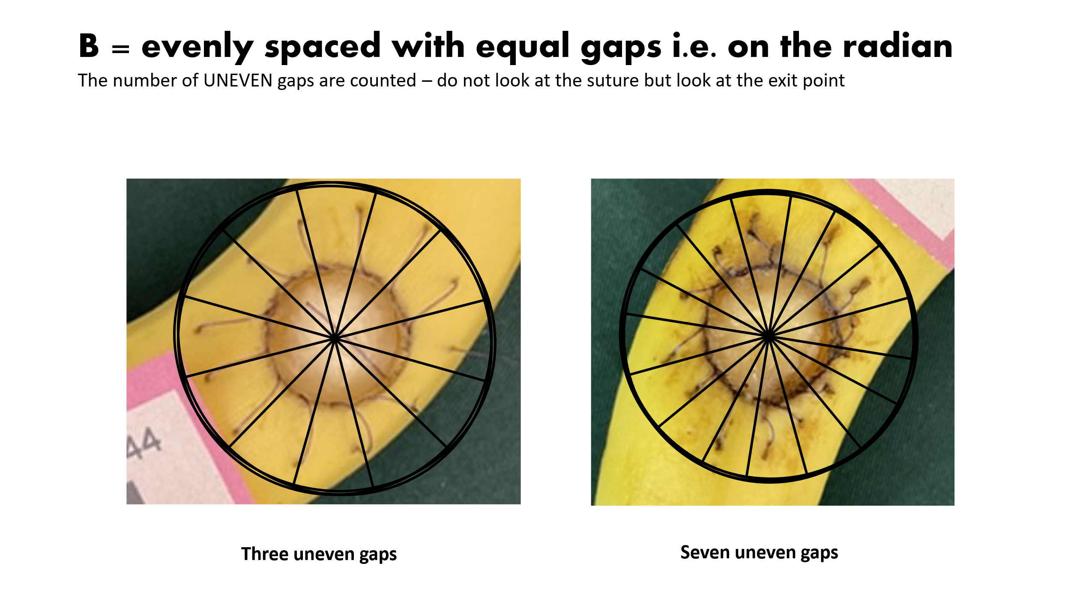
  - NOT EQUIDISTANT: This refers to the distance from the circumference of the banana hole to the exit point of the suture. The scorers imagine a circle drawn outside the circumference of the hole that matched the greatest number of exit points. All the exit points inside the circle and outside the circle are counted as not equidistant.
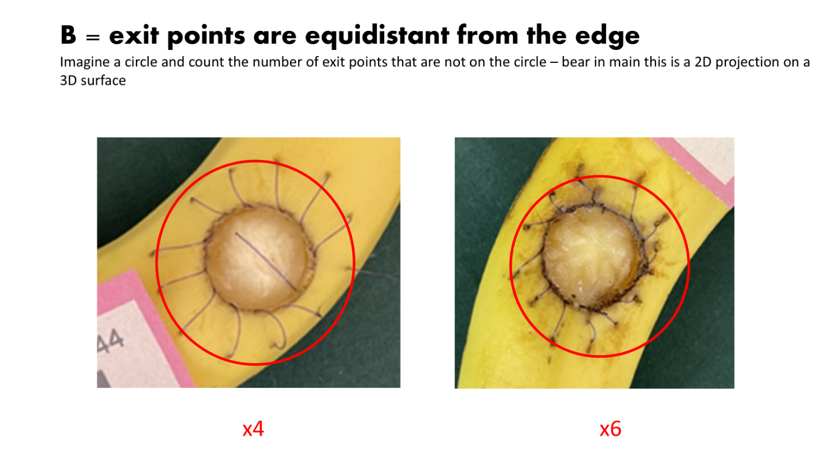
This was taken by imagining the drawing of a circle around the exit points of the sutures, with the scorer requiring consideration of the 3D nature of the banana when looking at a 2D photograph. Benefit of the doubt was at scorers’ discretion.
- EXIT: The exit of the needle from the banana is marked by a blackening of the skin. The perfect exit is a circular hole created by the needle in which the suture sits.
  - SKID – A skid is defined as an exaggerated ellipse and is much larger than the size of the suture.
  - TEAR is defined as having a linear element. The tear is a significant injury and penalised proportionally i.e. more than the SKID. This may also be due to the suture pulling through the banana and not just the exit of the needle.
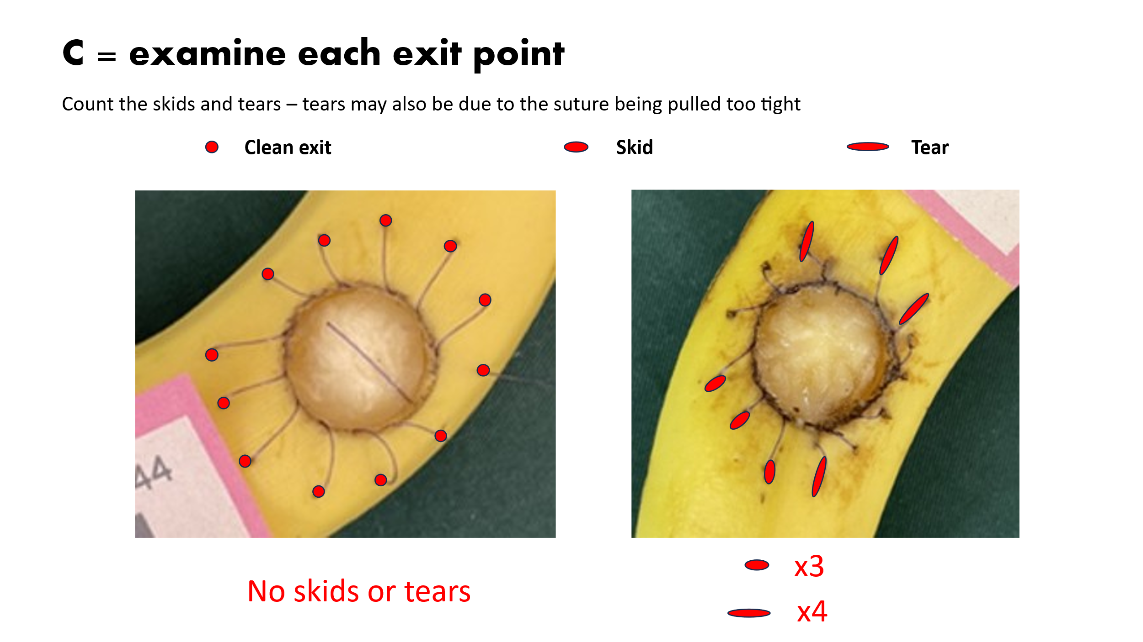

Explanation of scoring domains
These domains represent three elements of stitching.
- Correct needle mounting is required to ensure the needle driver does not touch the flesh of the banana and the needle can be rotated back to the perpendicular such that the needle POINTS into the ‘hole’ and is rotated out without the shaft touching the flesh.
- This element examines the cognitive visual spatial awareness the of the operator which is a critical skill for the novice surgeon¹. The number of sutures is defined as twelve, but many ignore this instruction, and others put twelve sutures in forgetting the eleventh pass through the banana is number twelve. The radian is circumference spacing and equidistant is linear spacing. Alignment can only be achieved by deliberately orientating the needle to the vector direction of the stitch PLACE. Possessing a high level of visual special awareness is required ¹ The visual spacial test of radial sutures and equidistance on the banana provide good indicators of performance in OSATS scores (Burkhardt et al., 2019a) and the clock face is often used to describe and test trainee abilities ²
- Skids and tears show if the needle was able to ROTATE smoothly through the tissue, especially on delivery. The banana is unforgiving if the needle drags out of the tissue/banana skin. This is often worse when forceps are used to stabilise or deliver the needle. Hence our requirement for the non-dominant hand to be held behind the back. The banana holds the needle on a curve, and it should be picked up at the “right” spot on the shaft as it is delivered through the banana. On pick up, the needle follows the curve.
The three domains underscore the principles of effective needle control. Most needles are utilized along the circumference of a circle; clean rotation ensures minimal tissue damage. This is governed by mathematics and geometry of needle anatomy (Euclid). The ideal angles for alignment are ninety degrees to the tissue, ninety degrees across what is being stitched, and ninety degrees into what is being stitched, followed by a simple rotation.
The scorers feedback enabled further refinement and definition of each element of the scoring process. This was an iterative process where we continually cross-checked scoring during the process.

The calculations and formula
The calculation focused on key stitching aspects: needle alignment, placement, and rotation. The scoring formula, equally weighted across three domains, yields a final score out of 100.
The original instruction required 12 sutures, but we revised the formula to include all stitches with proportional penalties since some participants showed good stitching in other aspects that were considered during scoring.
- The mushed area is given as an estimated percentage surface area of the 2cm diameter hole made by the apple corer in the banana. 100% means that whole surface of the banana flesh is disturbed
  - 100% undisturbed (ideal state) - % not disturbed = % banana flesh intact
  - This % intact banana was then divided by 3 i.e. 100% undisturbed realises 33.3 (maximum) points
- This element looked at visual spatial capability – 12 x perfect radial and equidistant suture i.e. on the hour every hour will achieve 100%
  - RADIAN – i.e. the perfect sutures would be arranged radially i.e. 12 x on the hour every hour of a clock
    - The number of uneven gaps was multiplied by 8.3 (100/12)
    - 100-derived a score
  - EQUIDISTANT – the exit points are on a perfect circle from the edge – that distance was not prescribed
    - The number of non-equidistant suture was multiplied by 8.3 (100/12)
    - 100 – derived score
  - PENALTY was subtracted for extra sutures = Number of extra sutures multiplied by 8.3
  - FINAL Score for B section amount to a potential total of 200 points (a+b) provided there was no subtraction penalty in c (a+b-c) and divided by 6 to give a maximum of 33.3 points
- Skids and Tears - Skids and tears examine the exit wound of the needle -a tear incurs a bigger penalty than a skid. A clean circular exit does not incur any penalty points i.e. 12 perfect exits will score a maximum of 100%
  - Skid score was calculated as 100 – number of skids X 100/ total number sutures
  - Tear score was calculated as 100 – number of tears X 100/ total number sutures x2
  - The combined score (maximum of 200) was divided by six to give a maximum of 33.3 points
Final Score is A +B +C = score to give a total out of 100 or a percentage mark

References
1. Hedman L, StrÖM P, Andersson P, Kjellin A, Wredmark T, FellÄNder-Tsai L. High-level visual-spatial ability for novices correlates with performance in a visual-spatial complex surgical simulator task. Surgical endoscopy. 2006;20(8):1275-1280. doi:10.1007/s00464-005-0036-6
2. Treil L, Neumann N, Chanes N, et al. Objective Evaluation of Clock Face Suture Using the Objective Structured Assessment of Technical Skill (OSATS) Checklist. EJVES vascular forum. 2022;57:5-11. doi:10.1016/j.ejvsvf.2022.10.001

