Supplementary Information for the article:

Individual variation and social influence of risk-taking behavior in bottlenose dolphins

Muhammad Mahmudur Rahman*, Jennifer S. Lewis, Kyra Bankhead, Mauricio Cantor*
* Corresponding authors: muhammad.rahman@oregonstate.edu; mauricio.cantor@oregonstate.edu

Here, we report the results of the analyses for the subset of well sampled individual dolphins with more than 60 minutes of focal follow data (“+60 shallow subset”). Overall, we show that the results in the main text are not sensitive to variation in sampling effort, as the removal of the less sampled individuals have not altered the overall patterns.

Shallow water foraging among well-sampled individuals

To calculate probabilities of dolphins to engage in shallow water foraging, we used Bayesian generalized linear models (GLMM). The Bayesian GLMM on the “+60 shallow subset”, focusing on the individuals followed at least 60 min, yielded a posterior mean estimate of the intercept of −2.50 and Standard Deviation of the posterior distribution (Est. Error) of 0.21 (95% Credible Interval = −2.93 to −2.09). This suggested that these individuals generally had a low probability of foraging in shallow waters relative to the model on the shallow dataset including all individuals (main text: intercept = −3.07, Est. Error = 0.23, 95% CrI: −3.54 to −2.63).

Table S1. Individual probability of engaging in risk-taking behaviors across three datasets: the “+60 shallow subset, the full shallow dataset, and the high vessel traffic dataset.

Dataset | Estimate | Est. Error | l-95% CrI | u-95% CrI
+60 shallow subset | -2.5 | 0.21 | -2.93 | -2.09
Shallow dataset | -3.07 | 0.23 | -3.54 | -2.63
Traffic dataset | -7.36 | 0.59 | -8.58 | -6.27

Estimating repeatability of engagement in shallow water foraging

We estimated repeatability (R) for the “+60 shallow subset” to assess variation in risk taking for the well sampled individuals. The Bayesian model provided a moderate mean repeatability of R = 0.62 (95% CI = 0.54–0.69), mirroring the frequentist GLMM repeatability estimate of R = 0.61 (95% Confidence Intervals = 0.53–0.67).

Table S2. Repeatability estimates (R) for individual risk-taking behavior across three datasets, estimated using both Bayesian and frequentist (GLMM) methods.

Dataset | R | 95% CrI (Bayes) | R (Freq, glmer) | 95% CI
+60 shallow subset | 0.62 | 0.54 - 0.69 | 0.61 | 0.53 – 0.67
Shallow data set | 0.67 | 0.60- 0.74 | NA | NA
Traffic data set | 0.92 | 0.89 – 0.94 | NA | NA

Testing for social preferences and avoidances

We tested the null hypothesis that individuals associate at random against the alternative hypothesis of social preferences or avoidances. The observed coefficients of variation (CV) of the association indices for the “+60 subset” was higher than the CV of permuted networks (SRI CV observed = 330.78., 95% CI = 269.50 – 323.44), providing additional evidence of non-random social structure.

Table S3. Observed coefficients of variation (CV) of association indices compared to the 95% confidence intervals (CI) from 1,000 null model permutations for each dataset.

Dataset | Observed CV | 95% CI
+60 shallow subset | 330.78 | 269.50 – 323.44
Shallow data set | 387.15 | 329.81 – 377.48
Traffic data set | 457.75 | 397.13 – 457.00

Describing modular social structure

The community detection algorithm applied to the “+60 shallow subset” identified fewer (6) modules in the network in comparison to the full shallow water dataset. This network partition was significant (Q = 0.58, 95% CI = 0.29-0.57; Figure S1). The observed mean risk-taking similarity was higher (0.36) than the null expectancy (permuted mean = 0.25, p <0.001), indicating a strong correlation between shallow water foraging and the social community formation.

Comparing within-community risk probabilities

When comparing the central tendency of individuals in engaging in this behavior, the “+60 shallow subset” displayed a similar pattern than that found for the “shallow dataset”. Here, community 2 has a notably higher median risk-taking probability around 0.25 compared to others (Figure S1A).

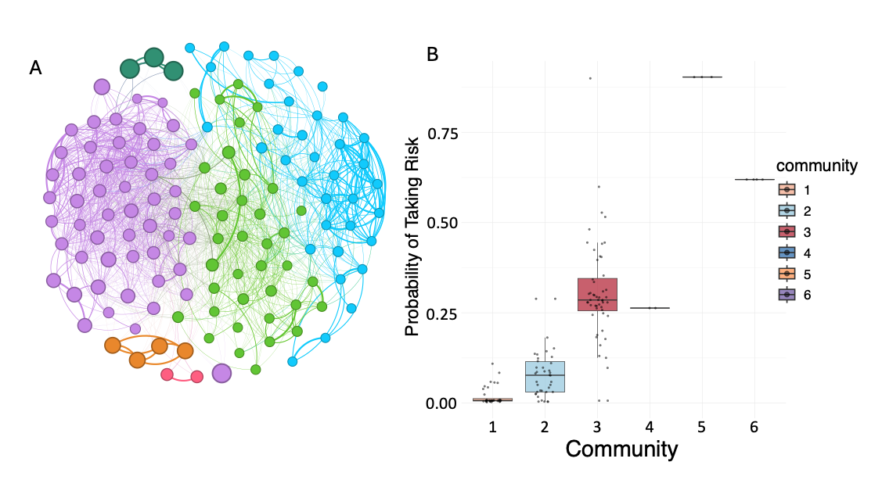
Figure S1. Dolphin social network restricted to the well-sampled individuals and in the context of foraging in very shallow waters. (A) Nodes representing individual dolphins are connected by edges whose thicknesses are proportional to the association between individuals. Node colors represent different social communities, node sizes are proportional to the probability of foraging in shallow (<0.54m deep) waters. (B) Distribution of the risk-taking probability across dolphin social network communities.

Relating social associations and similarity in risk-taking behavior

Using MCMC GLMM models, we found that dolphins with more similar shallow water foraging frequencies were more likely to associate (main text). This relationship was stronger in the subset of individuals with over 60 minutes of observation (β = 0.68, SE = 0.06, 95% CrI = 0.56—0.79), reinforcing that similarity to shallow water foraging predicted social associations.

Table S4. Posterior estimates from Bayesian GLMMs testing the relationship between risk-taking similarity and pairwise behavioral similarity across three datasets.

Dataset | Predictor | Estimate | Est. Error | l-95% CrI | u-95% CrI
+60 shallow subset | Euclidian distance similarity | 0.68 | 0.06 | 0.56 | 0.79
Shallow dataset | Euclidian distance similarity | 0.42 | 0.04 | 0.33 | 0.51
Traffic dataset | Euclidian distance similarity | 0.07 | 0.02 | 0.02 | 0.11

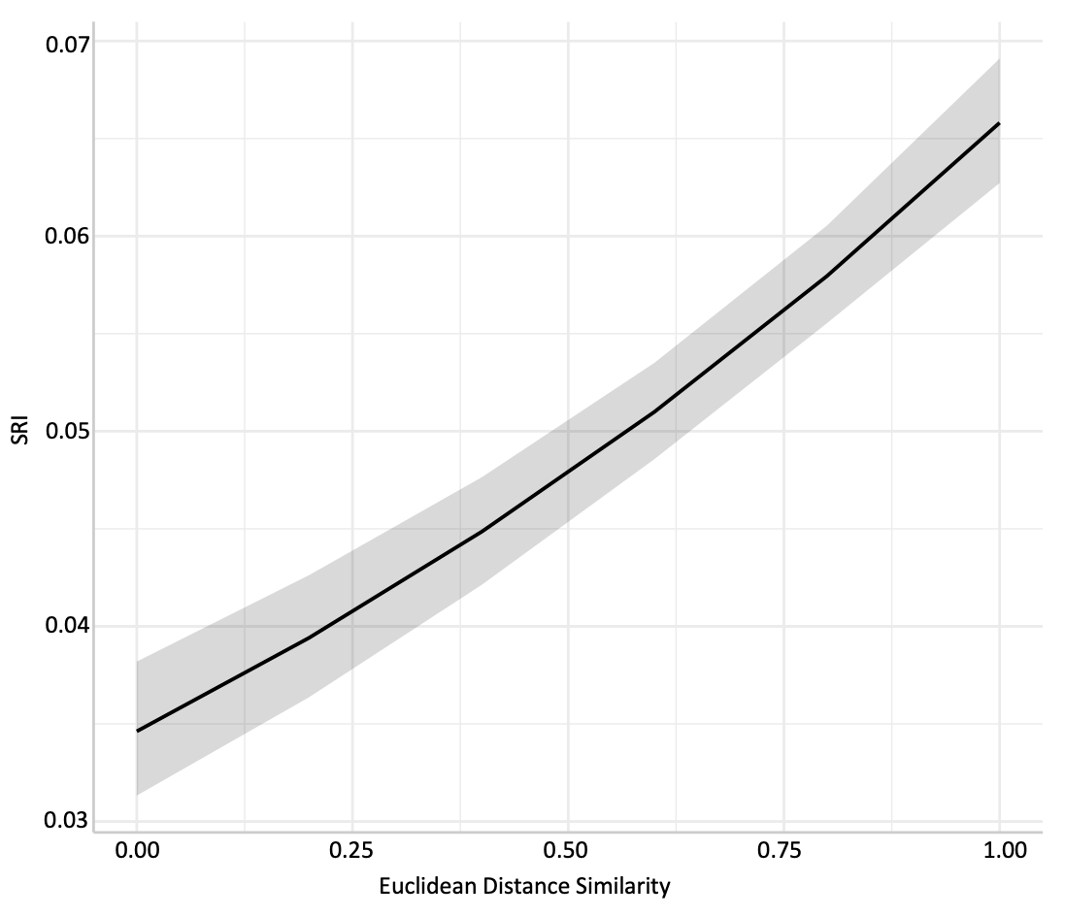

Figure S2. Relationship between similarity in shallow-water foraging behavior and social association strength (SRI) among dolphins. The black line represents the model-predicted relationship from the MCMC GLMM, and the shaded area shows the 95% credible interval. Dolphins with more similar shallow-water foraging frequencies were more likely to associate socially.

