SUPPLEMENTARY RESOURCE
Food or urbanization? Assessing the diversity of urban insectivorous bats in a Neotropical city
Urban Ecosystems
Rebeca Selene Miguel-Méndez¹, M. Cristina MacSwiney González², Víctor Rosas-Guerrero³, Yvonne Herrerías-Diego¹, Miguel Angel Salinas-Melgoza ^{1, 4}, Alejandro Salinas-Melgoza^{1*}
¹ Facultad de Biología. Universidad Michoacana de San Nicolás de Hidalgo. C.P. 58004. Morelia, Michoacán, México.
² Centro de Investigaciones Tropicales, Universidad Veracruzana.
³ Escuela Superior en Desarrollo Sustentable, Universidad Autónoma de Guerrero. C.P. 40900. Tecpan de Galeana, Guerrero, México.
⁴ Escuela Nacional de Estudios Superiores (ENES) Unidad Morelia, Universidad Nacional Autónoma de México, C.P. 58190. Morelia, Michoacán, México
Corresponding author: alejandro.salinas@umich.mx.

- List of the potentially bat species distributed in the area.
Family | Potential species | % correct identification | Acronym | Urban | Urban Park | Transition | Echolocation call frequency | Foraging mode
Emballonuridae | Balantiopteryx plicata | 92 | Balpli | x | x | x | High | Open
Mormoopidae | Mormoops megalophylla | 100 | Mormeg | x | x | x | High | Open
Mormoopidae | Pteronotus fulvus | 97 | Pteful | x | x | x | High | Open
Mormoopidae | Pteronotus mexicanus | 100 | Ptemex |  |  | x | High | Narrow
Mormoopidae | Pteronotus psilotis | 99 | Ptepsi
Vespertilionidae | Corynorhinus mexicanus | 82 | Coryno | x | x | x | High | Narrow
Vespertilionidae | Corynorhinus townsendii | 81
Vespertilionidae | Eptesicus fuscus | 41 | Eptfus | x |  |  | Low | Edge
Vespertilionidae | Neoeptesicus furinalis | 83 | Neotfur | x | x | x | High | Open
Vespertilionidae | Neoeptesicus brasiliensis | 68.3 | Neobra | x | x | x | Low | Edge
Vespertilionidae | Idionycteris phyllotis | 100 | Idiphy |  |  | x | High | Narrow
Vespertilionidae | Lasiurus franzii | 75 | Lasfra |  | x | x
Vespertilionidae | Lasiurus xanthinus | 76 | Lasxan | x | x | x | Low
Vespertilionidae | Lasiurus cinereus | 84 | Lascin
Vespertilionidae | Lasiurus ega | 53 | Lasega
Vespertilionidae | Myotis californicus | 81.8 | Myotis | x | x | x | High | Open
Vespertilionidae | Myotis thysanodes | 100
Vespertilionidae | Myotis velifer | 74
Vespertilionidae | Myotis volans | 47.4
Vespertilionidae | Myotis yumanensis | 69
Vespertilionidae | Rhogeessa parvula | 40.7 | Rhopar
Molossidae | Eumops underwoodi | 100 | Eumund | x | x | x | Low | Open
Molossidae | Molossus molossus | 69.2 | Molossus | x | x | x | Low | Open
Molossidae | Molossus nigricans | 66.6
Molossidae | Molossus sinaloae | 54.5
Molossidae | Nyctinomops macrotis | 77.2 | Nycmac | x | x | x | Low | Open
Molossidae | Promops centralis | 94.4 | Procen | x | x | x | Low | Open
Molossidae | Tadarida brasiliensis | 76 | Tadbra | x | x | x | Low | Open

- Urbanization index model and Resource availability index model
Urbanization index
 | Abundance |  | Q0 |  | Q1 |  | Q2
Predictors | Estimates ± Standard Error | p | Estimates ± Standard Error | p | Estimates ± Standard Error | p | Estimates ± Standard Error | p
(Intercept) | 298.43 ± 0.2 | <0.001* | 7.09 ± 0.1 | <0.001* | 2.99 ± 0.1 | <0.001* | 0.87 ± 0.1 | <0.001*
Transition | 0.65 ± 0.3 | 0.178 | 1.14 ± 0.1 | 0.493 | 1.18 ± 0.1 | 0.403 | 0.09 ± 0.1 | 0.584
Urban | 0.44 ± 0.4 | 0.058 | 0.72 ± 0.2 | 0.154 | 0.88 ± 0.2 | 0.531 | -0.12 ±0.1 | 0.504
Dry-warm season | 0.82 ± 0.1 | 0.294 | 1.06 ± 0.08 | 0.48 | 1.11 ± 0.05 | 0.045 | 0.14 ± 0.05 | 0.009*
Dry-cold season | 0.67 ± 0.1 | 0.038* | 0.78 ± 0.08 | 0.004* | 0.91 ± 0.05 | 0.081* | -0.04 ± 0.05 | 0.474
PC1 | 0.89 ± 0.1 | 0.421 | 0.95 ± 0.05 | 0.375 | 0.99 ± 0.03 | 0.846 | 0.01 ± 0.03 | 0.778
Random Effects
Marginal R2 / Conditional R2 | 0.146 / 0.282 |  | 0.220 / 0.314 |  | 0.220 / 0.381 |  | 0.040 / 0.082
Formula | Abundance ~ urbanization level + season + PC1+ (1|sitio) |  | Q0 ~ urbanization level + season + PC1+ (1|sitio) |  | Q1 ~ urbanization level + season + PC1+ (1|sitio) |  | Q2 ~ urbanization level + season + PC1+ (1|sitio)
Resource availability index
 | Abundance |  | Q0 |  | Q1 |  | Q2
Predictors | Estimates ± Standard Error | p | Estimates ± Standard Error | p | Estimates ± Standard Error | p | Estimates ± Standard Error | p
(Intercept) | 272.85 ± 0.2 | <0.001* | 6.88 ± 0.1 | <0.001* | 2.98 ± 0.1 | <0.001* | 0.87 ± 0.1 | <0.001*
Transition | 0.6 ± 0.3 | 0.098 | 1.11 ± 0.1 | 0.595 | 1.18 ± 0.1 | 0.406 | 0.1 ± 0.1 | 0.56
Urban | 0.61 ± 0.3 | 0.104 | 0.82 ± 0.1 | 0.302 | 0.89 ± 0.1 | 0.536 | -0.15 ± 0.1 | 0.353
Dry-warm season | 0.82 ± 0.1 | 0.299 | 1.05 ± 0.08 | 0.528 | 1.11 ± 0.05 | 0.043* | 0.15 ± 0.05 | 0.006*
Dry-cold season | 0.67 ± 0.1 | 0.034* | 0.78 ± 0.08 | 0.004* | 0.91 ± 0.05 | 0.103 | -0.03 v 0.06 | 0.628
PC2 | 1.18 ± 0.09 | 0.069 | 1.03 ± 0.03 | 0.39 | 0.99 ± 0.02 | 0.715 | -0.02 ± 0.02 | 0.244
Random Effects
Marginal R2 / Conditional R2 | 0.162 / 0.290 |  | 0.220 / 0.316 |  | 0.221 / 0.380 |  | 0.041 / 0.083
Formula | Abundance ~ urbanization level + season + PC2+ (1|sitio) |  | Q0 ~ urbanization level + season + PC2+ (1|sitio) |  | Q1 ~ urbanization level + season + PC2+ (1|sitio) |  | Q2 ~ urbanization level + season + PC2+ (1|sitio)

- Performance-Score Analysis

Name | Model | R2 cond. | R2 marg. | ICC | RMSE | Sigma | AIC weights | AICc weights | BIC weights | Performance-Score
Abundance
Resource availability index | glmmTMB | 0.29 | 0.162 | 0.153 | 132.33 | 1.667 | 0.735 | 0.735 | 0.735 | 80.00%
Urbanization index | glmmTMB | 0.282 | 0.146 | 0.16 | 135.67 | 1.642 | 0.265 | 0.265 | 0.265 | 20.00%
Q0
Urbanization index | glmerMod | 0.314 | 0.22 | 0.121 | 2.105 | 0.337 | 0.51 | 0.51 | 0.51 | 50.00%
Resource availability index | glmerMod | 0.316 | 0.22 | 0.123 | 2.095 | 0.335 | 0.49 | 0.49 | 0.49 | 50.00%
Q1
Urbanization index | glmerMod | 0.381 | 0.22 | 0.206 | 0.751 | 0.24 | 0.488 | 0.488 | 0.488 | 50.00%
Resource availability index | glmerMod | 0.38 | 0.221 | 0.204 | 0.751 | 0.24 | 0.512 | 0.512 | 0.512 | 50.00%
Q2
Resource availability index | glmerMod | 0.083 | 0.041 | 0.043 | 0.578 | 0.607 | 0.644 | 0.644 | 0.644 | 87.50%
Urbanization index | glmerMod | 0.082 | 0.04 | 0.044 | 0.581 | 0.611 | 0.356 | 0.356 | 0.356 | 12.50%

- Principal Component Analysis (PCA) of the variables of artificial light, urban noise and prey biomass.

Importance of components:
 | PC1 | PC2 | PC3
Standard deviation | 1.3354 | 0.9486 | 0.563
Proportion of Variance | 0.5944 | 0.2999 | 0.1057
Cumulative Proportion | 0.5944 | 0.8943 | 1

Variable loads:
 | PC1 | PC2 | PC3
Artificial light | 0.6568729 | -0.2939773 | 0.69433086
Urban noise | 0.6719954 | -0.1893887 | -0.71592887
Prey biomass | -0.3419653 | -0.9368614 | -0.07314712

- Alluvial graph of dam categories at different levels of urbanization (urban, urban park and transition)

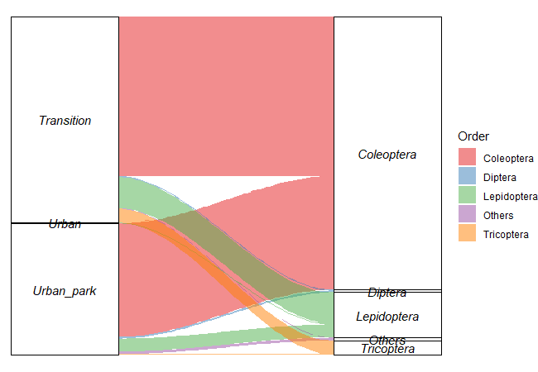

- Range-Abundance Curves of Abundance Log10 in the urban, urban park and transition

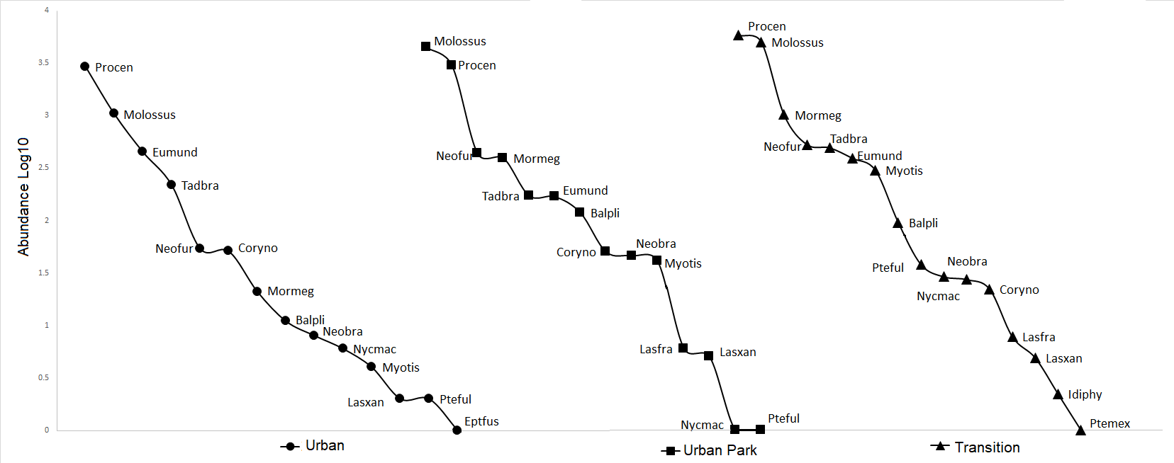
Balpli: Balantiopteryx plicata, Mormeg: Mormoops megalophylla, Pteful: Pteronotus fulvus, Ptemex: Pteronotus mexicanus, Coryno: Corynorrynus sp., Eptfus: Eptesicus fuscus., Neofur: Neoptesicus furinalis Neobra: Neoptesicus brasiliensis, Idiphy: Idionycteris phyllotis, Lasfra: Lasiurus franzii, Lasxan: Lasiurus xanthinus, Myotis: Myotis sp., Eumund: Eumops underwoodi, Molossus:Molossus sp., Nycmac: Nyctinomops macrotis, Procen: Promops centralis, Tadbra: Tadarida brasiliensis.

- NMDS analysis. The points represent species abundance per site, and the circles represent site adjustment. The analysis shows that bat communities are heterogeneous across disturbance levels.

