SUPPLEMENTAL INFORMATION
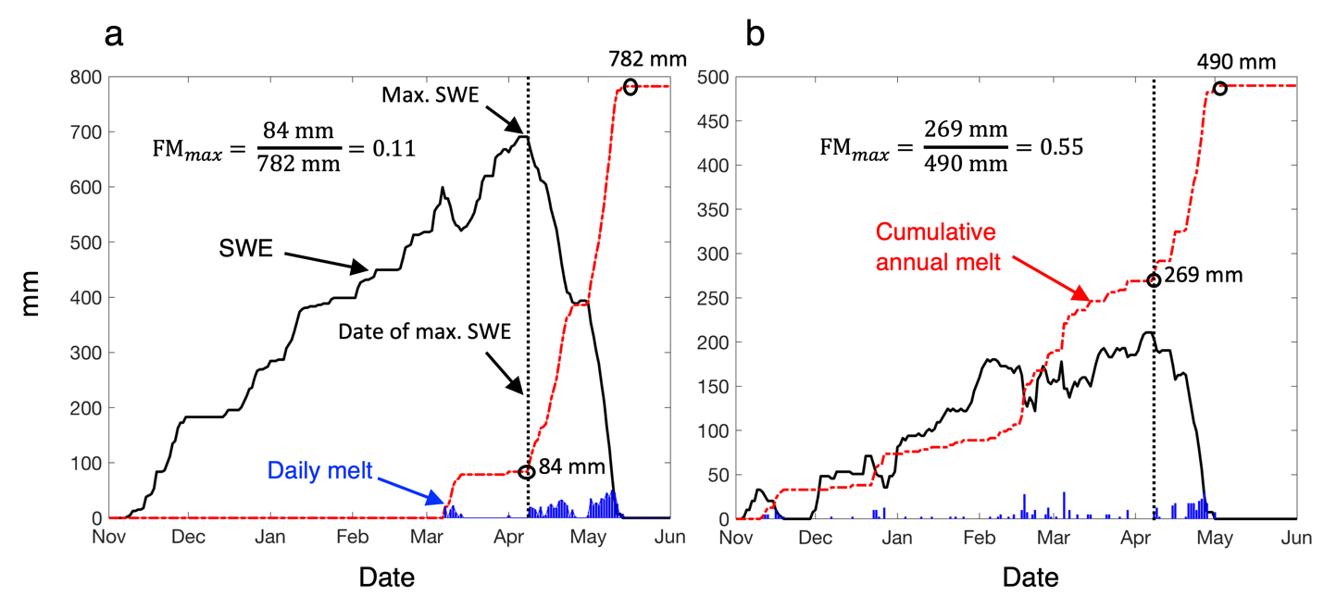
Figure S1 | Examples of seasonal SWE time series measured at mountain snowpack telemetry stations in (a) continental and (b) maritime climates showing daily SWE (solid black line) and two metrics derived from the daily decrease in SWE: daily melt (blue bars) and cumulative annual melt (red hashed lines) computed for Oct. 1 – Aug. 1 of each year. The date of maximum SWE is indicated by the vertical dashed line. Calculations of the fraction of cumulative annual melt that has occurred by the date of maximum SWE (FM_{max}) are shown.
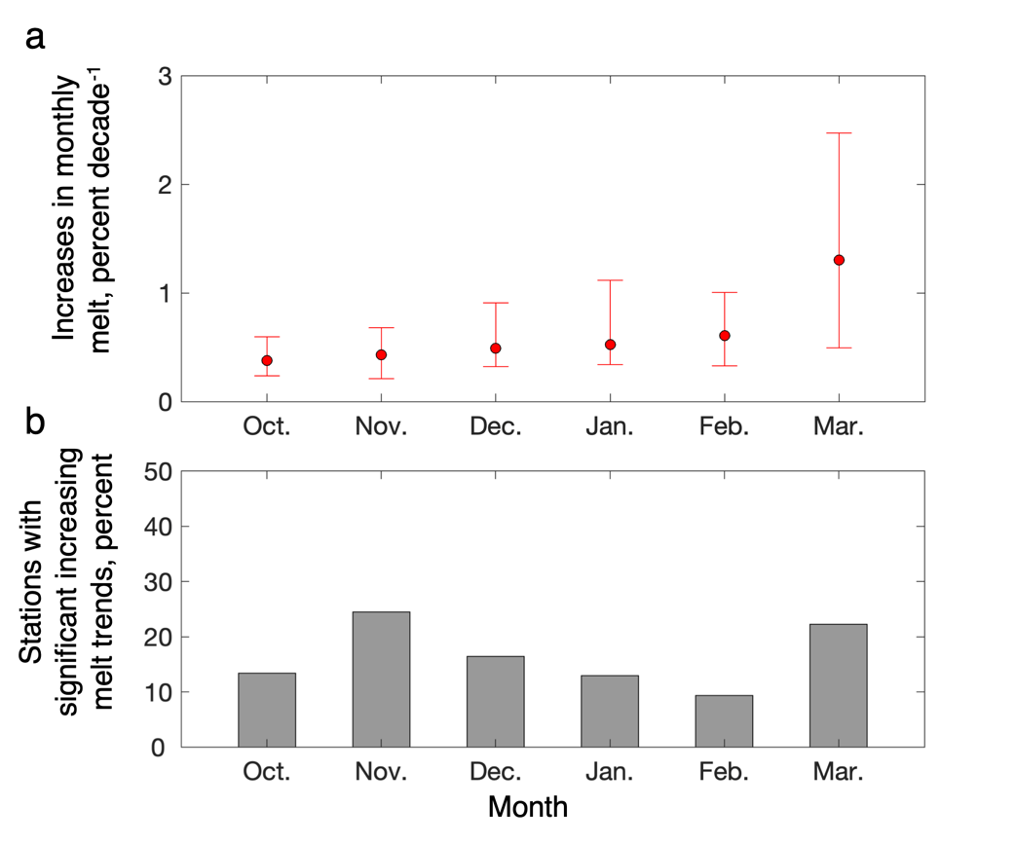
Figure S2 | a) Increases (% decade⁻¹) in monthly melt as a fraction of total annual melt (median shown by red circles, lower and upper quartiles indicated by whiskers) from b) snowpack telemetry stations with data records $≥$ 30 years that have statistically significant (p$≤$0.05) positive trends (in percent of n=634 stations). Stations with negative trends not shown: <1% in Oct. and Nov., ~2% in Dec., Jan., Feb. and Mar.
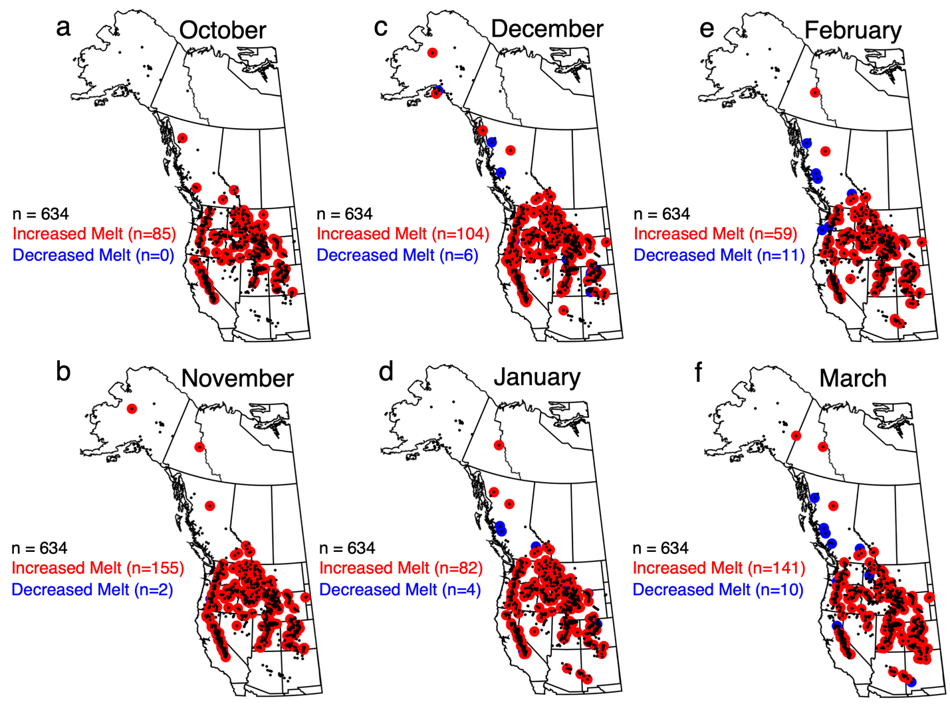
Figure S3 | Geographic distribution of the monthly melt trends shown in Figure S2 mapping stations with data records $≥$ 30 years (small black markers; n=634) that have statistically significant (p$≤$0.05) long-term increases (red markers) and decreases (blue markers) in monthly melt as a fraction of total annual melt for the months of (a) October, (b) November, (c) December, (d) January, (e) February, and (f) March.
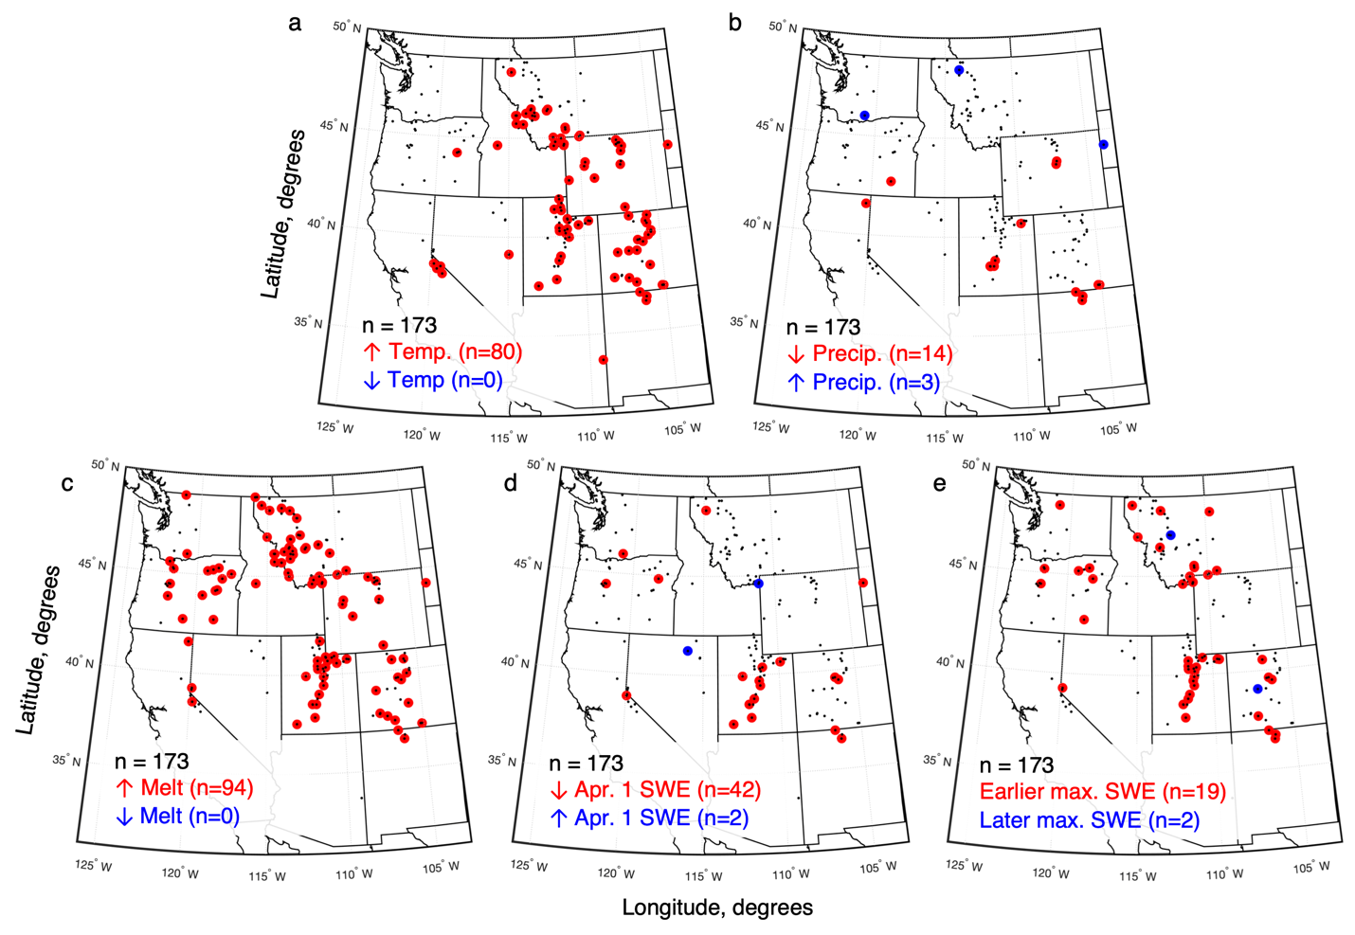
Figure S4 | As in Fig. 2 but showing trends (see legends) in a) temperature, b) precipitation, c) FM_{Apr1} (melt), d) April 1 SWE, and e) date of maximum SWE at the 173 U.S. stations with long records (small black markers) coincident with the PRISM climate data (1979-2019).

