Tabel 6 Six fern species commonly harvested from forests and sold in local markets by the Dayak Sisang community
Spesies | (nᵢ) | (N) | RFC (%) | WEP Specimen
Stenochlaena palustris (Burm.f.) Bedd. (cekas) | 50 | 53 | 94.34 | 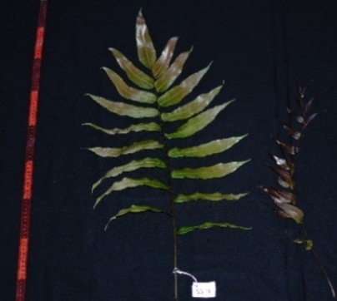
Diplazium esculentum (Retz.) Sw.  (pekuh iko) | 52 | 53 | 98.11 | 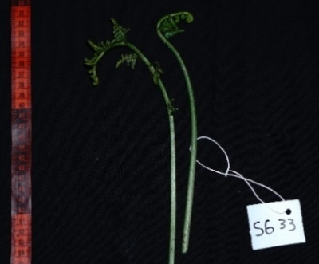
Blechnum orientale L.  (pekuh prengkis) | 14 | 53 | 26.42 | 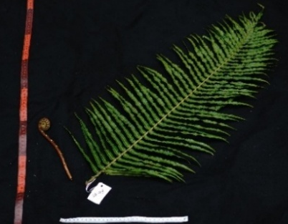
Thelypteris interrupta (Willd.) K.Iwats.  (pekuh orut) | 8 | 53 | 15.09 | 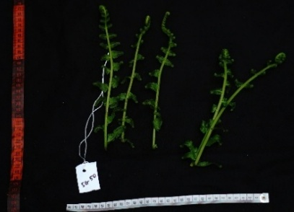
Nephrolepis radicans (Burm.f.) Kuhn  (gerubu') | 52 | 53 | 98.11 | 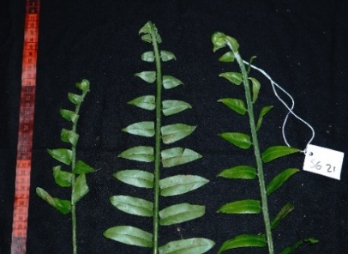
Dryopteris cycadina (Franch. & Sav.) C.Chr.  (pekuh entawa) | 42 | 53 | 79.25 | 