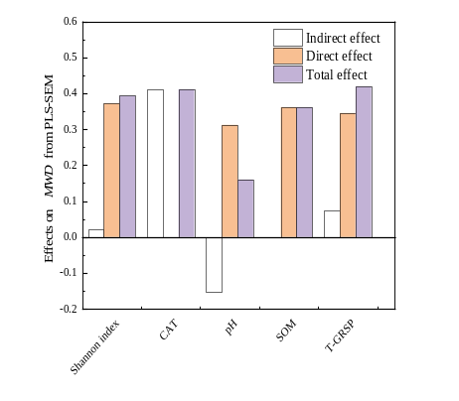
- (II)
Fig. 9 Structural equation modeling revealing the effects of Shannon index, CAT, pH, SOM, and T-GRSP on MWD

