Supporting Information
Light-induced borazine/triazine-containing conjugated polymer spatial twist boosting high-performance photo-assisted Li-CO₂ batteries

Authors
Ling Li,^{1,2,3†} Dihua Tian,^{2†} Fuquan Ma,^{1,4} Xiyue Peng,² Xuexia He,^{1,5} Jie Sun,^{1,5} Ruibin Jiang,^{1,5} Zhibin Lei,^{1,5} Yongxin Huang,² Run Zhang,² Jifei Liu,³ Lianzhou Wang,^{6,7} Bin Luo,^{2,6}* Qi Li,^{1,5}* Zong-Huai Liu^{1,5}*
Affiliations
¹ School of Materials Science and Engineering, Shaanxi Normal University, Xi’an 710119, P. R. China.
² Australia Institute for Bioengineering and Nanotechnology (AIBN), The University of Queensland, Brisbane 4072, QLD, Australia.
³ School of New Energy and Power Engineering, Lanzhou Jiaotong University, Lanzhou 730070, P. R. China.
⁴ School of Textile Science and Engineering, Xi’an Polytechnic University, Xi’an 710048, P. R. China.
⁵ Key Laboratory of Applied Surface and Colloid Chemistry (Shaanxi Normal University), Ministry of Education, Xi’an 710062, P. R. China.
⁶ School of Chemical Engineering, The University of Queensland, Brisbane 4072, QLD, Australia.
⁷ Department of Applied Biology and Chemical Technology, Faculty of Science, The Hong Kong Polytechnic University, Hong Kong SAR, P.R. China.

Email: zhliu@snnu.edu.cn; clliqi@snnu.edu.cn; b.luo1@uq.edu.au.

①
②

Supplementary Fig. 1 The possible decomposition products of urea precursors.
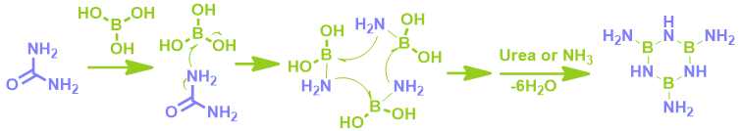
①

②

Supplementary Fig. 2 The relevant reaction processes involved in the pyrolysis of boric acid and urea precursors.
According to the reported reactions^{1, 2}, the possible pyrolysis processes of boric acid and urea are described as follows.
First, the three molecules of urea undergo condensation to form a triazine analogue upon heating, which could be further ammoniated with additional urea before the dehydration of boric acid. Thus, when the mass ratio is 1:1 (M_{(boric acid)}= 61.83 g mol⁻¹, and M_{(urea)}= 60.06 g mol⁻¹, means the mass ratio is approximately equal to the molar ratio), the relatively high concentration of boric acid in the precursor prefers dehydration, condensation, and followed by reaction on the edge with triazine analogue. As the mass ratio increases to 1:5, the residual urea after self-polymerization continues to react with boric acid to give borazine. Triazine and borazine analogue then were randomly linked by free boric acid or urea and results in highly disordered polymerization. With further increase in the mass ratio to 1:10 and 1:20, a large amount of triazine rings undergo self-polymerization to form nC₃N₄ structures, with only a small amount of disorder-induced polymerization caused by boric acid doping. At this stage, most of the structural units are composed of rigid C₃N₄ units.

Supplementary Fig. 3 SEM images of of the as-prepared samples (the inset in the yellow box is an enlarged view).

Supplementary Fig. 4 TEM images of (a) B₂O₃ and (b) C₃N₄. The insets show the corresponding HRTEM and FFT patterns, respectively.

Supplementary Fig. 5 Dark-field TEM image of BTCP-2 sample.

Supplementary Fig. 6 XRD patterns of (a) B₂O₃ and (b) C₃N₄.

Supplementary Fig. 7 BET analysis. (a) N₂ adsorption/desorption isotherms, (b) Pore size distribution.

Supplementary Fig. 8 XPS spectra of the four samples were obtained.

Supplementary Fig. 9 FT-IR spectra of the B₂O₃, C₃N₄, and BTCP samples.

Supplementary Fig. 10 (a) UV-Vis-NIR DRS spectra of the BTCP samples, (b) Corresponding band gap values.

Supplementary Fig. 11 UPS spectra of the BTCP samples.

Supplementary Fig. 12 Band positions of the BTCP samples.

Supplementary Fig. 13 Mott-Schottky plots of the BTCP sample.

Supplementary Fig. 14 (a) PL spectra and (b)TRPL spectra of the BTCP samples.

Supplementary Fig. 15 (a) I-t curves and (b) EIS plots of the BTCP samples.

Supplementary Fig. 16 In situ photoirradiation N 1s XPS spectra.

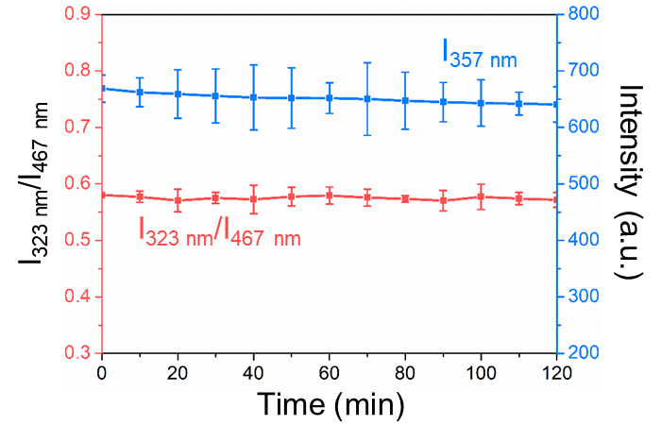
Supplementary Fig. 17 Photostability of material against time.

Supplementary Fig. 18 Continuous measurement of PL spectra for the C₃N₄ sample over a duration of 30 min.

Supplementary Fig. 19 Discharged and charged curves of C₃N₄ photocathode at 100 μA cm⁻².

Supplementary Fig. 20 (a) Comparative column chart of the discharged and charged voltage of BTCP and C₃N₄ photoelectrodes, (b) Corresponding overpotential and round-trip efficiency.

Supplementary Fig. 21 LSV curves of the BTCP-2 sample under light and dark testing conditions.

Supplementary Fig. 22 (a) Discharge and charge profiles of the BTCP-2 photocathode at a current density of 100 μA cm⁻² under light and (b) Impedance test results corresponding to different discharge/charge states.

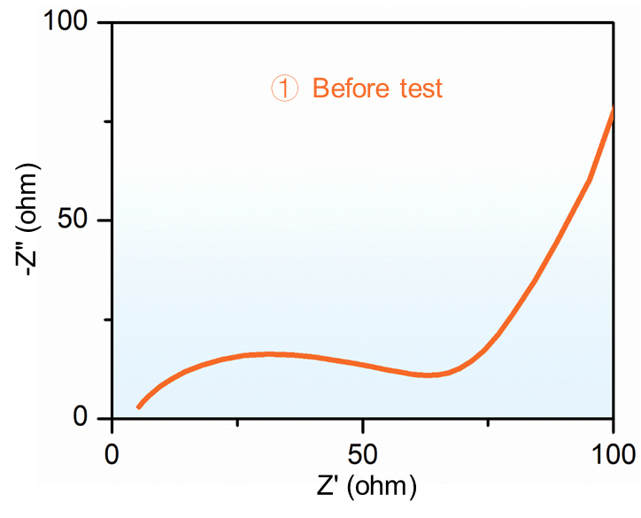
Supplementary Fig. 23 EIS curve before starting discharge.

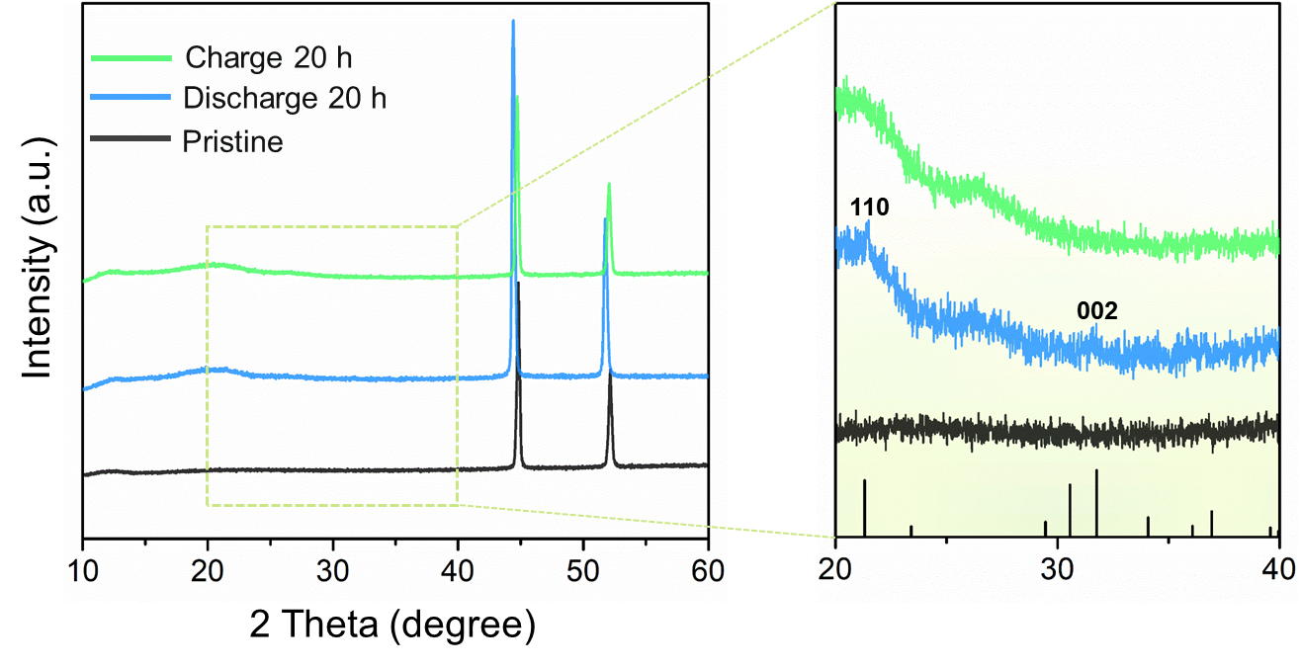
Supplementary Fig. 24 XRD patterns of products during discharge and charging processes.

Supplementary Fig. 25 C 1s and Li 1s XPS spectra of the BTCP-2 photoelectrode corresponding to different test states.

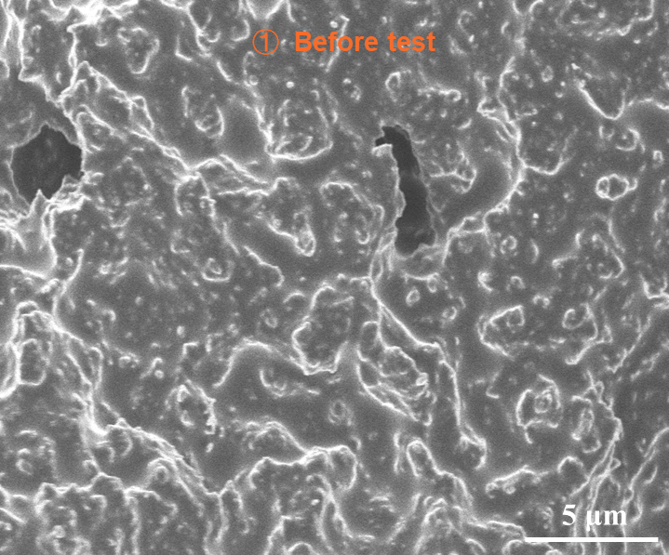
Supplementary Fig. 26 SEM image before starting discharge.

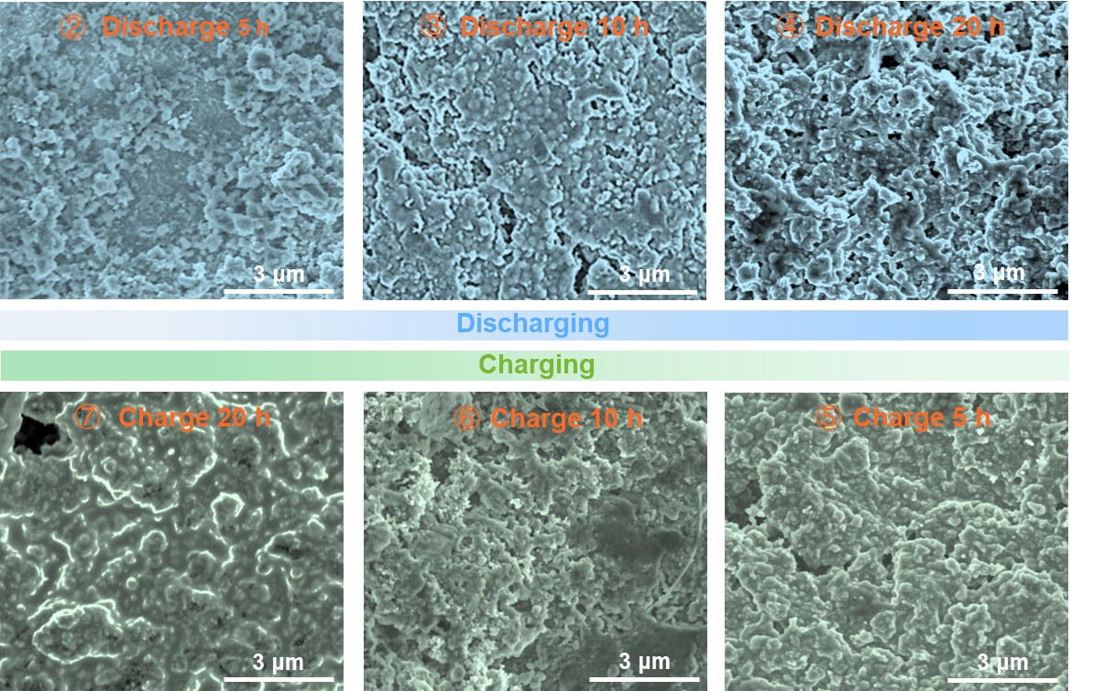
Supplementary Fig. 27 SEM images corresponding to different stages of the discharging and charging process.

Table 1 Comparison of the previously reported photocathode materials
Cathode catalysts | Current density (μA cm⁻²) | voltage gap | Round-trip efficiency |  |  | Cycling stability  (cycles) | Discharge capacity  (μAh cm⁻²) |  | Reference
Photo-assisted Li-CO₂ Battery
BTCP-2 | 100 | 0.13 |  | 95.5% | 323 |  |  | 32300 |  | This work
B@BA₂ | 100 | 0.25 |  | 91.3% | 125 |  |  | 12500 |  | ³
Mixed-PhaseTiO₂ | 25 | 0.78 |  | 74% | 52 (60.1%) |  |  | 3001 |  | ⁴
CNT@C₃N₄ | 100 | 0.36 |  | 89% | 100 (67.5%) |  |  | 15770 |  | ⁵
TNAs@AgNPs | 100 | 0.37 |  | 87.1% | 100 (87%) |  |  | 10000 |  | ⁶
Electrochemical Li-CO₂ Battery
CFB@NCNT-Mo₂N | 10 | 1.08 |  | 71.6% | 77 (60%) |  |  | 5586 |  | ⁷
Co₃O₄ | 20 | 1.0 |  | 75% | 55 (57%) |  |  | 2407 |  | ⁸
CoS-Vs-1.0 | 100 | 1.08 |  | 72.5% | 90 |  |  | 4637.6 |  | ⁹
NS_{v}-ReS₂/CP | 40 | 0.86 |  | 76.0% | 175 (70.3%) |  |  | 1811 |  | ¹⁰

References
1. Aghili, S., Masoud P., and Mahmood M. Kinetic analysis of formation of boron trioxide from thermal decomposition of boric acid under non-isothermal conditions. J. Therm. Anal. Calorim. 131, 2443-2455 (2018).
2. Wu, C. et al. Molecular-scale understanding on the structure evolution from melamine diborate supramolecule to boron nitride fibers. Ceram. Int. 46, 1083-1090 (2020).
3. Li, L. et al. High-concentrated electron-deficient boron through dual-function boric acid strategy significantly enhancing reaction kinetics and stability of photoassisted Li-CO₂ batteries. Energy Storage Mater. 71, 103634 (2024).
4. Long, L. et al. A carbon‐free and free‐standing cathode from mixed‐phase TiO₂ for photo‐assisted Li-CO₂ Battery. Small 19, 2300519 (2023).
5. Li, J. et al. High‐efficiency and stable Li-CO₂ battery enabled by carbon nanotube/carbon nitride heterostructured photocathode. Angew. Chem. Int. Ed. 61, e202114612 (2021).
6. Zhang, K. et al. Boosting cycling stability and rate capability of Li-CO₂ batteries via synergistic photoelectric effect and plasmonic interaction. Angew. Chem. Int. Ed. 61, e202201718 (2022).
7. Chen, L. et al. Flexible, stretchable, water‐/fire‐proof fiber‐shaped Li‐CO₂ batteries with high energy density. Adv. Energy Mater. 13, 2202933 (2022).
8. Liu, Y. et al. Uncovering the geometry activity of spinel oxides in Li-CO₂ battery reactions. ACS Energy Lett. 9, 2173-2181 (2024).
9. Lu, B. et al. Steering the orbital hybridization to boost the redox kinetics for efficient Li-CO₂ batteries. J. Am. Chem. Soc. 146, 20814-20822 (2024).
10. Chen, B. et al. Designing electrophilic and nucleophilic dual centers in the ReS₂ plane toward efficient bifunctional catalysts for Li-CO₂ batteries. J. Am. Chem. Soc. 144, 3106-3116 (2022).

