Supporting Information
Tailoring metal-oxide interface for fatigue performance engineering in HfO₂-based ferroelectrics
Yi-Xuan Liu^{a,b,*}, Ziyi Yuanª, Babak Bakhit^{a,c}, Han Yu^{a,b}, Jiahao Luª, Ji Soo Kim^{a,*}, Ke Wang^{b}, José P. B. Silva^{d,e}, and Judith L. MacManus-Driscoll^{a,*}
ªDepartment of Materials Science and Metallurgy, University of Cambridge, Cambridge CB3 0FS, UK
^{b}State Key Laboratory of New Ceramic Materials, School of Materials Science and Engineering, Tsinghua University, 100084 Beijing, People’s Republic of China
^{c}Thin Film Physics Division, Department of Physics (IFM), Linköping University, Linköping SE-58183, Sweden
^{d}Physics Center of Minho and Porto Universities (CF-UM-UP), University of Minho, Campus de Gualtar, 4710-057 Braga, Portugal
^{e}Laboratory of Physics for Materials and Emergent Technologies, LapMET, University of Minho, 4710-057 Braga, Portugal
* Corresponding author.
E-mail: yxl24@cam.ac.uk (Y.-X. Liu), jsk55@cam.ac.uk (J. S. Kim), jld35@cam.ac.uk (J. L. Driscoll)
Keywords: Ferroelectrics, Hafnia, Band alignment, Fatigue

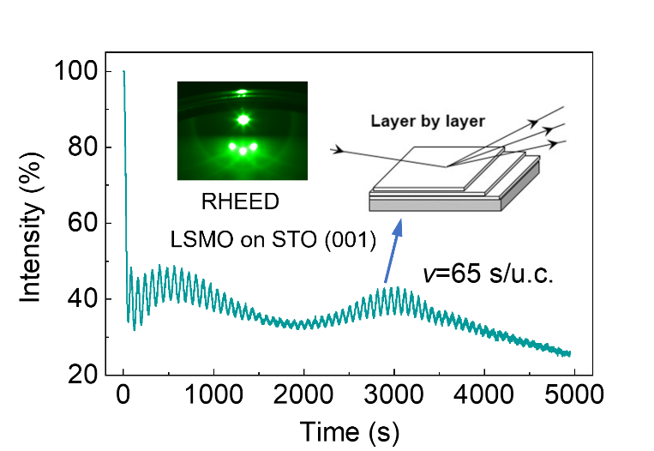
Fig. S1 Reflection of high-energy electron diffraction (RHEED) intensity oscillations during the growth of LSMO on STO (001) substrate. The insets indicate the RHEED patterns before the growth. The well-defined intensity oscillation suggests a layer-by-layer growth. The growth rate of 65 s/u.c can be determined from the oscillation period.

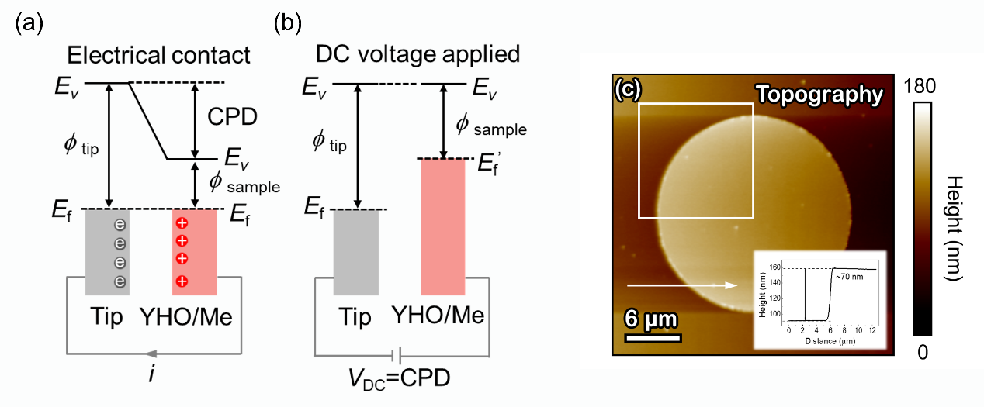
FIG. S2 a, b Working principle of KPFM measurement. The energy level diagram of the YHO with a top metal electrode and the tip (Pt coated) is shown in a. The electrical contact between the tip and the sample facilitates Fermi level alignment through current flow i, resulting in a shift in vacuum energy levels (E_{v}) and the contact potential difference (CPD). KPFM applies DC bias, V_{DC}, to compensate for the CPD, as shown in b. c, Topography of the surface of the YHO film with a top metal electrode. The potential difference mappings in Fig. 2d-h correspond to the region marked by the white box in c. The inset at the lower right shows the height profile of the electrode edge indicated by the white arrow.

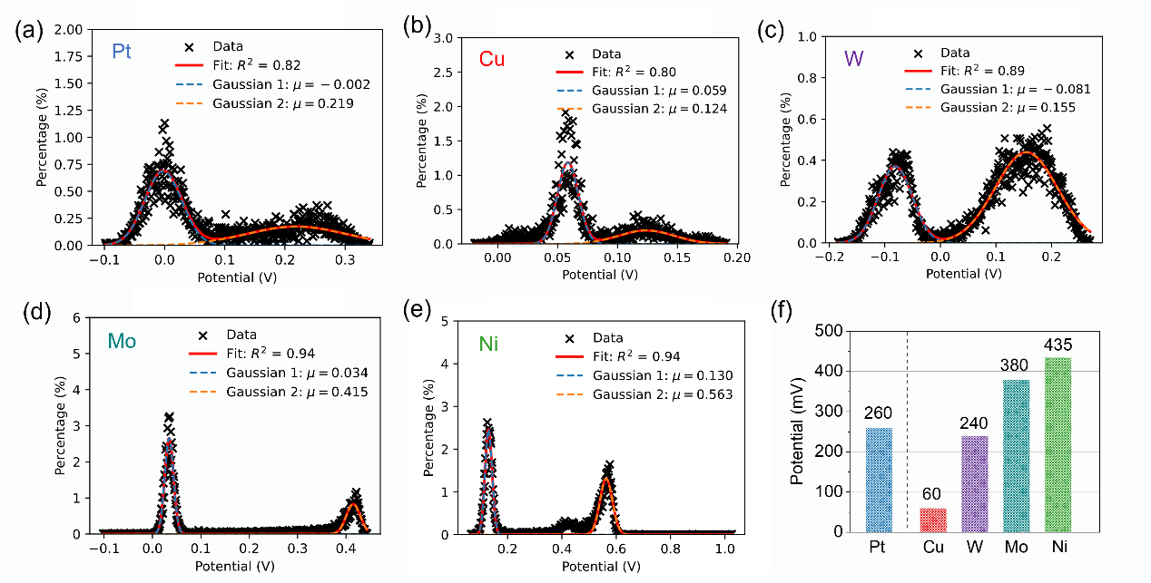
FIG. S3 The potential distribution measured by KPFM in the areas shown in Fig. 2d-h. a-e, distribution fitted by two Gaussian peaks, corresponding to the measured potentials of (a) Pt, (b) Cu, (c) W, (d) Mo, and (e) Ni (Gaussian 1) and YHO films (Gaussian 2). f, The potential difference between the YHO films and various metal top electrodes.

FIG. S4 Ferroelectric properties of YHO films with different top electrode metals. Ferroelectric P-V and current I-V measurement by the PUND method on YHO films with (a) Pt, (b) Cu, (c) W, (d) Mo, (e) Ni, and (e) Al top electrodes. The twice remanent polarization, 2P_{r}, and the twice coercive voltage, 2E_{c}, are marked correspondingly.

FIG. S5 a, DC leakage current density loops (J-V), b, DC leakage current (I-V) loops, and c, their values extracted at -2 V as a function of electrode areas for YHO film with Ni top electrode before fatigue. d, DC leakage current density loops (J-V), e, DC leakage current (I-V) loops, and f, their values extracted at -2 V as a function of electrode areas for YHO film with Ni top electrode after fatigue.

Table S1 The comparison of the work functions of different metals φ_{Me}, their corresponding oxides φ_{MeOx} and the polarization values at zero voltage differ for the positive and negative electric field, ΔP_{E=0}, for YHO films. A value of 4.8 eV is adopted for the work function of LSMO layer. The work function of metal oxides is correlated with the oxidation states of their cations. Here, we use the work functions of oxides with average cation oxidation states as illustrative examples for comparison.
Metal | Pt | Cu | W | Mo | Ni
φ_{Me} (eV) | 5.65 | 4.65 | 4.55 | 4.6 | 5.16
φ_{MeOx} (eV) | / | 5.5 | 5.2 | 6.3 | 5.5
ΔP_{E=0} (μC/cm²) | 0.89 | 0.68 | 0.13 | 1.32 | 0.67

