Clinical study on common infections and mortality among 40 000 geriatric patients hospitalized in Stockholm, Sweden
Molnár et al.

Supplementary materials

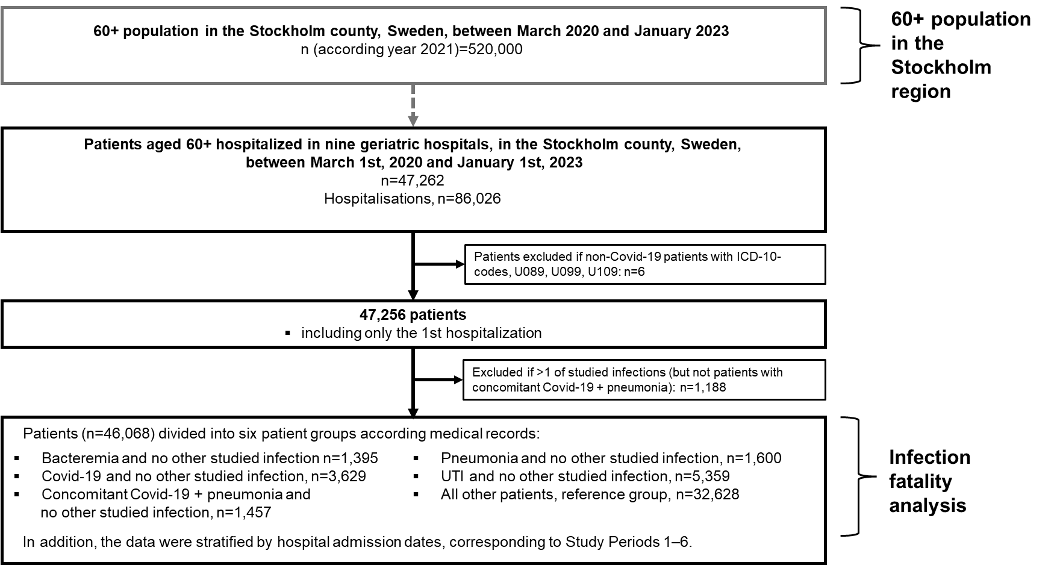
Supplementary Figure 1. Patient selection for the infection fatality analysis
a b
c
Supplementary Figure 2. Monthly numbers of Covid-19 deaths during 2020-2023 in 60+ population a) living in the Stockholm county or b) hospitalized in nine geriatric clinics. In panel c, the numbers in panel a and b are shown, on a logarithmic scale. Blue dashed lines indicate the cut points for the six study periods used in the statistical analysis.

