Supplementary material to:

Activated sludge treatment for high ammonium nitrogen wastewater: performance and microbial adaptation with synthetic media
Kinga Marek^{1*,} Katarzyna Pawęska¹, Aleksandra Bawiec¹
¹Institute of Environmental Engineering, Wrocław University of Environmental and Life Sciences, 50-375 Wrocław, Poland, 24 Grunwaldzki Square, (kinga.marek@upwr.edu.pl*Corresponding author, katarzyna.paweska@upwr.edu.pl, aleksandra.bawiec@upwr.edu.pl)

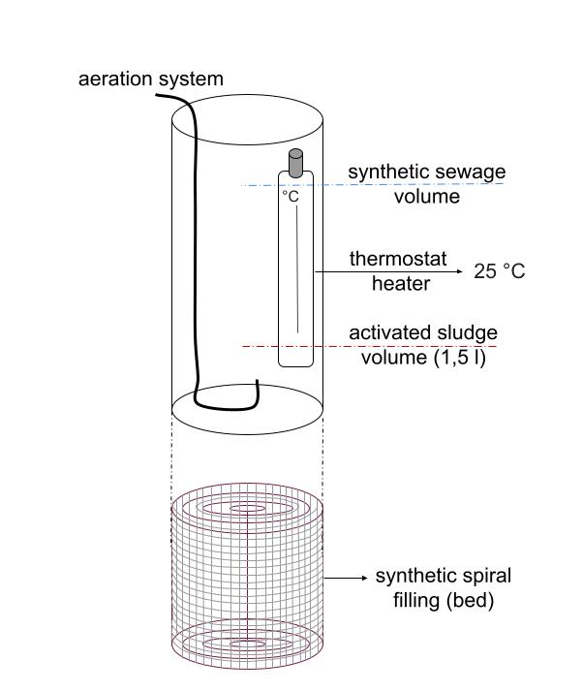
Figure S1. Single cylinder along with its equipment.

Table S1. Synthetic wastewater composition under influent conditions used in the experiment.
Parameter | Average value
pH [-] | 7.8
NH₄⁺ [mg/L] | 202.0 (I group)  453.0 (II group)
NO₃⁻ [mg/L] | 0.4
NO₂⁻ [mg/L] | 4.43
PO₄³⁻ [mg/L] | 6.67
TOC [ppm] | 190.0
C:N [-] | 1.4 (I group)  0.45 (II group)

Table S2. Analyzed wastewater and sludge parameters with frequency and measurement methods.
Parameter | Methodology | Measurement frequency
dissolved oxygen | luminescent quenching | controlled in each phase
pH | potentiometric measurement | controlled after each phase of the cycle
NH₄⁺ | spectrophotometric analysis | beginning and end of each cycle
NO₃⁻ | spectrophotometric analysis | beginning and end of each cycle
NO₂⁻ | spectrophotometric analysis | beginning and end of each cycle
PO₄³⁻ | spectrophotometric analysis | beginning and end of each cycle
NH₄⁺ | spectrophotometric analysis | beginning and end of each cycle
TOC | persulfate oxidation | beginning and end of each cycle
BOD₅ | manometric measurement | initial and end of the cycle
total solids (TS) | gravimetric analysis | end of the experiment
sludge volume index (SVI | settling test | end of the experiment
sludge/biofilm growth | weight measurement | end of the experiment

Table S3. Statistical significance of differences between cylinders with and without filling.
Group | Data Sets | Normality Test (Shapiro-Wilk) | Statistic (W) | p-value | Comparison Test | Statistic | p-value
Group 1 | C-1 | Shapiro-Wilk | 0.85 | 0.02 | Mann-Whitney U | 112.5 | 0.03
Group 1 | G1 | Shapiro-Wilk | 0.75 | <0.01 | Mann-Whitney U | 112.5 | 0.03
Group 2 | C-2 | Shapiro-Wilk | 0.96 | 0.33 | t-Student test | 2.10 | 0.04
Group 2 | G2 | Shapiro-Wilk | 0.94 | 0.20 | t-Student test | 2.10 | 0.04

Table S4. Details of relative abundance data for bacterial families (family level) in activated sludge samples providing for Figure 3.
Type | Relative abundance [%]
Type | C-1 | G1 | C-2 | G2
Rhodanobacteraceae | 1.30 | 2.80 | 15.90 | 26.10
Pirellulaceae | 4.50 | 5.70 | 1.90 | 4.30
Rhodobacteraceae | 2.80 | 3.80 | 3.20 | 5.70
Comamonadaceae | 1.70 | 2.50 | 3.00 | 3.50
Phycisphaeraceae | 4.00 | 2.50 | 1.30 | 1.80
Chitinophagaceae | 1.10 | 0.70 | 2.30 | 3.50
Gemmataceae | 4.50 | 1.60 | 0.60 | 1.60
SC-I-84 | 3.90 | 1.20 | 2.70 | 0.60
Rhodocyclaceae | 1.40 | 2.00 | 0.70 | 1.80
Proteobacteria uncultured | 2.30 | 1.60 | 0.80 | 1.50
S-70 | 0.60 | 3.70 | 0.30 | 0.30
Rhizobiaceae | 2.40 | 1.00 | 1.50 | 1.30
Xanthomonadaceae | 0.30 | 0.60 | 3.50 | 1.70
Xanthobacteraceae | 0.90 | 1.20 | 0.60 | 1.90
Nitrosomonadaceae | 1.00 | 1.90 | 0.40 | 1.20
Acetobacteraceae | 0.70 | 0.80 | 1.30 | 1.70
SAR324_clade(Marine_group_B);SAR324_clade(Marine_group_B) | 1.00 | 1.90 | 0.40 | 0.80
Bryobacteraceae | 1.20 | 0.90 | 0.70 | 1.50
OM190 | 1.40 | 1.40 | 1.10 | 0.70
Microscilaceae | 1.60 | 1.30 | 0.90 | 0.90
Caldilineaceae | 1.50 | 1.50 | 0.40 | 1.40
Sphingomonadaceae | 0.40 | 0.30 | 1.50 | 2.10
Gemmatimonadaceae | 1.10 | 1.60 | 0.00 | 1.10
Blastocetallaceae | 0.20 | 1.20 | 1.10 | 1.20
CCM11a | 0.80 | 2.40 | 0.00 | 0.20
other/ remaining taxa (243) | 57.40 | 53.90 | 53.90 | 31.60

Table S5. Details of relative abundance data for bacterial genera (genus level) in activated sludge samples providing for Figure 4.
Type | Relative abundance [%]
Type | C-1 | G1 | C-2 | G2
Rhodanobacter | 0.00 | 0.00 | 17.80 | 25.10
Proteobacteria uncultured | 6.10 | 6.20 | 2.70 | 3.50
Planctomycetota uncultured | 4.60 | 7.80 | 1.20 | 3.70
Chloroflexi uncultured | 2.50 | 2.60 | 0.60 | 0.80
Bacteroidota uncultured | 2.60 | 1.40 | 1.30 | 1.20
Pirellula | 1.30 | 2.00 | 0.90 | 1.60
SC-I-84 | 3.90 | 1.20 | 0.00 | 0.60
S-70 | 0.60 | 3.70 | 0.10 | 0.30
Rubelimicrobium | 1.00 | 1.60 | 0.80 | 1.30
SM1A02 | 2.90 | 1.10 | 0.50 | 0.90
SAR324_clade(Marine_group_B);SAR324_clade(Marine_group_B) | 1.00 | 1.90 | 0.40 | 0.80
Bryobacter | 1.20 | 1.20 | 0.70 | 1.60
OM190 | 1.40 | 1.40 | 1.10 | 0.70
Pir4_lineage | 1.40 | 1.20 | 0.80 | 0.70
Gemmatimonadota uncultured | 1.10 | 1.70 | 0.00 | 0.80
CCM11a | 0.80 | 2.40 | 0.00 | 0.20
Thauera | 0.50 | 1.80 | 0.00 | 1.30
Desulfobacterota uncultured | 0.90 | 1.00 | 0.00 | 1.10
Paracoccus | 0.80 | 0.50 | 0.70 | 1.20
OLB14 | 1.60 | 1.10 | 0.00 | 0.70
Dokdonella | 0.20 | 0.80 | 0.80 | 0.90
Thermomonas | 0.00 | 0.00 | 0.90 | 1.90
Nitrosomonas | 1.00 | 1.70 | 0.00 | 0.35
Nitrospira | 0.80 | 0.90 | 0.00 | 0.50
DS-100 | 0.20 | 1.10 | 0.00 | 1.20
other/ remaining taxa (437) | 61.60 | 53.70 | 68.70 | 48.35

